Teaching RDA: Day 3

Module 14: Putting it all together

Learning Outcomes:
- Identify and record attributes of the work
- Identify and record attributes of expression
- Identify and record attributes of manifestation
- Put the attributes into a marc bibliographic record
- Create a person authority record for Bram Stoker

Resources:
- Dracula: 3 items
- Catalogue templates for each group
There are no PowerPoint slides for this module.

In this module we will put together everything we have learnt over the three days.

Using the templates provided identify the attributes of work, expression and manifestation for a given resource.
Then create a bibliographic record for the resource and an authority record for the creator of the work.
You may also find Appendix 5 useful.

Exercise 22
Handbook: Page 191

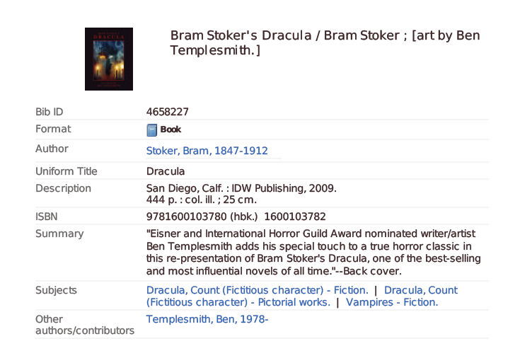
Item 1:

1. Identify the attributes of the original work by Bram Stoker
2. Identify the attributes of the expression of the work
3. Identify the attributes of the manifestation
4. Put the attributes in a marc bibliographic record
5. Create an authority record for Bram Stoker.
You can use additional resources to find further information as needed.
Navigate the RDA instructions and use the RDA/MARC mappings

1. Work record:
Record attributes of the work using the template below. Use the RDA instruction numbers as a guide.
- 6.2 to 6.8 Recording the attributes of the work
- 19.2 Recording creator associated with the work and Appendix I
- 6.27 Constructing the authorised access point for the work
- 7.2 to 7.9 Describing content of the work

RDA Reference | RDA Element | Data Recorded
6.2.1 | Preferred title of the work | Dracula | Known as Dracula
6.2.3 | Variant title |  | Not known by another title
6.3.1 | Form of work | Novel | Only core for differentiation
6.4.1 | Date of work | 1897 | Date first published
6.5.1 | Place of origin | England
6.6.1 | Other distinguishing characteristics |  | Only used for differentiation
6.7.1 | History of the work | Gothic horror novel, first published in 1897 by Archibald Constable and Company | 5.8 – source consulted: Wikipedia
6.8 | Identifier |  | No standard identifier
19.2.1.3  Appendix I | Creator associated with the work | Stoker, Bram, 1847-1912. Author | Apply guidelines at 18.4. Add dates as per 9.19.1.3
6.27 | Authorised access point for the work | Stoker, Bram, 1847-1912. Dracula | No further additions needed
7.2-7.3 | Nature of content; coverage of content
7.7 | Intended audience |  | No audience specified

2. Expression record:
Record attributes of the expression using the template below. Use the RDA instruction numbers as a guide.
6.9 to 6.13 Recording attributes of the expression
7.10 to 7.29 Describing content of the expression
Chapter 20 Persons, families and corporate bodies associated with expression and Appendix I
RDA Reference | RDA Element | Data Recorded
6.9 | Content type | text; still image | Terms from list
6.10 | Date of expression | 2009 | Earliest date of this expression
6.11 | Language of expression | English
6.12 | Other distinguishing characteristic of the expression |  | No other characteristics
6.13 | Identifier for the expression |  | No identifier
7.10 | Summarisation of content | Eisner and International Horror Guild Award nominated writer/artist Ben Templesmith adds his special touch to a true horror classic in this re-presentation of Bram Stoker’s Dracula. | From back cover
7.12 | Language | English
7.15 | Illustrative content | Illustrations
7.17 | Colour content | Colour
20.2  Appendix I.3 | Contributor to the expression | Templesmith, Ben. Illustrator | Construct heading according to 18.4

3. Manifestation record:

Chapter 2 Recording attributes of manifestation and items
Chapter 3 describing carriers
*Include attributes of the item if necessary
RDA Reference | RDA Element | Data Recorded
2.3 | Title of manifestation | Bram Stoker’s Dracula | From title page
2.3.6 | Variant title of manifestation | Dracula
2.4.2 | Statement of responsibility | Illustrated by Ben Templesmith | From cover. Not core
2.5 | Edition statement |  | No edition
2.8.2 | Place of publication | San Diego, C.A. | Abbreviation as appears on item
2.8.4 | Name of publisher | IDW Publishing
2.8.6 | Date of publication | 2009
2.13 | Mode of issuance |  | Single Unit
2.15 | Identifier for the manifestation | 9781100103780
3.2 | Media type | Unmediated
3.3 | Carrier type | Volume
3.4.5 | Extent | 444 pages
3.5 | Dimensions | 24 cm

4: MARC bibliographic record
Marc field | subfield | Data Recorded | Attribute of work, expression or manifestation
020 | $a | 9781100103780 | Manifestation
041 | $a | eng | Language code from marc
046 | $k | 2009 | Date of expression
100 | $a 1# | Stoker, Bram, $d 1847-1912.$e Author | Creator
240 | $a | Dracula | Work title. No additions needed
245 | $a 10 | Bram Stoker’s Dracula. | Manifestation titile
250 |  |  | No edition statement
260 | $a | San Diego, C.A. :$b IDW Publishing, $c 2009. | Manifestation. Abbreviation on item
300 | $a | 444 pages :$b colour illustrations ;$c 24 cm | Manifestation and expression
336 | $a | text  illustrations | Expression. Repeatable
337 | $a | unmediated | Manifestation
338 | $a | volume | Manifestation
520 | $a | Eisner and International Horror Guild Award nominated writer/artist Ben Templesmith adds his special touch to a grue horro classic in this re-presentation of Bram Stoker’s Dracula. | Expression
700 | $a | Templesmith, Ben. $e Illustrator | Contributor to the expression

5: Authority record for Bram Stoker:

9.0 to 9.18 Recording attributes for the person
9.19 Constructing the access point for the person
RDA Reference | RDA Element | Data Recorded | MARC Field
9.2 | Name of the person | Stoker, Bram |  | Known name
9.3 | Dates associated with a person | 1847-1912
9.4 | Title associated with a person |  |  | No associated title
9.5 | Fuller form of name | Abraham Stoker
9.6 | Other designation associated with a person |  |  | No other designation
9.7 | Gender | Male | 375
9.8 | Place of birth | Dublin, Ireland | 370 $a
9.9 | Place of death | London, England | 370 $b
9.10 | Country associated with a person
9.11 | Place of residence
9.12 | Address of a person
9.13 | Affiliation | Lyceum Theatre, London | 373
9.14 | Language | English | 377
9.15 | Field of Activity | Writer | 372
9.16 | Profession or occupation | Personal assistant | 374
9.17 | Biographical information |  | 678
9.18 | Identifier |  |  | No standard identifier
9.19 | Access point | Stoker, Bram, 1847-1912 | 100

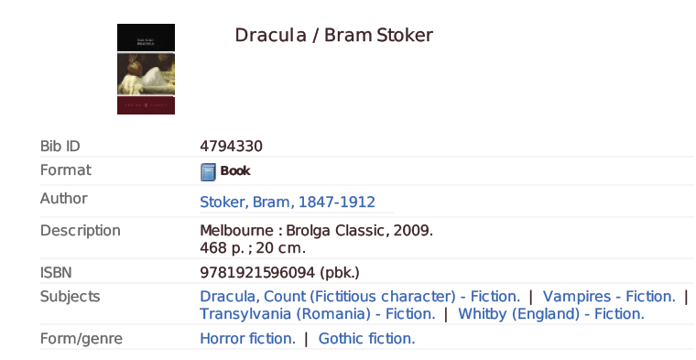
Item 2:

1. Record the attributes of the original work by Bram Stoker
2. Record the attributes of the expression of the work
3. Record the attributes of the manifestation
4. Record the attributes in a marc bibliographic record
5. Create an authority record for Bram Stoker.
You can use additional resources to find further information as needed.
Navigate the RDA instructions and use the RDA/MARC mappings

1. Work record:
Record attributes of the work using the template below. Use the RDA instruction numbers as a guide.
- 6.2 to 6.8 Recording the attributes of the work
- 19.2 Recording creator associated with the work and Appendix I
- 6.27 Constructing the authorised access point for the work
- 7.2 to 7.9 Describing content of the work

RDA Reference | RDA Element | Data Recorded
6.2.1 | Preferred title of the work | Dracula | Known as Dracula
6.2.3 | Variant title |  | Not known by another title
6.3.1 | Form of work | Novel | Only core for differentiation
6.4.1 | Date of work | 1897 | Date first published
6.5.1 | Place of origin | England
6.6.1 | Other distinguishing characteristics |  | Only used for differentiation
6.7.1 | History of the work | Gothic horror novel, first published in 1897 by Archibald Constable and Company | 5.8 – source consulted: Wikipedia
6.8 | Identifier |  | No standard identifier
19.2.1.3  Appendix I | Creator associated with the work | Stoker, Bram, 1847-1912. Author | Apply guidelines at 18.4. Add dates as per 9.19.1.3
6.27 | Authorised access point for the work | Stoker, Bram, 1847-1912. Dracula | No further additions needed
7.2-7.3 | Nature of content; coverage of content
7.7 | Intended audience |  | No audience specified

2. Expression record:
Record attributes of the expression using the template below. Use the RDA instruction numbers as a guide.
6.9 to 6.13 Recording attributes of the expression
7.10 to 7.29 Describing content of the expression
Chapter 20 Persons, families and corporate bodies associated with expression and Appendix I
RDA Reference | RDA Element | Data Recorded
6.9 | Content type | text | Terms from list
6.10 | Date of expression | 2009 | Earliest date of this expression
6.11 | Language of expression | English
6.12 | Other distinguishing characteristic of the expression |  | No other characteristics
6.13 | Identifier for the expression |  | No identifier
7.10 | Summarisation of content |  | None relating to expression
7.12 | Language | English
7.15 | Illustrative content |  | None
7.17 | Colour content |  | None
20.2  Appendix I.3 | Contributor to the expression

3. Manifestation record:

Chapter 2 Recording attributes of manifestation and items
Chapter 3 describing carriers
*Include attributes of the item if necessary
RDA Reference | RDA Element | Data Recorded
2.3 | Title of manifestation | Dracula | From title page
2.3.6 | Variant title of manifestation
2.4.2 | Statement of responsibility | Bram Stoker | From title page. Core
2.5 | Edition statement |  | No edition
2.8.2 | Place of publication | Melbourne
2.8.4 | Name of publisher | Brolga Publishing
2.8.6 | Date of publication | 2009
2.12 | Series | Brolga Classic
2.13 | Mode of issuance |  | Single Unit
2.15 | Identifier for the manifestation | 9781921596094
3.2 | Media type | Unmediated
3.3 | Carrier type | Volume
3.4.5 | Extent | 468 pages
3.5 | Dimensions | 24 cm

4: MARC bibliographic record
Marc field | subfield | Data Recorded | Attribute of work, expression or manifestation
020 | $a | 9781921596094 | Manifestation
041 | $a | eng | Language code from marc
046 | $k | 2009 | Date of expression
100 | $a 1# | Stoker, Bram, $d 1847-1912.$e Author | Creator
240 | $a |  | Not needed – same as title proper
245 | $a 10  $b  $c | Dracula  /$c Bram Stoker | Manifestation title
250 |  |  | No edition statement
260 | $a  $b  $c | Melbourne  Brolga Publishing  2009 | Manifestation. Abbreviation on item
300 | $a | 468 pages ;$c 24 cm | Manifestation and expression
336 | $a | text | Expression. Repeatable
337 | $a | unmediated | Manifestation
338 | $a | volume | Manifestation
490 | $a | Brolga classic | Manifestation
520 | $a |  | Expression
700 | $a

Item 3
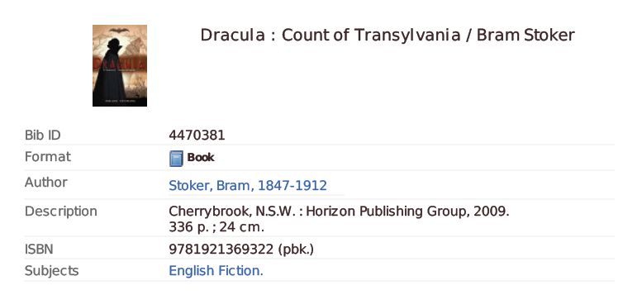
1. Record the attributes of the original work by Bram Stoker
2. Record the attributes of the expression of the work
3. Record the attributes of the manifestation
4. Record the attributes in a marc bibliographic record
5. Create an authority record for Bram Stoker.
You can use additional resources to find further information as needed.
Navigate the RDA instructions and use the RDA/MARC mappings

1. Work record:
Record attributes of the work using the template below. Use the RDA instruction numbers as a guide.
- 6.2 to 6.8 Recording the attributes of the work
- 19.2 Recording creator associated with the work and Appendix I
- 6.27 Constructing the authorised access point for the work
- 7.2 to 7.9 Describing content of the work

RDA Reference | RDA Element | Data Recorded
6.2.1 | Preferred title of the work | Dracula | Known as Dracula
6.2.3 | Variant title |  | Not known by another title
6.3.1 | Form of work | Novel | Only core for differentiation
6.4.1 | Date of work | 1897 | Date first published
6.5.1 | Place of origin | England
6.6.1 | Other distinguishing characteristics |  | Only used for differentiation
6.7.1 | History of the work | Gothic horror novel, first published in 1897 by Archibald Constable and Company | 5.8 – source consulted: Wikipedia
6.8 | Identifier |  | No standard identifier
19.2.1.3  Appendix I | Creator associated with the work | Stoker, Bram, 1847-1912. Author | Apply guidelines at 18.4. Add dates as per 9.19.1.3
6.27 | Authorised access point for the work | Stoker, Bram, 1847-1912. Dracula | No further additions needed
7.2-7.3 | Nature of content; coverage of content
7.7 | Intended audience |  | No audience specified

2. Expression record:
Record attributes of the expression using the template below. Use the RDA instruction numbers as a guide.
6.9 to 6.13 Recording attributes of the expression
7.10 to 7.29 Describing content of the expression
Chapter 20 Persons, families and corporate bodies associated with expression and Appendix I
RDA Reference | RDA Element | Data Recorded
6.9 | Content type | text | Terms from list
6.10 | Date of expression | 2009 | Earliest date of this expression
6.11 | Language of expression | English
6.12 | Other distinguishing characteristic of the expression |  | No other characteristics
6.13 | Identifier for the expression |  | No identifier
7.10 | Summarisation of content |  | None
7.12 | Language | English
7.15 | Illustrative content |  | None
7.16 | Supplementary content | Includes biography of author
7.17 | Colour content |  | None
20.2  Appendix I.3 | Contributor to the expression

3. Manifestation record:

Chapter 2 Recording attributes of manifestation and items
Chapter 3 describing carriers
*Include attributes of the item if necessary
RDA Reference | RDA Element | Data Recorded
2.3 | Title of manifestation | Dracula : count of Transylvania | From title page
2.3.6 | Variant title of manifestation
2.4.2 | Statement of responsibility | Bram Stoker | From title page. Core
2.5 | Edition statement |  | No edition
2.8.2 | Place of publication | Sydney | Only first named place is core
2.8.4 | Name of publisher | Horizon Publishing Group
2.8.6 | Date of publication | 2009
2.13 | Mode of issuance |  | Single Unit
2.15 | Identifier for the manifestation | 9781921369322
3.2 | Media type | Unmediated
3.3 | Carrier type | Volume
3.4.5 | Extent | 336 pages
3.5 | Dimensions | 24 cm

4: MARC bibliographic record
MARC  field | Subfield | Data Recorded | Attribute of work, expression or manifestation
020 | $a | 9781921369322 | Manifestation
041 | $a | eng | Language code from marc
046 | $k | 2009 | Date of expression
100 | $a 1# | Stoker, Bram, $d 1847-1912.$e Author | Creator
240 | $a |  | Same as title proper
245 | $a 10  $b  $c | Dracula :  Count of Transylvania  Bram Stoker | Manifestation title
250 |  |  | No edition statement
260 | $a  $b  $c | Sydney  Horizon Publishing Group  2009 | Manifestation. Abbreviation on item
300 | $a  $b  $c | 366 pages ;  $c 24 cm | Manifestation and expression
336 | $a | text  illustrations | Expression. Repeatable
337 | $a | unmediated | Manifestation
338 | $a | volume | Manifestation
520 | $a |  | Expression
700 | $a |  | Contributor to the expression

Item 4

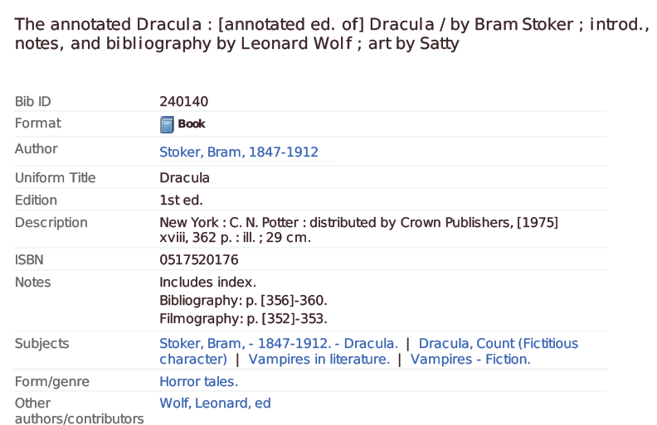

1. Record the attributes of the original work by Bram Stoker (already done for item one)
2. Record the attributes of the expression of the work
3. Record the attributes of the manifestation
4. Record the attributes in a marc bibliographic record
5. Create an authority record for Bram Stoker.
You can use additional resources to find further information as needed.
Navigate the RDA instructions and use the RDA/MARC mappings

2. Expression record:

Record attributes of the expression using the template below. Use the RDA instruction numbers as a guide.
6.9 to 6.13 Recording attributes of the expression
7.10 to 7.29 Describing content of the expression
Chapter 20 Persons, families and corporate bodies associated with expression and Appendix I
RDA Reference | RDA Element | Data Recorded
6.9 | Content type | text; still image ; cartographic image | Terms from list
6.10 | Date of expression | 1975 | Earliest date of this expression
6.11 | Language of expression | English
6.12 | Other distinguishing characteristic of the expression |  | No other characteristics
6.13 | Identifier for the expression |  | No identifier
7.10 | Summarisation of content |  | From back cover
7.12 | Language | English
7.15 | Illustrative content | illustrations, maps, portraits
7.17 | Colour content
20.2  Appendix I.3 | Contributor to the expression | Wolf, Leonard. Editor | Construct heading according to 18.4
20.2  Appendix I.3 | Contributor to the expression | Sätty. Illustrator | Construct heading according to 18.4

3. Manifestation record:

Chapter 2 Recording attributes of manifestation and items
Chapter 3 describing carriers
*Include attributes of the item if necessary
RDA Reference | RDA Element | Data Recorded
2.3 | Title of manifestation | The annotated Dracula : Dracula | From title page
2.3.6 | Variant title of manifestation | Dracula
2.4.2 | Statement of responsibility | Introduction, notes, and bibliography by Leonard Wolf ; art by Sätty : with maps, drawings, and photographs | From cover. Not core
2.5 | Edition statement |  | No edition
2.8.2 | Place of publication | New York | Abbreviation as appears on item
2.8.4 | Name of publisher | Clarkson N. Potter, Inc./Publisher
2.8.6 | Date of publication | 1975
2.13 | Mode of issuance |  | Single Unit
2.15 | Identifier for the manifestation | 0517520176
3.2 | Media type | Unmediated
3.3 | Carrier type | Volume
3.4.5 | Extent | xviii, 362 pages
3.5 | Dimensions | 29 cm

4: MARC bibliographic record
MARC field | subfield | Data Recorded | Attribute of work, expression or manifestation
020 | $a | 0517520176 | Manifestation
041 | $a | eng | Language code from marc
046 | $k | 1975 | Date of expression
100 | $a 1# | Stoker, Bram, $d 1847-1912.$e Author | Creator
240 | $a | Dracula | Work title. No additions needed
245 | $a 14 | The annotated Dracula :b Dracula | Manifestation titile
250 |  |  | No edition statement
260 | $a | New York :$b Clarkson N. Potter, Inc./Publisher, $c 1975. | Manifestation. Abbreviation on item
300 | $a | xviii, 362 pages :$b illustrations, maps, portraits ;$c 29 cm | Manifestation and expression
336 | $b | cristitxt $2 rdacontent | Expression. Repeatable
337 | $a | unmediated | Manifestation
338 | $a | volume | Manifestation
520 | $a |  | Expression
700 | $a | Wolf, Leonard. $e Editor | Contributor to the expression
700 | $a | Sätty. $e Illustrator | Contributor to the expression

