Teaching RDA: Day 3

Discussion and questions from previous day
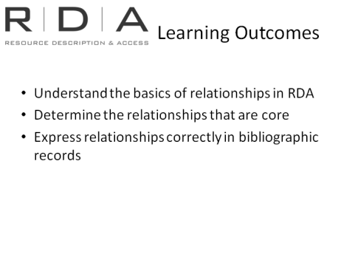
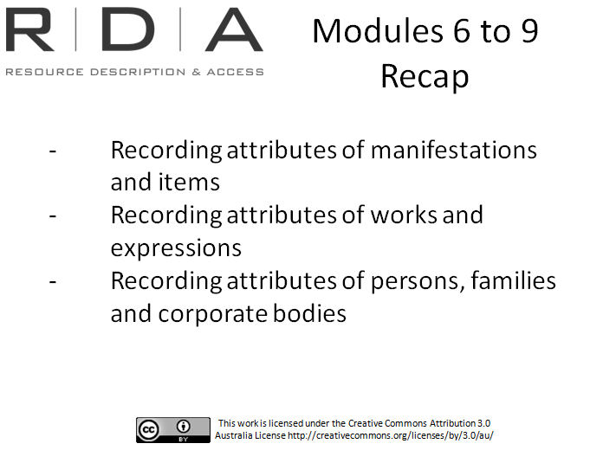

Discussion and questions relating to material from Day 2

Suggestion: Use Attributes reflection Quiz to help participants refresh what they learned on Day 2.

Module 10: Relationships
Handbook: Page 106

Learning Outcomes
So far in this course we have looked in detail at identifying the attributes of the FRBR and FRAD entities.
As we have said, the other major goal of the FRBR and FRAD model, and therefore of RDA is to record relationships.
These are sections 5 to 10.
In this module, we will learn about relationships and how they are handled in RDA.
Aims:
- Understand the basics of relationships in RDA
- Determine the relationships that are core
- Express relationships correctly in bibliographic records

Resources
- Example resources

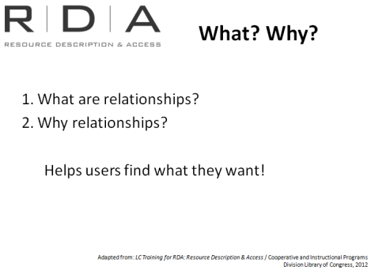
What, why and how

What are relationships?
The entities that we identify in our cataloguing are associated with one another, and these are relationships.
We are familiar with the fact that authors have a relationship to the literary works they have written, composers have a relationship to the musical works they create.
[For example Danielle Clode is the author of Killers in Eden]
We express relationships with linking fields such as when a serial changes its title, or when we want to link print and online manifestations.

Why are they recorded?
Expressing relationships in bibliographic and authority records helps users find what they want and tell users about other available resources. They give users pathways to related materials.
None of this is unfamiliar to us, and AACR2 certainly dealt with them, especially when it gave us instruction on “Choice of Access points” “Uniform titles” and “References”. But relationships play a much more prominent role in the structure of RDA.
And in an online world, it is much easier to provide real linkages between things using these relationships. So the more relationships we can record, the better we are able to help people find their way through the mass of online information.

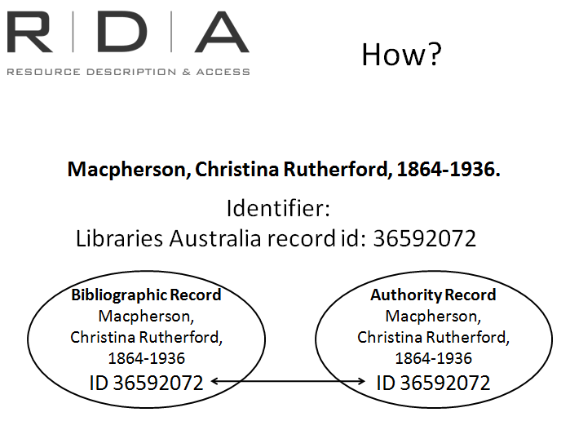
How are they recorded?
Relationships are covered in sections 5-10.
The beginning of each section outlines the conventions for recording relationships. As each section deals with a different relationship the conventions are slightly different in each section.
There are three conventions and each section outlines one or all of them:
[use chapter 18.4.1.1 to demonstrate]
- Identifier (as discussed in Module 8)
  - Either for the entity itself or a surrogate of that entity (eg. The authority record)
  - An identifier for a work could be system control number
The example on the slide shows how using an identifier permanently links the bibliographic record and the authority record. Even if the name is altered the link (or relationship) between the manifestation and the creator remains.

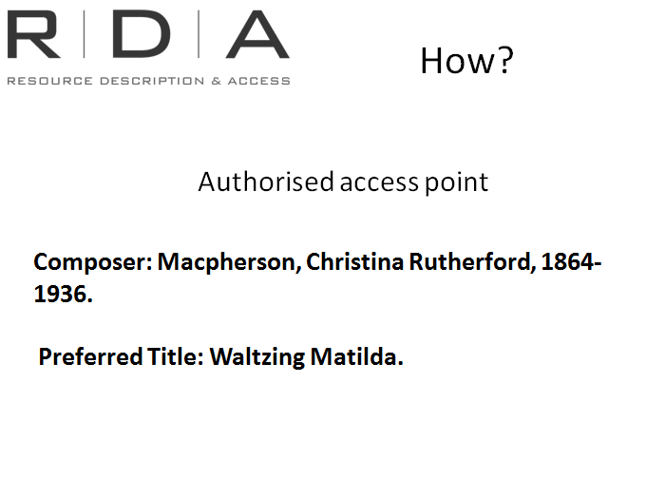
- Authorised access point
  - Not used for manifestation-manifestation, or item-item relationships
We already record authorised access points. The example on the slide shows the relationships between the work and creator.

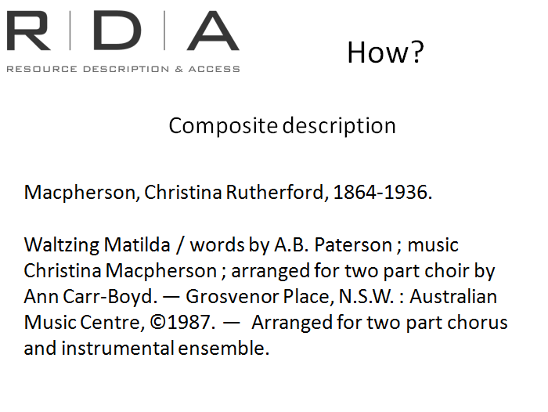
- [Composite] Description
  - Not used for relationships between Group 1 and Group 2 entities.
A composite description combines one or more elements identifying the work and/or expression with the description of the manifestation. This is essentially what our current MARC bibliographic records are: a combination of attributes of work, expression, and manifestation.
Other than the exceptions listed above libraries can choose which they use to record their relationships.

Core
Although all relationships can be very useful, as with attributes, RDA has stipulated certain relationships to be core relationships. We will highlight these as we go through.
Beyond these core relationships, libraries are free to determine which of the non-core relationships they will decide to record.

Relationship designators
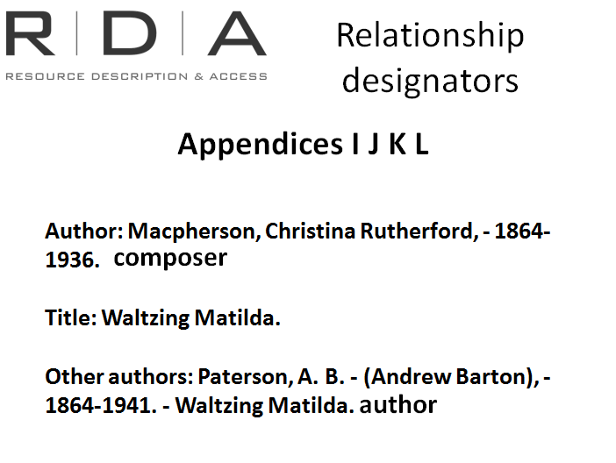
[Note: slide has progressively appearing text. The driver of the Powerpoint should click at the prompts in their text to add each part]
This is one area of key areas of difference between AACR2 and RDA.
Up until now we’ve seen the importance of recording relationships, but we’ve never been very specific about what those relationships actually ARE.
The example on the screen shows information as recorded currently.
RDA allows you to record information about the nature of relationships.
This helps:
- users navigate through large amounts of data, and;
- computer systems understand more about the relationship, so they can sort, collocate and present these relationships to uses in a meaningful way.
Relationship designators are sets of controlled vocabularies that enable you to describe relationships in a consistent way.
The terms are listed in appendices I, J ,K and L
For the example on the screen: Use appendix I (relationships between a resource and person, family, corporate body associated with the resource) to record the relationships between the creators and the work. The relationship designators allow us to record that Macpherson is the composer of the music and Patterson is the author of the text.
These are recorded in the marc $e subfield
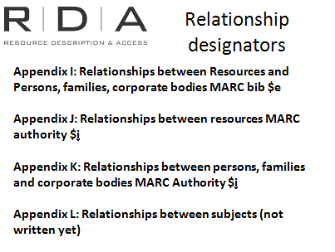
Appendix I: Relationships between a resource and Group 2 entities eg author, illustrator
- For example Anthony Antonadis is an author of Anthology and Esther Ling is the photographer
Appendix J: Relationships between FRBR Group 1 entities
- For example Pride and prejudice by Jane Austen and Pride and prejudice 2005 movie have a work to work relationship. The movie has an “adapted as” relationship
Appendix K: Relationships between persons, families and corporate bodies (Group 2 entities)
- For example Jane Austen is a family member of the Austen family
Appendix L: Relationships between subjects. There are no subject relationships yet

Advantages of Relationship designators:
AACR2 sometimes suggested using such information but only if it wasn’t clear from the data context.
RDA uses them a lot more broadly so that in any circumstance users can see exactly what relationship there is between entities.
Remember that the different ways that cataloguing data is now being used in the online world means that the “context” that may have been provided by the whole catalogue record might not always be there.
MARC already has subfields for recording the relationship terms, as well as the capacity to record machine readable codes to help systems to organise and display the data. These codes are already used by some libraries.
Relationship designators are non-core elements in RDA, which means that libraries can choose whether or not they use them. When you make this decision, as always, you should bear in mind the needs of your users and the impacts on your discovery systems. Relationship designators can be very helpful in demystifying the connections between entities, for both users and computer systems.

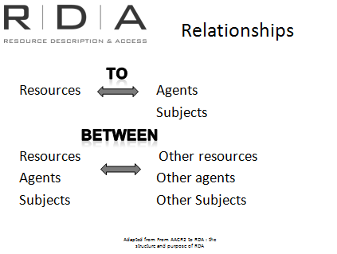
So in this unit we’ll be looking at both what relationships RDA allows us to record, and what relationship designators we can use to make those relationships clear.
In summary, RDA breaks relationships down into the relationships that resources have TO
agents (that is, persons, families and corporate bodies) and subjects. We would think of these relationship now as “access points” to a resource.
And relationships that occur BETWEEN
Resources, Agents and subjects and other resources, agents and subjects. We would think of these now as “references” or “related headings”
The relevant chapters on subject relationships are yet to be written, so we will not look at them in this course.

Relationships to persons, families and corporate bodies
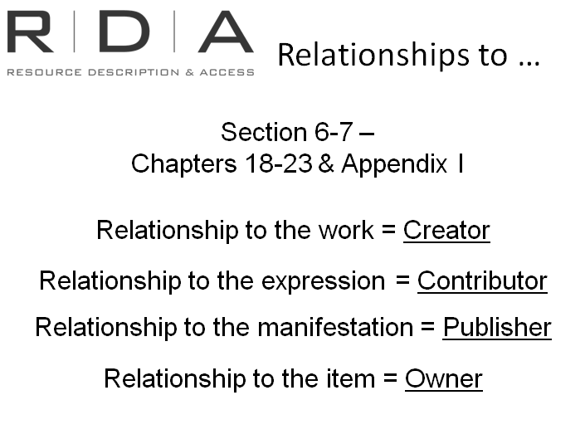
Chapters 18-23 of RDA cover the relationships resources have to persons, families and corporate bodies.
Appendix I lists the relationships designators that can be used.
We looked at constructing access points in an earlier module – here is where we find instructions for choice of access point.
There are four types of relationships resources have to persons, families and corporate bodies and they are summarised on this slide

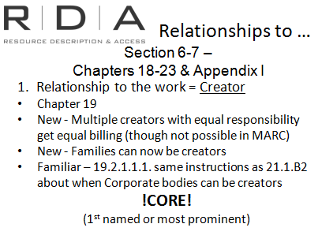
Relationship to the work = Creator (person, family, corporate body responsible for creation of work)
RDA recognises that multiple people can be equally responsible for the creation of a work, and gives them equal billing as part of the of the authorised access point for creators (See the third group of egs under RDA 19.2.1.3.)
Of course we can’t do this in MARC at present and we will still have to name one of them in the 1XX field, and the others in 7XX fields.
Familiar RDA 19.2.1.1.1 is the equivalent of AACR2’s 21.1B2 (look up 21.1B2 in AACR2 on Toolkit and link from there to RDA), helping you to determine, as AACR2 did, when a corporate body can be considered a “Creator”
New in RDA: Families can now be creators too (see second set of examples under RDA 19.2.1.3)
Core: The first named or most prominent creator is core. Other creators are non-core.

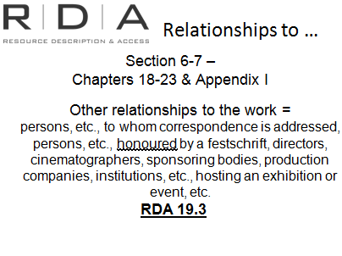
Also, relationships to work can include others who have an association with the work that are not creators. That is, “persons, etc., to whom correspondence is addressed, persons, etc., honoured by a festschrift, directors, cinematographers, sponsoring bodies, production companies, institutions, etc., hosting an exhibition or event, etc.” (RDA 19.3.1.1)
Core: The first named or most prominent creator is core.

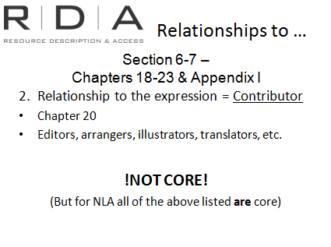
Relationship to the Expression = Contributor
(person, family, corporate body responsible for contributing to the expression of a work)
Are covered in Chapter 20
These are such persons as editors, illustrators, translators, arrangers, etc.
In RDA, none of these relationships are core to record in your bibliographic record.

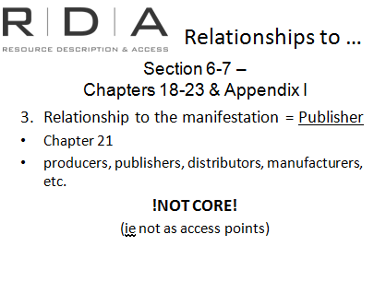
The third type of relationship resources have to agents, is the relationship of a person, family, corporate body to a manifestation of a work. These are your producers, publishers, distributors, manufacturers, etc., and are covered in Chapter 21.
None of these relationships are required as access points in a record. Of course, we still must record the information as an attribute of the manifestation (Chapter 2)

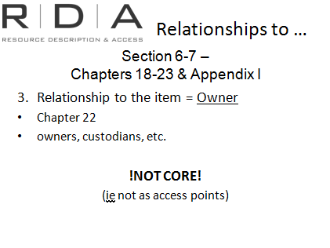
And finally, of course, there are the relationships that items have to persons, families, and corporate bodies. These are the owners and custodians of particular items.
These relationships are not required as access points in a record. Of course, we might still record the information as an attribute of the item (Chapter 2), but that is a different decision.

Relationships between …
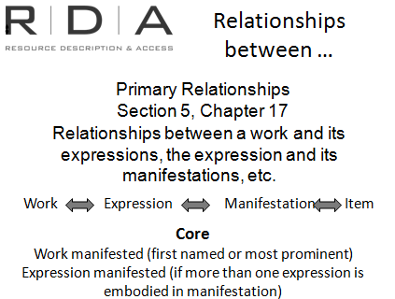
Next we come to the relationships between resources, persons, families and corporate bodies, and other resources, persons, families and corporate bodies.
Firstly,

Primary relationships (Chapter 17)
See RDA 17.4.1 for full definition.
Relationships between a work and its expressions, the expression and its manifestations and manifestation and its items
Work Expression Manifestation Item
A bit like the “uniform titles” we use now with AACR2.
[Suggestion: take some time to ensure people understand what “Primary” relationships mean. eg they don’t mean relationships between and expression and another expression of the same work, nor do they mean the “Main entry”]
Relationship designators not used for Primary relationships
Core:
- Work manifested – if more than one work, only first-named or predominant
- Expression manifested - if more than one

Recording primary relationships in MARC
It is not very easy to record these in our current MARC system. Designed for a scenario where there are separate records for each entity, ie work record, expression record etc (as opposed to the composite records we generally have now).
Current scenario: Bibliographic record = manifestation + elements of work, expression, item
Future scenario: Separate record for each WEMI entity, with links to each other.
Some libraries feel it is not possible to implement the instructions in this chapter. However, the “Conventions” for recording primary relationships (see RDA 17.4.2) do allow for this to some extent.
If you are using a MARC system there will be some limitations and you won’t be able to strictly follow all Chapter 17 instructions and make the full linkages that are suggested. However by using a combination of the recording conventions it is possible to at least express primary relationships.
Note : this paragraph is how we understand that Chapter 17 can be used in MARC. However, LC are not implementing Chapter 17 because they don’t believe it can be in the current MARC scenario.]

Example
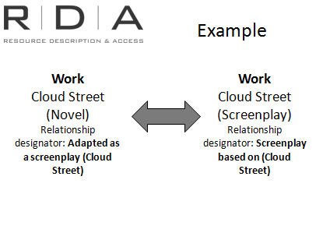
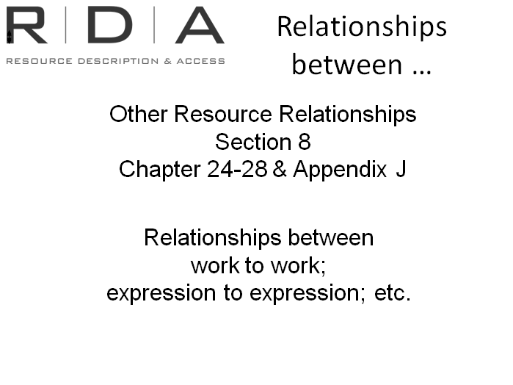
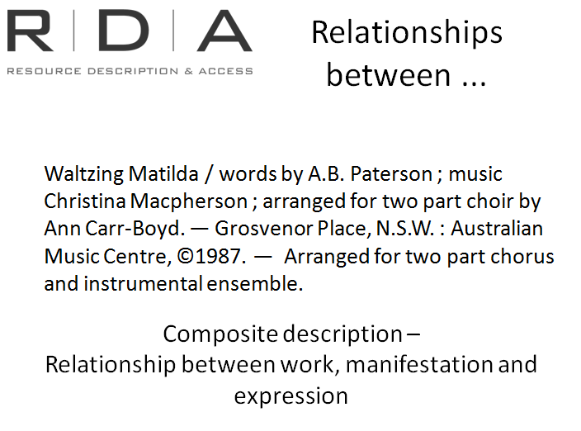
This example shows how we would currently record such primary relationships in MARC records.
The MARC bibliographic record is basically a “Composite” Description
It shows relationships between work (waltzing matilda), the manifestation (publisher) and expression (arrangement)

Other Resource relationships
Chapters 24-28 and appendix J.
Recording relationships between Work and other works, Expressions and other expressions. Etc.
Eg’s Adaptations, Sequels, “Continued by”, “based on”, “reproduction of” etc.
Work-to-work and Expression-to-Expression can be recorded using any one or more of the following conventions:
- Identifier
- Authorised access point
- Description
Manifestation-to-manifestation, and item-to-item relationships can only be recorded using an identifier or a description. Descriptions can be structured or unstructured (see RDA 24.4.3)
Note: These are not controlled lists, if you cannot find an appropriate term you can use another concise term indicating the nature of the relationship.

Example
Cloudstreet the screenplay has a work to work relationship with Cloudstreet the novel. Chapter 25 gives us the guidelines to recording related works.
Then we go to Appendix J to find the relationship designator term – J.2.2 Screenplay based on Cloudstreet

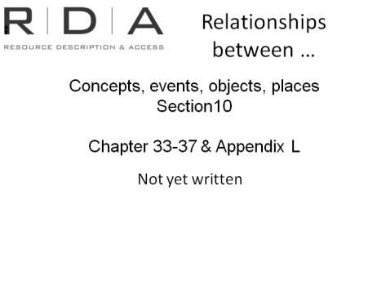
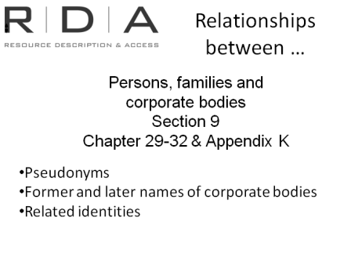
People, families, corporate bodies
Chapters 29-32, Appendix K
In AACR2, these would be equivalent to:
Persons: eg. Pseudonyms, related identities, etc. (ie NOT variant forms of names, see RDA 9.19.2)
For example relationship between Dame Edna and Barry Humphries
It also includes corporate bodies: eg. Former and later bodies, subsidiary bodies, mergers etc.
NEW
Now, however, it is possible to also record
- Family relationships
  - between families,
  - between persons and families
  - between corporate bodies and families
- Relationships between people and corporate bodies.
Core: None of the relationships between persons, families and corporate bodies are core in RDA.

Relationships between concepts, events, objects and places.

Not yet written
Included here to finish the section

Examples
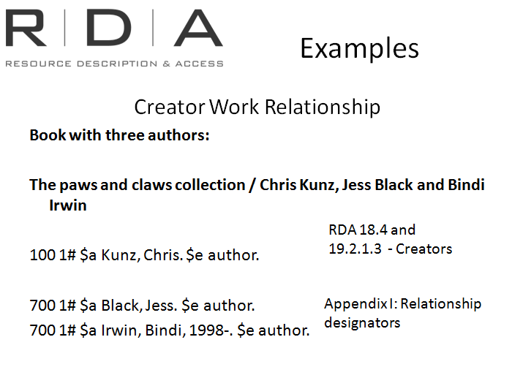
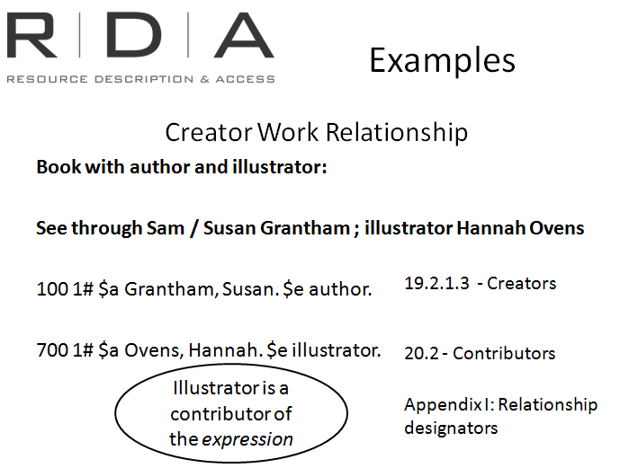
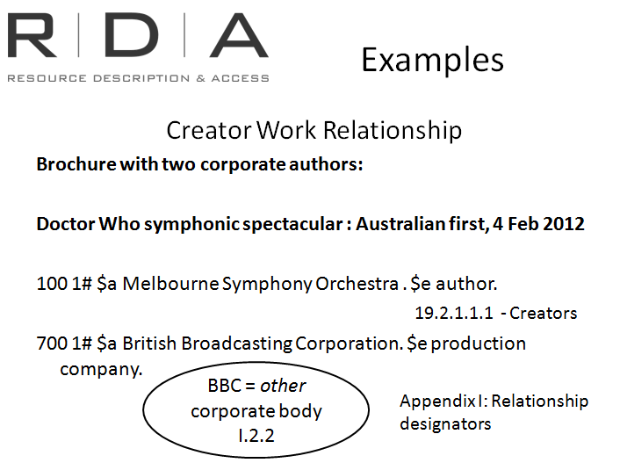
Handbook: Page 107-108

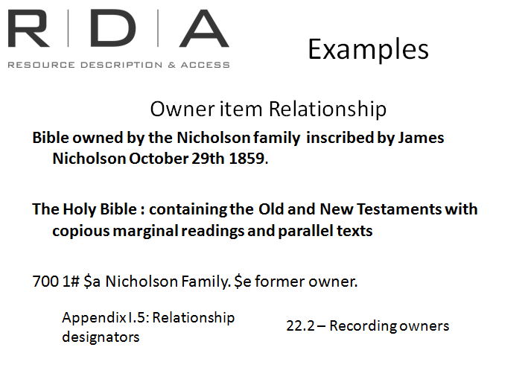

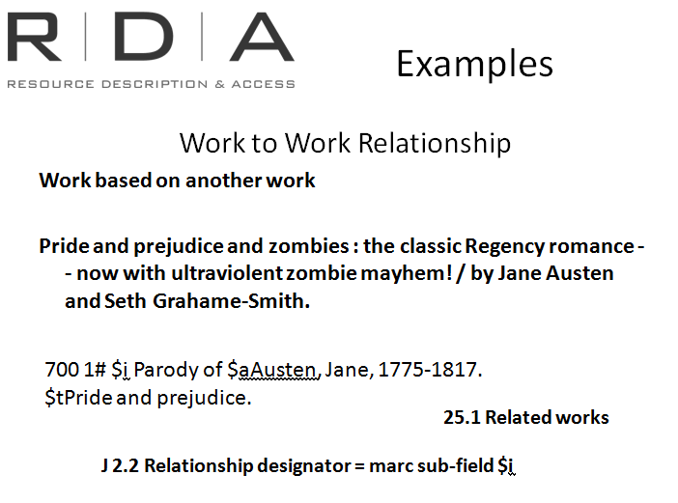
Exercise 18: Relationships
- French translation of Pride and prejudice
Handbook: Page 174
a) Add the relationship designators to the authorised access points
Orgueil et préjugé / Jane Austen ; traduit de l'anglais par Béatrice Vierne.

Published: [Paris] : Éditions du Rocher, [c1996].

ISBN: 2268040259

Collection Anatolia

100 1# $aAusten, Jane,$d1775-1817. $e author.
Hint : See chapter 19 and appendix i

700 1# $aVierne, Beatrice. $e translator.

b) What is the authorised access point for the expression
Hint : See chapter 26

240 00 $a Pride and prejudice. $l French

- List the various persons and corporate bodies related to this resource, and identify the relationship designator for each one. Also use the MARC relator codes list at http://www.loc.gov/marc/relators/ to identify the correct MARC relator code.
Waltzing Matilda

by Christina Macpherson, words by Banjo Paterson.
This arranged for 2-part choir by Ann Carr-Boyd

Australian Music Centre, Sydney

Author: Macpherson, Christina Rutherford, - 1864-1936. composer
Title: Waltzing Matilda.
Other authors: Paterson, A. B. - (Andrew Barton), - 1864-1941. Waltzing Matilda. author
Other authors: Carr-Boyd, Ann, 1938-. Waltzing Matilda. arranger of music

- Resource described: The blob / screenplay by Chuck Russell & Frank Darabont; produced by Jack H. Harris and Elliott Kastner; directed by Chuck Russell. Hollywood : Tri-star Pictures, 1998.
Summary: Remake of the classic 1958 movie. A horrific tale of malignant life-form which crashes into Earth, landing in rural Arborville. Untroubled by conscious or intellect, the Blob does only one thing, and does it well: devouring anything and everything in its path
a) What relationships can you identify in the description above? Work to work relationship, screenplay by ; produced by etc.
b) Which chapter discusses this type of relationships and how is the relationship recorded?
4. What types relationships can you identify in the following record:
Hint : See section 8

Title: Maitland mercury
Uniform Title: Maitland mercury (1980)
Description Maitland, N.S.W. : Maitland Mercury Newspaper and Printing Co., [1980]-
volume : illustrations ; 44 cm.
ISSN 1039-9895
Content text ; illustrations
Media unmediated
Carrier volume
Notes Caption title.
Also available on microfilm. Milson's Point, N.S.W. : W. & F. Pascoe.
Life Dates [Wednesday, Dec. 3, 1980]-

Former Title Mercury (Maitland, N.S.W. : 1980)

Related Title Hunter Valley weekend 1321-5450*

Subjects Australian newspapers - New South Wales - Maitland.
Maitland (N.S.W.) - Newspapers. | Australian
Place Australia New South Wales Maitland

*Hunter Valley Weekend is the Weekend edition of the Maitland Mercury
- Also available on microfilm is a related manifestation (chapter 27)
- Former title is a related work (chapter 25)
- Related title is a related work (chapter 25 -) whole / part relationship. Hunter Valley Weekend is a subseries of the Maitland Mercury

Summary

