Day 3

Module 11: Authority Work
Handbook: Page 115
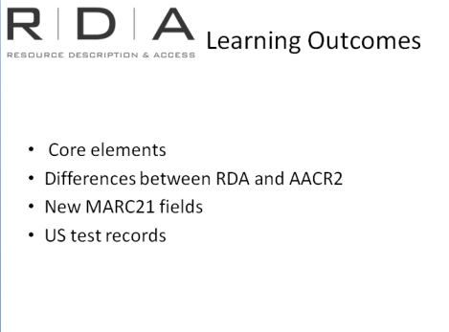
We looked in detail yesterday at recording information for works and expressions, and persons, families and corporate bodies, and constructing access points. Much of that information will be contained in authority records.
In this module, rather than revisiting all of that, we are just going to take a look at the impact of RDA on the “authority work” aspect of our cataloguing. Some of the information here I have already talked about in previous modules, but it’s useful to say it again in this context.

How much authority work and when
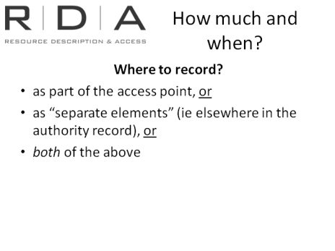
A change of cataloguing standard necessarily means that libraries will have to review their internal policies on cataloguing and authority control. As we have already seen RDA includes instructions on data that we record in authority records to a greater extent than AACR2.
This will mean that libraries need to make some policy decisions about authority work.

Part of authorised access point, or elsewhere in authority record
Yesterday we looked at the chapters (6 - 11) on recording the attributes of works and expressions, and persons, families and corporate bodies. In these chapters, the attributes (or “elements”) are recorded either:
- as part of the access point, or
- as “separate elements” (ie elsewhere in the authority record), or
- In both the access point and as separate elements.
Some useful elements can only be recorded in the authority record.
Where elements can be recorded as part of access points, but do not need to be, libraries need to make decisions on whether they record this information in the access point or the authority record itself. This has always been the case of course, but RDA both offers more elements to be recorded than we have had in the past, and is less prescriptive about how and when they are used.

Core elements
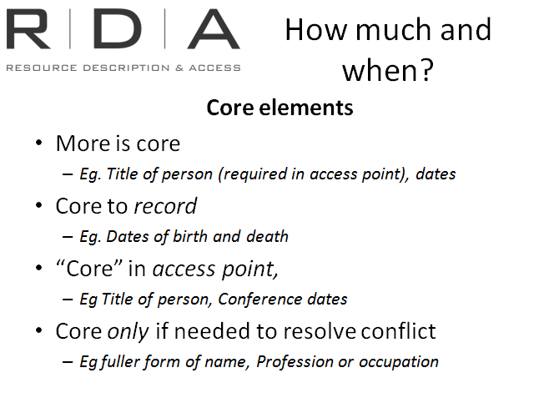
Another thing that will affect authority control policies is core elements for authority records. We learned yesterday that some previously “optional” information is now core in RDA. Most notably:
- Title of person (in both the authority record and the access point)
- Date of birth and death (in the authority record)
There are also three meanings of “Core” when it comes to authority data
- Core to record (Can be either in access point or elsewhere in authority record)
  - Eg. Dates of birth and death
- “Core” in access point,
  - Eg Title of person, Conference dates
- Core only if needed to resolve conflict (in access point)
- Eg fuller form of name, Profession or occupation

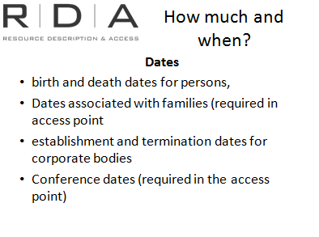
The core status of dates particularly has an impact on authority control policy because previously, dates were only required when needed to resolve a conflict, or for conferences. Now, all of the following dates are core requirements:
- birth and death dates for persons,
- Dates associated with families (required in access point)
- establishment and termination dates for corporate bodies
- Conference dates (required in access point)
For those dates that are not required as part of the access point to resolve a conflict, decisions will need to be made about whether you will record them as separate element in the authority record, as part the access point, or as both.
Recording them as a separate element in the authority record may require the creation of authority records where they would not previously have been done.
Recording them as part of the access point will remove this necessity, but may create differences with existing headings in authority files.

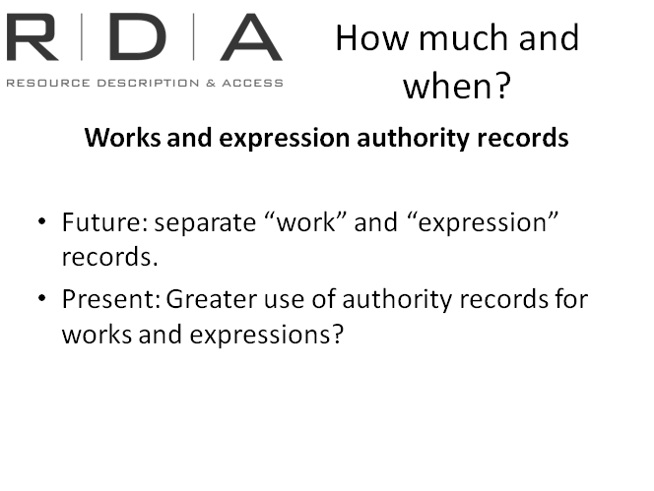
Works and expressions
The chapters on Works and Expressions (chapters 6 -7) work in the same way as the chapters on persons, families and corporate bodies. The elements are recorded either in the “record” for the work or expression, or as part of the access point.
As I have already explained, RDA is looking forward to a future scenario which will see us creating separate, linked, records for each of the Group 1 entities, rather than the composite records we now create.
While our current systems, in particular the MARC encoding standard, make this difficult to fully realise it is possible to create “authority” records for works and expressions. Most libraries do not currently routinely do this, so policy decisions will need to be made about whether the new information that RDA lets us record, and the possibilities this has for OPAC displays, justifies the need to revise policy on this matter.

Differences between AACR2 authorities and RDA authorities
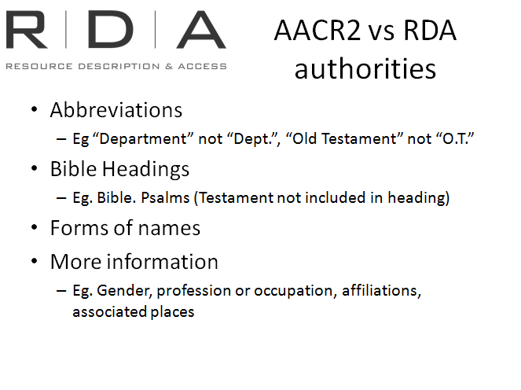
I have alluded throughout the training to changes in the way certain data is recorded and the impact on access points and authority records.

Abbreviations
The move away from the use of abbreviations affects headings and authority records as well as bibliographic data. The most notable of these is the change in practice with regard to the word “Department”, which will now no longer be abbreviated. This constitutes a significant change in practice when recording the preferred name for corporate bodies.

Bible Headings
We also learned in Chapter 6 of RDA that the references to the Old and New Testaments are no longer used in Bible Headings, which means any new authorised access points for books of the Bible will be different from their AACR2 counterparts.

Forms of names
There are other minor changes in choosing the preferred name that may result in differences between AACR2 and RDA headings, such as the removal of English language bias, choices among different forms of the same name etc.

More information
And finally, there is simply more information you can record in authority records.

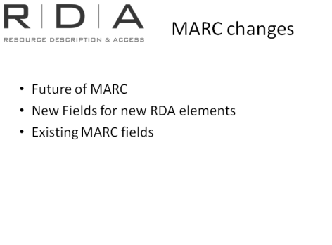
MARC changes
I have already touched on MARC changes earlier modules, but it is useful to bring them together again in this context.

Future of MARC
As we know, investigations into a replacement for the current MARC Standard are well under way, and this will have an impact on all aspects of cataloguing, including authority records.
In the meantime changes have been made to MARC to accommodate RDA. It also needs to be said MARC provisions already went beyond what was covered in AACR2 so some of the things RDA now covers are already provided for in MARC. For example, the provision for relationship designators

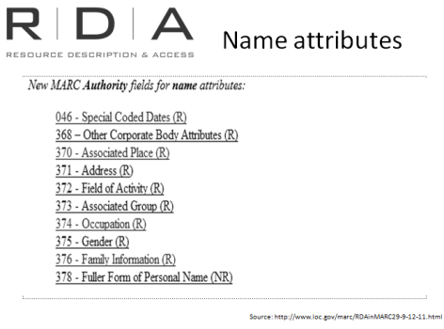
New Fields for new RDA elements
MARC has created a number of new fields for authority records to accommodate RDA. On the next couple of slides you’ll see some screen dumps from the MARC website showing a summary of changes.
(We will look at these fields and where the related instructions are in RDA when we look at the examples at the end of the module)

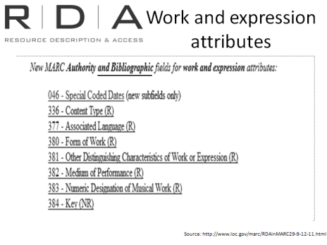
And these are for attributes of works and expressions. Note that for works and expressions, the new MARC fields are for both the authority and bibliographic record.

[RDA in MARC summary of additions - http://www.loc.gov/marc/RDAinMARC-7-12.html ]

Existing fields
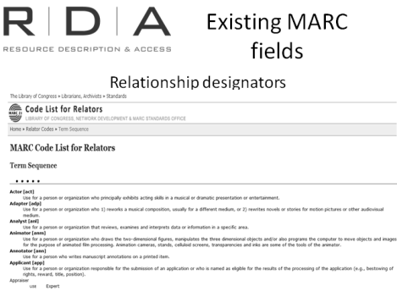
RDA introduces the concept of relationships designators which contains extensive lists of relationships terms that can be used for these designators.
MARC already makes provision for the recording of relationships so only minor changes have needed to be made to accommodate relationship designators.
A list of “relator codes” already existed in MARC, and many of the relationship designators from RDA are already in this list. Those that are not already in the list may be absent either because:
- In some places in the MARC record, MARC itself does not require a controlled vocabulary term or
- MARC has not finished updating the lists.
[MARC code list for relators http://www.loc.gov/marc/relators/relaterm.html]

Changing AACR2 authority records to RDA?
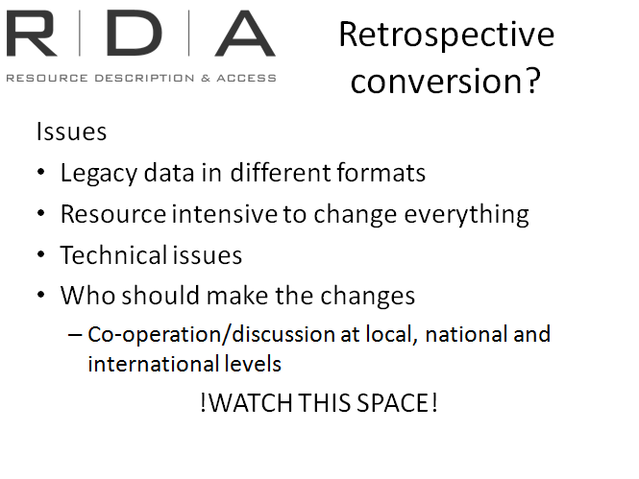
All of the above will raise questions in our minds about dealing with legacy AACR2 authority data. Whatever approach is taken comes with advantages, disadvantages and resource challenges. The issues are difficult for individual libraries to resolve in isolation, given the shared environment in which we now operate.
Decisions about whether to make retrospective changes to legacy data will therefore need to be considered at local, national and international levels.
Discussions are already taking place both within Australia and on the international scene but individual libraries will also need to consider these issues for their local catalogues.

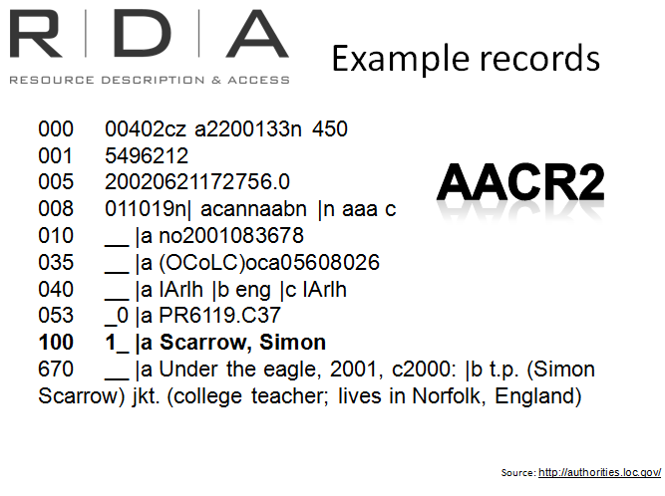
Example authority records
So let’s just refresh ourselves by looking again at the examples we saw in Module 8, to see how our authority records may change.
The first example is a brief authority record for Simon Scarrow. There is some information recorded in the 670 that helps to identify Simon, including that he is a college teacher in England.

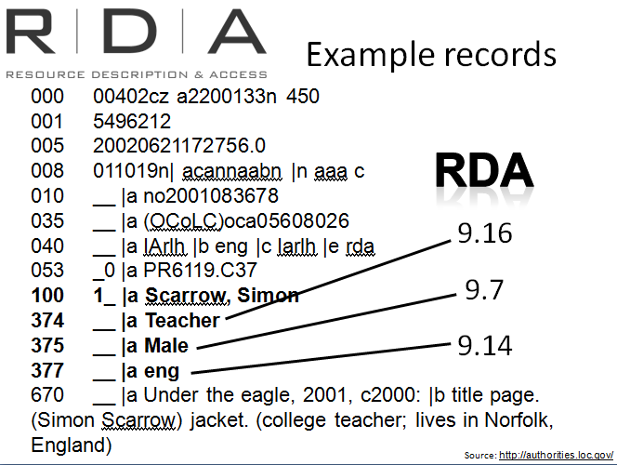
Here is the same record with extra RDA elements added
040 - $e indicates this is an RDA record
374 – Occupation from RDA 9.16
375 – Gender from RDA 9.7
377 – language from RDA 9.14 (RDA instructs to record the language used by a person in their activity, however the marc $a is the code from the marc language code lists.

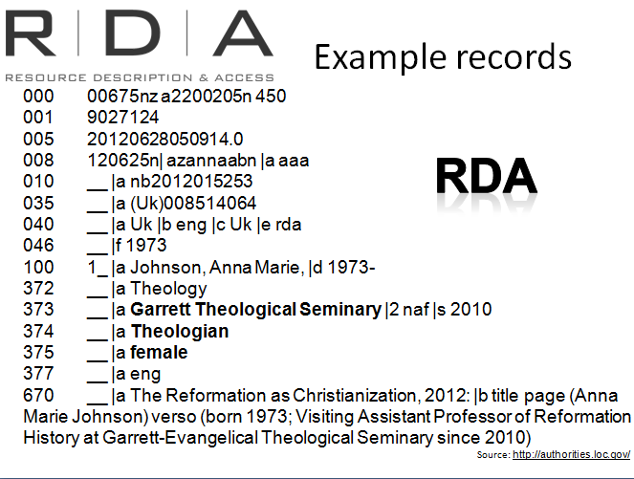
This RDA authority record, for Anna Marie Johnson, gives us this same information, but in a much more readable and dynamic way. It’s still in the 670, but now each piece of information that helps us uniquely identify Anna is also now in its own element. We can immediately see that she is a female theologian at the Garrett Theological Seminary and that her native language is English. In the previous example, this information was buried in the 670 field and not as easy to see. Not only that, but computer systems can’t distinguish between the different pieces of information contained in that field.
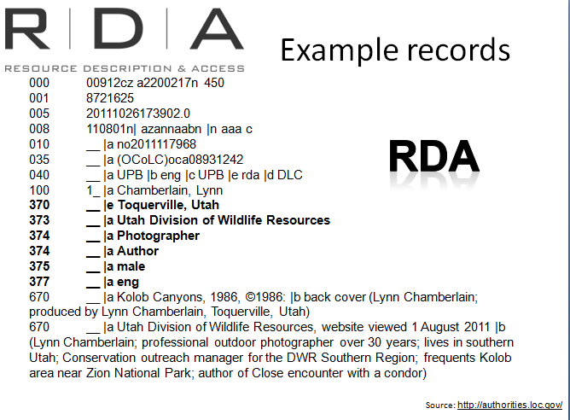
Here’s another example, for Lynn Chamberlain, who has two occupations, and works for an organisation in Utah. The interesting thing here worth noting is that it is a good example of where the “Gender” information can be very useful. Gender is not always immediately obvious from the name itself.

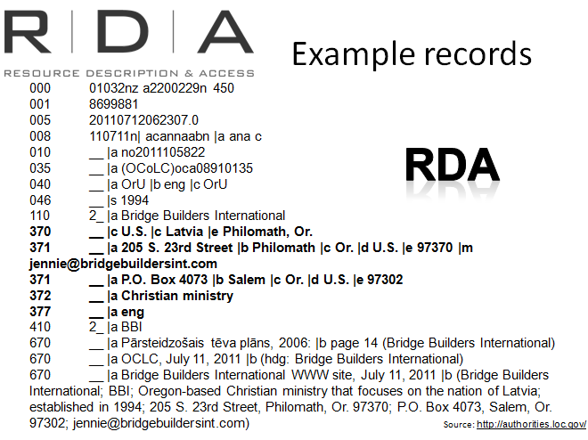
Here’s an authority record for a Company, called Bridge Builders International. Here there is a whole lot of new information we are not used to recording in our authority records, but it’s immediately obvious how useful it is. We can see that the company has associations with two countries, and that they are involved in Christian ministry, something not obvious from the name of the Company.
There is also address information, in case a user wants to contact the company.

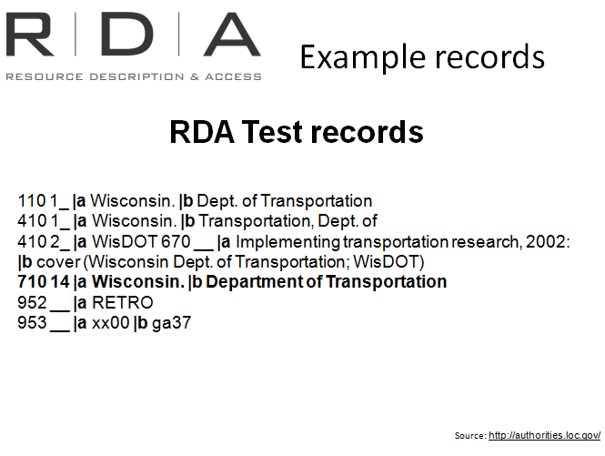
There’s just one last example I’ll show you, to illustrate something that happened during the US RDA test.
While conducting the Test in 2010, a decision was made that if an AACR2 authority record already existed for an entity, but the form of name did not conform to RDA practice, the record would not be changed, so as not to disrupt its use with AACR2 cataloguing. Instead, the RDA form of the name was placed in a 700 field.
I am showing you this because these headings are still in the LC and OCLC databases, so you may come across them. Plans are being made to “Flip” these headings once RDA is implemented, so that the RDA compatible heading is in the 1XX field.

Exercise 19: Authority work
Handbook: Page 184-187
The following two RDA personal name authority records include some new elements.
a) Identify the new elements and the RDA instruction numbers that tell you how to record the data.
b) Where are the instructions for constructing the access point? And what additions have been made to the access points?

LC control no.: no2011117968
LCCN permalink: http://lccn.loc.gov/no2011117968
HEADING: Chamberlain, Lynn
000 00912cz a2200217n 450
001 8721625
005 20111026173902.0
008 110801n| azannaabn |n aaa c
010 __ |a no2011117968
035 __ |a (OCoLC)oca08931242
040 __ |a UPB |b eng |c UPB |e rda |d DLC
100 1_ |a Chamberlain, Lynn
370 __ |e Toquerville, Utah
373 __ |a Utah Division of Wildlife Resources
374 __ |a Photographer
374 __ |a Author
375 __ |a male
377 __ |a eng
670 __ |a Kolob Canyons, 1986, ©1986: |b back cover (Lynn Chamberlain; produced by Lynn Chamberlain, Toquerville, Utah)
670 __ |a Utah Division of Wildlife Resources, website viewed 1 August 2011 |b (Lynn Chamberlain; professional outdoor photographer over 30 years; lives in southern Utah; Conservation outreach manager for the DWR Southern Region; frequents Kolob area near Zion National Park; author of Close encounter with a condor)
953 __ |b td08

LC control no.: n 94112934
LCCN permalink: http://lccn.loc.gov/n94112934
HEADING: Obama, Barack
008 941122n| acannaabn |b aaa
010 __ |a n 94112934
035 __ |a (OCoLC)oca03725304
040 __ |a DLC |b eng |c DLC |d DLC |d MoKU |d IAhCCS |d WaU |d DLC |d WaU |d DLC |d MH-L |d DLC |d UPB |d MH-L |d DLC
046 __ |f 19610804
100 1_ |a Obama, Barack
370 __ |a Honolulu, Hawaii |c U.S. |e Washington, D.C. |f Chicago, Ill.
373 __ |a Faculty, University of Chicago Law School |s 1992 |t 2004
373 __ |a State Senator, Illinois State Senate |s 1997 |t 2004
373 __ |a Senator, United States Senate |s 2005 |t 2008
374 __ |a United States President |a U.S. Senator |a Illinois State Senator |a Lawyer |a Community organizer
375 __ |a male
377 __ |a eng
400 1_ |a Obama, Barry
400 1_ |a Obama, Barack Hussein, |c II
400 1_ |a Soetoro, Barry
400 1_ |a אובאמה, ברק
400 1_ |a Obamah, Baraḳ
510 1_ |a United States. |b President (2009- : Obama)
667 __ |a Non-Latin script reference not evaluated.
670 __ |a Dreams from my father, 1995: |b CIP t.p. (Barack Obama)
670 __ |a Feinstein, S. Barack Obama, 2008: |b ECIP t.p. (Barack Obama) ECIP text (Barack Obama was born Aug. 4, 1961 in Honolulu; his father was from Kenya; his parents called him Barry [used throughout text]; while he was in college, he started to call himself by his Kenyan name, Barack; he took pride in the name; in 2004, elected U.S. senator from Illinois; his father is also named Barack Obama)
670 __ |a Wikipedia, July 21, 2008 |b (Barack Obama; Barack Hussein Obama II; b. Aug. 4, 1961 to Barack Obama, Sr., a Black Kenyan of Nyangoma-Kogelo, Siaya District, Kenya, and Ann Dunham, a White American from Wichita, Kan.) Nov. 3, 2008 (Hebrew page: ברק אובאמה = Baraḳ Obamah; Barack Hussein Obama Jr.)
670 __ |a Obama’s miracle, 2008: |b t.p. (Obama) p. 7 (Barry Soetoro)
670 __ |a Wikipedia, WWW, Feb. 8, 2011: |b (the 44th President of the United States, 2009-; United States Senator from Illinois, 2005-2008; a community organizer in Chicago before earning his law degree. He worked as a civil rights attorney in Chicago and taught constitutional law at the University of Chicago Law School from 1992 to 2004; served three terms in the Illinois State Senate from 1997 to 2004)
700 14 |a Obama, Barack, |d 1961-
953 __ |a lh04 |b ec04
The authority record for the Gubler Family contains many of the new elements.
a) Identify the new elements and the RDA instruction numbers that tell you how to record the data.
b) Where are the instructions for constructing the access point? And what additions have be made to the access points?

LC control no.: no2010173136
LCCN permalink: http://lccn.loc.gov/no2010173136
HEADING: Gubler (Family : Gubler, Kasper, 1835-1917)
000 00662cz a2200169n 450
001 8454241
005 20110210141233.0
008 101025n| aznnnabbn |a ana c
010 __ |a no2010173136
035 __ |a (OCoLC)oca08666736
040 __ |a UPB |b eng |c UPB |e rda |d DLC
100 3_ |a Gubler (Family : |g Gubler, Kasper, 1835-1917)
376 __ |a Family |b Gubler, Kasper, 1835-1917
500 1_ |w r |i Progenitor: |a Gubler, Kasper, |d 1835-1917
667 __ |a SUBJECT USAGE: This heading is not valid for use as a subject; use a family name heading from LCSH.
670 __ |a Nellie McArthur Gubler family papers, 1849-2007 |b (Gubler family; descendants of Kasper Gubler (1835-1917))
953 __ |b td08

For the rock band, Midnight Oil:
a) Use the RDA/MARC mappings to identify the marc tags for the RDA elements recorded
b) Construct the authorised access point

RDA Element | MARC tag and subfields | Data Recorded
11.2.2 Preferred name for the corporate body |  | Midnight Oil
11.2.3 Variant name |  | Oils
11.3 Place | 370 $a | Australia
11.4.3 Date of establishment | 046 $s | 1976
11.4.4 Date of termination | 046 $t | 2002
11.7 Other designation |  | Musical group
11.8 Language | 377 | English
11.10 Field of activity | 372 | Music
8.12 Source consulted | 670 | Allmusic.com web site, September 5, 2012 (Midnight Oil, also known as The Oils formed as The Farm in 1971. They changed their name in 1976. The band announced its split in December 2002 when frontman Peter Garrett left to pursue politics)
11.13.1 Access point | 110 2# | Midnight Oil (Musical group)
11.13.2 Variant access point | 410 2# | Oils (Musical group)

Summary
