Teaching RDA: Day 3

Module 12 – Appendices

Resources:
- RDA Toolkit
- AACR2 in cataloguers desktop
Note: the quick quizzes throughout this module can be found on Page 188 of the handbook.
Handbook: Page 121

Learning Outcomes
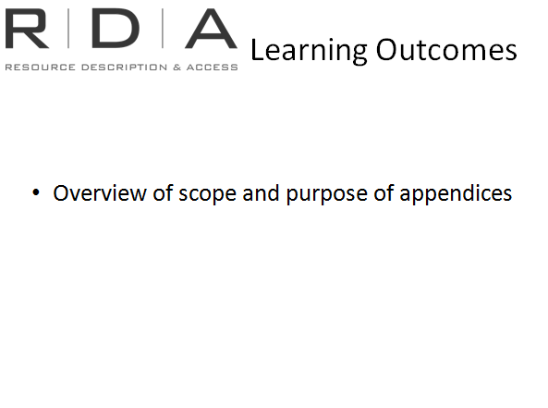
AACR2 gave specific guidance on presentation of information and it was explicitly tied to ISBD following both order of elements and prescribed punctuation.
RDA does not do this; it deals with what data to record but not how to record it.
Guidelines for presentation are given in the appendices and it is here that we find instructions on things like capitalisation and abbreviations.
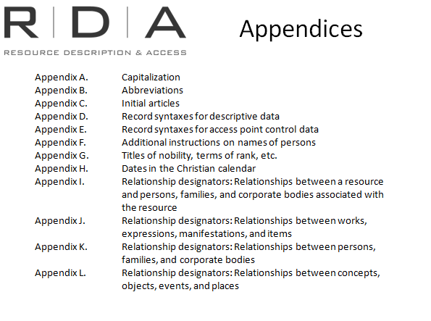
AACR2 gave specific guidance on presentation of information and it was explicitly tied to ISBD following both order of elements and prescribed punctuation.
RDA does not do this; it deals with what data to record but not how to record it.
Guidelines for presentation are given in the appendices and it is here that we find instructions on things like capitalisation and abbreviations.
There are 12 appendices – labelled A to L - we don’t need to look at them in detail but it is important for us to know what is in them.

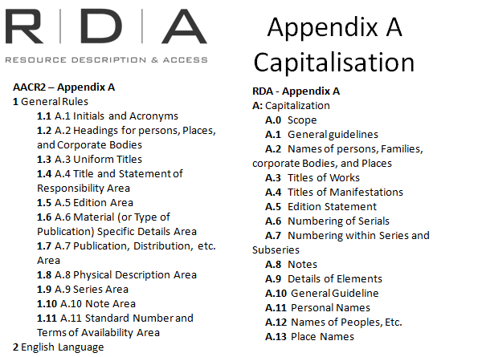
Appendix A
Like AACR2 this is where we find instructions on capitalisation of data transcribed in English and a number of other languages.
When you look closely at AACR2 and RDA you will see that the instructions have not changed very much.

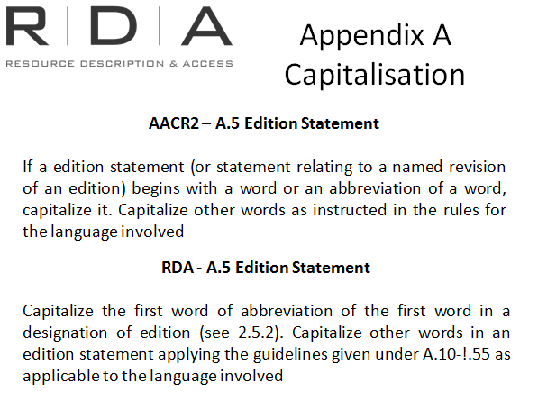
For example: Look at the Edition

AACR2 A.5:
If an edition statement (or a statement relating to a named revision of an edition) begins with a word or an abbreviation of a word, capitalize it. Capitalize other words as instructed in the rules for the language involved.

RDA A.5:
Capitalize the first word or abbreviation of the first word in a designation of edition (see 2.5.2). Capitalize other words in an edition statement applying the guidelines given under A.10–A.55, as applicable to the language involved.
Although they are worded a bit differently they are essentially the same.

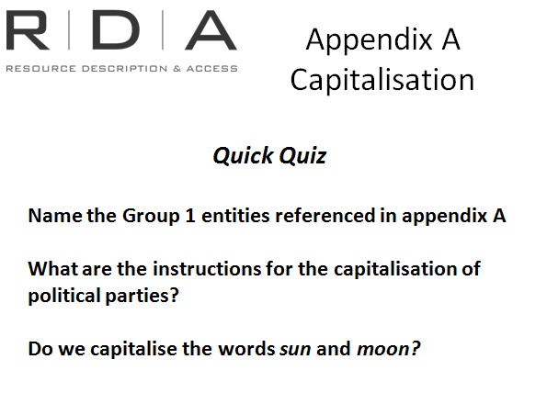
Quick Quiz:
- Name the Group 1 entities referenced in appendix A? Works A.3 and manifestations A.4

- What are the instructions for the capitalisation of political parties? A.16.3 [remember to click on + sign for more specific instructions

- Do we capitalise the words sun and moon? No A.25 [think about what category they belong to]

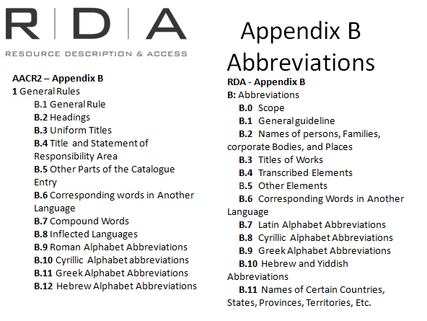
Appendix B: Abbreviations
Again, there are some similarities between AACR2 and RDA. However we know that there is less use of abbreviations in RDA than we used to use in AACR2. So what’s changed -
There is no sub-section for Roman alphabet abbreviations, eg. Dept., govt. are no longer abbreviated.
There are some circumstances where we still use abbreviations, for example:
- We can still abbreviate names for certain countries, states and territories (B.11) as part of a place located in that state etc. (that hasn’t changed from AACR2) or;
- As the name or part of the name of a place associated with a person, family or corporate body (this has changed from AACR2 which only recognised places as additions to corporate bodies)
It is useful to note in the General guideline (B.1) the alternative allows abbreviations for recording attributes of manifestations and items if the cataloguing agency has in-house guidelines.

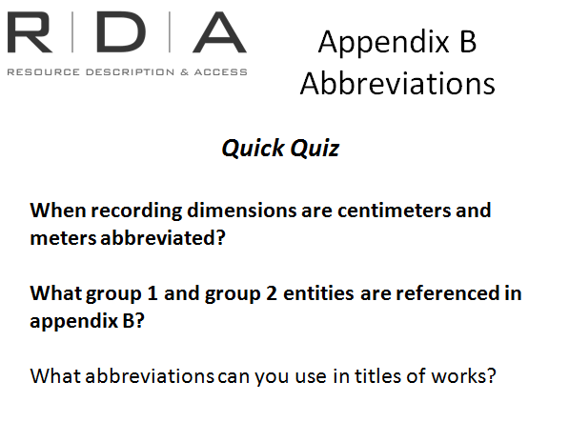
Quick Quiz:
- When recording dimensions are centimeters and meters abbreviated? B.5.1 cm and m are not considered abbreviations
- What group 1 and group 2 entities are referenced in appendix b? Works B.3 and personal names, families and corporate bodies B.2
- What abbreviations can you use in titles of works? B.3 etc.

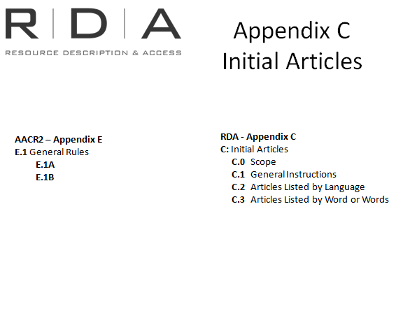
Appendix C – initial articles
Use of initial articles is a little bit different to what we are used to doing in AACR2.
AACR2 generally tells us to omit initial articles in headings for people, corporate bodies and uniform titles. Where as in RDA omiting the initial article is the alternative instruction in recording titles, names for persons and corporate bodies
The omission of Initial articles now being an alternative is a change to how RDA was originally published. It was introduced as a result of a proposal put to the JSC by Germany in recognition that initial articles work differently in different languages and can’t always be easily separated from the key words.
This change complies with the intended language neutrality of RDA.
In appendix C the list of initial articles is presented differently to AACR2. In AACR2 it is listed in alphabetical order, in RDA it is presented in alphabetical order by language and all the initial articles for each language grouped together.

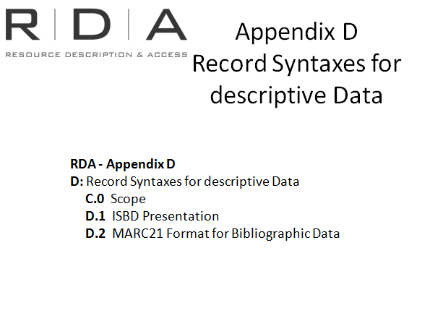
Appendix D – Record syntaxes for descriptive data
This is where we find guidelines for recording data using ISBD and MARC; this is useful for those of us who use these. There is no equivalent appendix in AACR2 as ISBD punctuation was incorporated into the main instructions and, being written in the era of card catalogues, there were no mappings to MARC.
Looking at the structure: In D.1 there is a table showing how specific RDA data elements are mapped to the areas and elements defined in ISBD. The display follows the established ISBD order of elements and punctuation that we are all familiar with.
There have been a couple of changes to the ISBD including:
- adjecent sets of square brackets;
- no longer using “et al” for more than three authors in a statement of responsibility;
- Add the full stop at the end of an element even when the final word is an abbreviation followed by a full stop (eg ed..)
Moving to D.2 there is another table mapping the RDA descriptive data elements to MARC21 format for bibliographic data. Reminder: the MARC21 to RDA mappings are also available in the Tools tab, it may be more useful to look there as the mappings work both ways.

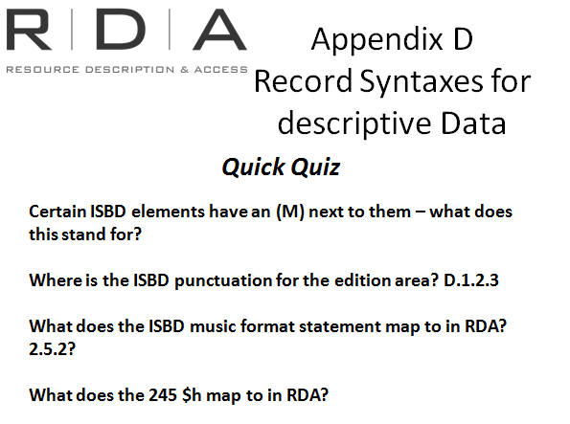
Quick Quiz
- Certain ISBD elements have an (M) next to them – what does this stand for? The answer is in D.1.1 Order of elements – they are mandatory elements in the consolidataed editions of ISBD
- Where is the ISBD punctuation for the edition area? D.1.2.3
- What does the ISBD music format statement map to in RDA? 2.5.2
- What does the MARC field 020 $c map to in RDA? 4.2 Terms of availability
- What does the 245 $h map to in RDA? N/A There is no mapping because the GMD is not used in RDA.

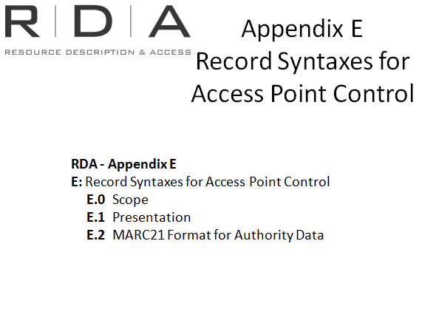

Appendix E
Some of you may have noticed that appendix D was about recording descriptive data. Appendix E is about recording data for access points.
The Scope tells us that this appendix provides guidelines on the presentation of access points and references derived from AACR2 rules and examples, and a mapping of the variable fields and subfields defined in the MARC 21 format for authority data to the corresponding elements in RDA
The table at E.1 gives us the AACR2 elements, punctuation in the middle column and the corresponding RDA element in the right hand column.
E.2 gives us the MARC21 field with the mapped RDA element.
[Note: If anyone asks why there is no mapping to consolidated edition of ISBD it is because ISBD only covers descriptive data not access points]

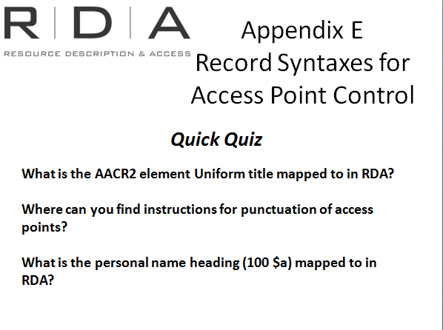
Quick Quiz
- What is the AACR2 element Uniform title mapped to in RDA? 6.2.2 preferred title for a work
- Where can you find instructions for punctuation of access points? Scroll down to E.1.2
- What is the personal name heading (100 $a) mapped to in RDA? 9.2.2 preferred name

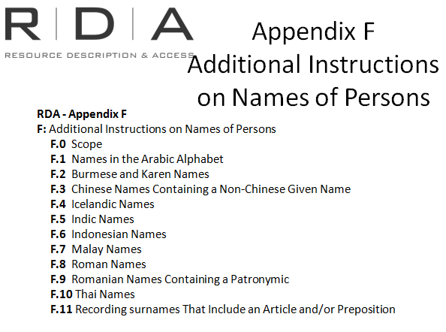
Appendix F
is the additional instructions on choosing and recording names of persons in a number of specific languages and supplements the general guidelines and instructions provided in chapter 9 (identifying persons).
If we look at chapter 9 the Purpose and Scope refers us to appendix F for the additional instructions in those specific languages
At the moment this appendix is virtually unchanged from AACR2 chapter 22. However it is currently under review and more work is planned

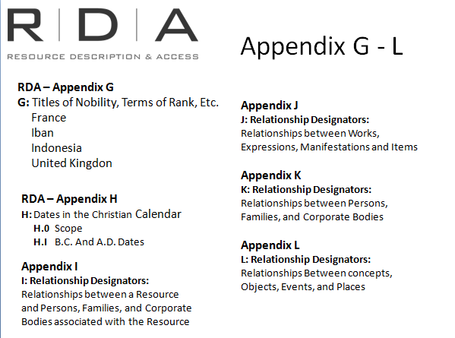
Appendix G
provides information on titles of nobility, terms of rank, etc., used in a number of specific jurisdictions.
It includes male and female equivalents where applicable. These terms also supplement general instructions in chapter 9. See 9.2.2.14 – refers us to Appendix G.
There were no equivalent lists in AACR2

Appendix H
provides information on recording dates according to the Christian calendar. It is quite short and referred to in various parts of the main body of RDA that relate to recording dates.
For example back in chapter 9 again 9.3.1 – recording dates associated with a person.

Appendices I, J, K, and L
provides lists of relationship designators.
These are the terms for use with the relationship elements covered in sections 6, 8, 9, and 10, respectively. They also provide definitions for terms used as relationship designators and instructions on their use. Note that appendix L – concerned with relationship designators for subjects has not been written yet.
How extensively these appendices will be used will be up to the discretion of individual cataloguing agencies. As we mentioned in Module 10, relationship designators are not core elements and are not included in the Libraries Australia minimum record standard.
[Note: The intention is that the National Library will make use of them]
As we already looked at these in module 10 we will not go into them in any more detail now.

Summary
This was a short module to show what is in the appendices and which RDA instructions they relate too. RDA instructions do not give guidance on presentation of data; this information is found in appendices.
We saw that many of the things that are familiar to us from AACR2 are found in the appendices (ISBD, capitalisation etc) and there are also some new things such as the relationship designators.

