Teaching RDA – Day 1

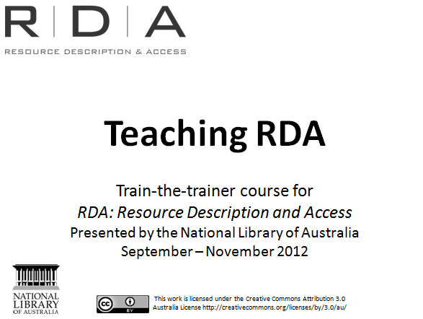
Introduction to course

This training documentation is intended to be used in conjunction with live access to the Internet and the RDA Toolkit

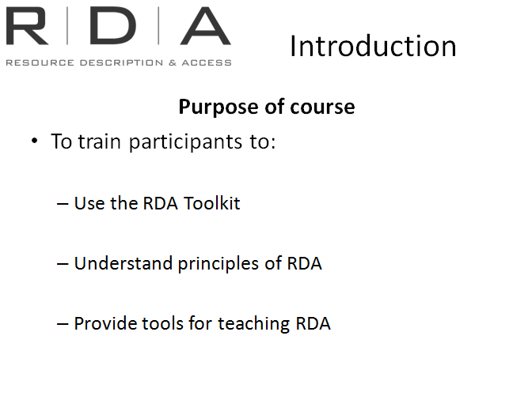
Purpose of course – to train participants to

There will be exercises and opportunities for discussion throughout the course

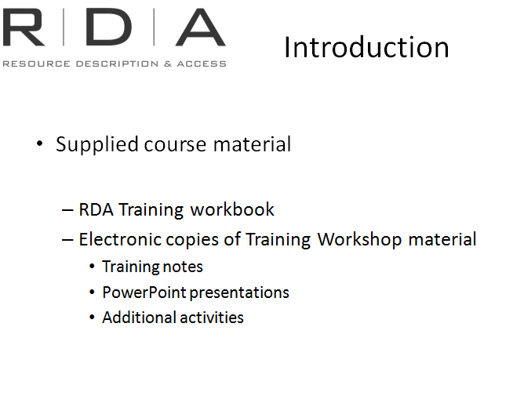
Supplied course material

  - RDA Training workbook – contains slides, exercises and appendix
  - Electronic copies of training material

This presentation was created under Creative Commons Licence 3.0. This means you can:
- Copy, distribute, display, and perform the work
- Make derivative works
- Make commercial use of the work
If you do use any of this material in your training documentation you will need to attribute the National Library. Each use of the material should be attributed as follows:
“From (or adapted from) Teaching RDA: Train-the-trainer course RDA: Resource description and access presented by the National Library of Australia in 2012 and made available under a Creative Commons Attribution 3.0 Australia License.”

Ice breaker
Participants to introduce themselves answering the following questions:
- Name
- Organisation they work for (if all in room from same organisation, ask what suburb they live in)
- One other interesting fact about the person.
Then introduce your new colleague to the rest of the group.
[Notes to presenters: This exercise has been deliberately chosen to tie in with later discussions about entities, attributes and relationships
Alternative for large training groups- Break into pairs and ask each other the questions, then report back to group]

Course overview
This course is not designed to teach everything there is to know about RDA:
- Not enough time in three days
- RDA is fluid and still being developed so some things may change
- Intended to be a guide to get you started

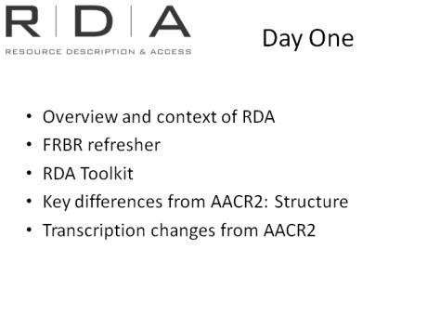
Modules for Day 1
These are the topics we will to cover today
- We will start with some discussion about the background to RDA
- Then we will have a refresher of FRBR. It will be useful to revisit this as understanding FRBR is crucial to understanding the focus and structure of RDA
- Next we will look at the RDA Toolkit. We will learn how to use the Toolkit and also look at different types of subscriptions and access to it.
- Afternoon we will start to look at key structural differences between RDA and AACR2
- End the day looking at transcription changes and changes to the GMD

Module 1: Overview and context of RDA

Resources:
- Marker pens
- Butchers paper

Learning outcomes
Handbook: Page 13
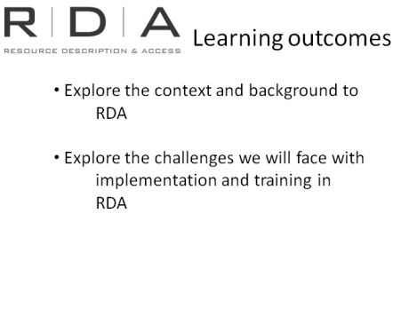
This module is intended to be a discussion about the reasons around the context and background that led to the development of RDA.
We will also think about the challenges we will face before implementation.
Finish with a quick look at how developments of the Internet have influenced the development of RDA.
FRBR and FRAD will be covered in the next module.
Note to presenter
The information management environment, within which our cataloguing now exists, is key to understanding the need to move to RDA. Therefore trainees need to have basic understanding of this context. Information you might need to go over is given below. If FRBR, Structure, or ICP are mentioned, note that they will be covered in later modules.
Handbook: Page 140

Activity:

Why do we need a new cataloguing standard? What’s wrong with AACR2?

Divide the participants into two groups.
Group 1- What are the challenges of implementing a new standard
Group 2- What are the reasons for moving to a new cataloguing standards
Give each group butchers paper to write their answers and select one person from each group to present their work

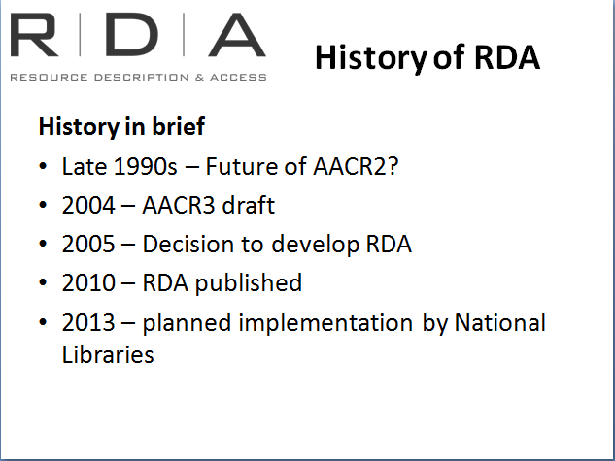
Background notes

AACR2 was introduced in 1978.
At this time:
- Card catalogues were still dominant as “Automated” catalogues were still in development.
- Australia’s ABN network (the pre-cursor to our National Bibliographic Database) was still two years away.
- Library collections were mainly print based.
- This was the information world in and for which AACR2 was created.
A lot has changed since 1978
By the mid-1990s it was clear that there were significant issues with AACR2 and there were increasing calls for fundamental revisions to the standard.

AACR3 to RDA
In 2004 the work began on a new edition of AACR2 – initially called AACR3.
The revision gave greater emphasis to content rather than format. However it became clear that keeping the AACR structure could not fully address challenges posed by digital materials.
In 2005 AACR3 was abandoned in favour of a completely new structure - based on a new theoretical model called FRBR.
To reflect this change in approach it was given a new name – Resource Description and Access

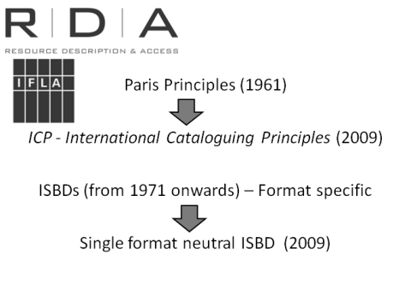
ICP and ISBD
Two other key international documents, the Statement of International Cataloguing Principles or ICP), and the International Standard for Bibliographic Description (ISBD) have also been revised to align with FRBR/FRAD, and be more relevant to the digital information environment. These documents both strongly influenced the development of RDA, and the new standard is fully compatible with them.
We recommend that when you are training others, you take some time to go through particularly the Statement of International Cataloguing Principles, as it will assist in their understanding of RDA. Many of the key changes to the way we record information originate from these documents, so in this training session, we will look at them in Module 5 when we talk about those changes.
Handbook: Page 14

Semantic Web and its’ influence on RDA development

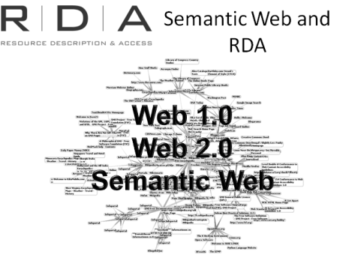
Worldwide web
One of the driving forces behind most of the developments to our catalogues is the Internet.
Technology has changed the way information is provided and published and this has had a major impact on library collections and our efforts to catalogue them. There are new ways of providing access to information and new contexts within which catalogue data was being used.
How has this online world developed:
- First we had web 1.0 – this was static; things were published and we read them
- Then came web 2.0 (around 2004) – this was interactive. We became the creators and publishers of content with wikis, blogs, etc. This allowed people to connect with each other
- Now we have the Semantic web (around 2010) – this is not about people talking to each other through social media. This is about computers talking to each other. It puts meanings behind the structure and content of websites.

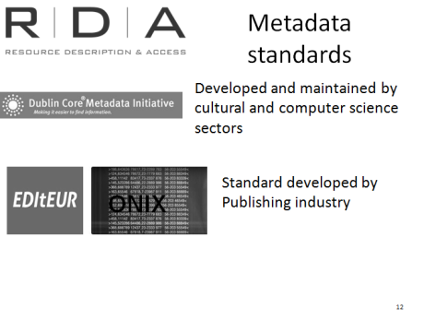
Outside the Library community, significant development has taken place to standardise the creation of online data so that it is transferable across computer networks and the web.
Metadata standards such as the Dublin Core Metadata Initiative and ONIX significantly influenced RDA, which has been designed to be compatible with both standards
Consideration has also been given to the metadata standards used in other communities (archives, museums, publishers, semantic Web, etc.) to attain an effective level of alignment between those standards and RDA. [Quoted from RDA, Section 0.2]

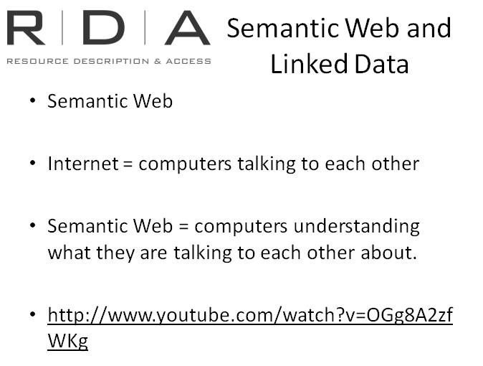
Semantic web
[Semantics =study of meaning]
The Semantic Web refers to computers talking to each other, sharing information and understanding the meaning behind the information they are sharing.
Of course computers don’t actually talk to each other; it is about how WebPages are coded. When a computer accesses a webpage, the metadata tells the computer what that website is about and how it may relate to other WebPages.

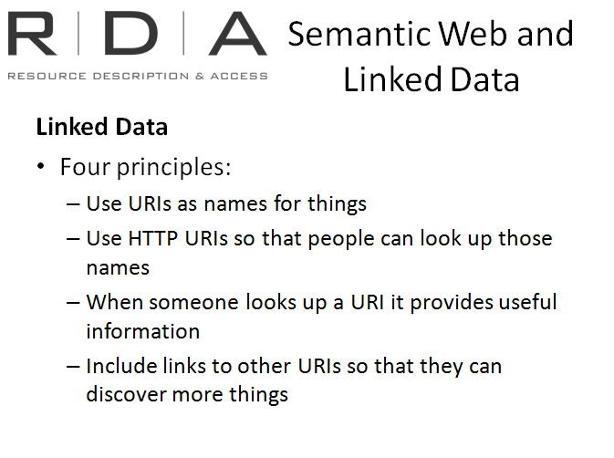
Linked data
Further developing his thinking on the Semantic Web, Tim Berners-Lee also coined the term “linked data”, which is basically about making data linkable so that humans or machines can explore the web to find other related things. His principles for linked data were that when naming things on the web, they should be given URIs so that they are structured and findable. Preferably, these should be http URIs (like web addresses) so that people can look them up. When the URI is retrieved, it should contain useful information about the thing that has been named, including its relationships to other things that have, ideally, also been named using an http URI so you can link through to information about them. There’s plenty of information available on the web about linked data, and the full text of Tim Berners-Lee’s original issues paper can be found at:
http://www.w3.org/DesignIssues/LinkedData.html

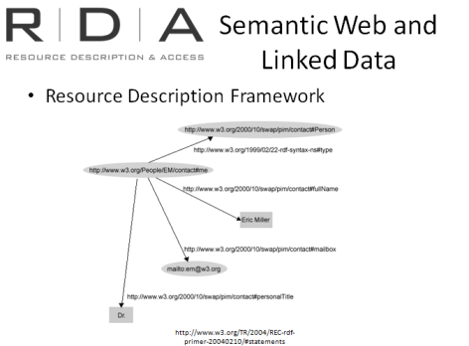
The Resource Description Framework (RDF) is a major component of Semantic web activity, and also incorporates the principles of linked data. RDF is a model for labelling pieces of information and the relationships between them in a structured way, using URI’s. It allows structured and semi-structured data to be mixed, exposed, and shared across different applications.
The RDA cataloguing standard is designed to move library data towards this Semantic Web environment, so that it too can be shared across different applications. RDA’s element set has been clearly defined, and incorporated into the Open Metadata Registry, which is a set of RDF-based controlled vocabularies, and a fundamental piece of technical infrastructure for the Semantic Web.
You don’t need to understand this diagram in detail, it just to give you an idea of the sort of modelling that is used in RDF.
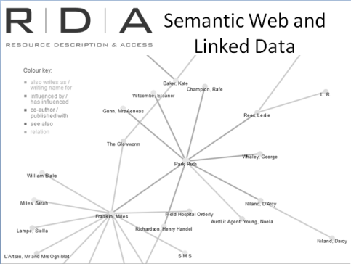

Example:
This “network visualisation” in Austlit gives you a bit of an idea of how linked data works in practice. This is a “resource map” for Ruth Park, the Australian author, showing the relationship links between her and other people. The Colour key shows you what type of relationships they are.
See how one of the people she is linked to, Miles Franklin, has her own resource map.
You can also see that this sort of linking can go on forever, and make the web truly a “web” of connected information.

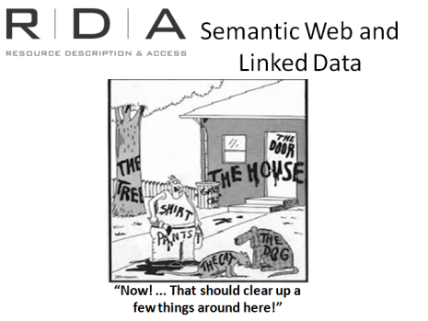

Recommended Readings
For further information about the development and context of RDA see the recommended readings listed in Appendix 1 of the Training Handbook

