Teaching RDA - Day One

Module 2: FRBR refresher

Resources:
- Trove - FRBR final report
- Pride and prejudice activity sheets
Handbook: Page 17

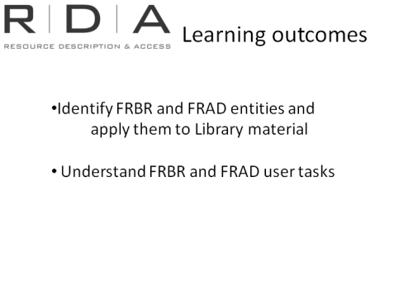
Learning outcomes
In this module we will look at FRBR and FRAD.
Having a grasp of the these conceptual models is essential to understanding and finding your way around RDA, so let’s just do a refresher on these and then do an exercise to consolidate our understanding.

Entities
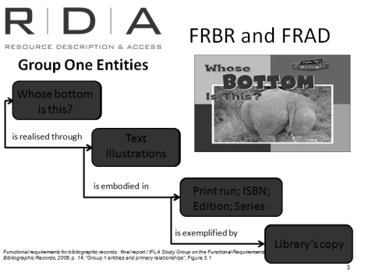
FRBR and FRAD have defined three groups of entities:

Group 1 entities.
The first group of entities are the products of intellectual or artistic endeavour that our users are interested in. They comprise:
- Work
- Expression
- Manifestation
- Item
For example: Whose bottom is this?
- Work –intellectual or artistic creation
- Expression –the intellectual or artistic realisation of a work
- Manifestation –the physical embodiment of an expression of a work
- Item – a single exemplar of a manifestation

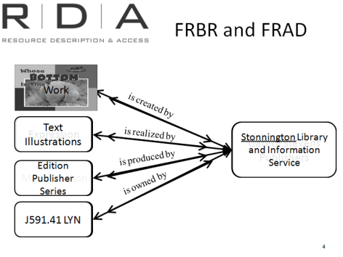
Group 2 entities
The second group of entities represent those that are responsible for the intellectual or artistic content, the physical production and dissemination, or the custodianship of the entities in Group 1. They are:
- Person
- Family (not mentioned in FRBR, but added in FRAD)
- Corporate body

Whose bottom is this? -
- Work is created by Wayne Lynch
- Expression is realised by Wayne Lynch
- Manifestation is produced by Gareth Stevens publications
- Item is owned by Stonnington Library and information service

Group 3 entities
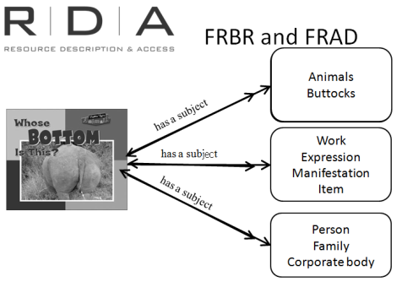
The entities in the third group serve as subjects of the Group 1 entity work. The group includes
- Concept
- Object
- Event
- Place

Group 3 also includes all of the Group 1 and Group 2 entities, because a work can also have these as subjects. Subject entities are not yet covered by RDA, but will be included in the future.

Whose bottom is this has subjects: Animals and buttocks.
For this example there are no more subjects. It is not about another work or a person.

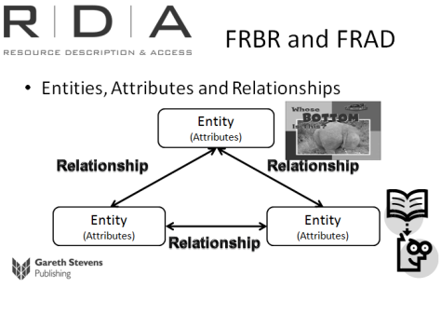
Entities, Attributes and Relationships
FRBR and FRAD are built on an entity relationship model.
We just looked at the three groups of entities. Each entity has attributes which help uniquely identify them. Each entity is also defined by its relationships to other entities.
The manifestation Whose bottom is this? has attributes – title, pages, edition, series
It has relationship to
the person who created it who also has attributes – name, date of birth
who has relationship to
the corporate body who published it which has attributes – name, place, number (eg ABN)
Knowing about these relationships helps to put the entities into context, enhancing our understanding of them.
This makes sense if you think about it. Think back to the ice-breaker exercise this morning.
[Optional reflection exercise: Pick out someone in the room and ask them to introduce their ice-breaker partner again]
Name: name is an attribute
Who work for: relationship
Other interesting fact: is this a relationship or attribute

Finding out about your colleague was not just about learning their name (an attribute) but also putting them into some sort of meaningful context. We did this by asking them who they worked for (a relationship).
Question: What about the other interesting fact you found out about your colleague? Was it an attribute or a relationship? [Group discussion]
This is the same process our users go through when they interrogate our catalogues.
Not only do they want to know the characteristics of the thing they are looking for, like the title, how many pages, and whether it’s a book or a website. These things are attributes. They also want to put it into a meaningful context. Who created it, and what else have they created? Which library holds a copy they can borrow? How is it related to that other, similar resource that they were looking at. All these things are relationships.

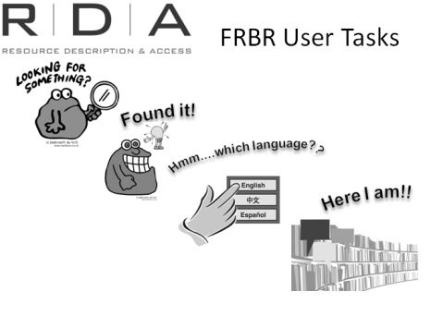
User tasks
FRBR and FRAD map the attributes of entities, their relationships to each other and also the relationships between entities directly to the tasks performed by users. That is, what users actually need to know about, and what they want to do with the information once they know it.
For example, the Group 1 entities described above, FRBR defines 4 user tasks:
to find resources relating to their needs
to identify the particular resource they are looking for.
to select a version of that resource that best meets their needs,
And to actually obtain a copy of it.
For Group 2 and 3 entities the user tasks are similar instead of selecting and obtaining, they need to clarify the context (eg. is this latest name for this corporate body or has it changed its name?) and they need to understand or have some justification as to why the entity has been described the way it has (eg why has this person’s name been expressed in this form)

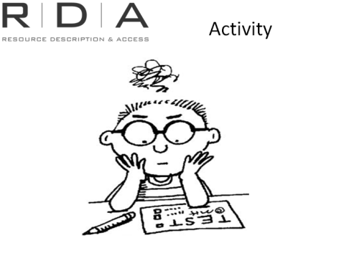
Activity: In Trove search a book title and go through the process of find, identify, select and obtain for that resource

[Note to presenter: Take the opportunity when the results screen comes up to show participants how Trove has made use of FRBR in its displays. See below]

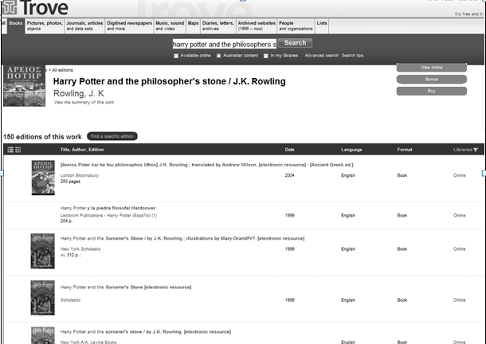

Work

Item

Expressions/
Manifestations

As you saw on Trove just now [perhaps return to the record as it appears above to refresh people’s memory] the use of FRBR/FRAD-like displays allowed us to be able to see items, manifestations and expressions of the same work in a meaningful hierarchical display which highlights the differences between them.
The user who is less interested in the differences between manifestations, but just wants to read, [insert example used in above exercise], can pick from the list the first version in their language that displays and is available to them, without having to rifle through whole records for multiple different manifestations to find it.

FRBR/FRAD, RDA and ILS systems
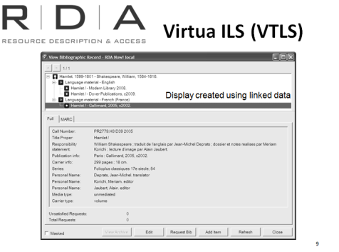
From the cataloguer’s perspective, basing ILS design on FRBR and FRAD has the benefit of making cataloguing activities much more efficient.
Currently our catalogue records contain information relating to all of the Group One entities - work, expression, manifestation, and item.
Every time we catalogue a different manifestation of the same work or expression, we are re-entering the same data about the work or expression.
Imagine if our systems allowed us to record work or expression information separately, and then link to that information each time there is a new expression of work, or a new manifestation of the expression.

Virtua Integrated Library System, from VTLS, is a key example of where the design of cataloguing systems is expected to go. Virtua enables the creation and display of “true” FRBR data.
The cataloguer starts by creating a Work record, then adds an Expression record and creates a link from it to the Work record. They can then add a Manifestation record and creates a link from that to the expression record, and finally creates the Holdings and item record which linked to the manifestation.
Later, when an additional Manifestation is acquired, another Expression record can be created and linked, if needed, and another Manifestation record can be added and linked.
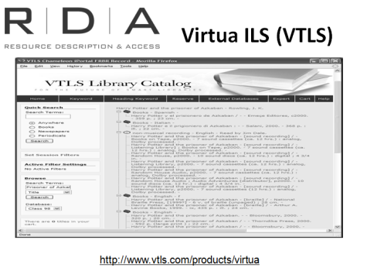
In the OPAC, the work title can be shown at the top, and all of the different expressions can be organised under it hierarchically, making it easier for the user to navigate through the different expressions and find what they want.
For the everyday cataloguer and library user such systems are still in the future.
But we hope that by showing you the example above you get an idea of how it might work.
Of course, these systems are not a perfect representation of a FRBRised system, because we are still creating data according to AACR2 and MARC. Once we start to create catalogue data using RDA, we will pave the way for better ILS development

Other examples to look at later:
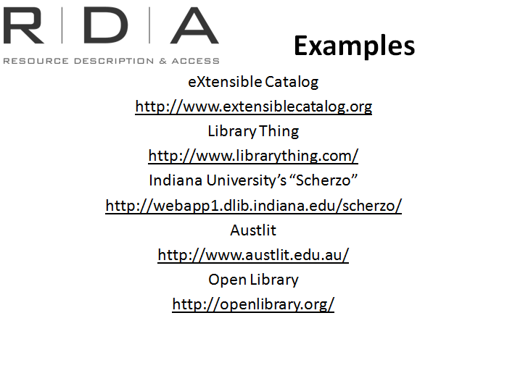
- eXtensible Catalog
http://www.extensiblecatalog.org (Follow the “Learn more” link to find out about their RDA work)
- Library Thing
http://www.librarything.com/
- Indiana University’s “Scherzo” (Music specific)
http://webapp1.dlib.indiana.edu/scherzo/
- Austlit [note: non-subscription holders will see an abbreviated version]
http://www.austlit.edu.au/
- Open Library
http://openlibrary.org/

Exercise to test understanding WEMI.
Handbook: Page 141

- Choose a work (for example Pride and prejudice) gather together as many manifestations of this work and its derivatives as possible. Split the trainees into groups and give each group a selection of the items (either the real examples, or photocopies representing them).
- How many works do you have?
For example, in the Pride and Prejudice example used by NLA Trainers, ten examples were handed out, and these represented four works
- The original Pride and prejudice by Jane Austen
- Pride & prejudice the 2005 movie
- Pride and prejudice the BBC TV series
- Pride prejudice and zombies

- Put aside everything except those that are versions of the original work (eg. Pride and prejudice by Jane Austen). How many different expressions of that work do you have?
In our example, there were two expressions: audio (audio book read by Helen Lisanti) and text (one hard copy printed by T. Egerton, one on the kindle and one printed by Fair price classics)

- Put everything back together again. How many different manifestations do you have?
The answer for the Pride and Prejudice example was 10 – each example handed out represented a different publication (they have been manifested by different publishers) so they are all different manifestations.

- How many items are there? What makes one item different from another item of the same manifestation
- There are 10 items. Differences in items of the same manifestation could include library call numbers, annotations on a book, condition of the material and ownership stamps

