Day One

Module 3: RDA Toolkit
Handbook: Page 21

Resources:
- RDA in print
- RDA Toolkit online
- ACOC Website

Learning outcomes
- Broad understanding of different subscriptions available
- Navigate the Toolkit using the table of contents, quick search and advanced search
- Understanding of functionality of the Toolkit
Setting up personal profiles and exploring user generated content will be covered in Module 13. [Note: slides relating to the personal profiles and user generated content are included in the PowerPoint presentation, so that the Toolkit demonstration can be used as standalone module]

Online interactive tool
A key point of difference between AACR2 and RDA is that RDA is designed to be used as an interactive online tool. In this module we will demonstrate the online tool and do some exercises to help you become familiar with navigating it.
But to begin with, let’s look at how you can get access the Toolkit.

Access to the Toolkit
[Information sourced from the RDA Toolkit Website: http://www.rdatoolkit.org/]
Open your favourite browser (Hint: Firefox sometimes needs settings adjusted to access IP sign in, and may not always work. If this is the case for you, use the latest version of Internet Explorer)
Address: http://access.rdatoolkit.org/ . This is on the front cover of the handbook.
Check that everyone is on the correct page
Open Publisher website (click on “RDA Toolkit”, top left of screen)
We will look at a few things about the website later in the Module. For now, let’s just see about Subscriptions. The Toolkit is a subscription product which can be purchased online through the Toolkit website or by contacting the publishers directly

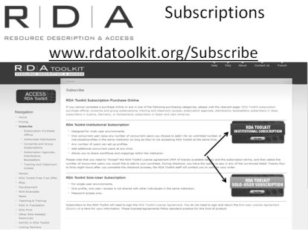
Types of subscriptions (see Pricing and Subscribe on the navigation menu)

There are several types of subscription to the online Toolkit:
- Solo user subscription
The solo-user subscription is for single-user environments where access to the RDA Toolkit is not shared with other individuals in the same institution. It is password access, and has one user and one profile.
- Site subscription
The site subscription is designed for multi-user environments where one or more concurrent users are shared with an unlimited number of individuals within the same institution.
You pay a base annual fee for the site subscription, which includes one concurrent user, and then pay an additional annual fee for each extra concurrent user that you need. Once you have your access, it can be used by an unlimited number of individuals in the same institution, as long as they are not all using it at the same time.
Within this subscription, institutions can set up cataloguing workflows that can be shared
Your staff can also set up individual user profiles within your site subscription allowing them to create their own workflows and add bookmarks to the text.
  - Site subscription administration
Site administrators can access an administration module of the RDA Toolkit using the username and password assigned to the subscription account. The URL for this is http://admin.rdatoolkit.org/
When you log into the admin module, you’ll be taken by default to an unpopulated “Add User” page. To get to the main page of your existing account, you need to click on the “Search User” button in the bar above it, and type in either your user name or the name of your institution.

On the main page, you can make changes to most of your details except for the start and end dates of your subscription and the number of users you purchased for your subscription (those criteria are greyed out).

Other things you can do in the administration module include configuring the administration module for your needs, and viewing statistical reports on the usage of the Toolkit in your organisation.
- Consortia and group subscriptions
The Toolkit publishers are also prepared to provide consortia and group subscriptions, and any libraries wishing to do this should contact the publishers directly to discuss this.
[If asked: NSLA has decided not to consider a consortial arrangement at this stage]
- Training and Classroom Access
To allow for training of current and future staff, the Toolkit publishers are offering access to the Toolkit at special pricing. The institution must purchase a subscription that matches its ongoing cataloguing needs and then inform RDA Toolkit staff via the RDA Toolkit Support Center of the number of additional users needed for the given training day or class period. RDA Toolkit access will be granted for that period to the additional users at no additional charge.

RDA Toolkit and Cataloguers’ Desktop
You can also access RDA via Catalogers’ Desktop. But you can only do this if you already separately subscribe the RDA.
Also, in Cataloger’s Desk you do have access to the full Toolkit. You can only access the text of RDA, and link from it to the LC-PCC PS, which are also in Catalogers Desktop. The full functionality of the Toolkit, such as its search functions, other tools and resources and user-generated content are not accessible via Catalogers’ Desktop.
Finally, from April 2013, AACR2 will no longer be in Cataloger’s desktop, so you will need a subscription to the Toolkit to see AACR2.

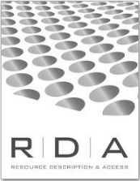
Print version of RDA
There is also a print version of the text of RDA. This full-text print version of RDA offers an offline access point to help solo and part-time catalogers evaluate and use RDA. It can also support training and classroom use in any size institution. An index is included. The online RDA Toolkit is the preferred option for using the Toolkit as it will always be the most up to date, and also offers access to companion tools such as LC and JSC Policy Decisions, the full text of AACR2, Mapping to MARC and ISBD, and workflow tools. However, purchasing the print version offers an alternative for those unable to access the online version.
We have a couple of copies here today for you to look at.
For Australian users, RDA in print can be purchased from Facet Publishing in the UK, and the details, including price, can be found at http://www.facetpublishing.co.uk/title.php?id=7494&category_code=910
Updates to the print version will be issued irregularly.

Toolkit demonstration
Check everyone is logged onto the Toolkit.
The National Library has an IP authenticated logon and you should be seeing our name in the top right corner of the screen.

Overview of Window

Open the toolkit and explain the parts indicated by arrows and circles:
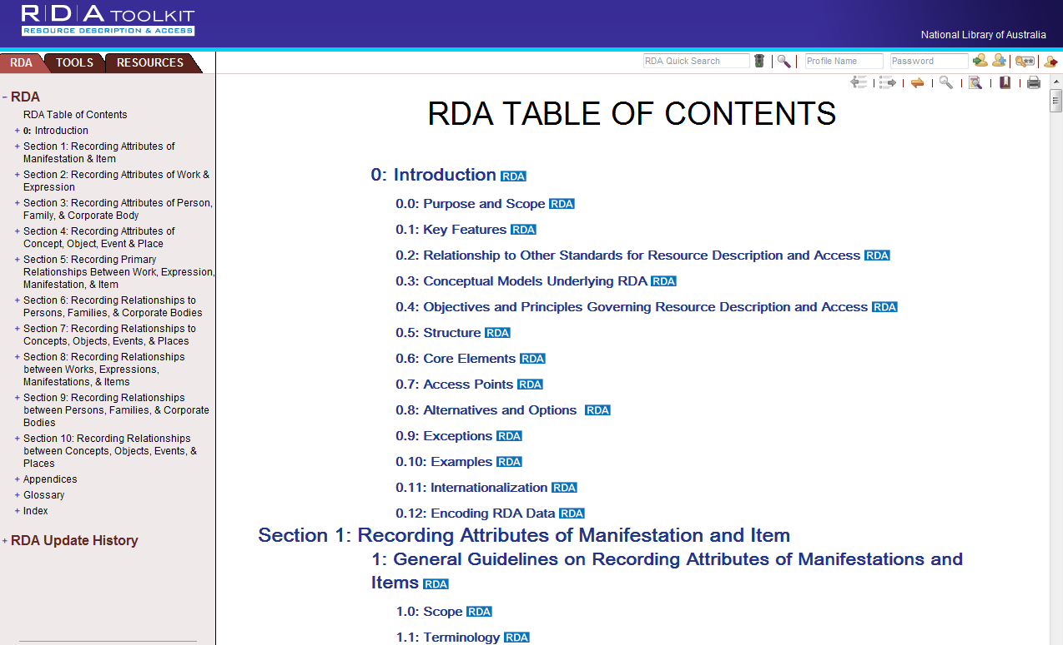
- Tabs
- User menus
- Table of contents
- Document pane
- NLA authenticated login
- RDA Toolkit logo
- Quick search

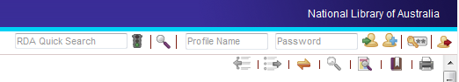

Screen image from the RDA Toolkit (www.rdatoolkit.org) used by permission of the Co-Publishers for RDA (American Library Association, Canadian Library Association, and CILIP: Chartered Institute of Library and Information Professionals)

User menu (Top menu)
- Quick search: Visible where ever you are in toolkit, but only searches RDA content
- Magnifying glass – Advanced search
- Login to personal profile
- Create new user profile
- Email password
- Logout – it is a good idea to log out at the end of your session to make it available for other cataloguers

Document menu (below User menu)
- Forward and backward buttons (searching)
- Synch TOC (See below)
- Magnifying glass – return to results (searching)
- Filtering options (see below)
- Bookmark (Module 13)
- Print
Note: There is a guide to the RDA icons in Appendix 3 of the handbook

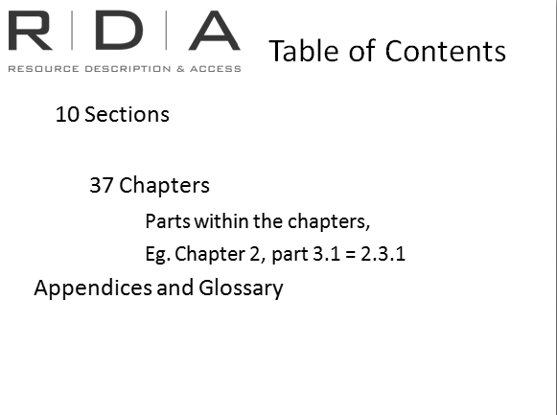
RDA Tab

Navigational structure of RDA text
We are not going to talk in detail here about the Structure of RDA and how it is different from AACR2, but it will be useful as part of this demonstration to understand how the contents are structured at a broad level, so that you can navigate around the TOC. There are:
10 Sections, which contain
37 Chapters
Appendix, Glossary and Index
Each chapter is divided up into numbered parts and these are numbered subordinately to the Chapter.
Eg. 2.3.1 – Basic instructions for recording title
The “2” above, refers to Chapter 2, and not Section 2. This is because the Chapters are continuously numbered throughout RDA, so when quoting an instruction number, we don’t include the broader Section. They are just there to help you find your way around a bit better.
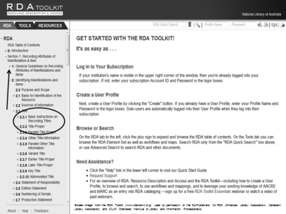
You can expand and contract the Table of Contents to see and navigate through the contents of RDA. Just click on “+” [arrow] to open up a section, and keep clicking on “+” until you come to Chapter and subpart you want. You can also click on “–” signs to close the parts you no longer want to see in the contents pane.
When you mouse over a part of the contents, it becomes underlined, and if you click on it, the Toolkit will open that part of the RDA text in the Document pane to the right.
For example, under Section 1: Manifestations and items, click on (Chapter) 2: Identifying manifestations and items, then 2.3: Title.

A note about page loading
Please be aware that when the text of RDA is loading, its background process is to go to the beginning of the section your destination page is in, before loading the page you have requested. Most of the time you won’t see this, but if the Toolkit is running a bit slow, you may see the beginning of the section pop up. Always check the blank space in the user menu, where it will say “Loading...” if it hasn’t finished yet.

Finding your way around the Document pane
So now that we’ve found some of the RDA text, let’s have a closer look at the Document Pane.
“Page” numbers
In the Document Menu on the left, indicating how many sections the chapter you are in is broken into, and which section you are in (indicated by the square brackets). Red arrow=previous page and the green arrow=Next page
Warning: This can be a quick way around, but you probably won’t know exactly which section the instruction you are looking for is in, so it is better to go through the Table of Contents if you are looking for a specific instruction. However, if you are reading through the text and come to the end of a section, you might wish to keep reading. In this case, click on the “next page” arrow at the top.
Text area
In the text area [use 2.3.1.6 as eg]
- “Core element” in light blue.
- Glossary terms highlighted in maroon, linked to the Glossary.
- Hyperlinking to other rules.
- Examples
- Options, alternatives (Green headers, and a green line next to text)
- “LC-PCC PS” [next to 2.3.1.7] = “Library of Congress-Program for Cooperative Cataloging Policy Statement”. Replacement for LCRI’s. Full text in Resources Tab.

Menu options to highlight
- Synch TOC – only needed if:
  - Auto option switched off (when in personal profile)
  - Scrolling the text rather than using TOC or hypertext links
- View text options [“View Text” menu icon (a page with a magnifying glass over it)],
  - Hide Examples
  - Core elements only (Note: may be some display issues)
  - Basic RDA (“abridged” version of RDA)
- Print text

Browsing the Table of contents: Exercise in Handbook
Handbook: Page 142
- What is instruction number 2.3.2? Title proper
- Where is information on use of capitalisation? Appendix A – RDA has 12 appendices. Here we find guidelines on presentation of data such as capitalisation and abbreviations
- What is the glossary definition of a piano score? A reduction of an instrumental work or a vocal work with instruments to a version for piano. May include the words of a vocal work. – There are links to the glossary from the main body of RDA
- How many sections are there in RDA? 10 and; How many chapters? 37 Which sections deal with recording attributes? 1-4 and; Which sections deal with recording relationships? 5-10.
- Is 19.2 a core element? Yes. – Core elements are those which RDA has determined as core.
- Where in chapter 2 are instructions for recording copyright date? 2.11
- Is there a LC-PCC PS for recording copyright date? Talk about LC-PCC PS (click on LC-PCC PS goes to resources tab, click on RDA tab to go back)
- Can you record acquisition and access information? Yes, chapter 4. Scroll down to 4.2.1.3 and see the optional addition to qualify the information

Tools tab:
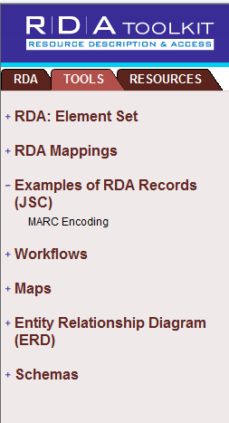
Element Set: RDA instructions sorted by RDA element
RDA Mappings: Tables that map RDA instructions and elements to MARC and MODS coding.
Examples: Takes you to another window to select bibliographic or authority examples (same examples we looked at earlier)
Workflows: User contributed content. Allows users to create, share, copy and modify local workflows, policies and documentation
Maps: User-contributed content that allows the user to create, share, copy and modify maps to additional encodings and other standards
Entity relationship diagram: Visual representations of RDA elements*
Schemas: Machine readable representations of RDA elements*

Screen image from the RDA Toolkit (www.rdatoolkit.org) used by permission of the Co-Publishers for RDA (American Library Association, Canadian Library Association, and CILIP: Chartered Institute of Library and Information Professionals)

*From the FAQ: RDA Toolkit is designed to reach multiple audiences. The largest audience is catalogers, but some of the functions (while still marginally useful for catalogers) were designed with educators, system developers, researchers, and the wider metadata community in mind. Entity Relationship Diagrams are visual representations of data elements (sometimes referred to as RDA Elements) defined or inferred by RDA instructions. Schemas are machine-readable representations of these same data elements. While some catalogers may find the Entity Relationship Diagrams and the Schemas useful tools, the main audiences are likely to include database developers, IT staff, library and computer education professors, and others.

Of most use/relevance to cataloguers

The RDA/MARC mappings:
- Hyperlinks to RDA text and MARC webpages.
- “N/A” means either not just one RDA instruction for this Tag or may not be in scope of RDA. Doesn’t necessarily mean you can’t keep using that tag (exception: GMD). Remember RDA independent of MARC.
- Not very navigable. Can use scrolling and Ctrl F.

Workflows/Maps:
- Local and globally shared workflows, policies, documentation.
- Global = shared with whole Toolkit community. Local = shared only in your institutional subscription.
- User generated.
- Some different egs. - LC Staff: Adding Attributes For Persons with Surnames and Given Names (simple one); LC Staff: Simple Book (complex); CONSER MARC-to-RDA core elements (Map)

Browsing the Tools tab: Exercise in Handbook
Handbook: Page 143
- What RDA rule numbers map to marc code 250, subfield a? 2.5.2 and 2.5.6. Talk about diagonal arrow new to marc fields - In the mapping Tools, you will notice that each MARC tag is in grey, with an upwards diagonal arrow next to it.
Eg.
This arrow symbol is used in RDA to indicate a link out to an external website, in this case, the MARC21 website. So if you’ve been looking at an RDA rule, and then found its MARC tag in the mapping tool, you can then click on the MARC tag, and the detailed information on that tag from the MARC website will be brought up in a separate browser window.

- Are the RDA to marc mappings for bibliographic data and authority data in the same map? No – there are separate maps for bibliographic and authority data
- Where can you find marc to RDA mappings for music scores? User contributed shared mapping under the Maps heading
- What is the RDA core element set schema? the core element set is a subset of the RDA element set that specifies the minimum set of data consistent with RDA compliance
- What are the core attributes of the FRBR entity Expression? Content type, date of expression, identifier for the expression, language of expression, other distinguishing characteristic of the expression and scale – you can find this out by going to the “RDA: Element Set” or the “Entity Relationship Diagrams”

Resources Tab
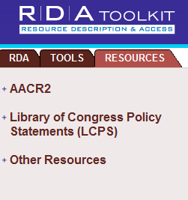
- Full text of AACR2 and contains links to corresponding RDA guidelines (show this)
- LC-PCC PS*
- Other resources contains links to FRBR and FRAD, Dublin Core Metadata as well as MARC Standards and Cataloger’s Desktop. These are links to the websites containing these resources, or access to them

Screen image from the RDA Toolkit (www.rdatoolkit.org) used by permission of the Co-Publishers for RDA (American Library Association, Canadian Library Association, and CILIP: Chartered Institute of Library and Information Professionals)

*LCRI, LC-PCC PS and other Anglo-American policy decisions
Many of you will be familiar with the Library of Congress Rule Interpretations which outlined Library of Congress policies and interpretations of the instructions in AACR2.
These have now been replaced by the Library of Congress-Program for Cooperative Cataloging Policy Statements (or LC-PCC PS) which offer a similar set of policies and interpretations on the instructions in RDA.
The LC-PCC PS are currently available in both the RDA Toolkit and Cataloger’s Desktop, and can be accessed one of two ways (in both Tools).
Firstly, as with the LCRI in Cataloger’s Desktop, any RDA instructions for which an LCPS exists will have a link to the relevant LCPS. When you click on this link, you are taken to the relevant part of the LC-PCC PS. We saw this just now when looking at the RDA Tab. This linkage is available in both the Toolkit and Cataloger’s Desktop
Secondly, the full text of the LC-PCC PS is available as a separate document on the “Resources Tab” in the Toolkit, and in the list of resources available on Cataloger’s desktop.
LC-PCC PS are currently the only policy statements loaded into the RDA Toolkit with links embedded. However, as other national libraries and related groups develop their own policy statements, the Co‐Publishers are happy to work with them to embed their policy statements in addition to the LC-PCC PS.
Anglo-American policy decisions
In addition to the LC-PCC PS, the four countries represented on the Joint Steering Committee are developing a set of shared policy statements on options and alternatives in RDA, and these may also be available and linked in the RDA Toolkit.

Searching the Toolkit

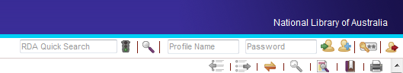

Screen image from the RDA Toolkit (www.rdatoolkit.org) used by permission of the Co-Publishers for RDA (American Library Association, Canadian Library Association, and CILIP: Chartered Institute of Library and Information Professionals)

Quick search:
The quick search box is visible on the user menu wherever you are in RDA. However it only searches RDA content.
To demonstrate:
- Search for an instruction number – Eg. 2.3.1
- Search for “Title proper”. For a phrase search like this you should put the phrase in quotation marks to get the best results.
- “Wildcard” or “truncation” symbol is *
On results screen:
- In the top of the screen you can see the total number of items found, and the number that are showing on the first page.
- In the bottom right of the screen is where you can navigate to the next page.
- Blue “core” icon comes up next to results relating to “core” elements of RDA (see explanation of “core elements” earlier in this presentation).
- Red “basic” icons indicate those rules which JSC identified as being basic to RDA cataloguing.
- Results are relevance ranked and you can change this to document order
- Click on the hyperlinked text of the result you want, (eg 2.3.1 Title proper) to go to that section of RDA.
The term you searched by will be highlighted in yellow wherever it appears. If you want to go back to your results set, click on “Return to results” – which is the magnifying glass icon that has now appeared in the Document Menu.
2 things to note:
- While the “RDA Quick Search” box is VISIBLE wherever you are in the Toolkit, it is only searching the text of RDA, not all the other parts of the Toolkit. To do this, you need to do an advanced search, which we will look at in a moment.
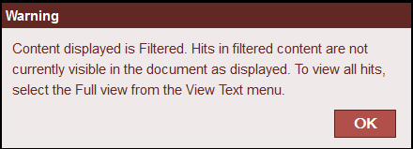
- For you search to be thorough, you will need to make sure your text view [see view text icon] is “full” (ie not “core” or “hide examples”). If your text view is less than “full”, you will get a warning message that you are only seeing a “filtered” version, and you are therefore not seeing all the results.

Advanced Search
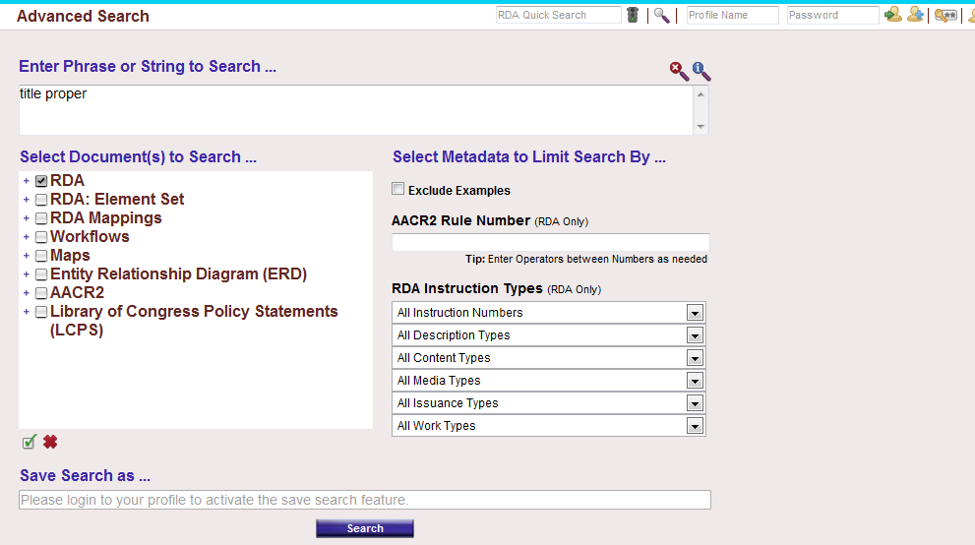
5
4
3
1
2

Screen image from the RDA Toolkit (www.rdatoolkit.org) used by permission of the Co-Publishers for RDA (American Library Association, Canadian Library Association, and CILIP: Chartered Institute of Library and Information Professionals)
- Search box
- Advanced search allows you to search the entire Toolkit, or selected parts of it. You can also limit your search by type, or exclude examples.
- Choose to include or exclude examples
- Search AACR2 rules numbers – brings up mapped RDA rules
- Drop down menus to limit by instruction types – eg music, maps, core etc – note that RDA is format neutral and limiting to types may exclude rules you need
In the Advanced search:
- Search the word “scale” (as in the scale of a map or object).
- “Select all” under “Select document(s) to search”
- Then “search” (the search button is at the bottom of the screen)
- The result set not only contains RDA instructions, but also results from AACR2 (from the Resources Tab) and the RDA Element Set View that’s in the Tools tab
- Back in the Advanced Search screen, try searching just RDA (Click the red “X” button under the “Select Documents” box to clear the tick boxes, and then select just “RDA”), and limiting the search to the “Core” instructions (choose “Core element instructions” from drop down menu under “All instruction numbers” on the right)
- Notice that this time, our results are just from RDA, and they all have the little blue “Core” icon next to them.
- Use to clear search box and reset settings if you want to start a new search.
Things to note:
- Remember that terminology is different to AACR2, so if you search RDA using AACR2 terms, you might get an unexpected result.
- Remember the structure of RDA is format neutral. Certain limiting features might not give you the results you seek.

Exercise: Searching the Toolkit
Handbook: Page 144-145
Note to presenter: may wish to do the first few as a group
- Search AACR2 rule number 5.3. What is the corresponding RDA rule number?
In Advanced search, if you know the AACR2 rule number you can search for the mapped RDA instruction using the AACR2 Rule number search box. Answer: 7.20.1.3

- How do you record the content type of a map?
In Advanced search there is an option to limit by content type. However if you limit this search to content type you will not find the answer as the instruction we want is not specific to maps. Search “content, type, maps”. Answer 6.9.1.3 Cartographic image.

- Are there any special instructions for recording titles for music material? This time we are looking for special instructions relating to music only. Search title and limit content type to music only. Answer: Yes

- In which marc field is content type recorded? Search “content type” and limit to RDA to marc mapping. Answer: 336. [Note: this search brings up results in a number of other MARC fields as well. You are looking for the result where it says “Content type” in the “MARC 21 field/subfield name” column]

- Is there an LC-PCC PS for a related work? In “Select Documents to Search” expand the LC-PCC PS. Scroll down to Related Works. Answer: 25.1
- Search “Uniform title” in the RDA Quick Search box, how many results do you get? 5 results without “ “ 3 results with “ “ . Ask for comments on the number of results; would people expect more? As we are only searching within RDA instructions the AACR2 instructions on uniform titles are not retrieved

Help, support and other resources
2
1
3

- Tells you a bit about RDA. Note “RDA Toolkit Copyright Statement” if you are writing presentations using screen images from the Toolkit
- Help documentation for the Toolkit
- Feedback on Toolkit functionality. Online service ticket system for submitting feedback regarding the Toolkit. See below for suggestions for change to RDA text.

RDA Toolkit Website
www.rdatoolkit.org
A few things about the website:
- Blog: Latest news on what is happening with RDA
- Development blog: for latest updates to the Toolkit. Updates will take place roughly monthly, and will usually consist of:
  - Changes to RDA text
  - Enhancements to the Toolkit
  - Bug fixes
- Examples from JSC
- Tutorials: Under teaching and training – video help using the Toolkit (note: this help is about using the Toolkit not cataloguing guides)
  - Presenter tools – Here are the RDA logos to use in training materials
- FAQs: Lots of useful information in here: Eg “What is the copyright policy for the toolkit” – click on the link “RDA Toolkit copyright statement”. At the bottom of this page is the wording you must use to attribute use of images from the Toolkit in your training.
- Subscriptions
RDA on Facebook and Twitter.

Proposing changes to the RDA Toolkit
Changes to RDA can be proposed through the Australian Committee on Cataloguing, who represent Australia on the JSC. Currently, the ACOC member who attends JSC meetings is Kevin Marsh from the State Library WA, but proposals can be submitted to any member of ACOC.
Information about the process and contact details are on the ACOC RDA website. Go to the ACOC website (http://www.nla.gov.au/acoc) and click on “Resource Description and Access (RDA)”, then “Proposals for revision of RDA” in the left navigation menu.
RDA users from countries not represented on JSC can submit proposals directly to the chair of JSC, (currently Barbara Tillet from the Library of Congress), whose contact details are available on the JSC website (http://www.rda-jsc.org/)

And the final word...

Get into the habit of logging out at the end of each Toolkit session.

These exercises were designed increase familiarity of the toolkit. A more detailed Toolkit demonstration is available on the ACOC Website. Written by Jenny Stephens in 2010, revised 2012 http://www.nla.gov.au/acoc/training-materials-for-resource-description-and-access

