Teaching RDA: Day One

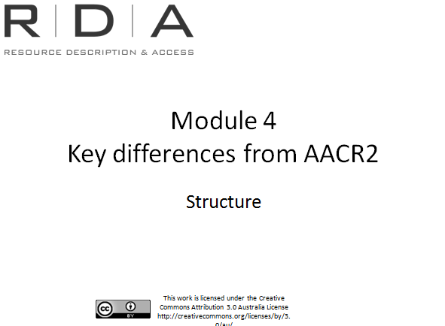
Module 4: Key differences from AACR2: Structure
[Note to presenters: From this module on, as you talk, get the participants to follow along in RDA with you]

In this module, we’re going to look at the key aspects of RDA’s structure and how it differs from AACR2.

Resources:
- RDA Toolkit
- International Cataloguing Principles (ICP)
- PowerPoint quiz (on desktop)
- Structure template

Learning outcomes
Handbook: Page 28
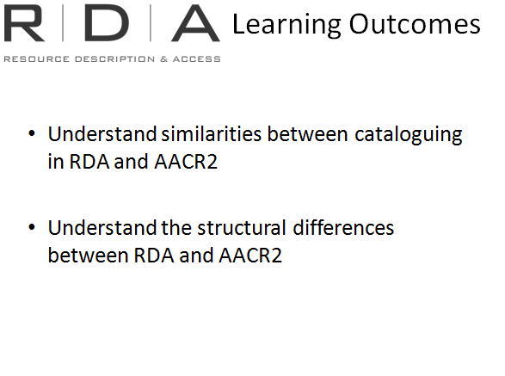
- Similarities between AACR2 and RDA
- Structural differences between AACR2 and RDA
Understanding how RDA is structured is very important when cataloguing with RDA because although the instructions themselves aren’t very different (and we will go into that in more detail tomorrow), how you find them is.

What has not changed

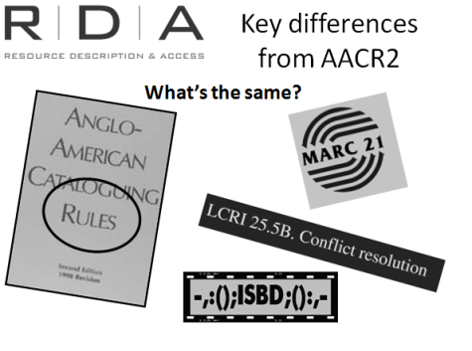
Firstly, let’s look at what HASN’T changed.
- The instructions that were in AACR2 formed the basis of the text for RDA, so you will find that MANY of them haven’t changed much. They may have been reworded to make them easier to understand, but they’re still there.
- It also includes options and alternatives, like AACR2 does, and many of these are the same, though there’s more now, and some AACR2 options have become part of the main instructions of RDA.
- There are still LC policies and interpretations, now called LC-PCC PS, and many of these won’t change either. I will talk more about policies in a moment.
- We’ll still be able to code in MARC records and use ISBD record structure that we are used to. There are some changes to MARC and ISBD, and we’ll look at them later.

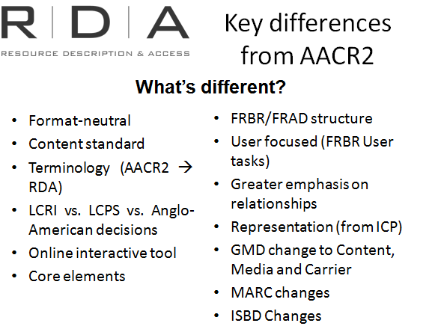
What has changed

This slide shows some of the broad differences between AACR2 and RDA.

We will look at these in more detail

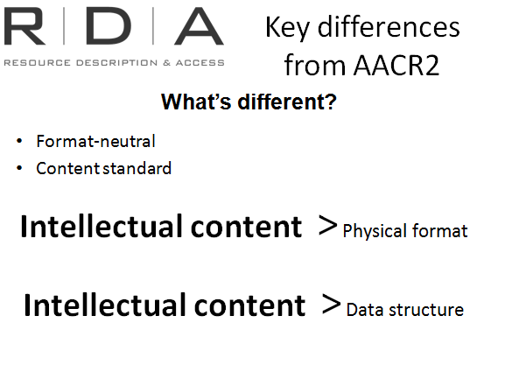
Format neutral
- RDA is not organised according to format; it gives greater emphasis to intellectual content than physical format.
- There is no one section to go to where you will find all the instructions for cataloguing a particular format of material
- RDA assumes that whatever you are describing will have a common set of content elements (title, creator) so it is arranged according to these elements.
- At each element there are basic instructions on how to record that element and then any specific instructions that may be needed for a particular type of resource
For example: 2.3.2.11 – Recording devised titles

Content standard
- AACR2 tells us what to record, how to arrange the data and structure the record. It begins with general instructions on the order of the catalogue description from ISBD and then instructions for each area (title, edition etc). It also gives guidance on conventions for indicating certain types of information such as using square brackets.

- RDA does not prescribe any of these things. Have a look at chapter 2.0 – you will see there is nothing about punctuation or order of elements. For those of us who use ISBD presentation it is included in an appendix (See appendix D).

- Even conventions of indicating cataloguer supplied information RDA only gives broad guidance and does not stipulate how the indication is to be made. Eg look at RDA 2.2.4 it doesn’t tell us that information from outside the preferred source must be enclosed in square brackets. It says “indicate that fact either by means of a note or some other means” – ie. Square brackets.

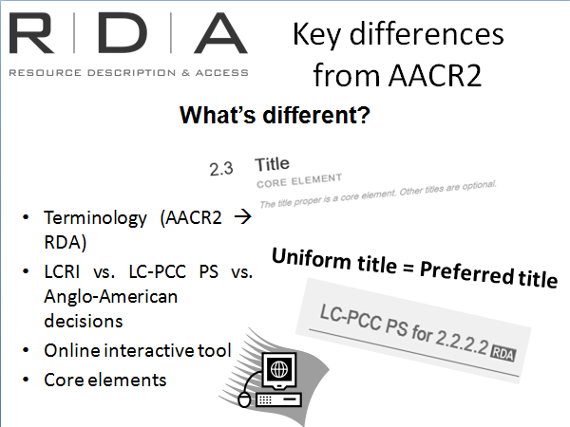

Terminology
- There is some different terminology in RDA from AACR2. Much of this comes from FRBR and FRAD models. To assist with the transition RDA has a full glossary of terms. When terms from the Glossary are used in the text of RDA there is a hyperlink to the Glossary. It’s probably a good idea to initially follow these links as a way of getting used to the terminology

  - There is a list of key terms in Appendix 2 of the workbook

- LC-PCC PS: We have already seen the LC-PCC PS have been loaded into the Toolkit

- Online interactive tool: of course RDA is designed to be an online tool. It is available in print but it is better to use online to make best use of all the features

- Core elements: With AACR2 we had three levels of description; RDA has core and non-core elements. We saw some of them in our Toolkit exercise and we will look at them a bit more now.

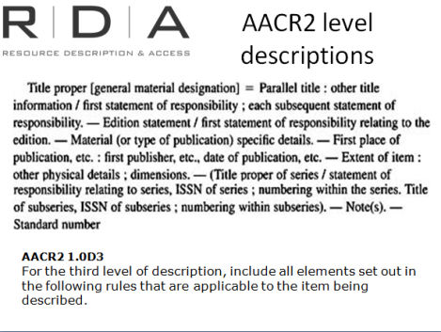
Core elements

In AACR2 we had Levels of description
The focus was on what goes in the whole record.

In RDA the focus is on data elements rather than whole catalogue records so means a change in the way we think about levels of cataloguing. RDA does not have levels of description...

...RDA has core and non-core elements.
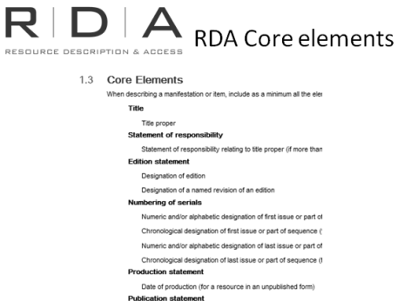
The core elements are those elements that RDA considers to be “core”, in order to fulfil the most basic of the user tasks defined in FRBR. RDA states that “as a minimum” a resource description should contain all the Core elements that are applicable to that resource or entity and readily ascertainable. Other, non-core elements can be added if they are required in particular situations to assist in performing the basic user tasks.

How do I know which elements are core:
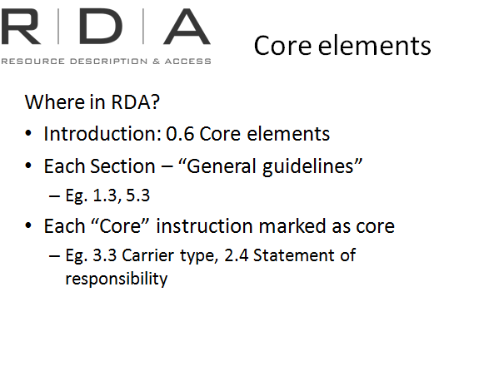
There are several places in RDA where you can find information about which elements are core.

- Firstly, core elements and their application are explained in RDA Section 0.6. Let’s go there now and have a look and some of the key things it says.

  - 0.6.1 outlines the basic FRBR user tasks that the core elements meet

  - 0.6.2 - 0.6.9 lists the core elements in each section of the Standard. [look at what some of these]

- Secondly, the “General guidelines” chapter in each Section of RDA sets out the Core or conditionally core elements for that section. Let’s have a look at the following examples in the Toolkit:

Section 1: 1.3 Core elements, and;
Section 2: 5.3 Core elements

Note that the position within the General guidelines chapters, “.3”, is the same throughout.

- And lastly, when using the instructions themselves, each element that is Core or conditionally core is marked as such. Any conditions attached to the core status are clearly outlined. Let’s have a look at some examples:

3.3 Carrier type – core element

2.4 Statement of responsibility – conditionally core.
NOTE: the term “conditionally core” does not appear in the Toolkit, it is a way of describing those core elements that are core in certain circumstances

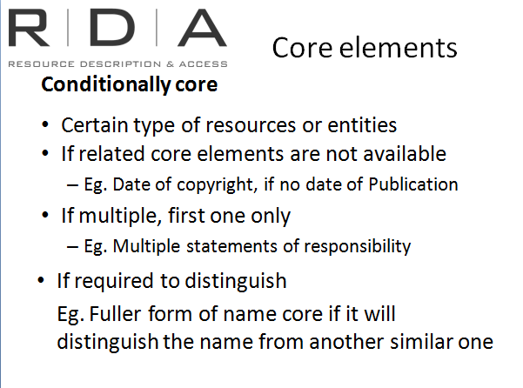
Many elements are only conditionally core. This means that they are only core in certain circumstances, such as:

- Some elements are only core for certain type of resources or entities

- Some elements are only core if other related core elements are not available (eg. Date of copyright is only core if there is no date of Publication)

- If there are multiple instances of a core element, usually only the first instance is core (eg, if there are multiple statements of responsibility)

- Some elements are only core if they are required to distinguish that resource or entity from another similar resource or entity (eg. The fuller form of a person’s name is only core if there is someone else with the same name and the fuller form is needed to distinguish them)

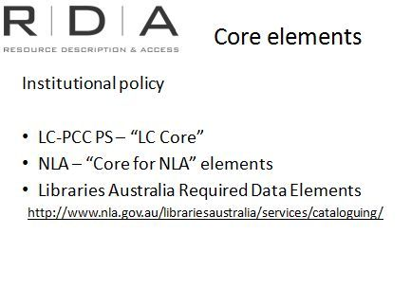
Institutional policy decisions on Core elements

- Some institutions may identify additional elements, beyond the RDA Core elements, that they consider mandatory for their cataloguers to include. The Library of Congress has already done this and they are included in the Library of Congress-Program for Cooperative Cataloguing Policy Statements we showed you during the Toolkit demonstration.

- The National Library of Australia has also selected a number of non-core elements that NLA cataloguers will be required to include. When they are finalised we will have them loaded to the Toolkit. We will also make these available on our website.
- Records contributed to Libraries Australia will be required to meet a Minimum Record Standard (required data elements) which is available in provisional form on the website linked to here, and will come into force in early 2013

[For presenters: If asked whether libraries can use less than the RDA core elements, say that it is possible but RDA discourages this, and libraries should first seriously consider the impact of doing so on their users. Also, those contributing data to Libraries Australia must adhere to the minimum standard required by them, as this is necessary for matching and merging incoming data. You may also wish to go back to the list of core elements at 0.6 and point out that there are very few core elements that aren’t conditionally core, so they don’t necessarily always have to be recorded. Some of those that don’t have a condition mentioned in 0.6, do have one listed in the instructions (eg. Date of publication is only core for published resources)

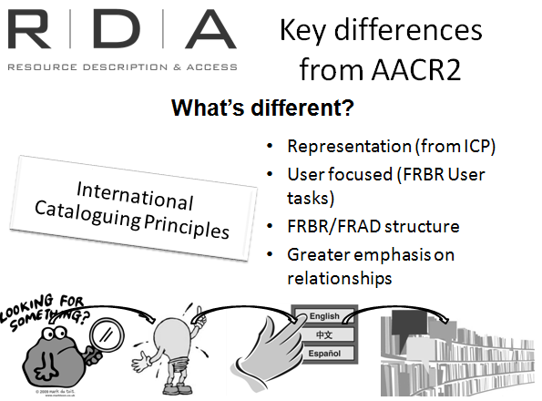
International Cataloguing Principles

We have talked a lot about the influence of FRBR and FRAD on RDA. There is another important document called the Statement of international cataloguing principles (ICP) on which RDAs key principles are founded. We won’t go into these in detail but it is important to be aware of them. The key principles are listed in Appendix 6 of the handbook.

User focused
When we talked about FRBR we looked at the user tasks – Find, identify, select, obtain – these are a recurring theme throughout RDA. Each section begins with a statement of functional objectives that relate the instructions in the section back to the FRBR and FRAD user tasks they intend to assist.

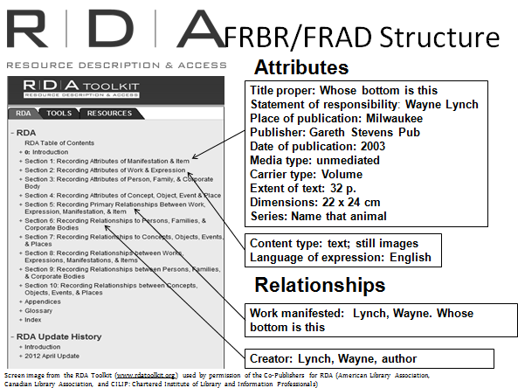
FRBR/FRAD Structure

RDA’s set of data elements have been derived from the FRBR/FRAD model, so they encompass the entities, attributes and relationships that we looked at earlier today.

They also encompass not only bibliographic resources but also all the other FRBR/FRAD entities, such as people, corporate bodies, and even subjects (though the subject part of RDA is not yet written).
This means a significant change in the way the standard is arranged. RDA still has all the instructions you need to describe a resource and give access to it, but they are arranged according to the attributes of FRBR and FRAD entities, and their relationships to each other.
The broad division of RDA is:
- Part 1: Attributes contains the instructions for recording the attributes of all of the FRBR/FRAD entities, including persons, families and corporate bodies. It is arranged according to these entities, beginning with the Group 1 Entities (Work, Expression, Manifestation and Item), then covering the Group 2 entities (Person, Family and Corporate Body). The Group 3 entity, place has also been included because the names of place are commonly used when describing other entities such as persons, corporate bodies (especially Governments) and even the titles of Works and Expressions. In the future, RDA will include instructions for “Place” as a subject, as well as the other Group Three subject entities (Concept, Object, and Event).
- Part 2: Relationships contains the instructions about recording relationships between the FRBR/FRAD entities.
It is important to become familiar with this broad division in order to find the instructions you are seeking. What we currently understand as the descriptive elements, actually encompass attributes of all four Group 1 entities. And much of what we are used to finding under “Access points” in AACR2, is actually about the attributes of Group 2 entities, rather than the relationships they represent.
Relationships are a way of identifying the resource so that machines can use the data. A person can look at the list of attributes and see this is a book by Wayne Lynch, but a machine cannot
In this case we’ve used an authorised access point to identify the work. RDA 17.8 Work manifested
This is a relationship that is only recorded in AACR2 if there are several versions of the same work or several works with the same title.
The next set of relationships are those to Group 2 entities linked to the resource. These are the basic “access points” of AACR2. In this example we just have the one between the author and the resource. RDA 19.2 recording creators
Appendix 4 of the workbook contains a table titled “Where is it in RDA” which is adapted of Training Document #2 of the documentation developed by LC for the US RDA test. This table is designed to help you with this orientation

Greater emphasis on relationships

AACR2’s second part, providing “access points”, is about recording relationships. But it just records that a relationship exists rather than the nature of that relationship.

MARC went a little further by providing subfields you can add to the access point containing either a term or code describing the nature of the relationship. For example NLA oral history cataloguers use relationship codes in access points to indicate which access point belongs to the interviewer and which to the interviewee.

RDA places strong emphasis on relationships because they are a key part of the FRBR/FRAD models.

- RDA defines the types of relationships more clearly than AACR2 to enable our users and computers to better understand and retrieve information about these relationships.

- As well as better defining and expanding the types of relationships that can be recorded, RDA makes provision for, and encourages, the use of “relationships designators”. These are controlled vocabulary terms that can be added to an access point in a bibliographic record to indicate the nature of the relationship between the entity in the access point, and the entity it is attached to.

- Appendix I, J, K, and L list and explain these designators. Again, they have been divided up according to the various Group 1 entities and types of relationships mentioned above.

RDA Section | What’s in it
1 – Recording attributes of manifestations and items | - Instructions on recording the bibliographic description of manifestations and items – eg title, publisher, date of publications etc.
2 - Recording Attributes of Work & Expression | - Instructions for recording preferred titles (uniform titles) – eg title of the work (note this is different to recording the title of a manifestation)  - Instructions on recording expression elements of the item being catalogued – eg how the work is expressed, language etc.
3 - Recording Attributes of Person, Family, & Corporate Body | - Data elements that are recorded in name authority records  - Constructing access points for persons, families and corporate bodies  NOTE: This is not about constructing access points
4 - Recording Attributes of Concept, Object, Event & Place | - Data elements that are recorded in subject authority records – Not yet written
5 - Recording Primary Relationships Between Work, Expression, Manifestation, & Item | - Broadly about making links between work, expression, manifestation and item by using identifiers, authorised access points and composite descriptions
6 - Recording Relationships to Persons, Families, & Corporate Bodies | - Choice of access points for persons, families and corporate bodies  - Relationships established through ‘relationship designators’
7 - Recording Relationships to Concepts, Objects, Events, & Places | - Not yet written  - Choice of subjects
8 - Recording Relationships between Works, Expressions, Manifestations, & Items | - Relationships between work to work ; expression to express etc. by using identifiers, access points and descriptions
9 - Recording Relationships between Persons, Families, & Corporate Bodies | - Instructions for recording information about pseudonyms, former and later names and variant names
10 - Recording Relationships between Concepts, Objects, Events, & Places | - Not yet written

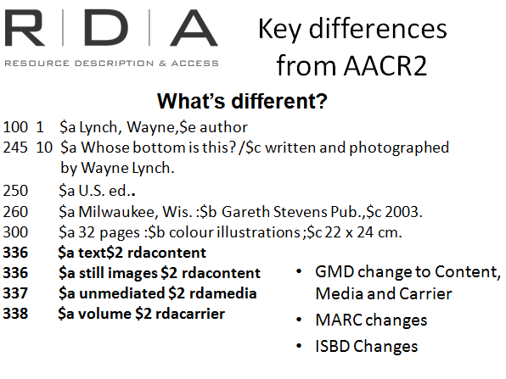
Marc and ISBD changes
- Although RDA is compatible with MARC and ISBD it is independent of these. This means RDA’s element structure is designed so that data can be encoded in other formats. The advantage of this
  - Changing or replacing marc with not require changes to RDA
  - Non-library communities can potentially use RDA to describe their resources

GMD change
- We will no longer use the AACR2 GMD terms. There are three new elements instead – Content, Media and Carrier. We will look at them more in the next module

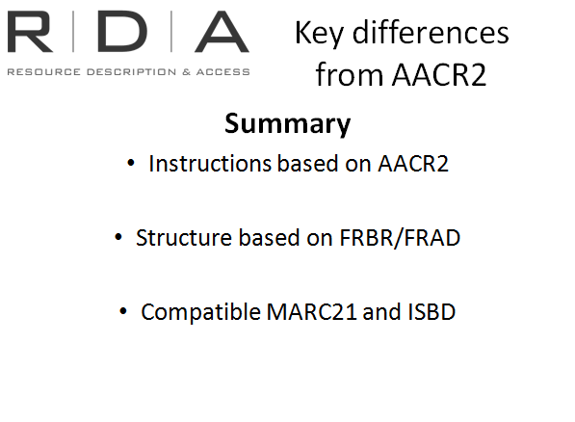
Summary
Differences from AACR2: Structure

Quiz
Handbook: Page 146
These questions can be asked as a group exercise or can be answered individually as a Powerpoint quiz

- The instructions in AACR2 form the basis for the instructions in RDA
  - True
  - False

Although the structure has changed significantly many of the instructions have not changed much. They may be reworded to make them easier to understand

- AACR2 is structured on FRBR/FRAD
  - True
  - False

AACR2 is arranged according to ISBD elements and a set of resource formats. RDA is structured on the FRBR and FRAD models.

- RDA is format neutral, this means...
  - Instructions are laid out by format
  - Format is not considered at all
  - Instructions give more emphasis to intellectual content than physical format

RDA sees bibliographic data as a set of elements that provide information about a resource. Format is one of those elements rather than the thing that defines the whole structure of the record. There is no one single section to go to in RDA where you will find all the instructions for cataloguing a particular format or material. It assumes that whatever you are describing will have a common set of content elements, such as title, creator, date etc. so it is arranged according to these elements

- RDA is user focused. This means…
  - AACR2 was not user focused
  - RDA is based on FRBR and FRAD user tasks
  - The user creates the catalogue record

It does not mean AACR2 was not user focused. Being designed for a card catalogue meant there were certain limitations to what could fit on the cards and how they were arranged in the drawer. Each section of RDA begins with a statement of functional objectives that relate the instructions in each section back to the FRBR and FRAD user tasks they intend to assist

- LCRIs and other institutional policies are not needed with RDA
  - True
  - False

There will still be LC policies and interpretations; these are now called LC-PCC PS (Library of Congress and Program for Cooperative Cataloguing Policy Statements) and all libraries may develop their own internal policies as before

- MARC21 will become obsolete when we start using RDA
  - True
  - False

Many librarians will still catalogue using MARC coding. There will be some changes to MARC to accommodate new elements

- Sections 1-4 of RDA deals with
  - General rules for description
  - Recording attributes
  - Subjects of works

Contains the instructions for recording the attributes of all of the FRBR/FRAD entities. It is arranged according to these entities, beginning with the Group 1 Entities (Work, Expression, Manifestation and Item), and then covering the Group 2 entities (Person, Family and Corporate Body). The Group 3 entity, place has also been included because the names of place are commonly used when describing other entities such as persons, corporate bodies (especially Governments) and even the titles of Works and Expressions. In the future, RDA will include instructions for the Group Three subject entities (Place, Concept, Object, and Event)

- In RDA, GMD is recorded
  - the same way as in AACR2
  - With new terminology and in new marc fields
  - In new fields but with the same terminology used in AACR2

What we are used to calling the GMD is replaced with content type, media type and carrier. These will be recorded in the marc 336, 337 and 338 fields respectively. This is an example of how RDA is format-neutral – format is more diverse and fluid that a format-based structure can address. Content and carrier are core elements

- RDA is a content standard, this means
  - It emphasises what should be recorded but not how
  - It is independent of encoding schemes such as ISBD and marc
  - data created cannot be adapted and shared across different systems

There are no instructions on the order or display of information.

It is compatible with schemes such as ISBD and marc but is designed to work independently of these so it can be applied to whatever conventions or encoding standards you use. This opens up RDA to be used by other content management industries such as archives and museums

- Each section of RDA begins with a statement of the functional objectives of the FRBR and FRAD user tasks
  - True
  - False

This is an example of how RDA has been developed with the user in mind. Each section begins with a statement of functional objectives that relate the instructions in the section back to the user tasks they are intended to assist

- Data created in RDA will no longer be abbreviated because
  - Data was less important in AACR2
  - We are no longer constrained by limitations of card catalogues
  - Users don’t understand abbreviations

AACR2 was designed for card catalogues with limitations on how much data could fit on them. Our OPACs no longer have these constrains and this is reflected in RDA. Abbreviations, omissions and restrictions to access points are not applied in RDA

- Terminology in RDA is
  - The same as in AACR2
  - Based on FRBR and FRAD models
  - Unique terms developed specifically for RDA
There will be different terminology in RDA to what most cataloguers are used to. Much of this comes from the FRBR/FRAD models, so being familiar with these will be a great help in understanding RDA Terminology.
To assist with the transition, RDA contains a full glossary of terms. In the online version of the Toolkit, as we saw in the demonstration, when terms from the Glossary are used in the text of RDA, there is a hyperlink to the Glossary. Initially, we recommend that cataloguers always follow these links, as a way of helping get used to the terminology.
Additionally, each section of RDA contains a “general guidelines” chapter, which among other things, will set out and clearly define key terminology used in that section.

When standards such as marc are changed, or even replaced in the future, we will not need to change our cataloguing standard

- Where are the instructions for Core elements?
  - In the introduction at 0.6
  - In the General Guidelines chapter at the beginning of each section
  - At the beginning of each instruction
  - All of the above
Instructions about core elements can be found in all these places – so D is the best answer

- RDA is independent from schemes such as marc and ISBD, this means
  - RDA is incompatible with marc and ISBD
  - Data created can only be used in the library environment
  - Future changes to encoding standards will not require changes to RDA

