# Day One

## Module 5 Key differences from AACR2: Recording data

Handbook: Page 33

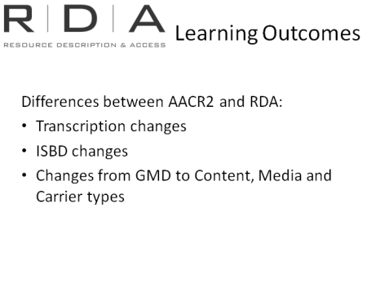In this module, we’re going to continue to look at the key areas in which RDA differs from AACR2. As well as outlining them here, we will also refer back to them as we look tomorrow at cataloguing with RDA.

-Transcription changes

-ISBD changes

-Content, media and carrier types

### Resources:

* RDA Toolkit
* Examples for demonstration
* International Cataloguing Principles (ICP)

### Changes to the way we record and transcribe descriptive information

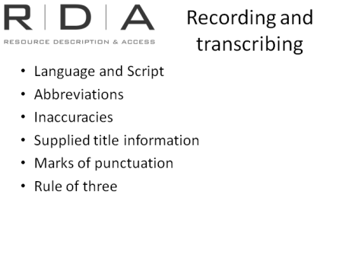

A number of changes to the way we record information in key elements have come out of IFLA’s *Statement of International Cataloguing Principles (ICP).* They are the key guiding principles upon which RDA is founded. They stipulate that decisions in making descriptions should be done with the user in mind and include: convenience to the user, representation, common usage, accuracy, consistency and standardisation, sufficiency and necessity.

We are now going to look at some examples that highlight some of these changes.

These are from Adam Schiff’s (University of Washington) detailed set of examples outlining the changes. [A link to his document is in the back of your workbook].

**A couple of points before we start:**

#### Language and script

In the introduction at 0.11 “Internationalisation” there is a section on language and script (0.11.2):

Transcribed elements should be in the language and script in which they appear on the source from which they are taken. In AACR2 we transliterate everything that is not in a Roman script. In RDA allowance is made for the transliteration if the original script cannot be used but preference is on using the original script.

With non-transcribed elements RDA instructs the use of the language and script appropriate to the cataloguing agency.

There will still be some elements that specify the use of an English-language term. Such as the controlled lists of English language terms in content, media and carrier types. However, even here agencies creating data for use in a different language or script context may modify such instructions to reflect their own language or script preferences. Any authorised translations of RDA will do this.

Language and script instructions appear in the “general guidelines” chapter of each section of RDA as well as certain individual instructions. Keep your eye out for these as what language and script you use will depend on the type of information you are recording.

#### MARC21 and non-Latin scripts

If you catalogue in MARC you should be aware that the current contention in MARC is that the key fields of the MARC record should still appear in Romanised form with any script information recorded in parallel 880 fields.

#### Abbreviations

Handbook: Page 34

|  |  |
| --- | --- |
|  | A key aim of RDA is to reduce use of abbreviations.  When transcribing data, abbreviations should only be included in catalogue data when and *as* they appear in the source the data is being transcribed from. When recording data, abbreviations should generally be avoided.  In these edition statements edition terms are transcribed **as they are** on the resource. If they are abbreviated on the resource, as in the last example, then they are abbreviated in the catalogue data, but if they are spelled out on the resource, they will not be abbreviated as they would have been in AACR2. |
|  | Punctuation Note the last example on the slide and the two full stops; This is an ISBD change.  The revised ISBD fixed up a small inconsistency that had crept into ISBD with regard to the full stops that separated elements. It is basically that full stops which separate elements **should always be recorded,** regardless of any ending punctuation in the data contained in the previous element.  Previously ISBD contained an instruction that if the data in an element ended with a full stop or mark of omission, the full stop that preceded the next element could be omitted. But this was in contradiction with the overall principle that punctuation between elements should always be included, even if it results in double punctuation. In reality of course, most of our systems are providing the element separation (eg through means of a delimiter) so we will generally not see these double full stops. |
|  | Publication area:  In AACR2 we could abbreviate any words found in appendix B. In RDA we transcribe place of publication and name of publisher as found on the item.  State and country names and the word “Department” will now be spelt out if spelt out in full on the item.  The “Department” example applies in corporate body access points as well |
|  | Latin abbreviations that were used in AACR2 to indicate incorrect, omitted, or missing data, were seen to be largely meaningless to most people, so these have been eliminated where possible.  [Note 2.4.1.4: Statements of responsibility are also fully transcribed. Terms of address (Mrs, Dr.) are recorded if on the source; optional omission if this can be abridged without loss of essential information] |
|  | Abbreviations indicating missing or omitted data have now been replaced by natural language phrases.  “S.l.” becomes “place of publication not identified”  “s.n.” becomes “publisher not identified”  **NOTE:** There is an equivalent for dates – “date of publication not identified” - which can be used in rare cases when no date can be found on the item or ascertained from elsewhere. However, RDA considers date to be a key piece of data, and strongly encourages that a date be recorded, wherever possible, even if you have to give estimation. An estimated date, even if it is date range, is better than no date at all. |
|  | Note use of square brackets in the bottom two examples. This is an ISBD change  Previously, if adjacent elements had data that was enclosed in square brackets, a single set of square brackets was used to encompass all the elements.  ISBD now requires that **each** element be enclosed in its own set of square brackets. This acknowledges that in the online world, catalogue data no longer necessarily travels as a whole unit, but that individual elements can be taken and used in different contexts. |
|  | In Bible Headings, O.T and N.T. are now spelt out.  Testament is only included in the heading when the resource is the **WHOLE** of the stipulated Testament.  Individual books are recorded directly under “Bible” rather than as a subset of one of the Testaments.  This change will require authority work in our databases |
|  | We also no longer use Latin abbreviations to indicate typographical errors on title pages.  In order to represent a resource as it represents itself, RDA instructs us to leave inaccuracies in titles *as they appear* and correct them using a variant title entry. This is instead of using the Latin abbreviation “Sic” or “i.e”.  The exception to this is for Serials, where the inaccuracy is corrected, presumably because the typographical error is unlikely to be present on all issues. However, as is the case with AACR2, the Latin abbreviations are not used, the error is simply corrected, and if considered important, the incorrect spelling can be given in a note. 2.3.1.4 – under exceptions |
|  | When recording data in elements that are transcribed, such as the title element RDA discourages adding additional information that is NOT present anywhere on the resource and has therefore been supplied by the cataloguer.  Of course, if you are cataloguing something that doesn’t have a title at all, like a picture, RDA still has instructions for devising titles. |
|  | In AACR2, if the punctuation marks “...” or “[ ]” appeared in the title of a resource, they had to be changed to “—“ and “( )” so that they weren’t confused with ISBD punctuation.  Because RDA does not assume the use of ISBD, it now asks us to transcribe these *as they appear on the item* without changing them.  [Note: 2.3.1.4 – for long titles there is an optional omission which allows “...” to be used as a mark of omission. Never omit the first five words] |
| **C:\Users\rgibbs\AppData\Local\Microsoft\Windows\Temporary Internet Files\Content.Word\~MyBitmap.bmp** | The provisions for parallel titles have changed a bit. They are a non-core element now, so you are not required to record them. However, if you do record them, you would record all of them, instead of the specified number prescribed by AACR2 (depending on which level you were cataloguing at).  Also, the source of information for parallel titles has now been expanded to include the whole resource, not just the preferred source.  This is an example which illustrates how this would look in a MARC record. |
| **Rule of three** | AACR2 cataloguers will be familiar with the “Rule of three” instructions, which was an arbitrary cut-off set by AACR2 when recording information about resources with large numbers of people and corporate bodies responsible for its creation. RDA essentially removes this arbitrary cut-off and instead all people, families or corporate bodies listed in the resource as having a relationship to it can and in many cases should be listed in statements of responsibility and given access to in access points.  This is of course a simplistic explanation of how “rule of three” has changed, and it certainly doesn’t mean you are *required* to record all of them |
|  | if you choose to follow the optional omission (remembering that we don’t use Latin abbreviations any more)  Abbreviations indicating missing or omitted data have now been replaced by natural language phrases. Eg.  “et al...” becomes “and others” or “and 3 (or 4, ... etc) others” |
| C:\Users\rgibbs\AppData\Local\Microsoft\Windows\Temporary Internet Files\Content.Word\~MyBitmap.bmp | What does this mean in reality. Let’s look at an example.  There are more than 3 authors, but “et al” is gone now, replaced by “and three others”. This applies the optional omission at 2.4.1.5, which allows you to omit all but the first. However, in following the main instruction you would include all the authors.  There are some abbreviations that can be spelt out  250 – This phrase is spelt out in the item, so it is *not* abbreviated in the record.  260– State of publication and spelt out in full.  300 – 698 p. Becomes 698 *pages.* However cm stays as cm – it’s *not* an abbreviation but a metric symbol see RDA 3.5.1.4  [we are going to look at the 336-338 fields next] |

### Exercise 5: Transcription changes

Handbook: Page 148-151

Using the surrogate information for resources choose the correct form of transcription. Refer to the examples from the Adam Schiff and the RDA instructions.

The correct answers are highlighted in red.

**1. Book**

**Title page Title page verso**

IP Communications

East Hawthorn, Vic.

2010

ISBN 9780980458695 (pbk.)

Infectious Diseases:

A clinical approach

Third edition

Edited by:

Allen Yung

Denis Spelman

Alan Street

Joe McCormack

Tania Sorrell

Paul Johnson

IP Communications

Melbourne

Other information: xxix, 698 pages ; contains illustrations ; height 26 cm.

***245 field (Title and statement of responsibility)***

245 00 $a Infectious diseases : $b a clinical approach / $c edited by Allen Yung ... [et al.].

245 10 $a Infectious diseases :$b a clinical approach/ $c edited by Allen Yung, Denis

Spelman, Alan Street, Joe McCormack, Tania Sorrell, Paul Johnson.

245 $a Infectious diseases ... / $c editors: Allen Yung [and others].

***250 field (Edition)***

250 ## $a 3rd edition.

250 ## $a Third ed..

250 ## $a Third edition.

***260 field (Publication, distribution)***

260 ## $a East Hawthorn, Vic. :$b IP Communications, $c 2010.

260 ## $a East Hawthorn, Victoria :$b I.P. Communications, $c 2010.

260 ## $a East Hawthorn, Melbourne $b IP Comms., $c 2010.

**2. Notated music**

**Front cover**

Though I travel far...

I do not forget

by

Betty Beath

Publications by Wirripang

2008

© 2005

Other information:

Publications by Wirripang are located in Wollongong

*245 field (Title and statement of responsibility)*

245 10 $a Though I travel far – I do not forget $h[music] /$c by Betty Beath.

245 10 $a Though I travel far... I do not forget /$c by Betty Beath.

***260 field (publication, distribution)***

260 ## $a [Wollongong] :$bPublications by Wirripang,$c 2008,©2005

260 ## $a [Wollongong] :$bWirripang, 2008.

*Note: RDA does not prescribe use of square brackets; rather it says to indicate that the information was taken from outside the resource and uses square brackets as an example.

**3. Book**

Title page

##### I wood send you my hart if I could

##### a family story told in letters

##### Colleen Arulappu

East Keilor, Victoria

2006

*245 field (Title and statement of responsibility)*

245 10 $a I wood [sic] send you my hart [sic] if I could :$b a family story told in letters /$c Colleen Arulappu.

245 10 $a I wood send you my hart if I could :$b a family story told in letters /$c Colleen Arulappu.

***260 field (publication, distribution)***

260 ## $a East Keilor, Victoria :$b Colleen Arulappu, $c 2006.

260 ## $a East Keilor, Vic. :$b Colleen Arulappu,$c2006.

**4. Poster**

Advertisement for Little Birdy shows in Cannington and Perth, supported by The Bank Holidays and The Panda Band. Features black silhouette of the band against a red backdrop.

Little Birdie



2010 Tour

***245 field***

245 00 $a Little birdie [picture].

245 00$a Little Birdie.

245 00$a Little Birdie :$b[advertisement for Little Birdy shows supported by The Bank Holidays and The Panda Band].

***260 field***

260 00 $a [Western Australia? :$b s.n.,$c 2010?]

260 00 $a [W.A. :$b publisher unknown, $c2010?]

260 00 $a [Western Australia?] :$b [publisher not identified], $c [2010?]

For a while we will have a hybrid catalogue environment. There will still be lots of AACR2 and RDA records in our databases. We need a way of identifying RDA records.

For this reason subfield $e in the 040 field has been made repeatable and “rda” has been added as a code for use in this field. Therefore all RDA records should contain the **$erda.**

For an example go to: the following record in Libraries Australia:

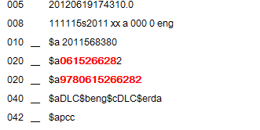

The use of AACR2 is currently indicated in the leader position 00/18, this should not be sued if you are cataloguing using RDA. Instead the leader 00/18 will be used to indicate the presence or absence of ISBD punctuation at subfield boundaries

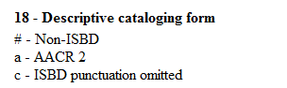

MARC standards

*[If anyone asks why Leader 00/18 was not used to indicate the use of RDA: Although the use of AACR2 is currently indicated here it was decided by the MARC community that the 040 was the preferred location for the RDA coding]*

### Where to find more examples

* Library of Congress Test Records

<http://www.loc.gov/catdir/cpso/RDAtest/rdatestrecords.html>

* North Carolina State University

<https://staff.lib.ncsu.edu/confluence/display/MNC/RDA>

* RDA Toolkit

<http://www.rdatoolkit.org/examples/MARC>

**Where to find more examples**

These records were collated as part of testing; we have not made any attempt to confirm that the records actually conform to RDA or that the marc structure is valid [where appropriate]. The best source for information about RDA instructions is RDA itself. Be cautious about forming conclusions about RDA provisions based solely on these test records

There is a link to these in Appendix 1 of the handbook

### Content Type, Media Type, Carrier Type to replace GMD

Handbook: Page 41

#### C:\Users\rgibbs\AppData\Local\Microsoft\Windows\Temporary Internet Files\Content.Word\~MyBitmap.bmpWhat are the new elements that replace GMD?

The three new elements in RDA for Content, Media and Carrier allow cataloguers to provide consistent and searchable information about all the content, physical and technical characteristics of a resource, using controlled vocabulary lists. Each element can also be recorded more than once, for resources encompassing multiple content, media and carrier types.

#### Why are we making this change?

Look at the examples on the slide: What is the GMD for these three materials. Why is GMD insufficient?

* Can only record one term - how the content is *expressed* (map), or the physical characteristics of the *manifestation* (Electronic). In some cases it would be necessary to be able to record both
* Out of date (DVD or website are not options)
* Inconsistent – Some of the terms describe the type of **content** (that is, how the work is expressed), like music or cartographic content, while others describe the **Carrier** type (that is, the physical characteristics of the resource), like filmstrip and slide. Still others were about the **media** required to view/access the resource, like microform.

For these reasons RDA catalogue records will not include the GMD. Content, media and carrier information will be recorded using a combination of three new 300 fields and the coded data that is already available in the 007 and 008. There may also be further changes to the fixed fields in the future to better accommodate content, media and carrier information.

Although the GMD subfield in the 245 will no longer be used, it will remain valid in MARC for the time being.

**Content, media and carrier**

Content type – RDA 6.9

Media type – RDA 3.2

Carrier type – RDA 3.3

#### Content type

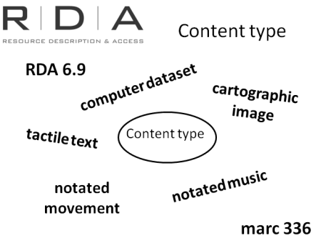

Content type is the form of communication in which the content of the resource is expressed and the human sense through which it is intended to be perceived.

Where – RDA 6.9

Recorded in Marc field – 336 (repeatable)

It is a core element

The instruction at 6.9 allows you to use as many terms as appropriate for the resource.

The alternative instruction allows you just to record the predominant content type.

National Library Policy - do not to apply the alternative.

**Group exercise**

[note to presenter: you may have at hand a number of items to demonstrate this exercise]

Use the list of terms at 6.9 and find the content type for various material types; suggestions below:

**Material Content type/s**

* book containing text and pictures text; still image
* Digital photograph still image
* sheet music; includes pictures notated music; still image
* globe cartographic three-dimensional form
* audio book spoken word
* The RDA Toolkit text

#### Media type

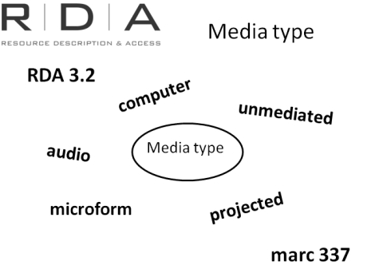

Media type is a category of the general type of device required to view, play, run, etc., the content of a resource.

Where – RDA 3.2

Recorded in Marc field – 337 (repeatable)

It is *not* a core element – however will be mandatory for NLA

The instruction at 3.2 allows you to use as many terms as appropriate for the resource.

The alternative instruction allows you just to record the predominant content type.

National Library Policy - do not to apply the alternative.

**Group exercise**

[note to presenter: you may have at hand a number of items to demonstrate this exercise]

Use the list of terms at 3.2 and find the media type for various material types; suggestions as previous exercise:

|  |  |  |
| --- | --- | --- |
| **Material** | **Content type/s** | **Media type** |
| Book containing text and pictures | text; still image | unmediated |
| Digital photograph | still image | computer |
| Sheet music with pictures | notated music; still image | unmediated |
| Globe | Cartographic three-dimensional form | unmediated |
| Audio book | Spoken word | audio |
| The RDA Toolkit | text | Computer |

#### C:\Users\rgibbs\AppData\Local\Microsoft\Windows\Temporary Internet Files\Content.Word\~MyBitmap.bmpCarrier type

[Carrier type](http://access.rdatoolkit.org/document.php?id=rdagloss&target=rdagloss-130#rdagloss-130) is a category reflecting the format of the storage medium and housing of a carrier in combination with the type of intermediation device required to view, play, run, etc., the content of a resource.

Where – RDA 3.3

Recorded in Marc field – 338 (repeatable)

It is a core element

The instruction at 3.3 allows you to use as many terms as appropriate for the resource.

The alternative instruction allows you just to record the predominant content type.

National Library Policy - do not to apply the alternative.

**Group exercise:** [note to presenter: you may have at hand a number of items to demonstrate this exercise]

Use the list of terms at 3.3 and find the media type for various material types; suggestions as previous exercise:

|  |  |  |  |
| --- | --- | --- | --- |
| **Material** | **Content type/s** | **Media type** | **Carrier type** |
| Book containing text and pictures | text; still image | unmediated | volume |
| Digital photograph | still image | computer | [computer carrier as appropriate] |
| Sheet music with pictures | notated music; still image | unmediated | volume |
| Globe | Cartographic three-dimensional form | unmediated | object |
| Audio book | Spoken word | audio | [audio carrier as appropriate] |
| The RDA Toolkit | text | Computer | online resource |

### Content, media and carrier: Exercise 6

Handbook: Page 152-159

Add the content, media and carrier types to the following records.

The records below are the existing **AACR2 records** with space provided for content, media and carrier.

[Note to presenter – do the first one as a group]

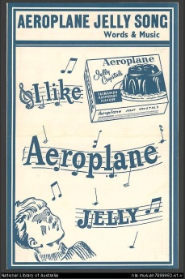1. Hard copy sheet music item.

Link to AACR2 catalogue record <http://nla.gov.au/nla.cat-vn263241>

100 1 $aLenertz, Albert Francis,$d1891-1943.

245 1 0 $aAeroplane jelly song$h[music].

260 $a[West Ryde, N.S.W.? :$bAeroplane Jelly Co.?,$c193-?]

300 $a1 score ([4] p.) ;$c24 cm.

336 $a notated music $2rdacontent

337 $a unmediated $2rdamedia

338 $a volume (or sheet) $2rdacarrier

500 $aFor voice and piano.

500 $aCaption title.

650 0 $aAeroplane jelly.

650 0 $aJelly$xSongs and music.

710 2 $aAeroplane Jelly Company.

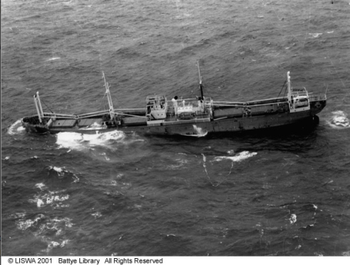2. Hard copy photograph print.

Link to AACR2 catalogue record [http://innopac.slwa.wa.gov.au/record=b2038940#](http://innopac.slwa.wa.gov.au/record=b2038940)

245 00 $aStanford on the rocks at Geraldton, 1936$h[picture].

260 __ $c1936.

300 __ $a1 photoprint :$bb&w ;$c17 x 22 cm.

336 $a still image $2rdacontent

337 $a unmediated $2rdamedia

338 $a sheet (or card) $2rdacarrier

500 __ $aTitled taken from reverse of image.

500 __ $aAerial view of ship.

540 __ $aThis image is for personal use only. To publish or display it, contact the State Library of Western Australia.

610 20 $aStanford (Steamship)

650 _0 $aShipwrecks$zWestern Australia$zGeraldton$vPhotographs.

3. Hard copy printed map

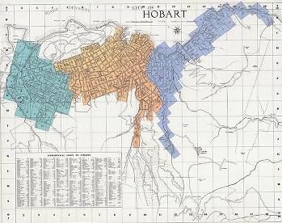Link to AACR2 catalogue record <http://catalogue.statelibrary.tas.gov.au/item/?id=553788>

**Title**: Hobart plans / Hobart City Council Metropolitan Drainage Board

**Creator**: Metropolitan Drainage Board (Hobart, Tas.)

**Map data**: Scale 44 ft. to 1 in

**Publisher**: Hobart, Tas. : John Vail, Govt. Printer, 1905-1947

**Description**: 2 sets.

**Content :** cartographic image

**Media**: unmediated

**Carrier** sheet

**Format**: [cartographic material] / Map

**Notes**: Sets consist of original plans and photocopies held by the Hobart City Council.

Maps double spread.

Key map held in Reading Room identifying area covered by each plan.

In some instances the photocopied plans have been updated to c.1947.

**Contents**: Key map and index -- Battery Point (33-39, 41) -- Dynnyrne (71) -- Glebe (10, 11) -- Hobart (12, 13, 42, 51) -- Hobart City Centre (3-9, 14-16, 31, 43-45, 48) -- Mount Stuart (63) -- North Hobart (17-27, 29, 58, 59, 65) -- Sandy Bay (40, 70) -- South Hobart (49, 52, 73) -- Sullivans Cove (32) -- West Hobart (53-57, 60, 61, 66)

**Subjects**: Real property - Tasmania - Hobart - Maps

Drainage, House - Tasmania - Hobart - Maps

Hobart (Tas.) - Maps - 1905-1910

**Alternate title**: Metropolitan Drainage Board plans

Metropolitan Drainage Board maps

**Other creators**: Hobart (Tas.). Council

[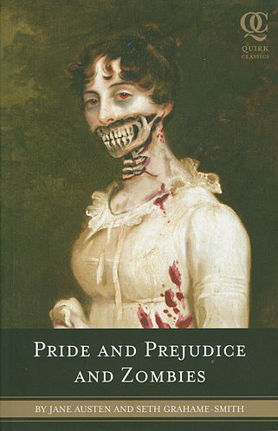](http://upload.wikimedia.org/wikipedia/en/f/f0/PrideandPrejudiceandZombiesCover.jpg)4. Audio book on CD

Link to AACR2 catalogue record <http://trove.nla.gov.au/work/38422703>

020 __ $a9781441816771

040 __ $aVALP$beng$cVALP

042 __ $aanuc

082 04 $a813/.6$222

100 1_ $aGrahame-Smith, Seth.

245 10 $aPride and prejudice and zombies$h[sound recording] /$cby Jane Austen and Seth Grahame-Smith ; read by Katherine Kellgren.

250 __ $aLibrary ed.

260 __ $aGrand Haven, MI :$bBrilliance Audio,$c2009.

300 __ $a9 sound discs (CD) (ca. 11 hr., 4 min.) :$bdigital, stereo ;$c4 ¾ in. ; in container.

336 # # $a spoken word $2 rdacontent

337 # # $a audio $2 rdamedia

338 # # $a audio disc $2 rdacarrier

500 __ $aUnabridged.

511 0_ $aRead by Katherine Kellgren.

650 _0 $aTalking books.

650 _0 $aBennet, Elizabeth (Fictitious character)$vFiction.

650 _0 $aDarcy, Fitzwilliam (Fictitious character)$vFiction.

650 _0 $aZombies$vFiction.

650 _0 $aParodies.

651 _0 $aEngland$vFiction.

700 1_ $aAusten, Jane,$d1775-1817.$tPride and prejudice.

700 1_ $aKellgren, Katherine.

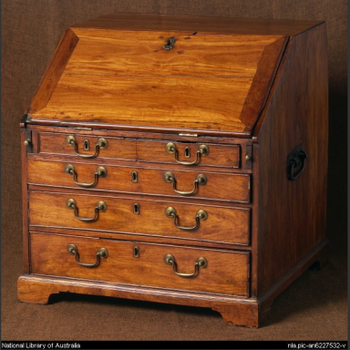5. Captain Cook’s writing desk (physical object)

Link to AACR2 catalogue record <http://nla.gov.au/nla.cat-vn643495>

040 $aANL$beng$cANL$dANL

245 0 0 $a Mahogany fall-front bureau believed to have been used by Captain Cook on his Pacific voyages $h[realia].

246 1 $aCaptain Cook's desk

260 $c[ca. 1765]

300 $a1 desk :$bmahogany, Brazilian rosewood ;$c60.9 x 56.4 x 54.8 cm.

336 # #$a three-dimentional form $2 rdacontent

337# # $a unmediated $2 rdamedia

338# # $a object $2 rdacarrier

500 $aFile P21/5/963; presented by the directors of Angus & Robertson, February 1970.

500 $aAlso known as: Captain Cook's desk.

510 4 $aRoyal Naval Exhibition 1891 : official catalogue$cItem 2954

530 $aAlso available in an electronic version via the Internet at: http://nla.gov.au/nla.pic-an6227532

585 $aExhibited: "Treasures Gallery", National Library of Australia, 7 October 2011 - 15 December 2012.$5AuCNL

600 1 0 $aCook, James,$d1728-1779$xRelics.

650 0 $aWriting desks$zGreat Britain.

900 $aExhibited: Changing coastlines, NLA 1993-1994, ANMM Sydney, 1994, W.A. Museum, 1994.

900 $aRoyal Naval Exhibition 1891 : official catalogue held: YY 359.00941 R888.

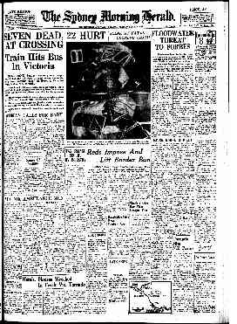6. Sydney Morning Herald newspaper – copy on *microform*

Link to AACR2 catalogue record <http://nla.gov.au/nla.cat-vn128996>

022 $a0312-6315

040 $aANL-S$beng$cANL-S$dAAWM$dANL

042 $aanuc

043 $au-at-ne

082 0 4 $a079.944$222

245 0 4 $aThe Sydney morning herald$h[microform].

260 $aSydney :$bCharles Kemp and John Fairfax,$c1842-

300 $av. ;$c59 cm.

336 # #$a text $2 rdacontent

336 # # $a still image $2 rdacontent

337# #$a microform $2 rdamedia

338# #$a microform reel $2 rdacarrier

362 0 $aVol. 14, no. 1623 (Monday, Aug. 1, 1842)-

500 $aMicroreproduction. Originally published daily: Sydney : Charles Kemp and John Fairfax.

500 $aOriginal publisher varies.

500 $aFrom June 1985 published: Balgowlah, N.S.W.

500 $aFrom Oct. 11 1953 includes: The Sun-herald.

530 $aAlso available in print. 1842-1954 issues also available online via the Australian Newspapers service. Address as at 29 Jan. 2010: http://nla.gov.au/nla.news-title35

533 $aMicrofilm.$bMilsons Point, N.S.W. :$cW. & F. Pascoe,$emicrofilm reels ; 35 mm.

650 0 $aNewspapers$zNew South Wales$zSydney.

651 0 $aSydney (N.S.W.)$vNewspapers.

651 0 $aSydney (N.S.W.)$vPeriodicals.

7. Sydney Morning Herald newspaper – paper copy

Link to AACR2 catalogue record<http://nla.gov.au/nla.cat-vn2300554>

022 $a0312-6315

040 $aLC$beng$cLC$dNSL:R$dVIT$dNNCU:A$dNSL$dANL

042 $aanuc

043 $au-at-ne

082 0 4 $a079.944$222

245 0 4 $aThe Sydney morning herald.

260 $aSydney :$bCharles Kemp and John Fairfax,$c1842-

300 $av. ;$c59 cm.

310 $aDaily (except Sunday)

336 # #$a text $2 rdacontent

336 # # $a still image $2 rdacontent

337# #$a unmediated $2 rdamedia

338# #$a volume $2 rdacarrier

362 0 $aVol. 14, no. 1623 (Aug. 1, 1842)-

515 $aFrom Oct. 23, 1993, 2 issues published each Saturday with the same numbering, the extra issue being called: Sydney morning herald (Weekend Canberra ed.)

650 0 $aAustralian newspapers$zNew South Wales$zSydney.

651 0 $aSydney (N.S.W.)$vPeriodicals.

730 0 $aSydney morning herald (Weekend Canberra ed.)

8. Sydney Morning Herald newspaper – Trove Digitised newspaper

Link to AACR2 catalogue record <http://nla.gov.au/nla.cat-vn4769412>

000 02195cas a2200469 a 4500

001 4769412

005 20100201110937.0

007 cr mn ---aubaa

008 100129c18429999xnadn nes 0 a0eng

022 $a0312-6315

040 $aANL$beng

042 $aanuc

043 $au-at-ne

082 0 4 $a079.944$222

245 0 4 $aThe Sydney morning herald$h[electronic resource]

246 1 $iSunday issue published as:$aSun-herald

246 3 3 $iTitle of electronic version:$aSydney morning herald online

260 $aSydney :$bCharles Kemp and John Fairfax,$c1842-

300 $av. ;$c59 cm.

310 $aDaily (except Sunday)

336 # #$a text $2 rdacontent

336 # # $a still image $2 rdacontent

337# #$a computer $2 rdamedia

338# #$a online resource $2 rdacarrier

362 0 $aVol. 14, no. 1623 (Aug. 1, 1842)-

500 $aDigitised as part of the Australian Newspapers service which allows access to historic Australian newspapers.

530 $aAlso available in print and on microfilm.

533 $aElectronic reproduction.$m1842-1954.$bCanberra, A.C.T. :$cNational Library of Australia,$d2008- .$f(Australian newspapers).$nMode of access: World Wide Web.

650 0 $aAustralian newspapers$zNew South Wales$zSydney.

651 0 $aSydney (N.S.W.)$vNewspapers.

730 0 $aSydney morning herald (Weekend Canberra ed.)

830 0 $aAustralian newspapers

856 4 0 $uhttp://nla.gov.au/nla.news-title35

Mention that MARC21 has created codes for the content media and carrier type terms.

They are recorded in 007 and 008 fields and the $b subfields in 336, 337 and 338.

Comparison tables listing all the available terms, their corresponding MARC codes, and any 007 and 008 codes is available on the MARC website.

<http://www.loc.gov/standards/valuelist/rdacontent.html>

<http://www.loc.gov/standards/valuelist/rdamedia.html>

<http://www.loc.gov/standards/valuelist/rdacarrier.html>

[There are links to these at the back of the workbook]

At this point make reminder about semantic web and sharing data:

A consistent, or “controlled” set of terms in this area is important not only for our users, but also because they provide data that be easily understood and shared by computer databases. For this reason, the terms in RDA for Content, Media and Carrier were carefully developed by JSC in consultation with the developers of ONIX and have been included in the Open Metadata registry, so that they will be recognised vocabulary throughout the metadata community.

# End of Day One

## End of Day Activity

Ask each participant to share one thing they learned today