# Teaching RDA: Day 2

## Module 7: Attributes of Works and Expressions (RDA Section 2)

### Resources

Handbook: Page 66

Box of resources to illustrate describing content

### Learning Outcomes

In this module, we’ll look at Section 2 of RDA, Recording attributes of Works and Expressions. The section is about *identifying* and *describing* works and expressions.

This module is less straightforward than Section 1 because we are now dealing with the less tangible FRBR entities of *Work* and *Expression,* and the complexities of how we record this data in MARC, the database structure that most of us are currently working with.

So before we discuss specific instructions in this section, let’s have a quick look at the FRBR entities for work and expression and how they fit into our current MARC structure.

### Exercise

What are the attributes of Work and expression?

### Bibliographic and authority data

We know that when we catalogue we are cataloguing a particular *manifestation*.

However the marc record also contains elements that are characteristics of *work* and *expression.*

*Works* and *expressions* would ideally be recorded in the “work record” or “expression record” in a full FRBR implementation scenario.

We don’t have such a scenario at present so we don’t, and won’t, make separate bibliographic work and expression records.*

This slide gives a summary of marc fields and the FRBR entities they correspond to. You don’t need to memorise this and don’t worry if it isn’t easy to understand right now. After you’ve created some records, you will start to understand about the characteristics recorded in the marc fields.

Note that RDA, being a content standard, does not specify where in MARC the information should go. This may cause confusion when recording information regarding the *work* and *expression* entities, but the MARC mapping tools will help. There are also clues in the wording of the instructions that will help you – we will see these when we come to Chapter 6.

* If you are interested in seeing a full FRBR implementation scenario see the link to the Tom Delsey document in your handbook (Appendix 1 – further resources)

### Structure of Section 2

Section Two spans chapters 5, 6 and 7 and it is structured in a similar way to Section 1.

The instructions again proceed from the general to the specific, beginning with general instructions and proceeding to specific instructions for specific situations.

Section 2 is divided into instructions for *identifying* works and expressions (such as title, date and form); and instructions for *describing the characteristics* of works and expressions, (such as nature of the content, intended audience, language, etc.)

### Chapter 5: General guidelines

Here again is the General guidelines chapter, like the one we encountered in Section 1. Many of the same things are covered, but what they *say* will be slightly different, and there are also some *new* things talked about in this chapter, because we are now looking at access points, and not just descriptive information.

#### Activity:

[Note to presenter: You can either present the slides as a talk, or alternatively do the activity below]

In groups of two or three, depending on number of trainees, give each group two or three questions on a particular section of chapter 5, from the exercise below

Ask each group to report their findings to the rest of the trainees.

## Exercise 11: Chapter 5

Handbook: Page 165-166

5.1 – Terminology

1. What are the key terms introduced for section 2; and give a brief definition of each

2. How is “Title of a work” (RDA 5.1) different to “Title of a manifestation” (RDA 2.3.1)

5.2 – Functional Objectives

1. What are the functional objectives for section 2; and what do they aim to do

5.3 – Core Elements

1. What are the core elements for section 2; and where are the instructions for these elements

5.4 – Language and script

1. In what language should you record the title of a work?

5.5-Authorised Access points

1. What is the glossary definition of Authorised access point; what do you use at the basis when constructing your authorised access point

2. What two elements do you use to construct an authorised access point?

5.6- Variant Access points

1. What is the glossary definition of a Variant access point?

2. When would you make additions to a variant access point; and where can you find the instructions for making the additions?

5.7 – Status of Identification

1. What sort of marc record would you put this information in?

5.8 – Source consulted

1. When might you record this information?

5.9 – Cataloguer’s notes

1. What reasons might you want to make a cataloguer’s note?

#### 5.1 Terminology

The key terms introduced here for Section 2 are:

* Work and Expression
* Title
* Access point

Again, we are reminded of the FRBR definitions for **Work** and **Expression**, as this is what this section covers.

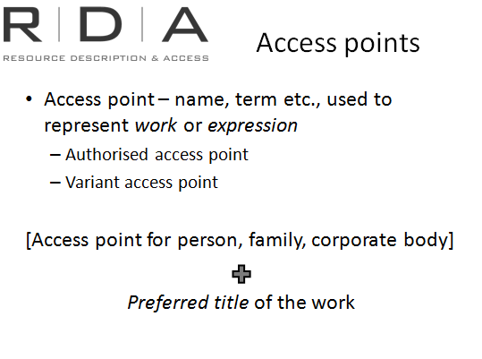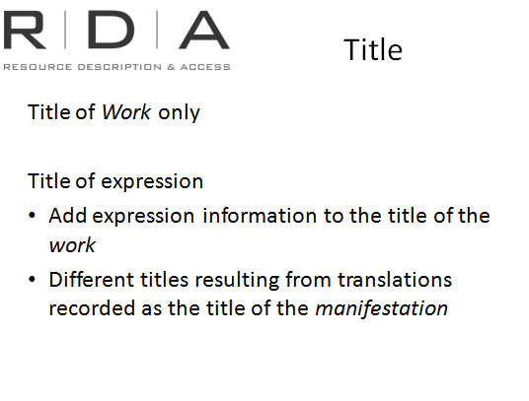**Title**

in the context of this section, refers to the title of the *work* only.

FRBR does define a “title” element for *expression,* but because the *expression* is simply a realisation of the *work*, it can be identified by simply *adding* information to the title of the *work* to bring out the attributes of that particular *expression* of the *work* (such as language and date).

In cases where a particular *expression* results in different title (such as translation into another language), this different title is usually recorded as the title of the manifestation.

**Access point**

in RDA,is the broader term to cover all terms that are used to represent *entities* in what we have often referred to up until now as “headings”.

In the context of this Section, access points represent names, terms, codes, etc. used to represent *works* and *expressions*.

These roughly equate to what we have been used to calling “Uniform titles” in AACR2, and we construct the access point using the *preferred title* of the work, and where applicable, preceding that with the *authorised access point* for the person, family or corporate body that was responsible for creating the work.

Here are some examples:

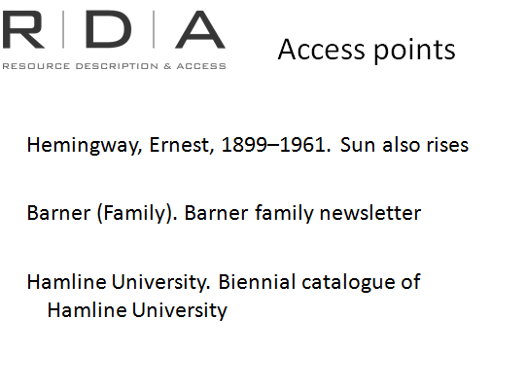

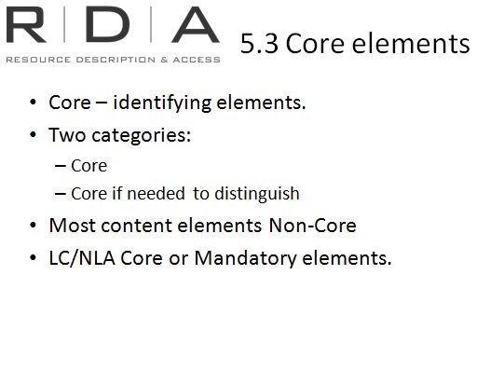

Other terminology used throughout Section 2 is defined within its context, so keep an eye out for these. Some terms may even appear in Chapter 6 and Chapter 7 with different meanings, so beware (eg Medium of performance)

#### 5.2 Functional objectives

5.2 lays out the functional objectives for recording data about works and expressions. Since I already talked about functional objectives in the last module, I won’t go into it again, except to remind you that they’re here and to check them.

#### 5.3 Core elements

For works and expressions, the Core elements are largely those that *identify* works and expressions, and are divided into those that are core *always*and those that are only core if they are needed to distinguish the work or expression from another similar work or expression.

The Content elements in Chapter 7 are almost all non-core, with the exception of scale elements for cartographic materials.

However both LC and the National Library of Australia have identified a number of other content elements as “Core” or “Mandatory” for their cataloguers. Look out for the “LCPS” in the toolkit [NLA mandatory elements” will also be uploaded to the toolkit]

#### 5.4 Language and script

Determining which language and script should be used is less straightforward in Section 2, because for the most part, Section 2 deals with either non-transcribed information, or information that needs to be recorded in a consistent way.

Titles of *works* should be recorded in the language and script in which they appear on the sources from which they are taken.

For *works,* these sources are *either* manifestations that embody that work, *or* reference sources, with the focus being on choosing the title most consistently used for that work.

For other identifying elements individual instruction will be given where needed.

Descriptive elements are entered in the language and script preferred by the agency.

#### 5.5-5.6 Access points

Here we are given general instruction on how to construct access points for works and expressions. This information is given in more detail in Chapter 6 so we will cover it when we look at Chapter 6.

#### 5.7-5.9 Status of identification, Source Consulted and Cataloguer’s note

These final parts of Chapter 5 are about the sort of tracking information we might wish to put in authority records for works and expressions, explaining things like what level of authentication has been undertaken, the source used in establishing the preferred title, and any other useful information about the access point. This information will be found in Sections 3 and 4 also.

### Chapter 7: Describing content

Handbook: Page 71

We’re going to skip over Chapter 6 for a moment and look at Chapter 7 which concerns the descriptive attributes of works and expressions associated with intellectual and artistic content.

Users typically rely on these attributes when selecting a resource to meet their requirements relating to content. These attributes can also help with identifying resources.

In this chapter there are many of the things that you may have thought were “missing” in Section 1. They weren’t covered there because although they form part of the description of a resource and are usually *taken* from the manifestationthey are actually *about* the workand expression*.*

We don’t need to look at each element individually, but there are few general characteristics about the chapter worth highlighting.

You will find the information in Chapter 7 largely familiar and straight forward.

Much of the instruction here has come from AACR2 but is presented differently and in more detail.

Instructions that were spread throughout the different chapters in AACR2 for each format are here combined under in the instructions for the RDA element to which they relate. So it will sometimes look like there’s more information than in AACR2.

In addition to this, RDA has drawn on extra elements already available both in MARC and specialist cataloguing manuals.

Finally, there are a few new elements and RDA offers more break-down of some areas than was previously available.

This is indicative of RDA’s overall aim to be format neutral, while breaking data down into smaller, more meaningful chunks.

#### A note about notes

We talked in Module 6, about how “Notes” are not a separate element in RDA. Chapter 7 is an example of this change. Many of the content elements covered here were in the “Notes” elements of AACR2 chapters. Here they each have their own element, so we can separate this information much more clearly in our systems, allowing more accurate sharing of data, and more meaningful displays and search results for our users.

Of course, many library systems have not realised the full potential of this yet, [and MARC, though better than AACR2 in this regard, still has limitations]. But as I have said, RDA is just one step towards a future where our data is more useful and sharable in an online world.

This screen shows the audience note in AACR2 and how it appears in RDA. Of course it will still be recorded in the marc 521 field

#### Note to presenter: Suggestion for presenting this section

1. Ask one person in the group to go to the RDA-MARC mappings and read out the marc field for each of the RDA instructions in chapter 7 as you go through them
2. Have a box containing resources that illustrate different aspects of describing content. Select people to pull out items from the box and outline the specific content of the item. All trainees to find in chapter 7 for the instruction relating to that content

#### 7.1 Sources of information

**Question**: What are the sources of information for describing content?

Most information about the content is taken from the resource itself but there will be occasions when information will come from outside the resource.

Check each instruction to be sure about this. Again, it is worth noting that you might find more flexibility in where you can take information from.

#### 7.9 Dissertation or thesis information

Recording thesis information was provided for in AACR2, but all as one string of data in one instruction 1.7B13.

RDA has broken this down in sub-elements for type of degree, conferring institution, and date awarded. These correspond with the separate subfields provided in the MARC 502 field, and is an example of RDA simply catching up with current MARC practice.

However, information that 1.7B13 asked us to record regarding resources that are revisions of theses or dissertations are not included here. This is because this is information about a related expression which we will look at in a later module.

#### 7.10 Summarisation of content

**Question:** What is included in the Summarisation of content?

Note the definition of “summarisation of content” here. This section just covers abstracts, summaries, synopses, etc.

**Question:** Why do you think *content* notes are not included here?

Actual formal contents notes listing the titles of parts of the resource are about the *relationship* between the whole resource and its parts, so are covered later in Chapter 25.

#### 7.11 Place and Date of capture

**Question:** What types of material would you record capture information?

This element was not in AACR2 but will be familiar to cataloguers of sound recordings and motion pictures.

MARC makes provision for this information, and the 033 and 518 fields have been in use for some time to record place and date of capture in both free text and coded form.

#### 7.12 Language of the content

Note that this instruction is *only* for recording language information in the descriptive elements. (MARC Fixed fields, 041 and 546). Language information in the access point for the expression is catered for in Chapter 6.

#### 7.13 Form of notation

**Question:** What forms of notation are covered here?

This is a new element too. It brings together information we had previously recorded in disparate and not well defined parts of the record, about the form of notation used to express the content. This means tactile notation (eg Braille), dance notation, music notation, or script used to express language content.

#### 7.14 Accessibility content

This is a new element, which allows us to record very useful information about whether a resource has been enhanced to assist users with a sensory impairment such as vision or hearing impairment. Covered here are things such as closed captioning, subtitles (though not alternative language subtitles), accessible labelling, and sign language.

**Question:** Large print is not included here; why do you think that is?

Large print is not covered here but has its own element in Chapter 3. (3.13.1.3). Braille, as we have just discovered, is a form of notation of the base content, and is covered in 7.13

[If anyone asks about the difference between Braille and “accessibility content”: Accessibility content is content that is ADDED TO a resource to assist those with a sensory impairment in interpreting it, such as subtitles, audio description, closed captioning, etc. Braille is a *form of notation* used at the *expression* level so is covered at **7.13.**]

#### 7.15 Illustrative content

Here at last, is the elusive “illustrative content” that was notably absent when we looked at physical characteristics in Chapter 3.

Illustrative content is included here because it is part of how a work is expressed and therefore is not related directly to the manifestation or item. The instructions here are fairly straightforward and not much different from AACR2, although you may find it is more simply worded.

**Question:** What are some of the terms we use to describe illustrative content? and; can they be abbreviated?

Note that this is one of the key areas of the description affected by RDA’s move away from using abbreviations. None of the terms used here are abbreviated, whereas in AACR2 they nearly all were.

Note also that references to colour illustrations are missing. Colour content is covered at a separate element, **7.17**, which brings together instructions on colour content from both the general and special material chapters in AACR2.

#### 7.16 Supplementary content

This element covers bibliography and index notes and appendices.

LC have marked this element as “core” for bibliography and index information, and NLA has also marked bibliography and index information as Mandatory for their cataloguers.

#### 7.28 Award

This is a new element allowing us to record information about whether the resource has received formal recognition by an award or prize-giving body.

MARC made provision for this in 586 field, and many cataloguers are already familiar with and using this field.

#### Cartographic content

There are a number of instructions in Chapter 7 that relate to cartographic content.

Those of you familiar with cataloguing maps will find no change from what you are used to, especially if you have been using *Cartographic Materials*.

In bringing together information from AACR2, MARC and *Cartographic Materials* in RDA offers a significantly higher level of detail in recording information about cartographic material than AACR2 did.

Most of the elements however are non-core. The only core elements are Horizontal and Vertical scale in **7.25.**

LC and NLA have also made additional scale information in **7.25** mandatory for their cataloguers

## Chapter 7: Exercise 12

Handbook: Page 167-168

Answer the following questions about chapter 7

1. [7.1] What are the sources of information for describing content?

2a. [7.9] What marc field is thesis/dissertation information recorded (remember the RDA to marc mappings)?

2b. Using marc coding record a Ph.D obtained from the Australian National University in 2012

3a. [7.10] What is included in the “summarisation of content”?

3b. Why are contents notes not included (Hint: It’s to do with *relationships*)

4. [7.11] For what type of material would you record place and date of capture

5. [7.12] Are these instructions for *description elements* or *access points* (Hint: look at the examples)

6. [7.13] What different forms of notation are covered here?

7a. [7.14] What sorts of content are covered here?

7b. Why is large print not included?

8a 7.15 What are some of the terms used to describe illustrative content, can they be abbreviated and what marc field does it go in?

8b Is this a core element for Library of Congress cataloguers?

9 In which marc field is Award information recorded?

### Chapter 6: Identifying works and expressions

Handbook: Page 76

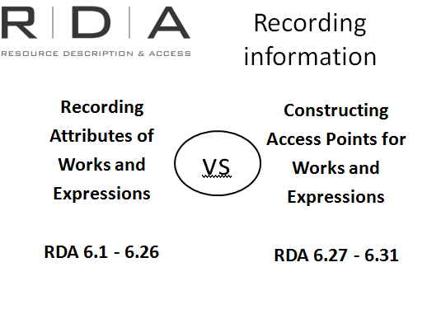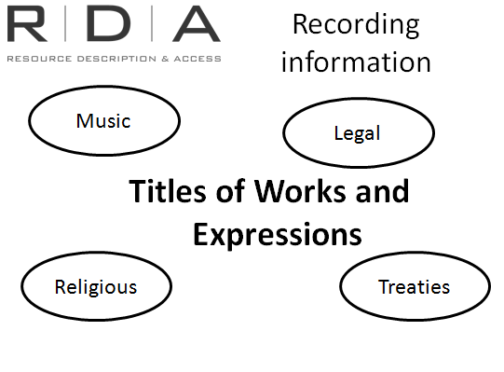We’ve just looked at the descriptive attributes of works and expressions which help people *select* a work or expression that’s appropriate to their needs.

Chapter 6 deals with the key elements that *identify* works and expressions, that is, the titles of works, and the other identifying attributes of works and expressions that be added to the title to make it unique. This information is traditionally recorded in our bibliographic records in both descriptive and access point fields (uniform titles) and in the authority records that we create for the uniform titles.

As I’ve said before RDA is designed for an environment where works and expressions have their *own* records and the manifestation records can be linked to the relevant work and expression records, without the information having to be re-recorded by the cataloguer.

#### Types of material covered

While Chapter 6 is intended to provide guidance on identifying works and expressions of all types, there are certain types of resources where work and expression information is more commonly of value and where detailed specific instruction is needed. Therefore Chapter 6 devotes a significant amount of instruction to these resources, specifically music, legal works, religious works and official communications.

#### Recording vs. constructing access points

In Chapter 6 there are two types of instructions, and it is important to understand the distinction between the two types.

Recording the attributes of works and expressions (6.1-6.26) gives instruction on what identifying information can be recorded and how to record it.. – Titles, dates, content type, medium of performance etc.

Constructing access points (**6.27-6.31**) is about using this identifying information to construct the authorised access point for the work or expression.

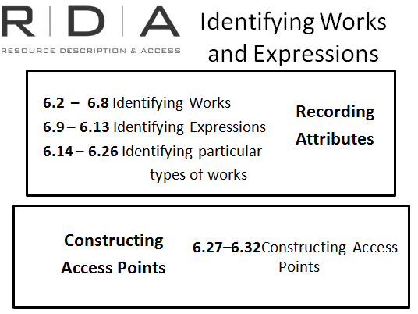**6.2 to 6.8** deal with how to identify **works** and **6.9 to 6. 13** deal with how to identify **expressions**. Then, **6.14 to 6.26**, deal with particular types of works, namely musical works, legal works and religious works. There is nothing new in that as in AACR2, musical, legal and religious works were treated separately because of their peculiar nature.

The remaining sections (**6.27-6.31**) are about constructing access points to represent works and expression, again going from the general to the particular (on musical, legal and religious works and expressions).

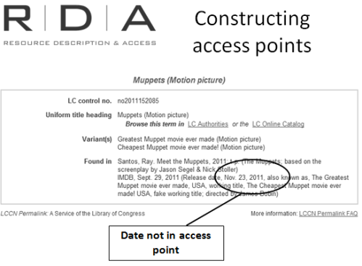Why are there separate instructions? If you are recording information, isn’t it assumed that it’s going to be in the access point? And if so, why not just put it all together in one instruction? Well, not necessarily. Some information that we *record* about a work doesn’t *necessarily* get used in the access point.

Let me use the familiar construct of the authority record to explain what I mean.

An authority record for a work is a bit like the Work’s“record” in RDA terms. The 1XX field is the part of the authority record that will appear in the all the bibliographic records it is attached to. In other words, it is the “authorised access point”. But there are other fields in an authority record where you can record information about the work that doesn’t appear in the access point, but that help us to know more about the work.

This explains why some instructions appear to be duplicated in Chapter 6. They are actually talking about different things.

#### Reflection exercise: (Excercise 13)

1. 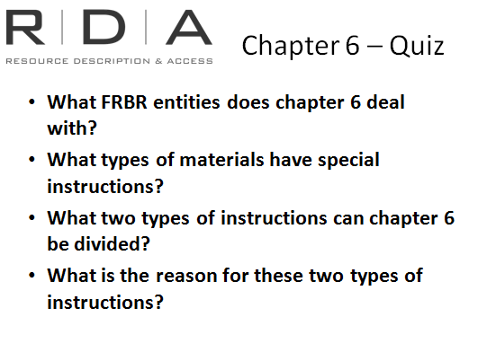What FRBR entities does chapter 6 deal with?

**Works and expressions**

1. What types of materials have special instructions

**Music, legal, religious, treaties**

1. What two types of instructions can chapter 6 be divided

**Recording attributes of works and expressions and constructing access points**

1. What is the reason for these two types of instructions

**Not all the information recorded about a work is used in the access point**

#### 6.2 Title of the Work

This is a core element. Instructions are given here on how to record the title (use of capitalization, diacritics and so on). The title can be taken from any source. RDA divides titles up into

1. 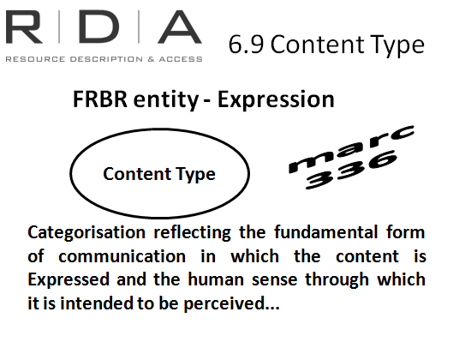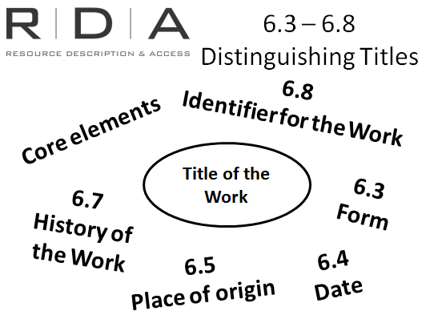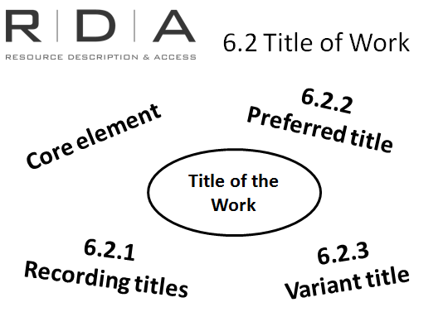Preferred title for the work
2. Variant title for the work

**6.2.2**  is about the “**preferred title**”. This is our old friend, “uniform title”.

RDA divides this section into two parts: works created after 1500 and works created before 1501.

This section covers not only whole works but parts of works. It also covers compilations of works by one person, family or corporate body

It also provides for variant titles for a work which differ from the title chosen as the preferred title of a work (whether a variant language, spelling or other such as “Personal history of David Copperfield” – for David Copperfield)

The next sections (**6.3-6.8**) are about the elements which can be used to differentiate a work from another work with the same title. In this capacity they are all core elements. Most of these are already familiar and they include:

* Form (Play, Motion picture, Computer file and so on - there is no controlled list of terms),
* Date (Earliest date associated with a work, e.g. date it was first published )
* Place of Origin (country or territory where work originated)
* Other distinguishing characteristics of works.
* History of the Work (used more for authority records, as a note)
* Identifier for Work (character string uniquely associated with a work that serves to differentiate that work from other works)

#### Expression

**Content type (refresher)**

We already looked at Content type in the previous module, because it is generally considered in conjunction with Media and Carrier types. However, the instructions for content type are here at **6.9** because Content type is defined as “a categorization reflecting the fundamental form of communication in which the content **is expressed** and the human sense through which it is intended to be perceived. ..”. It is therefore one of the *identifying attributes* for the We won’t cover it in detail as we have already looked at it in the previous module. But just to remind you, there is a list of fixed terms (such as cartographic dataset, notated music, performed music) which are to be used as appropriate. They are clearly defined in this section. What is different here is that is that you can **use as many terms as appropriate** to the resource being described

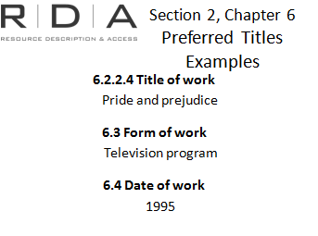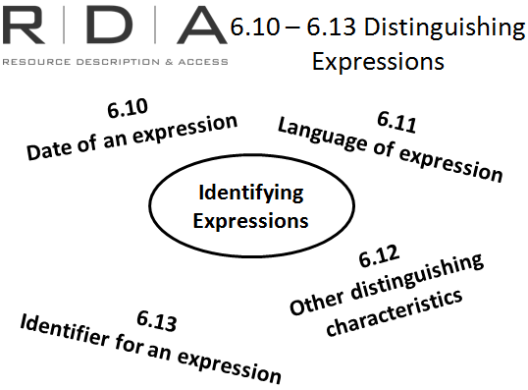

**6.10-6.13** are the elements used to differentiate an **expression of a work** from another expression of the same work. Again, these are mostly familiar. These are all core elements and include

* Date (the earliest date associated with the Expression, usually the date of the earliest Manifestation),
* Language (in which the work is expressed, this includes translations of the work being expressed)
* Other distinguishing characteristics such as “Director’s cut”, “Selections” (for selected parts or excerpts)
* Identifier for the Expression

#### 6.13 – 6.26 are concerned with particular types of works

#### Preferred titles examples

Referring to RDA 6.2 to 6.8, what elements are recorded in the *preferred title* for the following works:

**Pride and Prejudice, the 1995 televsion series.**

**6.2.2.4** Title of the work – Pride and Prejudice

Preferred title is “the title in the original language by which the work has become known through use in resources embodying the work or in reference sources”

**6.3** Form – Television program

This is a core element when needed to distinguish between. There is no controlled vocabulary so if you are cataloguing a form that is not in the list of examples you choose an appropriate term)

**6.4** Date – 1995

Record the date using the calendar preferred by the cataloguing agency. Refers to Appendix H for how to record dates in the Christian calendar

**Pride and prejudice (Television program : 1995)**

**Pride and prejudice, Northanger Abbey, Persuasion and Emma. Published by Octopus Book, 1982. ISBN: 0706417992.**

This example is a compilation of works by Jane Austen. There is no collective title.

Handbook: Page 80

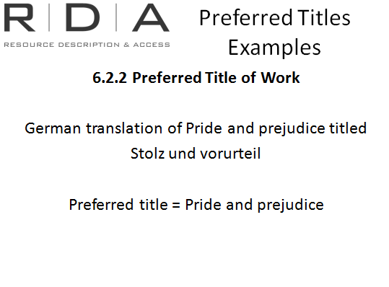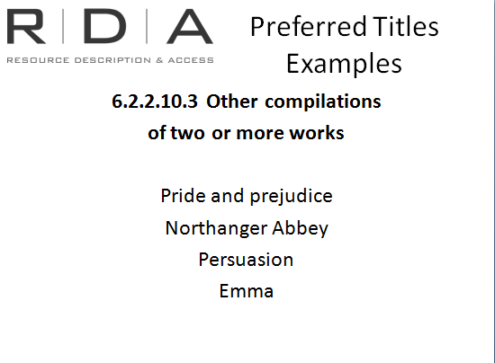For instructions for recording compilation:

**6.2** – Title of works

**6.2.2** – Preferred title of the work

**6.2.2.10** – preferred title of compilation of works by one person, family or corporate body

From here go to **6.2.2.10.3** – other compilations of two or more works.

Instruction here says to give the preferred title for each of the works as instructed in 6.2.1.

**Pride and prejudice**

**Northanger Abbey**

**Persuasion**

**Emma**

Note: The alternative instruction at 6.2.2.10.3 – record a conventional collective title followed by selections instead of or as well as the preferred title for each work

**Novels. Selections**

**Stolz und vorurteil. Translated into German by Karin von Schwab**

What language should we record the preferred title

6.2.2 The preferred title is still the original language

**Pride and prejudice**

In chapter 6.2 are there any instructions for adding the language? And why?

[Note **Pride and prejudice. German** is correct but remember that language is part of the FRBR attribute *expression*]

### Exercise 14: Preferred titles exercise - 6.2 to 6.12

Handbook: Page 170-171

1. What are the RDA instructions for the preferred title of a compilation of two or more works in *different forms* by the same creator?

**Answer: 6.2.2.10.3**

**Other Compilations of Two or More Works**

**For a compilation consisting of:**

**a) two or more but not all the works of one person, family, or corporate body, in a particular form**

***or***

**b) two or more but not all the works of one person, family, or corporate body, in various forms**

**record the preferred title for each of the works in the compilation applying the basic instructions on recording titles of works given under 6.2**

2. What is the alternative instruction at 6.2.2.10.3

**Answer: Instead of (or in addition to) recording the preferred title for each of the works in the compilation, record a conventional collective title as instructed under 6.2.2.10 or 6.2.2.10.2, as applicable, followed by Selections.**

3. Record the preferred title/or titles applying the instruction at **6.2.2.10.3** for the following example?

Edgar Allan Poe

Contents:

The Raven

The pit and the pendulum

*The Raven is a poem

*The pit and the pendulum is a short story

**Answer**

**Title of manifestation:** The raven ; the pit and the pendulum

**Preferred title: Raven (recorded in marc 240 field)**

**Pit and the pendulum (recorded in marc 700 field)**

4. What is the instruction for *choosing* the preferred title for a work that is published concurrently under two different titles proper in the same language in different countries?

Hint: See instructions for *choosing* the preferred title

**6.2.2.4 Preferred title is based on the title proper of the manifestation first received, not on the manifestation published in the home country**

5. What is the preferred title for a journal with the title proper “Rabbit droppings” and what MARC field would you record it in?

**Answer: Rabbit droppings (recorded in the marc 245 field)**

6. Another journal also has the title “Rabbit droppings”. It began in 2009 and is published in Wagga Wagga. What can you add to the preferred title to distinguish it from the other journal with the same name

**Answer: Rabbit droppings (2009) *or***

**Rabbit droppings (Wagga Wagga)**

#### 6.27 Constructing Access Points to Represent Works and Expressions

Here is where you are told how to put the elements together to create authorized access points for works and expressions.

Handbook: Page 80

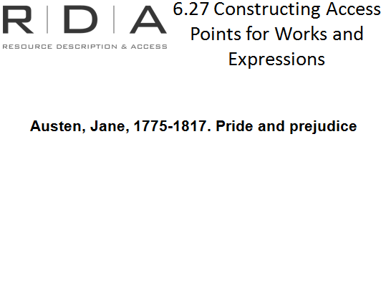What pieces do we put together?

RDA **6.27.1.2** says:

* Establish the preferred title.
* If applicable, **precede this** with the authorized access point for the creator/s (determining this is covered in Ch. 19 which we will be looking at tomorrow but is basically the process you currently use)
* add any other elements to the preferred title if needed according to 6.27.1.9 - these are Form, Date and Place of the Work, and any attributes of the *expression*.

Note that all of the instructions about the elements used in constructing the access point have references back to the element instructions so you can find more information about each element.

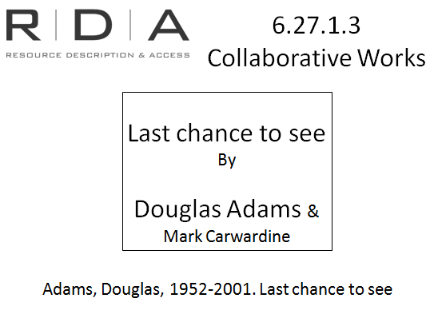If **more than one** person, family or corporate body is responsible, the instructions are similar to what you are used to in AACR2. One name is used as the authorised access point and is *either*:

* The one with principle responsibility;
* The first named; or
* If a collaboration between a corporate body and a person or persons, the corporate body (in cases where the corporate body is considered to be the creator)

However, it should be noted that there is the potential to name all the persons or bodies responsible for a work. Hence the presence of the “Alternative” in **6.27.1.3** which states “Include in the authorized access point representing the work the authorized access points for all creators named in resources embodying the work or in reference sources (in the order in which they are named in those sources)”.

Whether you apply the alternative will be a policy decision. LCPS states do not apply the alternative and NLA will also not apply the alternative

#### ~MyBitmap~MyBitmap~MyBitmapCompilations vs. Collaborations

RDA makes a distinction between compilations (**6.27.1.4**) and collaborations (**6.27.1.3**). It is an important distinction, and there is a difference in how each is “identified.”

If the resource is the responsibility of more than one creator:

* If it is a compilation, it is identified by the preferred title for the compilation
* If it is a collaboration, it is identified by the combination of principal (or first-named) creator and preferred title.

**6.27.1.9** covers additions to access points representing **works**. This is when the access point constructed according to 6.27.1.2 to 67.1.8 is the same as or similar to an access point representing another work. These additions were covered in **6.3 to 6.6** and are:

* Form of work
* Date of work
* Place of origin of the work
* Term indicating another distinguishing characteristic of the work

There is no order and more than one can be assigned if necessary.

**6.27.2** covers constructing access points representing parts of works except parts of musical and legal works.

**6.27.3** tells us how to construct access points for **expressions** of a work, or part or parts of a work, by adding the following as applicable

* Content type (see **6.9**)
* Date of the expression (see **6.10**)
* Language of the expression (see **6.11**)
* Another distinguishing characteristic of the expressions (see **6.12**)

**6.27.4** is guidelines for constructing a **variant access point** for a work or an expression, such as a variant title from the preferred title.

The remainder of Ch. 6 is concerned with constructing access points for musical, legal and religious

works and expressions.

## Exercise 15: Chapter 6

Handbook: Page 173-174

## 

## Work published under the title:

## Travels into Several Remote Nations of the World, in Four Parts. By Lemuel Gulliver, First a Surgeon, and then a Captain of Several Ships.

## Better known as:

## Gulliver's Travels (1726, amended 1735) by Jonathan Swift (1667-1745)

In four parts:

Part I: A Voyage to Lilliput

Part II: A Voyage to Brobdingnag

Part III: A Voyage to Laputa, Balnibarbi, Luggnagg, Glubbdubdrib, and Japan

Part IV: A Voyage to the Country of the Houyhnhnms

1. What is the preferred title for the work?

**6.2.2.4** Gulliver’s travels

1. What is the variant title for the work?

**6.2.3** Travels into several remote nations of the world

1. You are cataloguing part 1. What is the preferred title?

**6.2.2.9** Voyage to Lilliput

1. What are the order of elements go in constructing the access point for part 1 of Gullivers travels?

**6.27.1.3** – start with the access point for the creator (Swift, Jonathan, 1667-1745). Add the preferred title

1. What is the preferred title for the Armenian translation?

**6.2.2 Gullivers travels**

**6.11 Armenian**

1. What is the preferred title for the 2010 movie Gulliver’s travels?

**Gulliver’s travels (Motion picture, 2010)**

1. The 2010 movie was a collaborative work travels directed by Rob Letterman, written by Joe Stillman and Nicholas Stoller, based on Jonathan Swift’s work. According to 6.27.1.3 which of the following is the correct construction of the preferred title if Rob Letterman’s name appears most prominently on the resource?

**1) Gulliver’s travels (Motion picture, 2010) ­–** 6.27.1.3 *exceptions for Moving image works*

2) Swift, Jonathan, 1667-1745. Gulliver’s travels (Motion picture, 2010)

3) Letterman, Rob. Gullivers’s travels (Motion picture, 2010)

## ~MyBitmapSummary