Teaching RDA: Day Two

Module 8 Attributes of Persons, families, corporate bodies (RDA Section 3)
Resources:
- Group activities/excercises.
[Note: exercises can be done either at the end of each section or all together at the end of the module]
Handbook: Page 83

Learning Outcomes
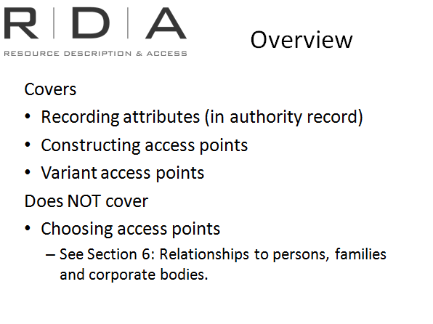
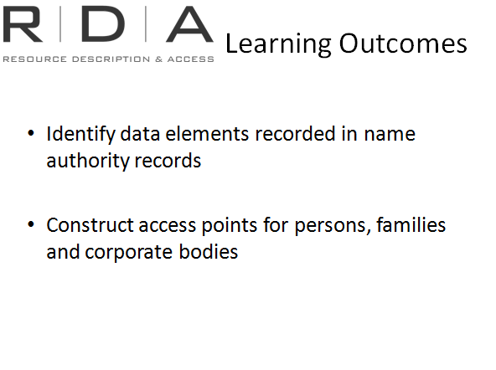
We’re back to some familiar territory now.
In this module we will be looking at the information that we record in our access points and associated authority records for the Group 2 entities of persons, families and corporate bodies. You’ll find the instructions here reassuringly familiar. Like AACR2, each entity has its own chapter, and the instructions cover choosing the preferred form of name, making additions to the name to make it unique.
Before we get stuck in, there are some important general points to make.

Recording and constructing access points
The scope of what was in AACR2 has now been broadened to encompass not only what goes in the access point, but also what you record in the authority record, including variant forms of name, and other biographical and historical information about the name.
The instructions in this section of RDA are arranged just as they were for Chapter 6. We are first given instructions for recording the attributes, and then instructions on how to construct access points. Again it is important to know which type of instruction you are looking at.

Section 3 is NOT about choosing access points
It is important to be aware that we are still in the “Recording attributes” part of RDA, so this section is just about describing persons, families and corporate bodies, and constructing access points for them.
Making choices about which persons, families and corporate bodies to give access to is dealt with later, when we come to talk about “Recording relationships”

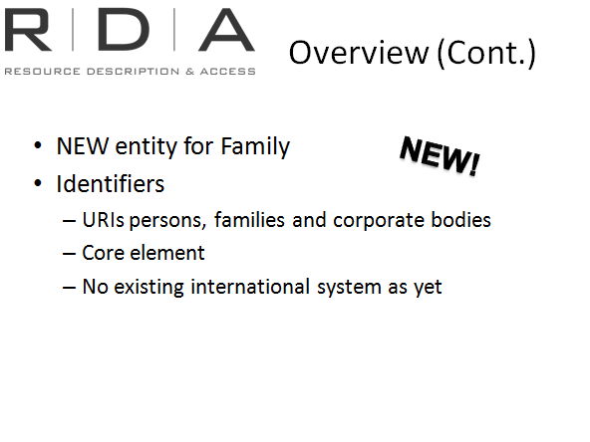
Families
The biggest new player in FRBR/FRAD and RDA is a whole new entity for Families! Family was added as a Group Two Entity in FRAD (it was not defined in FRBR) and consequently appears as an entity in RDA.

Identifiers (RDA 9.18)
You will find instructions in each chapter about identifiers for persons, families and corporate bodies (or the surrogate for same, eg authority record). This is something new in RDA. Identifiers are like the “ISBNs” or “URIs” of the Group 2 entity world. And like the ISBNs we record for manifestations, they are meant to be core elements.
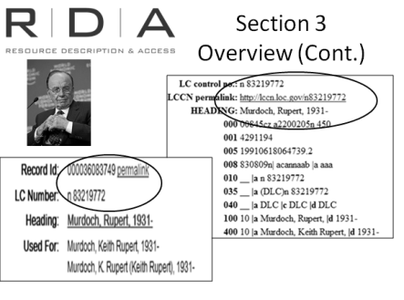
These identifiers are also present in Chapter 6, for works and expressions. Their intended purpose is to provide the linkages between each of the entities, but also to create linkages between databases worldwide, so that entities can be uniquely identified and matched between databases.
Although we do not currently have a single internationally recognised system for creating these identifiers, we do have the record IDs in our systems for the authority records for the entities (ie their surrogates). They are not really a unique identifier in global terms (each system has a different number), but they are “unique” in that no other authority record has that particular system number. Also, some of these numbers, such as the LC number and the OCLC number, do travel with the records to other systems, so do have a more global role to play. In Australia, for example, if we import an LC authority record into our system, it gets a new Libraries Australia number, but we still retain the LC authority number.
This slide exemplifies this point. Libraries Australia and Library of Congress have different (system generated) record numbers but records are for the same person, and the LC number has been retained in the Libraries Australia record.
Another thing to note is that in order for these numbers to truly be useful, they need to be linkable, as each of these numbers is. (See “permalink” for the URI)
Therefore, it is not necessary to record a special “identifier” beyond the system number generated by your system when you create an authority record.

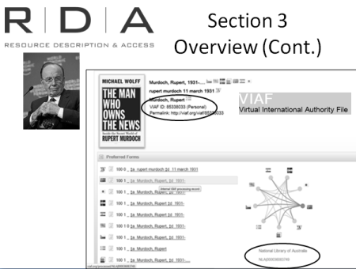
The Virtual International Authority file is the closest thing we yet have to an “international” authority file. It attempts to bring together the authority records from multiple databases, and combine them all into one record, while retaining all the useful information in each record. The system number in the VIAF system comes a little closer to being an international identifier. It has also, like the LC number, been set up as a URI so it is linkable across systems.
You will note also that in this record the local identifier from all the systems from which VIAF has obtained authority information have been retained in the consolidated record. I’ve highlighted the version that came from Libraries Australia to illustrate this.

Chapter 8: General guidelines
As with every section of RDA, this section has also chapter of general guidelines. There are the usual suspects, and a few new things.

8.3 Core elements
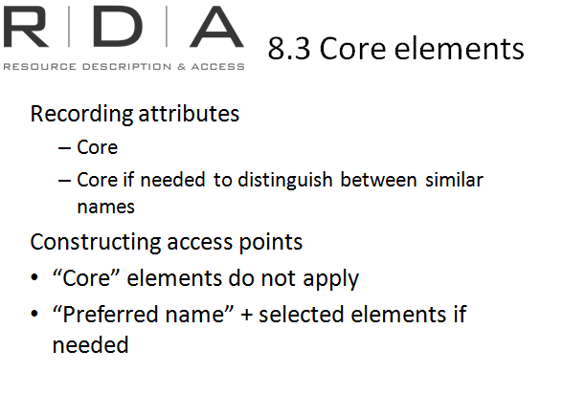
As in Section 2, the elements in Section 3 are divided into those that are core always and those that are conditionally core. In the case of Group 2 entities, the condition is, if the information is needed to distinguish the entity from others with similar names.
Note that core elements for Group 2 entities only apply when “recording the attributes”. They do not apply to the construction of access points. For the actual access point, the core attributes will be among a select group of elements that can be used in the access point but generally, beyond the name, extra attributes are only required if they are needed to make the access point unique

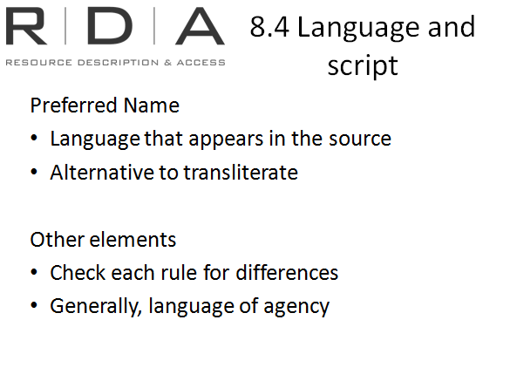
8.4 Language and script
Language and script for the name of a person, family or corporate body should generally be as it appears on the source from which it is taken, with the alternative to transliterate non-Latin script if desired by the agency. This is, of course, the general principle. The decisions that you make in choosing a preferred name will both affect and be affected by issues of language and script. (For example, choosing between different forms of the same name)
For other elements, language and script will vary, depending on the instructions. If there is no instruction, you will generally use the language and script preferred by your agency.

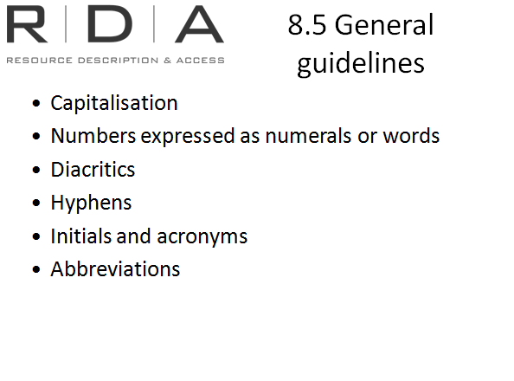
8.5 General guidelines on recording names
Recorded here are some general instructions that will apply for all names. [Listed on slide] Make sure you check these rules if they apply to a name you are recording. Due to the emphasis on the ICP Principle of “Representation”, some of the conventions might be different to what you are used to.

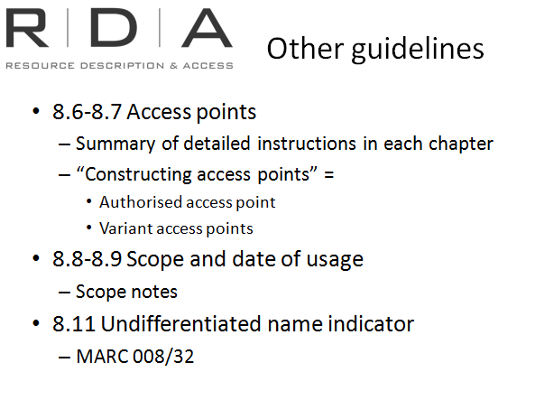
8.6-8.7 Access points
As in Section 2, the instructions here are an abbreviated version of what you will find in the individual chapters. But it’s worth noting from this that the instructions for constructing access points in each chapter apply to both authorised and variant access points.

8.8-8.9 Scope and date of usage
These are instructions for scope notes that explain when and how a particular name is used. This would be applicable when the same person, family or corporate body uses different names in different circumstances (eg. Pseudonyms)

8.11 Undifferentiated name indicator
This is just an instruction for the information we currently code in the 008 field (cp 32) of an authority record to indicate that it has not been possible to resolve a conflict with another name.

Exercise 16: Chapter 8
Handbook: Page 175
[This exercise may be left out if time is short]
Answer the following questions about chapter 8.
1. 8.3 lists the core elements for section 3. Which elements, if any, are core in constructing access points?
Answer: None. The core elements are only applicable when “recording attributes”. Although when recording the core elements, RDA says that you may “Record the elements either as parts of the authorized access point representing the person, family, or corporate body, or as separate elements, or as both”
The elements required when constructing the access point are listed at the instructions for constructing access points in each chapter.

2. What language and script is a name of a person, family or corporate body recorded?
Answer: Record names in the language and script in which they appear on the sources from which they are taken. (8.4)

3. Where can you find guidelines on capitalisation of names for persons, families and corporate bodies?
Answer: 8.5.2 states to apply instructions in appendix A.

4. Which category of name does “Date of usage” used for? And; how is this different to birth and death dates?
Answer: A date range associated with the preferred name of a person, for example for a pseudonym used for a particular period.

5. What is an undifferentiated name indicator? And; in what marc code is this recorded?
Answer: It indicates that there is not enough information available to distinguish between two people with the same name.
Marc authority mappings: 008 position 32 – Undifferentiated personal name

Chapter 9: Identifying Persons
[Note to presenter: The exercises are outlined at the end of the module. They can be presented either after each chapter, or together at the end of the module]
Handbook: Page 87
In chapter 9 the elements identifying a person are given first at the beginning of the chapter.
Then, at 9.19, instruction is given on which of those elements to use in constructing an authorized access point .

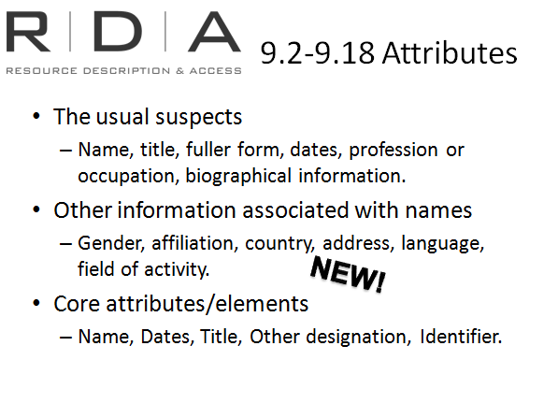
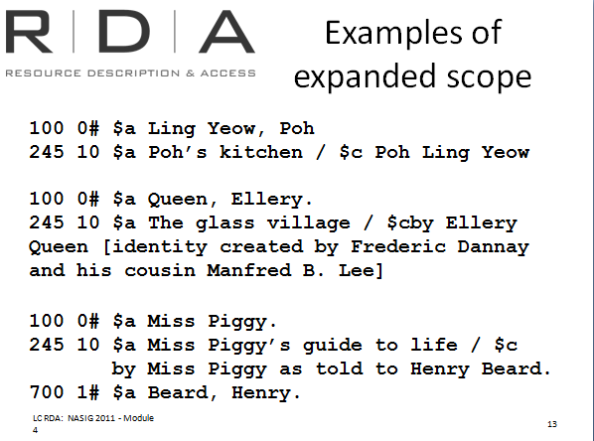
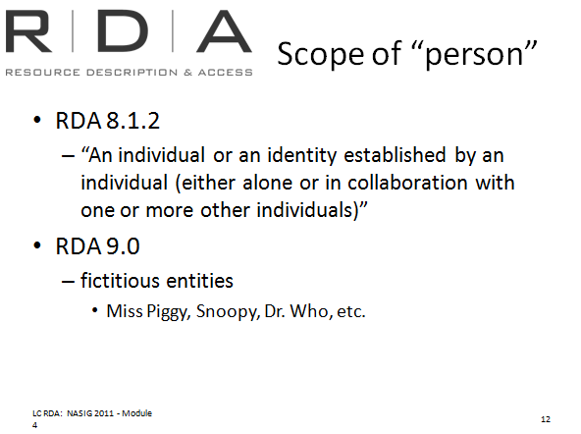
Scope of “persons”
In RDA a person has been defined more broadly than we have been used to in AACR2. A “person” can be
- an individual or
- an identity established by one individual alone or in collaboration with one or more other individuals.
- A fictitious entity can now be considered a “Person” having a relationship to a work, expression, manifestation or item, if they are presented as such on the resource.

For Example:

Recording attributes – 9.2-9.18
The instructions at 9.2-9.18 are just about recording the attributes of persons. This information may become part of the access point, or it might just be placed in a separate part of the authority record for the person. Sometimes it might appear in both. It is important to understand this. Just because you are being instructed to record certain information, it doesn’t mean that it will all be in the access point, even if it is considered core information.

Attributes
So let’s just look at what information RDA lets you record about persons. If we look at the contents at this part of the Toolkit, we see the usual suspects - Name, title, fuller form, dates, profession or occupation, biographical information.
But there are also some new elements for persons - Gender, affiliation, country, address, language, field of activity. These new elements have been identified by FRBR and FRAD as being useful elements in helping to identify and contextualise the entity of “Person”
Core attributes
The core attributes to record are Name, Dates, Title, Other designation (RDA 9.6), Identifier. As mentioned earlier, identifiers for names are just the system number generated by your database when you create an authority record, so you don’t have to think about that.

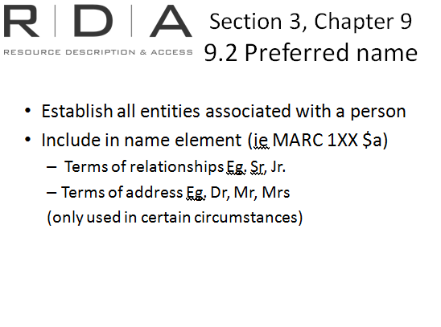
9.2 Name
Name is of course, the primary identifying element for person and it is this element that will form the basis of the access point later on in 9.19, so the instructions here are focussed on selecting and recording the preferred and variant names for persons. Much of this is the same as you are used to in AACR2, but there are a few changes worth highlighting:
- Instructions for individuals with more than one identity have been simplified a lot. In all cases where multiple identities exist establish a preferred name for each identity. 9.2.2.1
- Words or numerals that indicate relationship, such as Jr., Sr, IV, are now included as part of the preferred name, rather than an addition and are included whether or not they need to resolve a conflict. 9.2.2.9.5
- Terms of address such as Dr., Mr, Mrs., etc. are also now included as part of the preferred name, rather than as an addition. They are still only used, however, when they are part of a phrase that consists only of a surname or forename and the term of address. 9.2.2.9.3 and 9.2.2.18
Note that in the latter two cases, because the terms are now part of the preferred name, they should recorded in the $a subfield rather than in a separate $c subfield in MARC.

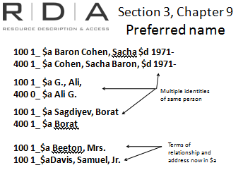
For example:

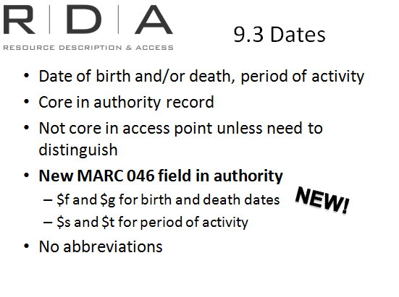
9.3 Dates
In RDA, dates associated with persons include both a person's date of birth and death, and also the date or date range of the person's period of activity.
Dates of birth and death are now unconditionally core elements for a person. Period of activity is only core if it is required as a distinguishing element.
Note, dates of birth and death are only core to record in the authority record. They are only required in the actual access point if needed to distinguish the person from someone else with a similar name. You can of course, put them in the access point even if they are not needed, and this may be what you choose to do if you do not wish to create an authority record for the person.
To accommodate the date in the authority record separate from the access point, there is a new MARC tag, the 046. It is also coded so that it is more readable by computers.
The 046 tag contains several different subfields for the different types of dates. The ones used for persons are:
$f and $g – birth and death dates
$s and $t – start and end dates (for period of activity)
When used in the 100 $d subfield, Information associated with dates is no longer abbreviated.
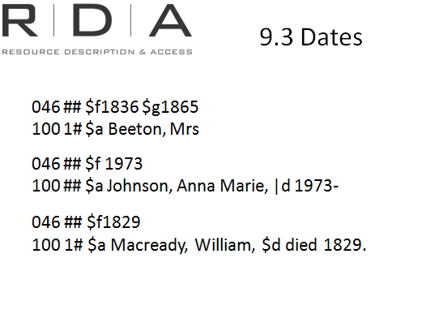
For example:

9.4 Title
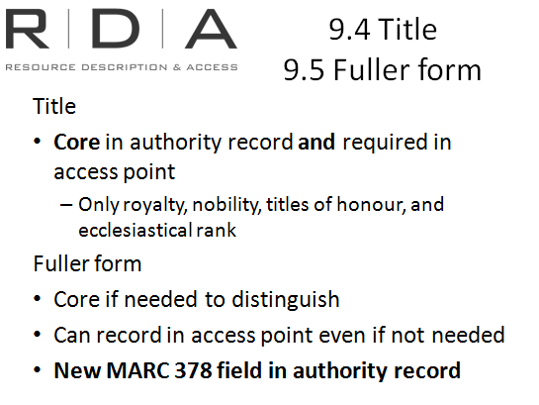
Title is now a core element, and is required both to be recorded and as part of the access point. But be careful to note the definition of “title” as only certain things are included [show instruction]

9.5 Fuller form
Fuller form of name is only core if it is required as a distinguishing element. If it is not required, you still have the option to record it if you wish, either in the access point or somewhere else in the authority record. But up until now, if you didn’t want to use the fuller form in the access point, the information was simply recorded in a note field. MARC has now established a new field, 378, to accommodate the fuller form of name if you wish to record it there either instead of in the access point (if it is not needed there) or in addition to putting it in the access point.
In the 1XX field, it still goes in the $q subfield

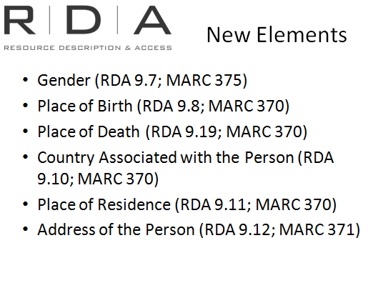
New elements for persons 9.7 - 9.18
As well as these elements, there are now a number of other elements that can be recorded when identifying persons, that have either not been available before, or not separate elements in AACR2. All of the new elements are either non-core, or core only if required as a distinguishing element. New MARC fields in the authority record have been set up for all of these. The Non-core elements would only ever be recorded in these authority record fields:
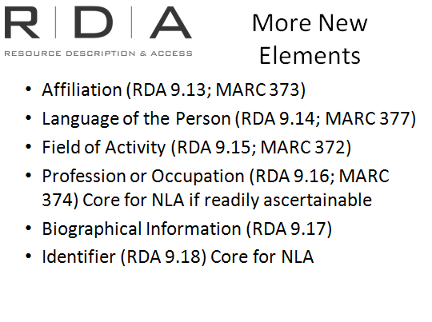
Gender (375), Place of birth and death and country associated with the person (370), Address (371), Affiliation (373), and Language of the person (377)
The “Core when...” elements not only have their own new fields but will also be recorded in the access point if they are required as distinguishing elements.
Profession/Occupation(374) and Field of activity (372)
At present, these elements both go in the $c subfield in the 1XX field.

For example:
9.7 Gender recorded in the 375 field
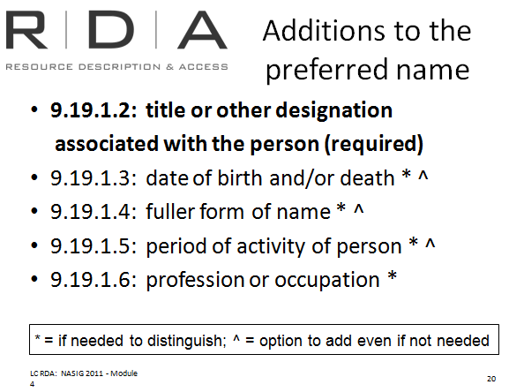
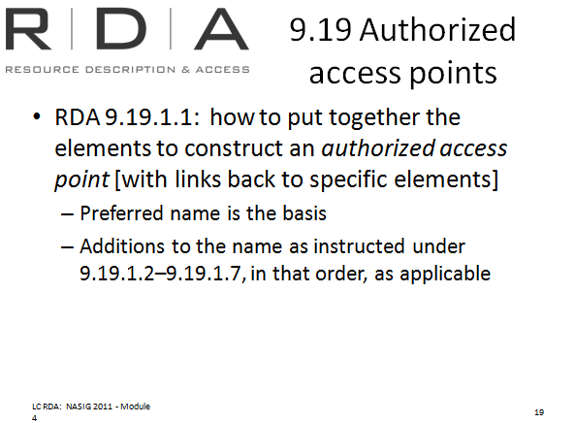
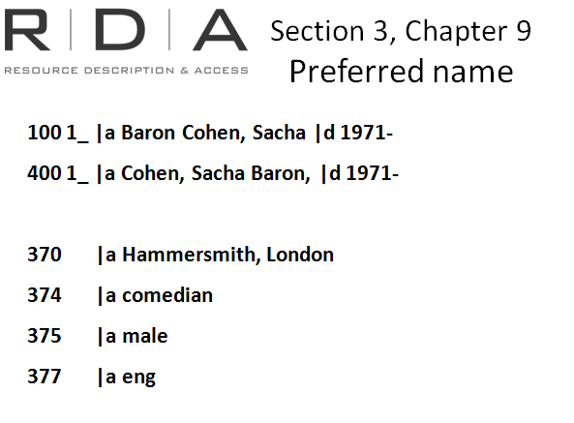
9.8 Place of birth 370 a subfield and
9.10 Country associated with a person in the 370 c subfield
9.16 Occupation
9.14 language – in the 377 field. MARC instructs to use the marc code list for language

Constructing access points – 9.19
We have just looked at all the elements you can now record about a person. Now we come to the instructions how to use some of these elements in constructing an authorized access point. It is important to note that not all attributes that can be recorded can be used in the access point. Only the ones that are listed in 9.19 can be used, and they must be applied in the order that is specified there. This is true for all access points, whether person, family, corporate body, or even the Group 1 entities we talked about in Chapter 6.

For persons, the preferred name is the basis for the authorized access point. There are five possible additions to the preferred name with a prescribed order. In the instruction for each of those elements, there is a link back to the element itself for guidance on how to construct the element. [9.19.1.2].
This slide lists the six additions. The instructions for each element will indicate whether they are core if needed to distinguish the name and whether or not there is an option to add the information even if it’s not needed to differentiate between names for different persons.
The first one, title of person, is required in the access point whether or not it is needed as a distinguishing element (9.19.1.2)

Examples;
Simon Scarrow
Anna Marie Johnson
Lynn chamberlain

Exercise 17
Create authority records for the following persons, families or corporate bodies.
Handbook: Page 176-178
RDA instructions are in chapter 9 (persons), chapter 10 (families) and chapter 11 (corporate bodies)
MARC standards for authority data is here: http://www.loc.gov/marc/authority/ecadhome.html

A: Persons
1. Create an authority record for yourself. Include as much of the following as possible:
RDA Reference | RDA Element | Notes | MARC field | Data Recorded
046
$f
9.2 – 9.5 |  |  | 100 1#  $a  $c  $q  $d
9.8 - 9.12 |  |  | 370  $a  $b  $c  $e
9.13 |  |  | 373  $a
9.16 |  |  | 374  $a
9.7 |  |  | 375  $a
9.14 |  |  | 377  $a
9.2.3 |  |  | 400  $a
8.12 |  |  | 670  $a

2. Actor Hugh Michael Jackman was born in Sydney, N.S.W. on 12 October 1968. Source of information Internet Movie Database, viewed on 2nd August 2012.

RDA Reference | RDA Element | Notes | MARC field | Data Recorded
 |  |  | 046  $f | 1968
9.2 – 9.5 |  |  | 100 1#  $a | Jackman, Hugh
9.16 |  |  | 374  $a | Actor
9.7 |  |  | 375  $a | Male
9.14 |  |  | 377  $a | eng.
8.12 |  |  | 670  $a | Internet Movie Database, August 2, 2012 |b (Hugh Jackman; born Hugh Michael Jackman, October 12, 1968, Sydney, N.S.W.)

3. Create an authority record for the creator of this DVD
Ditch the workout
Join the party

The Zumba weight loss program

Beto Perez

Published New York : Wellness Central, 2009. Information about the creator on the back of the container:
Beto Perez: Born in Colombia [South America]. He is a dancer, choreographer and fitness instructor. He is director of the [U.S.] national Zumba Master Trainer Team. He moved to the United States in 2001.

RDA Reference | RDA Element | Notes | MARC field | Data Recorded
046
$f
9.2 – 9.5 |  |  | 100 1#  $a | Pérez, Beto
9.8 |  |  | 370  $a | Colombia
9.11 |  |  | 370  $e | United States |s 2001
9.13 |  |  | 373  $a | Zumba Master Trainer Team
9.16 |  |  | 374  $a | dancer  fitness instructor
9.7 |  |  | 375  $a | male
8.12 |  |  | 670  $a | Zumba, c2009: |b container (Beto Perez; born in Colombia; Dancer, choreographer and fitness instructor; lived in United States since 2001)

Chapter 10: Identifying families
Handbook: Page 93
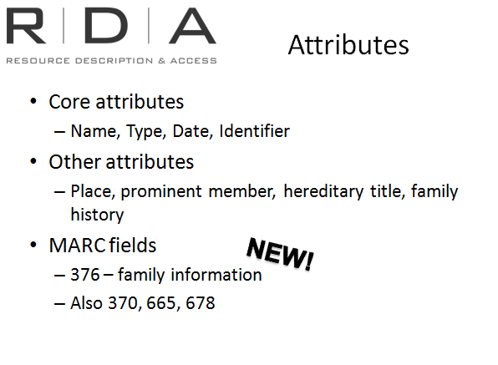
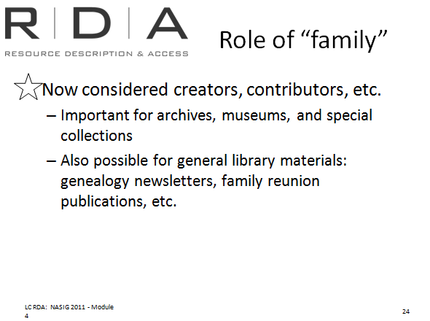
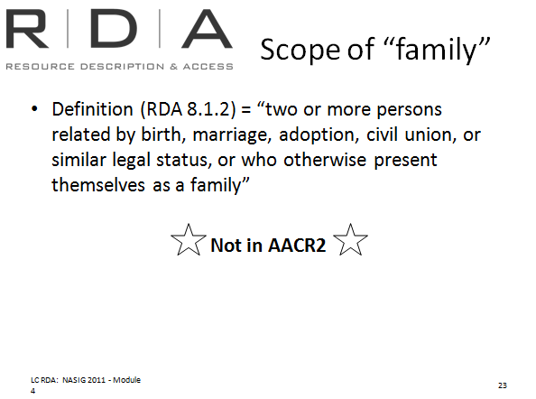
RDA now includes family groups among those entities that can be associated with resources.

Scope of “Families”
The definition of family in RDA is “two or more persons related by birth, marriage, adoption, civil union, or similar legal status, or who otherwise present themselves as a family” (RDA 8.1.2)

Considering families as creators and contributors not just as subjects, is part of expanding the application of RDA beyond libraries to other information communities including archives and museums, where families are key creators and contributors, owners or custodians of resources.
But there are also instances of families being responsible for general library materials (family histories, family reunion publications, etc).
Like Chapter 9, Chapter 10 is divided into two sections; recording the elements and constructing the access points.

Recording attributes – 10.2-10.9
There are 8 attributes for families. The core attributes are name, type (of family, eg Royal), date and identifier. Other attributes are place, prominent member, hereditary title, and family history.
A new MARC field, 376 – family information, has been set up to record most of the family information except for place, which is recorded in the 370 field, and family history, which is recorded either in the 665 or 678 fields. After we’ve talked through the attributes, we’ll look at some examples so you can see how it will look in MARC.
So let’s have a look at some of the family attributes

Form of preferred name
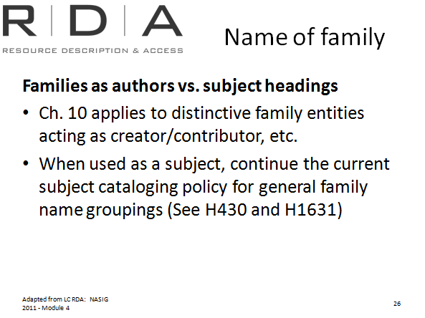
Chapter 10 of RDA applies only when families are acting as creators. When used in this context, the form of name used is the name preferred by that family only.
When families are used as a subject access point, we will continue the current subject cataloguing policy of using one preferred form of name to represent all families with that name in any its forms.
This is because it is still useful in the subject file to be able to co-locate all the resources relating to families with that name, whatever the form.
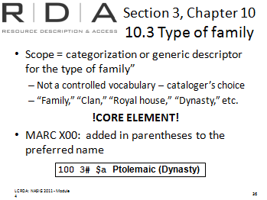

Type of family
This attribute is a descriptor with which you can categorise the group as simply a “family” or more specifically a “clan”, “royal house”, “dynasty”, etc. There is not a controlled vocabulary for the term used for the core element Type of family. The cataloger can choose an appropriate term such as “family,” “clan,” etc.
This element is given in parentheses at the end of the preferred name and is a core element
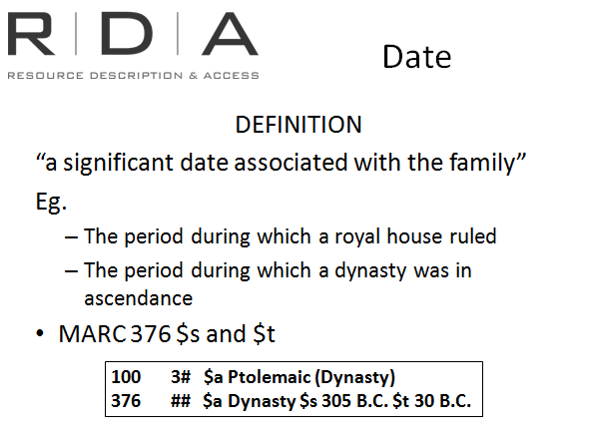

Date associated with family 10.4
RDA defines associated dates and places for a family as “a significant date associated with the family”. Remember that we are talking about the preferred way that family will be referred to whenever their name is used in association with a resource, so it can’t be just a date relevant to one resource. Some examples of dates might be:
- The period during which a royal house ruled
- The period during which a dynasty was in ascendance
Start and end dates are recorded in the $s and $t subfields of the 376
Instructions for recording dates are in Appendix H of the Toolkit

Place associated with family 10.5
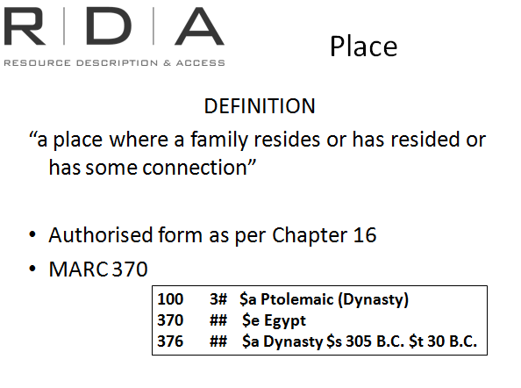
This is defined as “a place where a family resides or has resided or has some connection”. Place is given in the authorised form for that place (which we’ll look at in the next module) and is recorded in the 370 field – subfield e.

Other elements

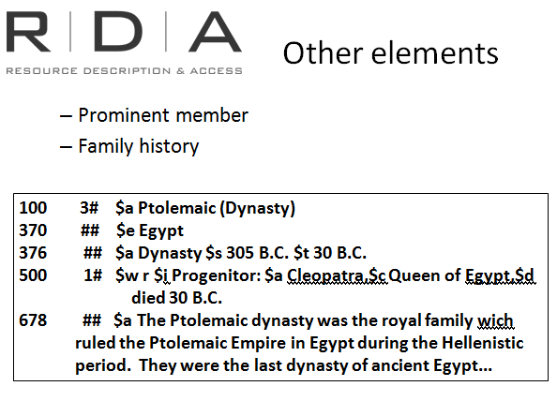
Prominent member 10.6
Those who have catalogued a lot of family histories will be familiar with the concept of the “founder” or “Progenitor” of a family who is often used as the starting point of the family history.
For the purposes of RDA, however, a prominent member is simply someone within the family who is well-known and can therefore be used to help uniquely identify this family.
Record in the 500 – see also from tracing – personal name

Family history 10.8
This is a note attribute, for recording a summary of the family’s history. The information is recorded either in the 665 (History reference), or 678 (Biographical or historical note)

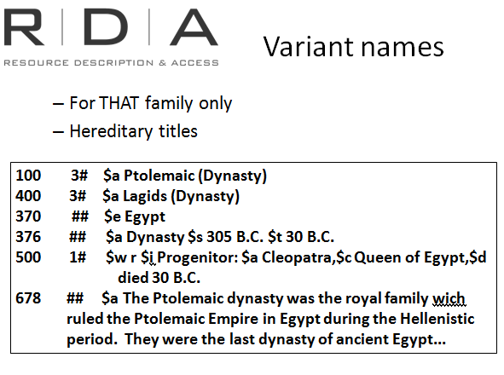

Variant names 10.2.3
When recording variant names for a family, remember that as for the preferred name, you are only recording the variant names that are used for that particular family, not every possible permutation of the name as in LCSH.

Hereditary titles
Hereditary titles are not used as the entry element for a family name, but rather an extra identifying attribute, when needed. However, if there is a hereditary title it should be recorded as a variant name for the family.

Constructing access points 10.10
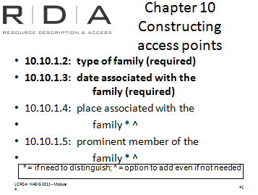
The same principles apply here as with personal names. The preferred name forms the basis of the access point, and then certain extra elements can be added to make it unique if required.
For families type, date, place, and prominent member can be used in the access point. Type of family and date (if known) should always be included in the access point.
In MARC, family names are recorded in a 100 field, with first indicator “3” to indicate that it is a family access point. Apart from the $d for dates, there are no specific subfields defined in 100 for family attributes. Mostly, they will be recorded as part of the $a subfield, and in the $c (Titles and other words associated with a name) or $g(Miscellaneous information). Let’s look at some examples:

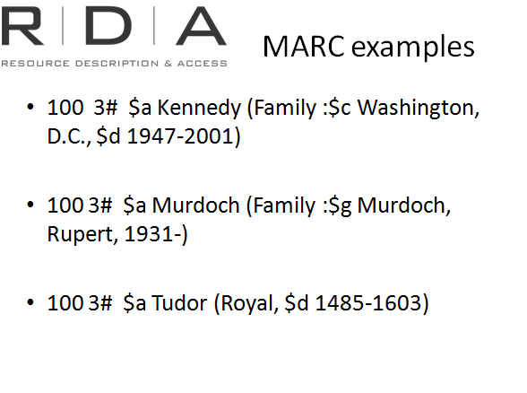
Examples
In MARC, family names are recorded in a 100 field, with first indicator “3” to indicate that it is a family access point.
Apart from the $d for dates, there are no specific subfields defined in 100 for family attributes. Mostly, they will be recorded as part of the $a subfield, and in the $c (Titles and other words associated with a name) or $g(Miscellaneous information). Here are some examples.
Preferred Name of family is core
Type of family
Date
Place – if needed to distinguish
Prominent family member – if needed to distinguish
None of these additions are core, however there are options to add

Exercise 17 cont.
Handbook: Page 179
B: Families
4. Use the information provided about the Jackson Family and fill in the table.
Note: Not all fields will apply.
The Jackson family is an American family of singers who originated in Gary, Indiana, performing as members of The Jackson 5 between 1964 and 1990.
As a group, the eldest sons Jackie (Sigmund Esco "Jackie" Jackson), Tito (Toriano Adaryll "Tito" Jackson ), Jermaine (Jermaine La Jaune Jackson), Marlon (Marlon David Jackson), and Michael (Michael Joseph Jackson), set the family on a path of musical success that spread among siblings Rebbie, La Toya, Randy, and Janet. All the siblings became professional musicians and continue to perform as solo artists.
In recent years, certain members of the family have been honoured for their work; in 1997 The Jackson 5 were inducted to the Rock and Roll Hall of Fame. Michael followed the group to the hall in 2001. The Jacksons, Michael and Janet all received stars on the Hollywood Walk of Fame in 1980, 1984 and 1990 respectively. Michael, born in 1958, died in June 2009.
(Source: Wikipedia viewed 10 August 2012)
RDA Element | MARC tag and subfields | Data Recorded
10.2.2 Preferred name for the family | 100 3# $a | Jackson
10.3 Type of family |  | Family
10.3 Date associated with the family |  | 1964-
10.5 Place associated with the family |  | Gary, Indiana
10.6 Prominent member of the family |  | Jackson, Michael, 1958-2009
10.7 Hereditary Title
10.8 Family History |  | The Jackson family is an American family of singers who originated in Gary, Indiana, performing as members of The Jackson 5 between 1964 and 1990.
10.9 Identifier for the Family
10.10 Access point |  | Jackson (Family : Jackson, Michael, 1958-2009)
10.10.2 Variant Access point

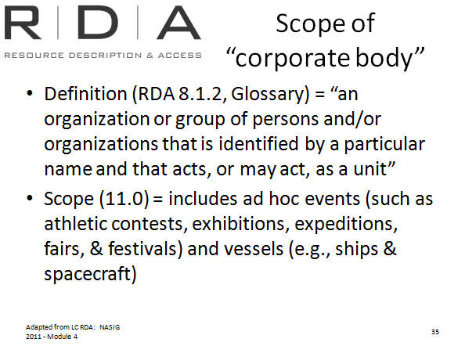
Chapter 11: Identifying corporate bodies

Scope of “Corporate body”
Handbook: Page 97
RDA continues the AACR2 definition of corporate bodies. A broad definition of corporate body is given under terminology in Chapter 8 and in the Glossary, but the scope statement at the beginning of chapter 11 is the most helpful in determining what constitutes a corporate body.

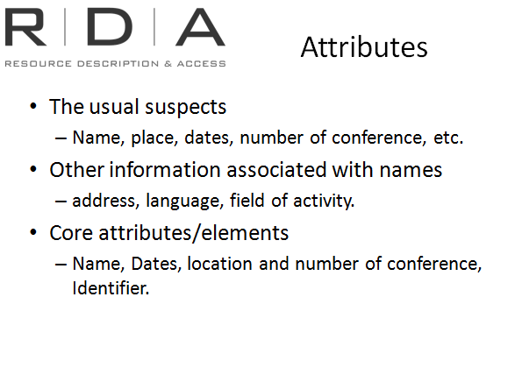
Recording attributes – 11.2 - 11.12
Again we start with the attributes, before looking at constructing access points. Among the attributes of corporate body, we see the usual suspects - Name, place, dates, number of conference, etc. But there’s also some new elements - address, language, and field of activity.
There’s also a key change in the core attributes for corporate bodies. Dates, which in AACR2 were core for conferences, but only used for other bodies if there was a conflict, are now a core attribute to record for all corporate bodies (though they are not required in the access point)

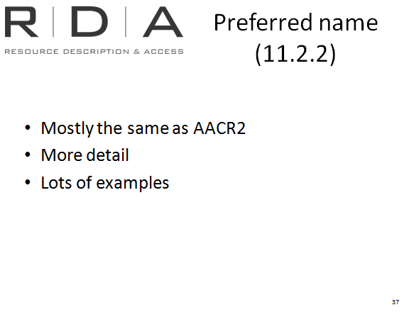
11.2 Name of corporate body
The instructions for choosing the preferred name do not differ very much from AACR2. There is more detail in the instructions and lots more examples.
There are a few changes worth drawing to your attention:
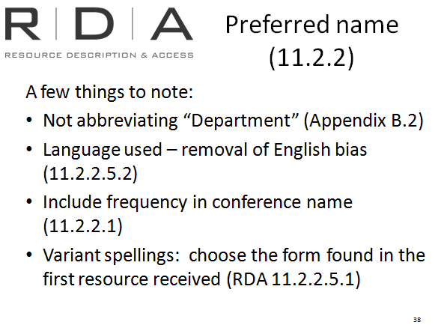
- We do not abbreviate the word “Department” in a preferred name. We should not have been abbreviating it in AACR2 either but we generally did so in line with an LCRI which specified the abbreviation. The LCPS does not contain such an instruction.
- RDA removes the English language bias when choosing which language to record the name in.
- Words indicating frequency are no longer omitted from conference names.
- For variant spellings: choose the form found in the first resource received, not the predominant spelling.

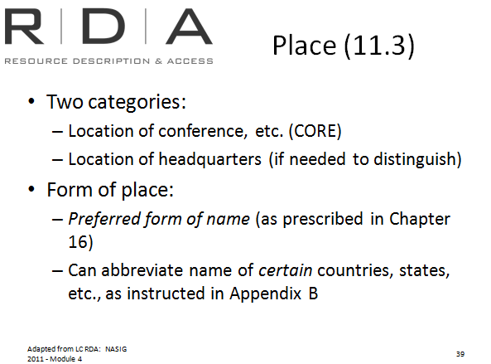
11.3 Place
The attribute “Place associated with a corporate body” is used in the same way as it was in AACR2, either to give the location of a conference or, for other corporate bodies, if needed to distinguish from another corporate body. The place element is core for conferences.
The form of the place is based on the instructions in chapter 16 (the counterpart to AACR2’s chapter 23 – which we will cover in the next module). Note that for place names, some abbreviations are able to be used in certain circumstances.

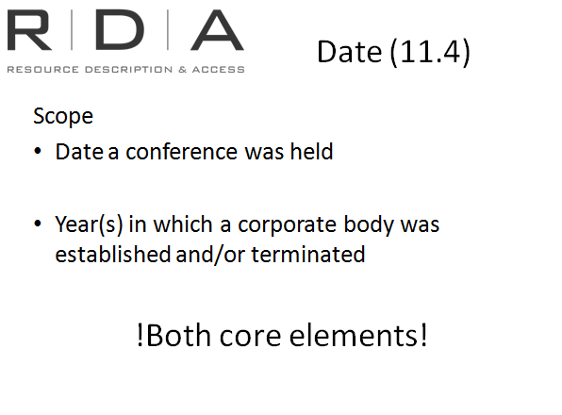
11.4 Date
The date element for corporate body covers both conference dates and dates of establishment and termination of corporate bodies. AACR2 also include both of these types, but only the conference date was routinely recorded.
In RDA, BOTH types of dates are now a core element (though only the conference date will be required for the access point)

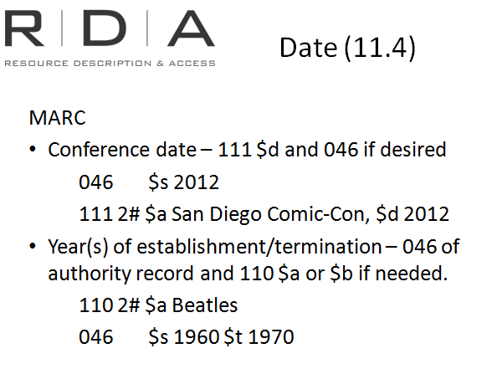
Conference date will be recorded in the 111 $d field, because it is a required addition to the access point. But it can also go in the 046 if desired. Dates for other corporate bodies will be recorded in the 046 of the authority record. If they are used in the access point, they are recorded in parenthesis in the same subfield as the name, so either the $a or the $b

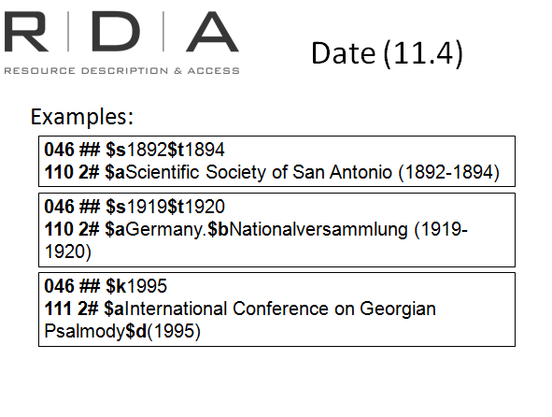
For example:

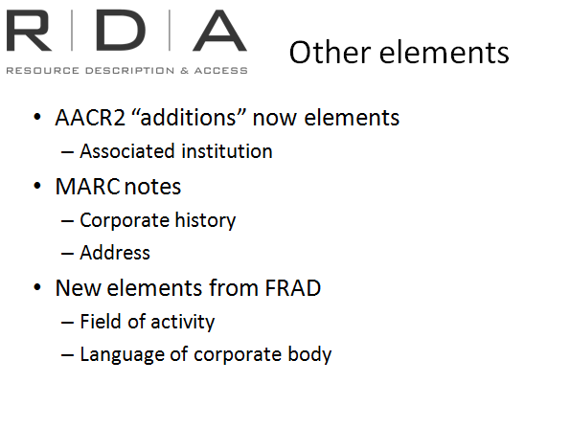
11.5-11.12 Other identifying elements
The other identifying elements that can be recorded for corporate bodies bring together
- AACR2 “Additions” that have been given element status in their own right in RDA, such as Associated Institution
- Information already recorded in note fields of the MARC authority record, such as corporate history, address
- NEW elements from FRAD, such as Field of activity and language of corporate body

11.13 Constructing access points
For Corporate Bodies, there are seven elements that can be added to name in the access point. Number, date and location of conference, and the qualifier for names not conveying the idea of a corporate body, are the only required additions. As usual, there are some others that required if needed to make the access point unique, and some that can be added whether or not they are needed.
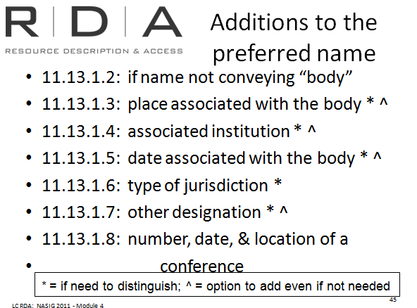

Here are those seven possible additions. The same symbols are used here to indicate when the additions must and can be used.

Examples
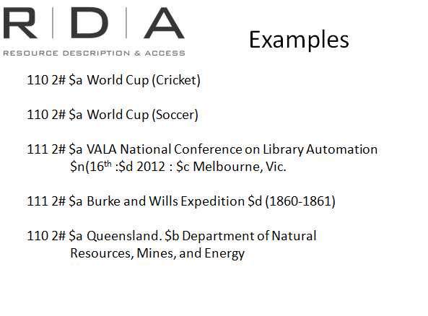
1. Additions to names as instructed under 11.13.1.7
and 11.7.1.6
2. Conference constructed according to 11.13.1.8
- number 11.6
-Date 11.4.2
-Location 11.3.2
3. Subordinate government body 11.2.2.19 (note “Department” not abbreviated”)

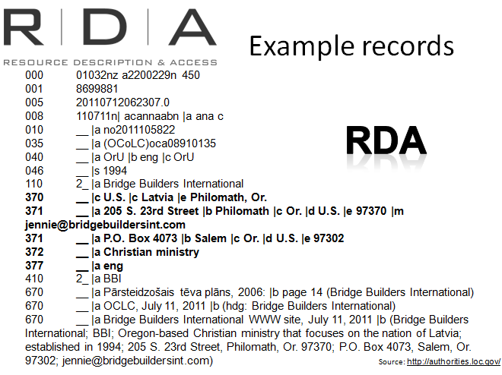

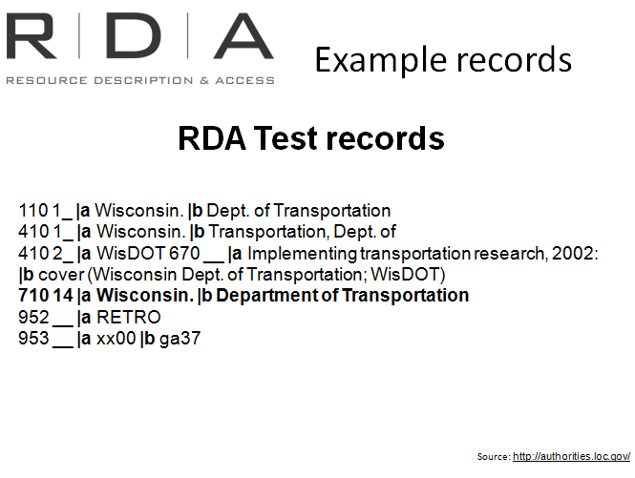
Exercise 17 cont.

C: Corporate bodies
Handbook: Page 180
5. Use the template below to create an authority record for the Abyssinian Cat club of Australasia.
Title page: Cover
The Abyssinian
Published by
Abyssinian Cat Club of Australasia

Abyssinian Cat Club of Australasia
Based in Sydney, the ACCA, is a specialist breed club for breeders, owners and exhibitors of Abyssinian and Somali cats. We are affiliated with the NSW Cat Fanciers Association.
Contact us:
PO Box 31, Branxton, N.S.W., 2335
somali@internode.on.net

RDA Reference | RDA Element | Notes | MARC field | Data Recorded
 |  |  | 046 $s | 1966
11.2 |  |  | 110  2# $a | Abyssinian Cat Club of Australasia
11.3 |  |  | 370  $e | Sydney, N.S.W.
11.9 |  |  | 371  $a | PO Box 31, $bBranxton, $cN.S.W., $e2335  $m somali@internode.on.net
11.10 |  |  | 372  $a | The Abyssinian Cat Club of Australasia is a specialist breed club for breeders, owners and exhibitors of Abyssinian and Somali cats.
11.8 |  |  | 377  $a | eng
11.2.3 |  |  | 410  $a | ACCA
11.2.2.6 &  32.1 |  | Former name | 510  $a | NSW Cat Fanciers Association
8.12 |  |  | 670  $a | The Abyssinian $b cover (Abyssinian Cat Club of Australasia Inc.)

Module 8: Summary
