Teaching RDA: Day 2

Module 9: Attributes of [concept, object, event], place (RDA Section 4)
Handbook: Page 102

Learning Outcomes
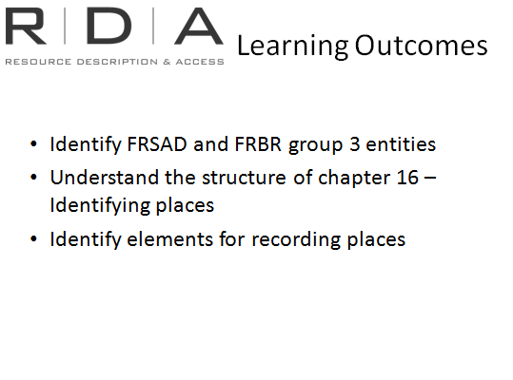
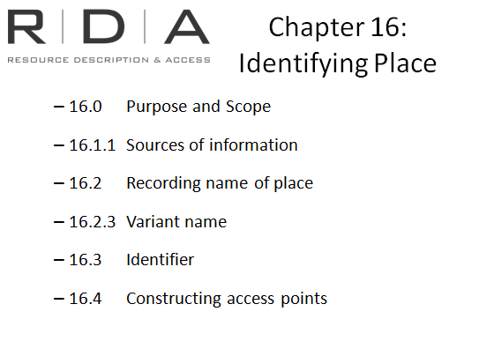
[This is a short module, because most of Section 4 of RDA is not yet written. Includes a quick quiz at the end].
Take a look in chapters 12 – 15 of RDA. There is nothing there!
FRBR and FRAD defined the “Group 3” or subject entities of Concept, Object, Event, and Place.
It was always intended therefore that RDA’s scope would expand on AACR2 by providing guidance on creating records and constructing access points for subjects. But it was decided to hold these off for a later phase of development, partly because FRSAD, the document intended to further develop a model specifically for subjects had not yet been developed. It was published at the same time as RDA, in June 2010.

Resources:
- No additional resources

Chapter 16: Identifying Place

Scope
It was decided that a chapter on Places should be included in the first phase of RDA because Place names are commonly used as the names of governments, or as additions to titles of works, families and corporate bodies, conference names, or even in simply recording places associated with a persons, families, and corporate bodies.
For now, it is only in this context that Chapter 16 should be used. The use of places as subjects has not yet been covered.
Largely, the instructions are unchanged from AACR2, but I will point out a few things about recording names of places.

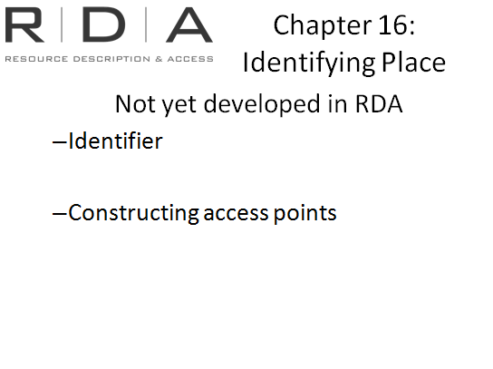
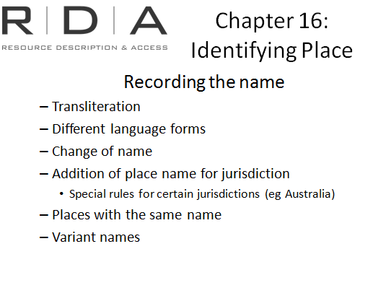
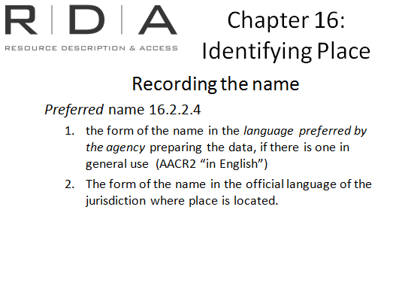
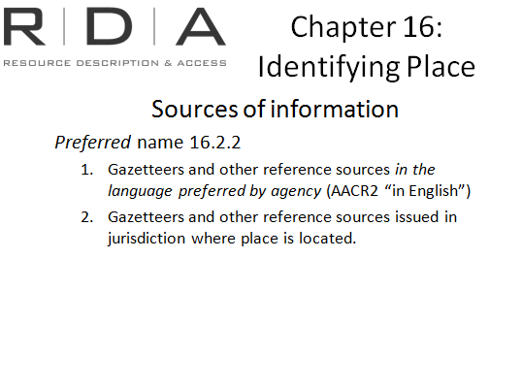
Firstly, RDA now has separate instructions for determining a source of information, which AACR2 did not (though sources of information were mentioned throughout the rules). This means they are easier to locate and more useful.
There is a key difference here from AACR2 related to language. AACR2 specified that the preferred name of a place should be determined from English sources. RDA removes this English bias and instead specifies sources in the language preferred by the cataloguing agency. If there is no commonly used version in that language, then sources from the jurisdiction in which the place is located should be consulted. This latter is unchanged from AACR2.

It follows then that when you are choosing the form of the preferred name, the same will apply.

The remainder of the section on recording the name of a place, contains instructions for all the special situations we are used to, and is unchanged from AACR2.

Identifiers for Place names and Constructing Access Points

16.3-16.4

These sections have not yet been developed, and will be done as part of expanding the scope of RDA to include subjects.

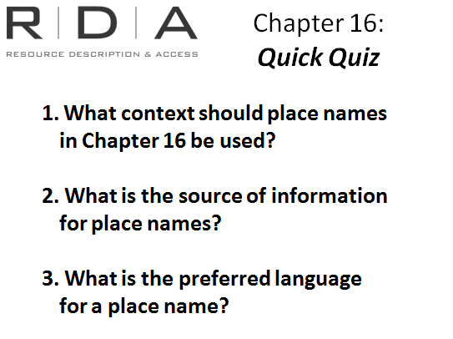
Reflection Exercise
- What context should place names in Chapter 16 be used?
In the names of governments and communities that are not governments. Additions to titles of works, as additions to the names of corporate bodies to distinguish between bodies with the same name, as additions to conference names and in recording places associated with a person, family or corporate body. They are not at present used in subject headings
- What is the source of information for place names?
Gazetteers and references sources in the language of the cataloguing agency or Gazetteers and reference sources issued in the jurisdiction of the location of the place
- What is the preferred language for a place name?
The language preferred by the cataloguing or; form of name in the language of the jurisdiction of the location of the place

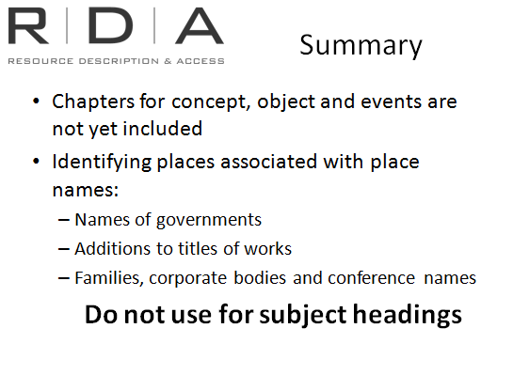
Summary

End of Day Two

