Slide 1



In this presentation I will examine some of the background to RDA:

How it came about, and;
What influenced its development.

Slide 2

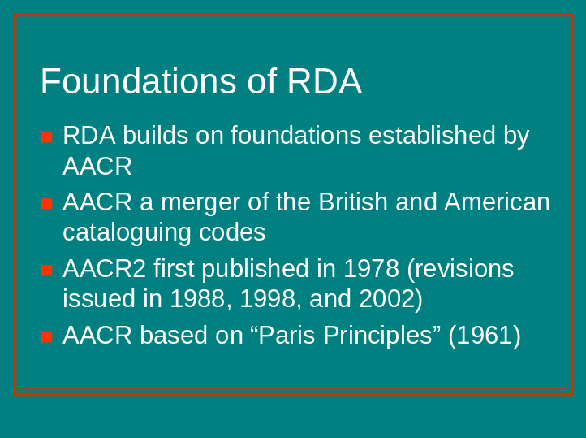

RDA is evolving from the Anglo-American Cataloguing Rules (AACR), which most of you will have used, or be familiar with.
AACR has a long history, and can trace its origins back to the 19th century in the UK and the US.
AACR is a merger of the British and American cataloguing codes, which had been developing simultaneously. AACR2 (2nd edition of AACR) was first published in 1978.
AACR2 was revised in 1988, 1998, and 2002 (the same basic structure was retained; the most significant changes reflect new approaches to cataloguing electronic resources, serials, and integrating resources).
AACR was based on the Paris Principles, developed in 1961 at a conference held by the International Federation of Library Associations (IFLA); these principles form the foundation of most national cataloguing codes.

Slide 3

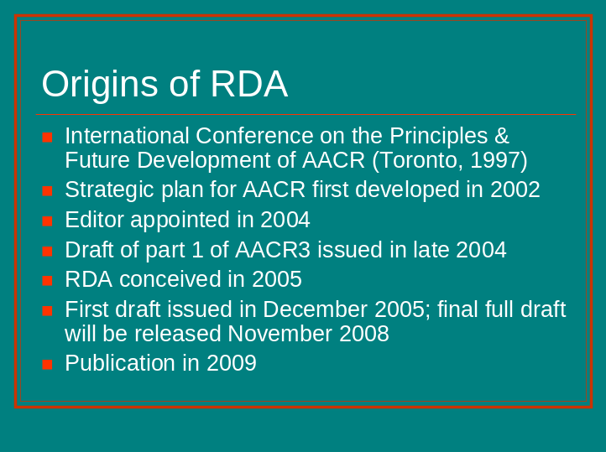

A conference was held in Toronto in 1997 to examine the underlying principles of AACR and to evaluate the need for fundamental change.
The recommendations from this conference set in train a program of work leading to the development of a strategic plan, which clearly stated the need to develop a new edition of the rules.
An editor (Tom Delsey) was appointed in 2004.
Work began on AACR3 after the Editor was appointed.
A draft of part 1 of AACR3 (rules dealing with description) was issued in late 2004.
In response to concerns expressed by the constituencies that the changes did not go far enough, JSC took a new direction and RDA was conceived.
The first draft of part 1 of RDA was released in December 2005, and the final full draft will be made available during the week beginning 3 November 2008.
RDA will be published in 2009.

Slide 4

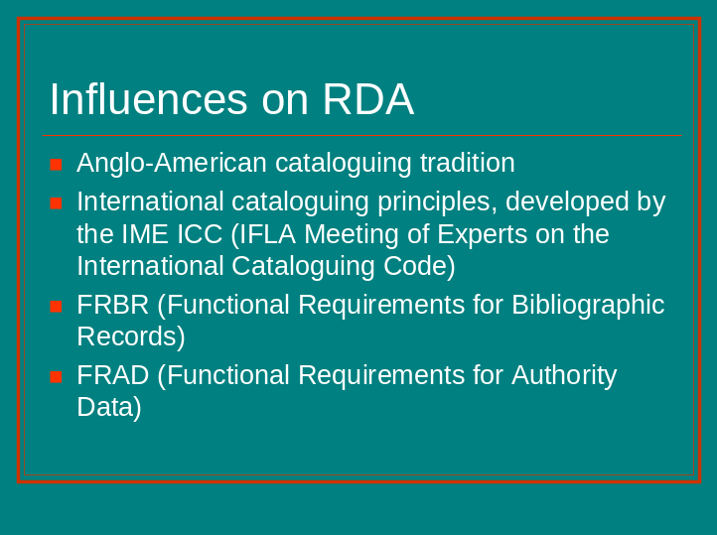

The guidelines in RDA are derived from the rules in AACR. It is intended that AACR2 and RDA records will be compatible and there will not be a requirement for libraries to convert AACR2 records into RDA records.
RDA is being developed with a set of objectives and principles which are based on the IME ICC draft Statement of International Cataloguing Principles, including a glossary of terms.
Underlying RDA are the conceptual models FRBR (Functional Requirements for Bibliographic Records) and FRAD (Functional Requirements for Authority Data).

Slide 5

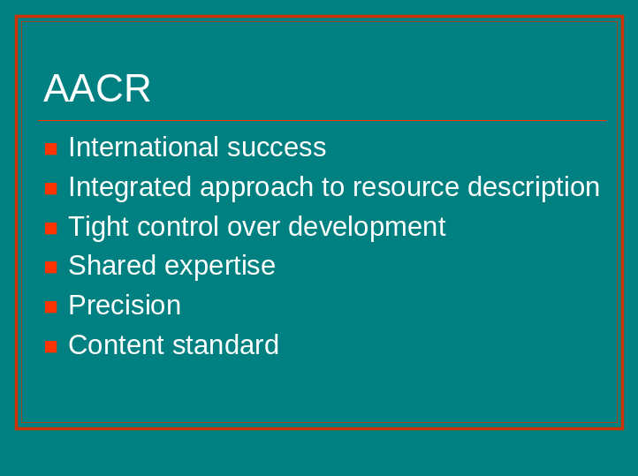

RDA draws on the great strengths of AACR.

International success
AACR is used in libraries throughout the English-speaking world, and also by many libraries in non-English-speaking countries (it has been translated into 24 other languages).
Because of the strict adherence by libraries to the standard, worldwide sharing of records is possible.
2. Integrated approach to resource description
The rules in AACR can be used to catalogue all types of resources, digital and analogue, tangible and intangible, and all types of content.
AACR is appropriate for use in a hybrid environment.
3. Tight control over development
The AACR community has been able to maintain a tight level of control over the development of the rules.
When revisions are published, national cataloguing agencies and most other libraries using AACR comply with the changes.
4. Shared expertise
AACR has benefited from the collective intellectual efforts of many great minds, working at national libraries and independently.
This collaborative approach can slow down the revision process, but it does mean that changes are considered carefully and their potential impact assessed.
5. Precision
AACR is very precise standard, resulting in a high level of precision and recall when searching.
The integration of records in large databases would be impossible without a high level of precision; precision is essential for identification and record matching.
6. Content standard
Unlike other metadata standards like the Dublin Core, AACR and RDA are content standards. The Dublin Core standard gives the categories of data elements to include in a record, but no instructions about how to record the content of these elements.

Slide 6

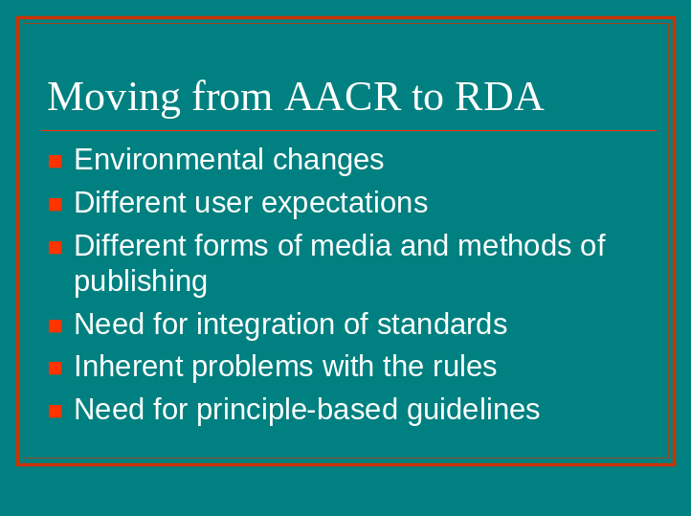

If AACR has been so successful as an international cataloguing standard for libraries, what is the rationale for changing to a new set of rules? Why not bring out a new edition?

1. Environmental changes
Since AACR2 was published in 1978 the world of information has undergone significant change. We have moved from a print-based environment to the World Wide Web.
AACR2 still reflects an emphasis on print and other tangible resources.
2. Different user expectations
Users in this new environment are more demanding; they are used to using search engines on the Web and expect systems that are easy to use and that produce instant results.
Users expect a “one-stop shop” and a more integrated approach when searching for information.
3. Different forms of media and methods of publishing
Print is not dead, but there are many more different carriers of information than there were in 1978.
The growing trend for works to be published in multiple manifestations is causing problems for catalogue users. It is an underlying principle of AACR that the manifestation is the focus of description, and this can result in several catalogue records for the same work or expression. The manifestation will remain the focus, but a way must be found of enabling library catalogues to group multiple manifestations for display.
4. Need for integration of standards
The pressure for “one-stop shop” searching has brought into focus the need for a more integrated approach to standards development.
The proliferation of other types of metadata standards will result in interoperability at the very broadest level unless there is more collaboration.
Library catalogues cannot exist in isolation.
AACR and RDA are metadata standards too.
One of the goals of RDA is to extend use of the standard beyond the library community. However, if other resource description communities are to use it, it has to be easy to use and interpret.
5. Inherent problems with the rules
There are a number of inherent problems with the current rules that need to be addressed. Examples include: the class of materials concept and the shortcomings of the rules for GMDs (General Material Designations) and SMDs (Specific Material Designations); outdated and complex terminology; deficiencies in the rules for cataloguing digital resources; retention of a card catalogue focus.
6. Need for more principle-based guidelines
AACR is a case-based standard and in some cases inconsistent. There is a need for more principle-based guidelines so that cataloguers can use more judgement and do not have to learn so many rules.

RDA is taking AACR to a new level, producing a standard that is more principle-based, easier to use, more adaptable, and more cost-effective.

Slide 7

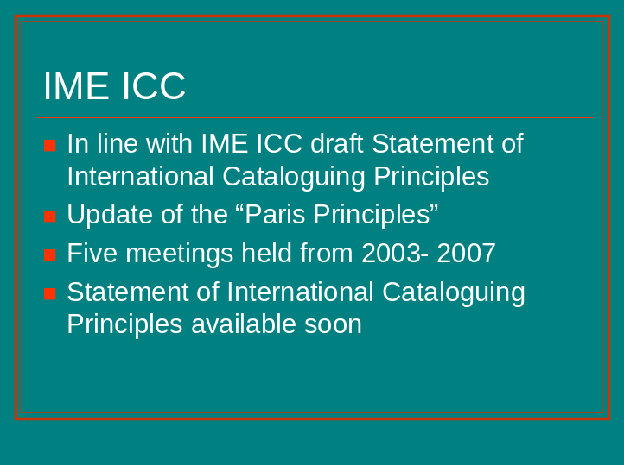

RDA is being developed in line with a set of objectives and principles which are based on the IME ICC draft Statement of International Cataloguing Principles.
The original statement of principles, the “Paris Principles” was approved by the International Conference on Cataloguing Principles in 1961.
The IFLA Cataloguing Section has held a series of five meetings in different regions of the world, beginning in 2003 and finishing in 2007, to bring rule makers and other cataloguing experts together to agree on basic cataloguing principles.
The goal is to develop a common set of principles to cover the content of bibliographic and authority records used in library catalogues worldwide.
The Statement of International Cataloguing Principles was issued as a draft for worldwide comment and is currently being finalised.

Slide 8

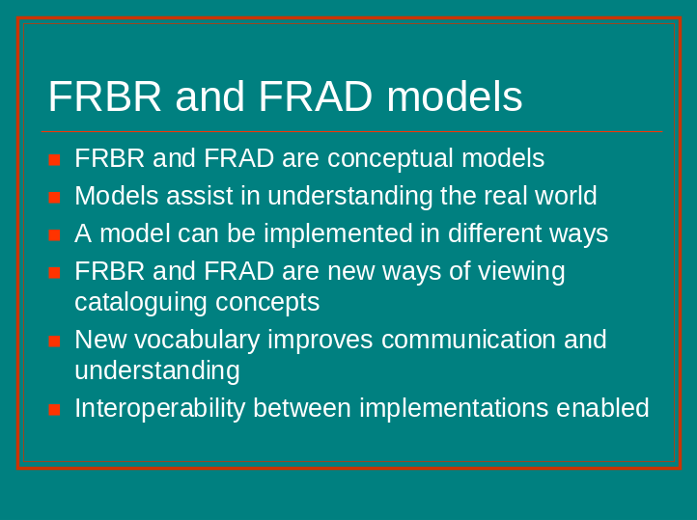

I am now going to look at FRBR and FRAD, and their influence on RDA.
FRBR and FRAD are not sets of rules, but theoretical models.
Conceptual models can help us to understand the real world.
Models do not proscribe how cataloguing rules or guidelines are constructed or implemented, or how online catalogues are designed. They can be based on an understanding and interpretation of the model.
The concepts in FRBR and FRAD are not new. The models give us a new perspective on cataloguing concepts. They also provide a new vocabulary to improve communication and to ensure a common understanding of cataloguing concepts, enabling interoperability between implementations.

Slide 9

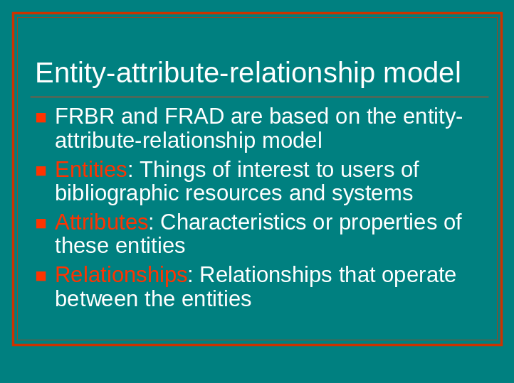

FRBR and FRAD are based on the entity-attribute-relationship model, applied to the bibliographic universe.
Entities are things of interest to users of bibliographic resources and systems. The models identify the key entities and defines them.
Entities have attributes or characteristics. In FRBR and FRAD, the attributes (or data elements) of each entity are identified.
Relationships between the different entities are also specified.

Slide 10

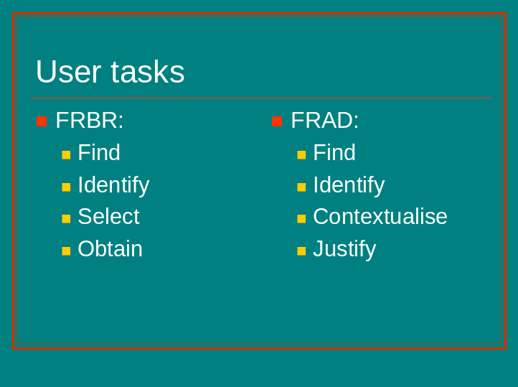

The models identify key user tasks and map the attributes and relationships to these tasks.

The FRBR user tasks are:
To find entities that correspond to a user’s search criteria
To identify an entity
To select an entity that matches a user’s needs
To acquire or obtain access to the entity described

The FRAD user tasks are specific to what cataloguers do when working with authority data. The first three tasks apply to end users and cataloguers; the fourth applies only to cataloguers. They are:
To find entities that correspond to stated criteria
To identify an entity
To contextualise an entity (i.e. to place a person, corporate body, work, etc. in context, clarifying the relationship between two or more persons, corporate bodies, works, etc., or clarifying the relationship between the person, corporate body, etc. and the name by which that person, corporate body, etc. is known)
To justify an entity (to document the authority record creator’s reason for choosing the name or form of name on which a controlled access point is based)

Slide 11

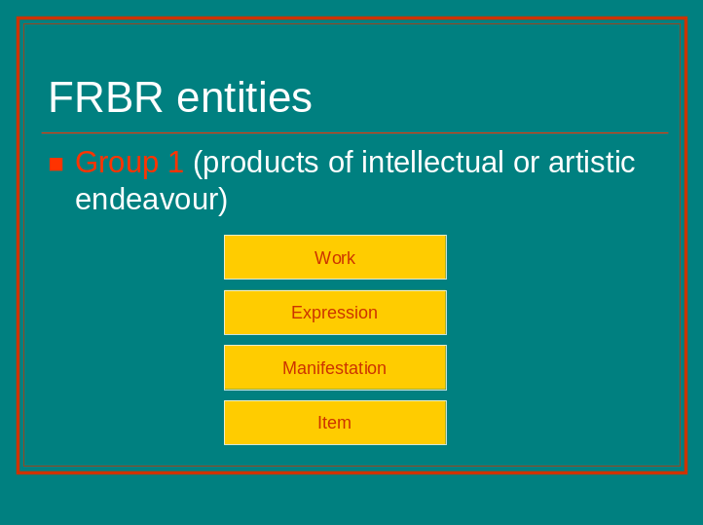

FRBR entities are divided into three groups.

Group 1 entities are the products of intellectual or artistic endeavour. These are the entities that you are probably most familiar with, and these are the entities that are being used in most “FRBRisation” projects. Cataloguers catalogue from the item in hand, drawing inferences about the attributes of other FRBR entities, from item to work. However, for display purposes, the top-down representation is the most helpful to users. The work entity can be named at the top level of the hierarchy, followed by names of the expressions, and then by descriptions of manifestations of the expressions.

A work is defined as a distinct intellectual or artistic creation. It is an abstract concept with no single material object that one can point to.
A work is realised through individual expressions of the work. A change in form (e.g. change from written word to spoken word) or a change in intellectual approach (e.g. a translation from one language to another or a new edition) results in a new expression. When the modification of the work involves a significant degree of independent intellectual or artistic effort, the result is a new work. Distinguishing between works and expressions is relatively straightforward in the print environment, but can be more problematic when dealing with resources like art objects, moving image materials, and continuing resources. Various communities are still working through the issues involved in distinguishing between the two entities for these types of resources.

Slide 12

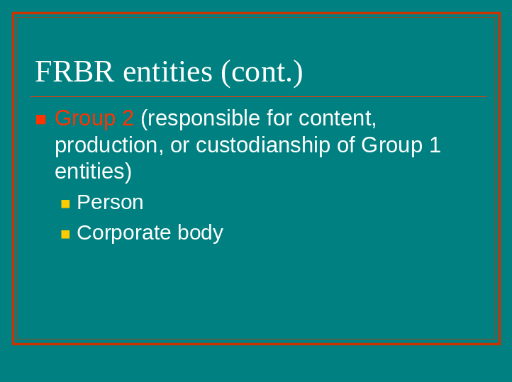

Group 2 entities are the entities responsible for the existence and/or the care of Group 1 entities.

A person is defined as an individual, living or deceased.
A corporate body is defined as an organisation or groups of individuals and/or organisations acting as a unit.
A person or a corporate body is an FRBR entity only if involved in the creation or realisation of a work, or is the subject of a work.
Descriptions of these entities are found in FRAD (more on these later in the presentation).

Slide 13

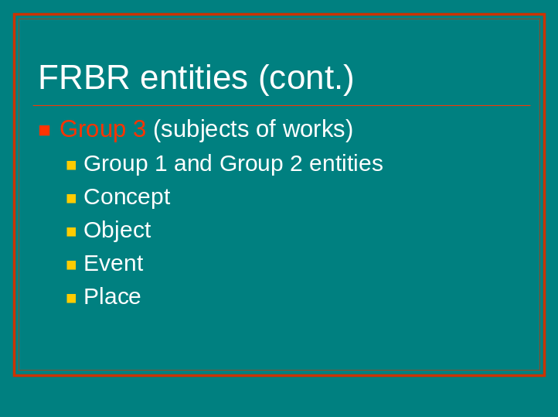

Group 3 entities are the subjects of works

Any Group 1 or Group 2 entity can be the subject of any Group 1 entity.
There are four additional entities in Group 3 that can be the subject of any Group 1 entity (what the work is about):
A concept is an abstract notion or an idea. Concepts can be broad in nature or narrowly defined and precise.
An object is a material thing, either inanimate or animate.
An event is an action or occurrence, e.g. an historical event or a period of time.
A place is a location.

Concepts, objects, events, and places can only be treated as FRBR entities if they are the subjects of Group 1 entities.

Slide 14

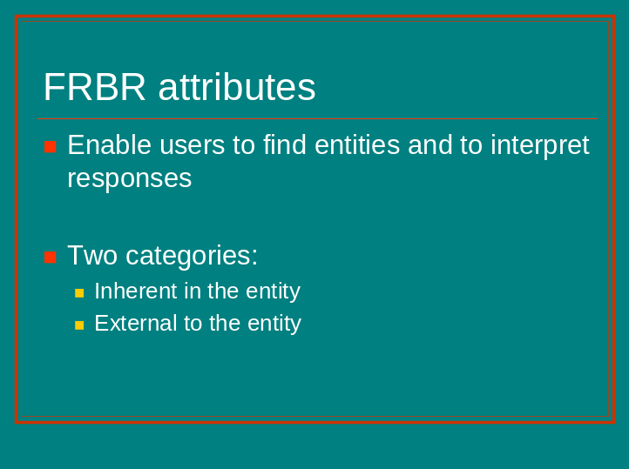

Attributes of an entity are its characteristics or properties.
They enable users to find the entities they need. Users specify particular attributes when formulating queries, e.g. the title of a work. They also interpret responses to their queries when seeking information about a particular entity.
There are two categories of attributes. The first category, which are inherent in the entity, includes physical characteristics (e.g. physical medium) and labelling information (e.g. statements appearing on the title page). Attributes in the second category are found only by reference to an external source (e.g. a thematic catalogue number for a musical composition).

Slide 15

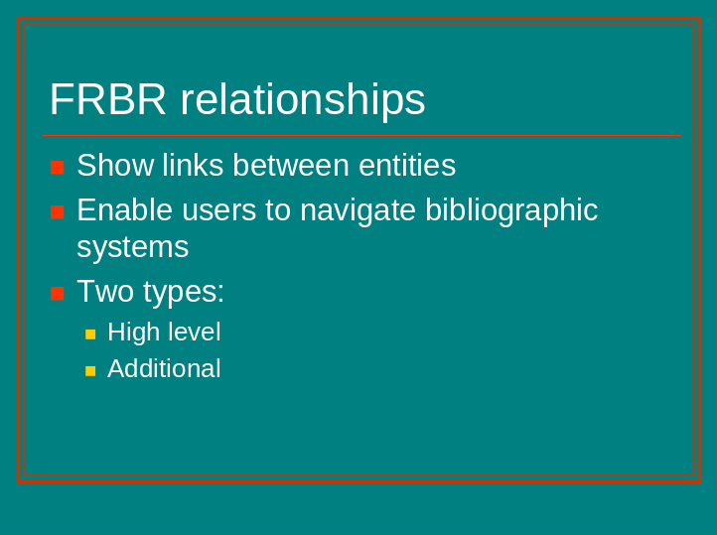

Relationships are used to show the link between one entity and another.
They assist the user to navigate bibliographic systems. The relationships reflected in the bibliographic record enable the user to make connections between the entity found and other entities that are related to that entity. For example, when a work created by a particular person is retrieved in a search, other works created by that person can be retrieved by clicking on the access point for that person.
There are two types of relationships in FRBR:
High level: These relationships between entities operate at the highest level of generalisation in the model – for example, works connected to expressions, works connected to persons and corporate bodies.
Additional: These relationships operate between instances of the same type of entity and between instances of different entity types – for example, work-to-work (sequels, supplements, adaptations, etc.), or expression-to-expression (abridgements, revisions, translations, etc.).

Slide 16

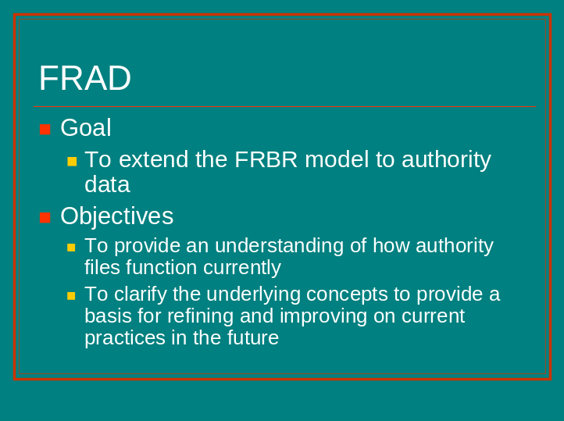

The current draft has the title FRAD (Functional Requirements for Authority Data); earlier drafts were known as FRAR (Functional Requirements for Authority Records).
FRAD extends and expands FRBR to cover authority data.
There are two main objectives:
To provide an understanding of how authority files function currently
To clarify the underlying concepts to provide a basis for refining and improving on current practices in the future
The model focuses on data, regardless of how it may be packaged, e.g. in authority records.

Slide 17

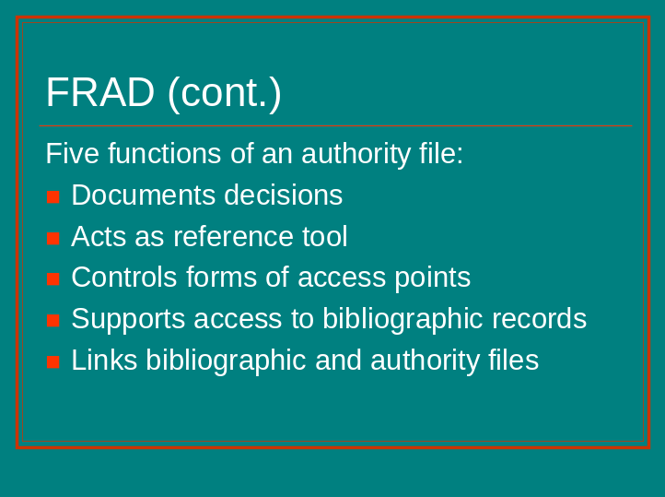

Five functions of an authority file were identified by the developers of the model:

It documents the decisions made by cataloguers when choosing controlled access points, and when formulating new access points.
The information in an authority file is a reference tool for cataloguers when making decisions about controlled access points.
It is used to control the forms of controlled access points used in bibliographic records.
It leads the user from the form of a name searched to the form of name used in the bibliographic file.
It can be used to link bibliographic and authority files.

Slide 18

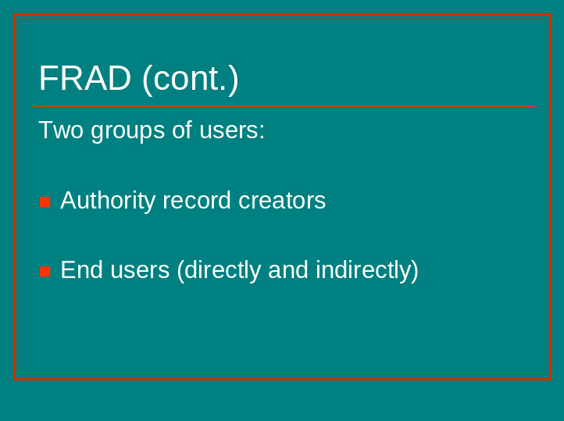

For the purposes of the model, users of authority data include:

Authority data creators who create and maintain authority files;
End users, who use authority information, either through direct access to authority files, or indirectly through the use of controlled access points and reference structures in library catalogues.

Slide 19

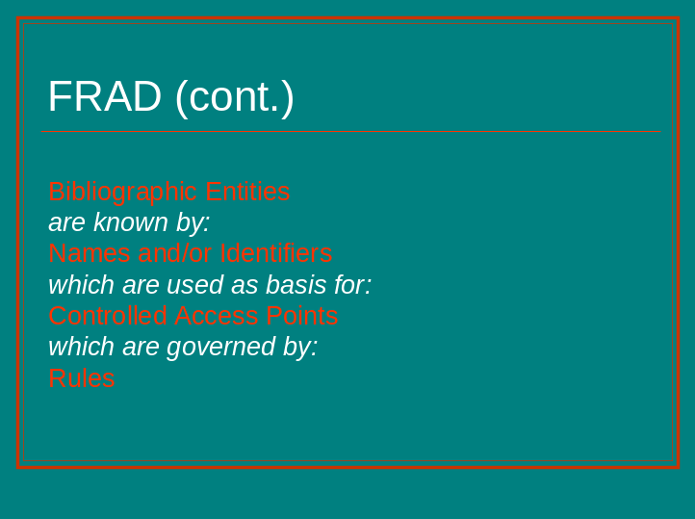

The model can be described in this way:

Entities in the bibliographic universe (those identified in FRBR, with an additional entity family) are known by names and/or identifiers.
In the cataloguing process, those name and identifiers are used as the basis for constructing controlled access points.
Controlled access points may be governed by rules, which may be applied by one or more agencies.

Slide 20

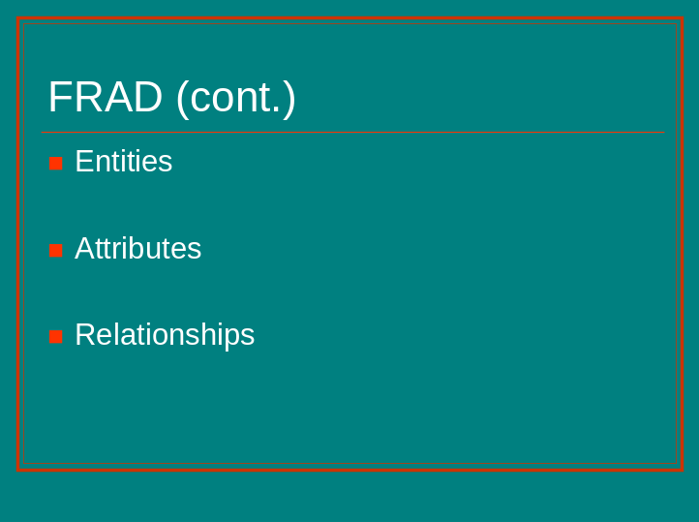

The FRBR entities are included in the model, with a new entity family to accommodate the needs of the archival community. The entities name, identifier, controlled access point, rules, and agency are also included.

Attributes for all the entities are defined in the model. For the FRBR entities, some additional attributes are included, as each entity has other attributes that are part of the processes for determining the names by which an entity is known, and of constructing access points based on those names.

FRBR defines the basic relationships that exist between and/or among the entities. FRAD adds the relationships that exist between and/or among the names of those entities, and between and/or among the access points based on those names.

Slide 21

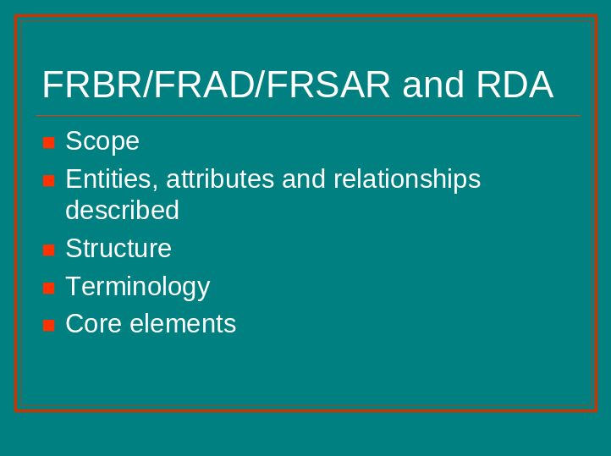

FRBR and FRAD are reflected in RDA in a number of ways. Work on FRSAR (Functional Requirements for Subject Authority Records) is just beginning and RDA will not cover it in its first release. However placeholders for concepts covered in FRSAR have been built into RDA.

The scope of RDA covers bibliographic and authority data as represented in FRBR and FRAD.
The models are reflected in RDA through the entities, attributes and relationships described by the data elements in RDA.
The organisation (i.e. the structure) of RDA reflects FRBR and FRAD. The chapters are linked to the user tasks they relate to.
The terminology of FRBR and FRAD is used in RDA.
The FRBR user tasks have influenced the RDA elements that are defined as core or essential elements.

Records will still be created at the manifestation level using RDA. However if systems change to incorporate the new models, indexing and displays in library catalogues should be vastly improved.

Slide 22

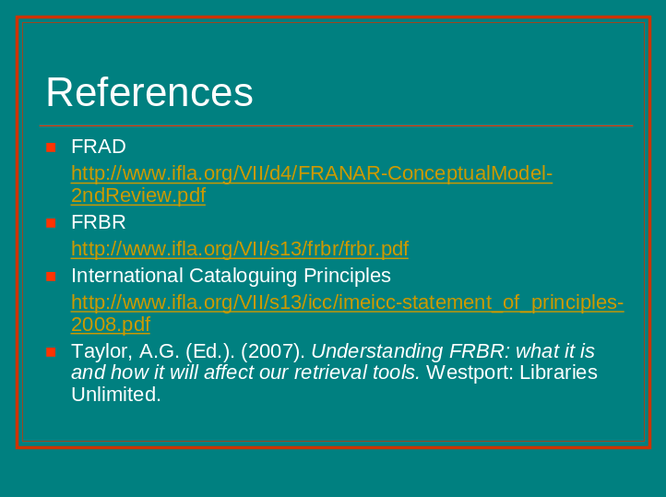

FRAD and FRBR are available online on the IFLA site.

The International Cataloguing Principles are also available online.

In this presentation I have used content from Understanding FRBR: what it is and how it will affect our retrieval tools, edited by Arlene Taylor. Chapters 1 and 2, which are introductions to FRBR and FRAD, written by Arlene Taylor and Glenn Patton respectively, are particularly helpful.

I have also drawn on various presentations, prepared by Deirdre Kiorgaard, Barbara Tillett and others, all of which are available on the RDA site.

