RDA Section | What’s in it
1 – Recording attributes of manifestations and items  Section 1-4 Recording Attributes | Manifestations  - Title of manifestation, publisher, date of publication, edition, series  Items  - Annotations, access, ownership
2 - Recording Attributes of Work & Expression | Works  - Authorised access points (uniform titles)  - Title of the work (note this is different to recording the title of a manifestation) and additions to preferred titles  Expressions  - Form of notation, content type, illustrations
3 - Recording Attributes of Person, Family, & Corporate Body | - Attributes recorded in authority records  - Constructing access points for persons, families and corporate bodies  NOTE: This is not about choosing access points
4 - Recording Attributes of Concept, Object, Event & Place | - Data elements that are recorded in subject authority records – Not yet written
5 - Recording Primary Relationships Between Work, Expression, Manifestation, & Item  Section 5-10 Recording Relationships | - Relationships between work, expression, manifestation and item by using identifiers, authorised access points and composite descriptions
6 - Recording Relationships to Persons, Families, & Corporate Bodies | - Choice of access points for persons, families and corporate bodies  - Relationships established through ‘relationship designators’
7 - Recording Relationships to Concepts, Objects, Events, & Places | - Not yet written  - Choice of subjects
8 - Recording Relationships between Works, Expressions, Manifestations, & Items | - Relationships between work and work ; expression and expression etc.  - Identifiers, access points and descriptions
9 - Recording Relationships between Persons, Families, & Corporate Bodies | - Relationships between a person and a person, person and family etc.  - pseudonyms, former and later names, variant names
10 - Recording Relationships between Concepts, Objects, Events, & Places | - Not yet written  - Relationships between subjects

FRBR / FRAD STRUCTURE
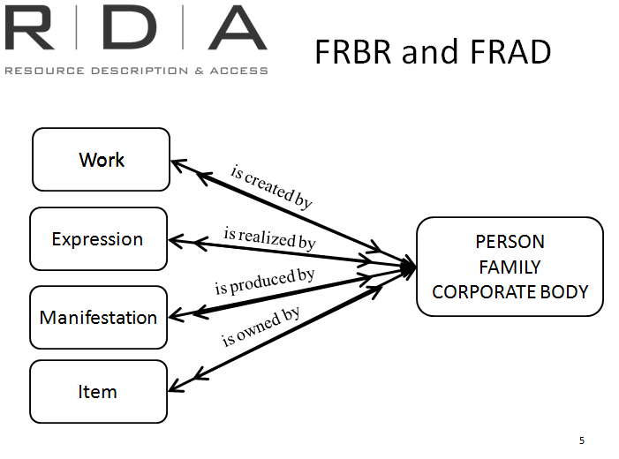
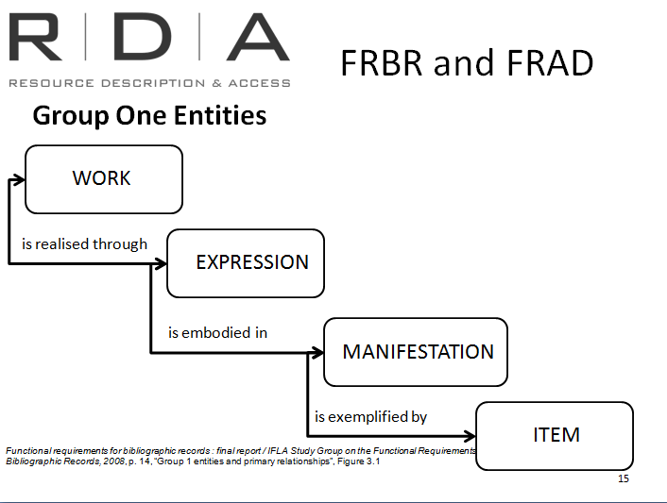

RDA section 2

RDA section 1
RDA section 3

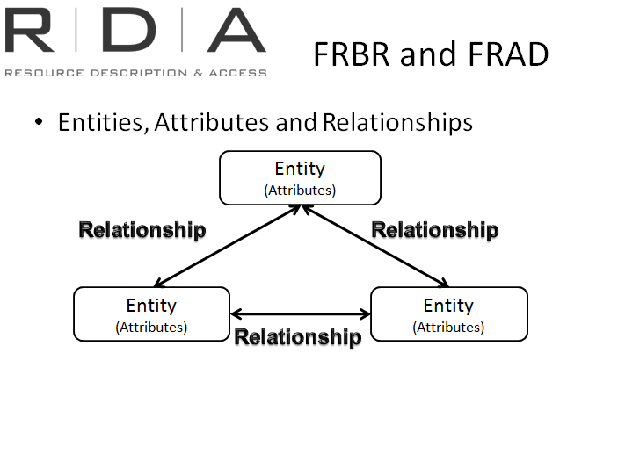
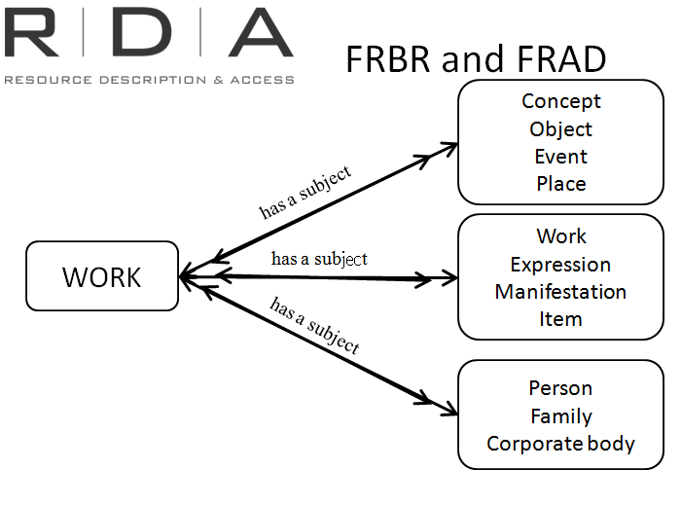

RDA sections 1 to 4
(Recording attributes)

RDA section 4

RDA sections 5 to 10
Recording relationships

