DIRECTORS’ VIEWS ON THE FUTURE OF CATALOGUING IN
AUSTRALIA/NEW ZEALAND, 2007: A SURVEY

JENNY WARREN
SENIOR CATALOGUER, MONASH UNIVERSITY
jenny.warren@lib.monash.edu.au
August 30, 2007

BACKGROUND 2
CONTEXT 2
LAST THINGS FIRST 3
Public libraries 3
State/national libraries 3
Special libraries 4
Tertiary education libraries 4
DETAILED SURVEY RESULTS 5
TYPE AND SIZE 5
ORIGINAL CATALOGUING 6
MULTI-SKILLING 7
PARTICULAR SKILLS OF CATALOGUING STAFF 7
OUTSOURCING 8
QUALITY VERSUS QUANTITY 9
THE MOVE TO METADATA WORK 10
DOWNGRADING AND DE-SKILLING 11
RECENT READINGS ON CATALOGUING 12
LIBRARY SCHOOL COURSES 13
ISSUES ARISING 13
NAME CHANGE 13
RELATIONSHIP WITH IT STAFF 14
CONTINUING EDUCATION 14
EVIDENCE-BASED APPROACH 14
ACKNOWLEDGEMENTS 16
APPENDIX 1 - DEFINITIONS USED IN SURVEY AND SUMMARY OF SURVEY QUESTIONS 17
DEFINITIONS 17
SUMMARY OF SURVEY QUESTIONS 17
APPENDIX 2 – FULL SURVEY RESULTS 20

BACKGROUND

In May 2007 a survey was sent out to directors in Australian and New Zealand libraries on their perceptions of the future of cataloguing. A “director” here is defined as the manager of the division which contains the cataloguing component, preferably at least one step removed from cataloguing and preferably not the head cataloguer.
There were 68 responses. Anonymity was built in, and in the final reporting of results, words which identified an institution were replaced with non-identifying terms. The survey was not intended to be a comprehensive statistical study, but a testing of views, attitudes and beliefs.

It was important and useful to receive responses from businesses and public, special, state and national libraries as well as libraries from the tertiary education sector.
Along with their differences (in staff size, responsibilities and priorities), the survey results were able to bring out the issues they have in common, by analysing all of the responses as one group.

The full survey results, preceded by definitions used and a summary of the questions, form the 55-page appendices of this paper. They provide several starting points for discussion, and create rather a gold mine of pithy observations, representative of the views held by Australian and New Zealand “technical services” managers towards cataloguing in 2007.

CONTEXT

The next generation catalogue might be getting a little easier to see.
A single interface for the discovery of diverse resources looks likely; opening up library data to non-library applications will continue to grow in importance, and faceted browsing is taking off in popularity. Cataloguers know that faceted displays work best with accurate, consistent and comprehensive data.

ILMS vendors have been too slow in their development of OPACs, so that much of the potential of catalogue records has been wasted. It has been difficult to argue the case for certain cataloguing practices when some of the best work has been hidden away on back screens.
This quote from a director in the survey: “High quality records are of importance for many of our materials however deficiencies in our OPACs to use and display high-quality data make this a lower priority than would otherwise be the case.”
That is why cataloguers are so delighted to see projects such as faceted browsing gain popularity. They can showcase the true value of the intellectual work invested in a catalogue record, for example the authority work which is performed on headings.

What the search engine revolution has done is given library OPACs the huge jolt they needed, and we have seen outstanding people in the library world respond by embracing the new principles for use in their own systems.
But they are doing better than that in some cases, with a more tailored use of library resources than a search engine can offer.

A good example of this is the National Library of Australia’s Library Labs search prototype.
One of its features is the use of the authority file in the default keyword search. The NLA has loaded authority records into the prototype and created an “other headings” index from “see” and “see also” references for the search term to run against, and to lead the user to the authorised heading as part of the results screen. After all, users should be able to do a simple keyword search on a see reference type of heading and at least be offered the authorised heading, without having any idea that such a thing as an authority record exists, or that it needs a special kind of search.
Some directors in the survey express firm beliefs that the future is with keyword searching rather then controlled vocabularies, but the NLA’s experiments are showing that perhaps the best answer lies in clever combinations of the two.
Many people suggest that the customising and targeting of information for an audience is where libraries can succeed. Libraries can highlight the fact that they do some things differently and better because they have a reasonable idea who their audiences are, and what elements of library data will help them most.

It would be useful to know where cataloguing fits in the resource discovery discussion.
Experienced cataloguers know how to talk about making their work more efficient; very few are accustomed to answering questions about whether some aspects of it should be performed at all.
It is known that some cataloguers are getting involved in metadata work, but it does not appear to be many, and it is not clear if directors believe that staff with cataloguing skills are the natural choice for that work. To what extent are digital repositories coming under the auspices of libraries?

It seems like a good time to ask managers how they rate cataloguing activity in 2007, and where they believe it might be heading.

LAST THINGS FIRST

The last survey question will be covered first, then the detail of remaining survey questions, and finally, issues arising from the responses.

The 20th and final question of the survey was simply “What do you see as the future of cataloguing in your library and also in Australia/New Zealand in the medium to long term?”

Public libraries
The overriding concern in the public library sector about cataloguing is cost:
As one director commented: “Cataloguing is perceived by many who hold the budgetary controls in our libraries as a resource waster in many ways.”
Respondents expressed a desire to join consortia and other cooperative efforts, and to look further into outsourcing and the centralising of processes.
With the need to devote more of dwindling budgets to customer assistance, there is increasing reliance on the cataloguing of other libraries and vendors. This is sometimes accompanied by concerns over record quality, and an unsatisfactory experience with taking cataloguing from a vendor was reported in the survey.
A belief was expressed that there is a decreasing place for original cataloguers at the local level, and that cataloguers will move from employment in public libraries to book suppliers and agencies.
A cataloguing agency in the survey did report an increasing demand for outsourcing generally.
One director envisaged moving to a single shared catalogue and linking to each library’s LMS for live holdings.

State/national libraries
With larger staff sizes, more original cataloguing and less outsourcing, state and national libraries describe a greater continuing need for highly skilled cataloguers.
Responsibilities to catalogue legal deposit materials and government publications and a concentration on unique, local and heritage items provide a more secure future for cataloguers.
But a wider range of tasks is expected, and more multi-skilling, such as extension into digitisation projects.
More attention is being given to the possibilities of batch processing for commercial materials, with cataloguers playing a quality management role.
There is concern about the loss of expertise as senior cataloguers retire, so that: “Ironically at the very time that there will be pressure to simplify cataloguing, new interfaces will depend on well structured metadata to deliver FRBR displays and features like faceted browsing.”

Special libraries
Special libraries report on average a large proportion of high-value original cataloguing devoted to specialised subject materials, carried out with relatively small cataloguing staff sizes and little outsourcing so far.
These libraries value analytical skills and subject knowledge in their staff, and some directors see MARC, LCSH and AACR as irrelevant in a context of keyword searching and specialised thesauri.
Most directors want library courses to give more emphasis to indexing and metadata than to traditional cataloguing skills.
Some of their cataloguers are already working on in-house web sites and databases, and there is an expressed requirement for cataloguers to widen their engagement with clients to build up their specialist knowledge.
“We do business using a variety of services and products, of which the catalogue (web OPAC) is only one. There is no future in special libraries for a person with one skill set only.”

Tertiary education libraries
Technical services departments in tertiary education libraries are taking on a broader range of tasks within the institution, such as involvement in research data management. There is an intense focus on institutional repositories at the moment, causing metadata skills to be increasingly required.
Some libraries are recognising a natural progression from cataloguing to metadata work and are training their staff successfully for a smooth transition. Others are reporting impediments such as the attitudes and abilities of the cataloguers themselves.

Budget pressures are driving the definition of a high quality record downwards.
There is a call for less rigidity in the adherence to cataloguing standards and rules. Directors want cataloguers to concentrate on the issues that affect retrieval and to become more aware of how users are actually searching for material. Cataloguers will also need to develop the capacity to handle bulk loads of records and perform quality management of them.
“Higher level technical ability will be required by a few key staff who will have broad data analysis skills.”
Directors are actively exploring partnerships between publishers, suppliers and libraries, including library consortia, for varying degrees of outsourcing. There is a stated aim of influencing providers to increase the quality of their records.

With the increase in availability of copy records and the increase in proportion of electronic resources covered by outsourced records, there has been a devaluation, de-skilling and multi-skilling of copy cataloguers, and a drop in the proportion of original cataloguing performed.
Original cataloguing is still valued, especially for rare and institutional material such as theses, and the skills that go with it are seen as capable of making necessary contributions to the overall research discovery effort, including federated searching configurations.
Amidst the significant difficulties which directors have recorded in finding trained staff as more and more highly experienced cataloguers retire, reports are coming from outside the survey of retiring staff being hired back as casuals to fill the skills gap in the short term.

DETAILED SURVEY RESULTS

TYPE AND SIZE

Making up the 68 respondents were directors from 38 tertiary education libraries, 13 special libraries, 7 public libraries, 7 state or national libraries, 1 Aboriginal library, 1 cataloguing agency and 1 business unit providing services to public libraries.
Initially categorising themselves as “Other” (specifically “TAFE”, “academic” and “small university”), 3 libraries were moved into the tertiary education category. A "state and public combined" library was moved into state/national, and a “government” library was moved into the special category.

Two of the special libraries have no cataloguing staff and use outsourcing and contract cataloguers.
Most libraries, except for state/national, employ fewer than 5 full-time equivalent cataloguers. Considerably fewer libraries employ 5-10 fte cataloguers, and 6 of the 7 state/national libraries employ more than 10, along with 6 of the tertiary education libraries.

It was expected that the survey would provide evidence that the term “cataloguer” is on the way out, particularly for non-professional staff, but some sites are well ahead on that score.
Also, many sites reported that their cataloguing staff are engaged in various other activities.
This comment from a tertiary education library: “[We do] not have specific "cataloguers" any more; those professional positions in our Collection Management Unit are now "CMU Team Coordinators" and they may be asked to do any professional tasks in the CMU.”
And this also from the tertiary sector: “There really is no such thing as a "cataloguer" any more. Cataloguing is just one of many tasks that librarians, library assistants and others perform. In this day and age no one should have such a narrowly defined job title – it’s very 1970's. Even having a separate "technical services" division is extremely outmoded.”

Interestingly, over 60% of directors expect the number of fte cataloguers in their departments to be about the same in 5 years’ time, while 35 % expect the number to be smaller and around 4 % expect a larger staff.
Even if sheer numbers of items to be processed increase over that time, this may signify that the physical downsizing of technical services operations is slowing.
Some comments from the survey bear this out: “We downsized our cataloguing teams many years ago. This trend is in the past and not current. We are currently multi-skilling existing staff.”
And: “The past trend towards downsizing information resources management and access departments has come to an end as executives realise that workload in the electronic environments is increasing, not decreasing.”

ORIGINAL CATALOGUING

The spread of percentages of titles receiving original cataloguing looks like this:

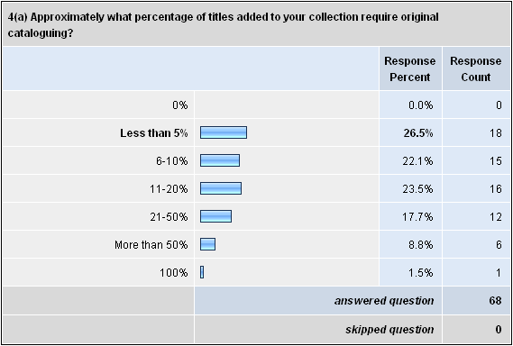

The one special library reporting 100% original cataloguing also commented that strict AACR2 is not followed, and LCSH is not used in their specialist database.

Directors expect improved access to OCLC to significantly reduce the amount of original cataloguing required for published materials, and acknowledge the role that increased usage of Z39.50 searching and downloading of records has already played.
The original cataloguing effort is now concentrated on institutional material such as theses and research reports, unique titles for special collections, legal deposit receipts, state government publications, overseas research material, learning objects, Aboriginal and Torres Strait Islander items, ephemera, photos and the like.

It is not clear to what extent directors saw the survey questions about original cataloguing as including digital repositories. Digital repositories are interesting in this regard: taking an object and creating a record to represent it in a collection of such records, in order for it to be identified and retrieved, could be called “cataloguing”. But that term is generally not used in relation to digital repositories, presumably because it is seen as old-fashioned and connected to MARC records rather than Dublin Core and other metadata schemas.

The value for money of original cataloguing is rated quite highly. Almost 49% of directors consider it of high value, and a further 41% consider it of moderate value. They cite reasons such as the uniqueness or rarity of material and its importance to specific users, and state and national obligations.
Negative comments concerning original cataloguing involve the high cost due to the time taken to perform it, the use of standards that are either irrelevant to a particular library or questioned by the director (for instance LCSH), the belief that keyword searching is more important than controlled vocabularies, and doubts about the level of cataloguing required for retrieval.

MULTI-SKILLING

One question in the survey queried the beliefs of respondents about the multi-tasking of cataloguing staff (whether or not it actually takes place in the library concerned), by requiring agreement or disagreement with a set of statements.
Multi-skilling is very popular, particularly in relation to non-professional staff. Over 82% of directors agree or strongly agree that multi-tasking within a technical services operation (e.g. having the same staff perform cataloguing and acquisitions) increases overall productivity, job satisfaction and allows for greater departmental flexibility. 72% of directors agree or strongly agree that job rotation to extra-departmental positions is beneficial to the department and individual.
When the training investment made in original cataloguers is mentioned however, there is more of a spread of opinions about whether their primary role should be contributing to cataloguing productivity.

PARTICULAR SKILLS OF CATALOGUING STAFF

Respondents were invited to specify the particular skills and abilities which they consider cataloguers bring to their departments which might otherwise not be present, by selecting one or more qualities from a list of 9.
Most prominent, with 92.7% selection, is the ability to perform original cataloguing.
Second is the ability to recognise relationships between records and place those records in their correct context in the catalogue. Third is value-adding to records for local consumption, e.g. the editing of bibliographic records. And fourth at 69.1% is authority work.
While these were closely followed by skills such as assisting with the setting up and working of electronic repositories, and knowledge which can contribute to discussions about resource discovery, these top four recognised skills are very much part of “traditional” cataloguing.
Other skills which were volunteered by the respondents include in-depth subject knowledge, capacity to handle bulk loads of records, knowledge which can be used in the training of non-cataloguing staff, and a predisposition to be “details” people, which is of use in other contexts.
There were also the following comments:
“It’s not just the cataloguing group that brings these skills - others may have them too.”
“Cataloguers have specific skills not special skills.”
“We don't need specialist roles for this. Resource discovery and metadata work should be able to be done by all.”

In response to a query about where cataloguers might carry their skills within the organisation, the most popular answers were: RQF records management, digital institutional repositories and metadata work (more about this later in the paper), reference and user services, website services and design, indexing and abstracting, and expert advice on controlled vocabularies.

OUTSOURCING

In the survey, the word “outsourcing” refers to non-electronic resources, and means that most or all of the intellectual work of cataloguing these materials for a library’s collection is performed by an agent other than the library’s own cataloguers (this can sometimes mean that materials have the bibliographic record created/edited and the call number assigned).

The spread of percentages of non-electronic resources titles catalogued through outsourcing looks like this:

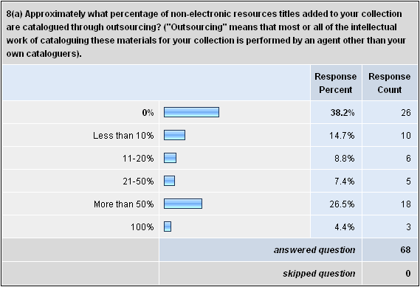

Unfortunately these figures cannot be completely relied on, as a number of directors interpreted “outsourcing” to include the downloading of records from Libraries Australia, LC, OCLC, etc. into the local database, which is normally part of the definition of copy cataloguing.
Whichever way it was that directors interpreted “outsourcing”, only one director (from a public library) expects it to decrease in that library. Over 57% of respondents expect it to increase, and over 41% expect it to stay the same.

Materials most often mentioned in relation to outsourced cataloguing are foreign language and audio-visual items, and fiction or large print items (where it is seen that the cataloguer adds little value). One tertiary education library uses vendor-supplied descriptive cataloguing and provides in-house subject cataloguing. Another special library uses an outsourced indexer, who provides subject analysis and abstracts for Australian records, while in-house staff perform pre-cataloguing and other subject analysis.
A business unit providing services to public libraries reported that, prior to the outsourcing of cataloguing, service level agreements were not being met and a large backlog existed. Shelf-ready cataloguing is now performed by vendors with the library staff playing a quality assurance role.
A director from a cataloguing agency reported that the demand on that agency for outsourcing is increasing.
Two libraries in the survey actually provide cataloguing services for other organisations.

Despite the variability in the interpretation of the word “outsourcing”, comments that were made in relation to the practice are revealing. For example:
“I am including Libraries Australia in my answer, and it would be 90+ percent in that case. I don't treat copy cataloguing as adding any significant intellectual work :-)”
“Outsourcing this activity to publishers is cheaper and "good enough" for resource discovery needs.”
“Outsourcing - It would "blow" the budget!!”
“We don't outsource - our staff know our business.”
“Outsourcing cataloguing for DVDs/CDs has proved unsatisfactory due to excessive turn-around time and sometimes poor quality control.”
“We believe that we will always need to add value to the records we download to make them more usable and more useful to our clients, even though we may not perform this task very often.”

QUALITY VERSUS QUANTITY

Respondents were invited to discuss the tension in cataloguing output between quality and quantity by selecting the statement which most closely approximated their views, or by providing an alternative statement, and then recording extra comments.
“Quality” means different things to different people, but in this paper it means that records are consistent, accurate and comprehensive, to enhance retrieval and allow new technologies such as faceted browsing. Quantity is of course important to reduce backlogs and satisfy user demand for timeliness.

Almost 12% believe that keyword searching yields a satisfactory OPAC experience, thus making high quality records and local editing unnecessary luxuries.
29.4% feel that high quality records are worth the necessary resources and time spent on record editing, combined with attention to automated solutions.
Almost 53% of directors agreed with the proposition that high quality records are a priority, but only by pursuing time-saving and automated solutions, not by supporting increased spending or much editing of records.

One special library commented: “High quality records are required, but not in the traditional MARC context... The MARC record is so technologically outdated in the web context we now operate in.”

Several libraries choose records with specific local, heritage or national value for extra handling and attention. Authority work, hyperlinked access points and table-of-contents/summary enhancements were especially seen as improving retrieval.
Some directors pointed out that it is not a matter of either cheap, low quality records or expensive, high quality records. By being selective about where the costly effort goes within records, new developments such as faceted browsing can still be supported within budget. That is, cataloguers need to concentrate on the elements that affect retrieval, and stop the purist approach of getting every tiny detail of a record perfect. Many see local variation to be just too expensive.

THE MOVE TO METADATA WORK

Almost 78% of directors believe that traditional cataloguing skills are transferable to metadata creation and analysis with the application of minimal or short-course training:

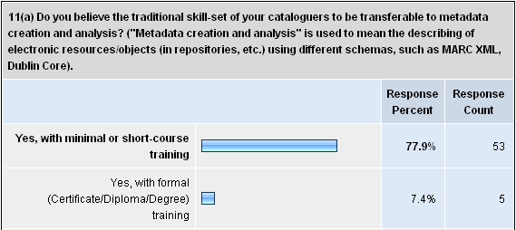
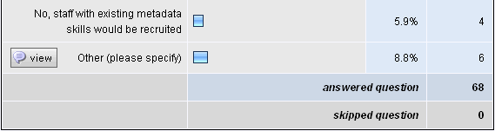

However, several respondents described barriers to this transfer amongst their own individual cataloguers. They cited problems such as lack of interest displayed by staff approaching the end of their careers, the expected failure of many cataloguers in an environment where timelines are tighter, the unwillingness of cataloguers to take it upon themselves to learn new schemas, and resistance to a change of role.

In retrospect a question which should have been asked at this point is whether or not cataloguing staff were offered training in and familiarisation with metadata schemas, regardless of whether they were required to perform metadata work immediately. It would be interesting to know if negative attitudes persisted after such sessions.

Positive comments about the possibility of transition emphasised that some metadata schemas such as Dublin Core are easier to learn than MARC and AACR2, and cataloguers have nothing to fear. More complex schemas may require more training. Existing understanding of controlled vocabularies, subject analysis and the structure of information already stand experienced cataloguers in good stead.
One director stated that metadata work has raised the profile of cataloguing skills, and the institution “accepts without question the library's assertion that they are the metadata experts.”

A few directors mentioned courses and workshops to which they have been sending staff, and the encouragement which has been provided to enable cataloguers to expand their skills. This question of training and encouragement will be revisited later in the paper.

37 of the 68 directors reported that some cataloguing staff in their libraries have already transferred their skills from traditional cataloguing to metadata work. This work includes the development of standards and thesauri for use in library and wider organisational databases, web pages and resource discovery services such as federated searching. Digital institutional repositories in Dublin Core figure prominently in metadata work, as well as the Australian Digital Theses database.

Over 70% of directors expect that in 5 years’ time, metadata work and cataloguing will be integrated or becoming integrated into one stream, and over 10% reported that they are already integrated.
A few comments added qualifications to this though, that within a common work group, the different tasks may still be carried out by different people. Further comment mentioned a push towards using IT staff for this work rather than cataloguers, which may mean that the work will not be as authoritative as it could be.

The following quotes were representative:
“Describing and organising resources is what cataloguers say they are good at. Here's a chance for them to prove they are, and can be relevant in the modern networked world. There is a new world of metadata and ontological effort outside MARC, authorities and Dewey.”
“I believe that this is where cataloguers can most enhance their value to the University and yet the cataloguers themselves seem resistant to taking on this role. Leaves me frustrated.”
“I firmly believe that metadata is what cataloguers have been doing forever and the rest of the world has just discovered.”
“It's just a new way of doing the same task.”

DOWNGRADING AND DE-SKILLING

Nearly 65% of respondents believe that there exists a trend of not fully replacing cataloguing staff when incumbents leave, or of replacing them at a lower salary level. Around 19% do not believe this trend exists. One director from the other 16% made this comment:
“We would not replace cataloguing staff at a lower salary level but would probably replace with staff with IT qualifications and not necessarily with library qualifications.”

The main factor identified as contributing to the downgrading trend is the dominance of copy cataloguing, due to better access to full records from a variety of databases. Many directors state that these records can be handled at a lower salary level, and the work integrated into a multi-skilled role.
With the concentration of retirements coming up, and the need for technical abilities in the department such as manipulating records en masse, cataloguing theory is seen as unnecessary compared with IT skills.
As the breadth of library resources expands, management is placing a lower value on traditional cataloguing skills. As one director expressed it: “Blending of libraries into overall IT/IM management areas has diminished the perceived value of many service lines attached to the management of hard copy.”

There was some concern expressed in the responses about the lack of understanding by management of the importance of what cataloguers do, and about the trend towards managerialism in which professionals are not as valued as the people who manage them. There are worries that essential skills may not be there in the future.
Some directors highlighted the unavailability of trained cataloguing staff, partly due to less emphasis on cataloguing in library courses.

It was felt that downgrading is helped along by better search capabilities of catalogues and search engines and the valuing of search algorithms over accurate description and careful analysis.
This was described by one director as the “Erroneous belief that copy-catalogued records are 'good enough' and a perception that search overlays that mimic search-engines remove the need for higher cost maintenance of catalogue records.”
Also cited were the opportunities to employ lower paid staff and use the savings for outsourcing, the intransigence and reluctance of current cataloguers to multi-skill, and plain budget pressures.

RECENT READINGS ON CATALOGUING

Respondents were referred to three papers from the US and UK dealing with issues related to cataloguing: the “Calhoun report”, “A white paper on the future of cataloging at Indiana University” and “Tomorrow never knows: the end of cataloguing?” by Alan Danskin.
Of the directors who were aware of these readings, most recorded that their thinking had been influenced by them, but not especially so.
Some feel that the papers only confirm what is already known and being implemented, that the Australian/New Zealand scene is different from the US or UK, or that the concepts discussed are more applicable to research libraries than for example public libraries.
Some directors had not seen the publications, or had no time to read them.
Discussion in the papers about the declining use of catalogues struck a particular chord with directors, giving rise to comments such as: “The key issue is the future of the catalogue as a resource discovery tool. If the catalogue is not being used, the issues surrounding the metadata found in same become largely irrelevant.”

Over 82% of directors agreed with an interviewee quote from the Calhoun report that “Cataloging needs to be simpler, faster and less expensive. There is too much hand wringing and worrying about each record: this is extreme and wasteful.”
Around 68% agreed with Calhoun’s recommendation that acquisitions and catalogue data should be managed through batch processes, avoiding one by one record treatment as much as possible.
About 53% agreed with her recommendation that local record editing practices should be eliminated in favour of taking copy records without review.
And over 82% agreed with Danskin’s contention that we must engage more with publishers and vendors for the reuse of metadata created by others.

But interestingly, almost 80% of directors also agreed with interviewee opinions in the Calhoun report that subject cataloguing is needed for clustering related content, and that subject analysis is better than relying on keyword alone. And 78% disagreed with a proposition discussed by Danskin that “cataloguing is rendered redundant by direct access to content”.
This indicates that there is a desire for quality and quantity, and suggests that there is much confidence in the anticipated quality of records arriving in batches for loading with minimal intervention. The assumptions behind this confidence will be touched on briefly later.

Opinions were slightly more spread about quotes from the Indiana white paper concerning the adequacy of training and the level of resources in cataloguing departments.
Around 30% of directors agreed that lack of resources prevents an organised training and professional development program for cataloguers, while 50% disagreed.
About 54% agreed that insufficient staffing is negatively affecting database clean-up, backlogs, authority work and the limited expansion of cataloguers into metadata work, while about 31% disagreed (mainly state/national and tertiary libraries).

LIBRARY SCHOOL COURSES

When asked what should be changed about library school courses to make them more relevant to the employers of cataloguers, only one director agreed that the current mix of subjects is appropriate.
There was a call amongst many directors for a greater emphasis on how library users actually search for information now, on the variety of metadata schemas in use, on technical infrastructure, record import/export and on real workflows.

While a grounding in descriptive and subject cataloguing and authority work is still seen as important, it was pointed out that the librarianship stream for subjects such as cataloguing has been diluted by integration with faculties of information technology.
There was a strong recommendation for schools to allow options for specialisation in certain areas, one of which would be resource description and access.

It was felt that library technicians come out of training better equipped to start cataloguing than do graduates. There was a suggestion that schools outsource their cataloguing training to practitioners, and another suggestion that we move to an apprenticeship model rather than an academic model for cataloguing instruction.

Several directors commented at this point that it is difficult to find trained cataloguers.

ISSUES ARISING

NAME CHANGE

If the words “cataloguer” and “cataloguing” are on the way out, then the word “metadata” has certainly caught on, and it should be remembered that MARC records are themselves a form of metadata. There really is no suitable verb for the noun “metadata” yet, but in a recent paper, Dick Miller from Stanford has used the word “metaloging” (or “metaloguing”) which is appealing, and a good candidate for the next label.
It would be a very acceptable term to represent the work of describing resources in any of a variety of schemas, so that a “metaloguer” could be working in MARC, XML, Dublin Core and so on, or with any taxonomy.
The word “cataloguer” is, rightly or wrongly, associated with the past and with one form of metadata only: MARC records.
As one director commented: “… a "cataloguer" is however sadly a bygone relic.”

But perhaps having any label at all is passé, and what we will have are generic information resources workers who will adapt their activities to processes as they evolve.

RELATIONSHIP WITH IT STAFF

It is clear from the survey that cataloguers should seek a closer engagement with the IT staff within their organisations. There is more scope than ever for a cross-fertilisation of skills to enable the inflow of resources to the library to reach the quantity and quality to serve patrons well.

We often hear that we will be forced to do more with fewer staff, but for cataloguers in many Australian and New Zealand libraries this survey is saying that we will be doing different things with roughly the same number of staff, but a bigger ratio of lower level staff.
The future seems to consist of fewer higher level staff involved in quality issues surrounding bulk loads, responsible for authority control and original cataloguing, and a higher percentage of lower level deskilled staff handling copy with minimal intervention.

Cataloguers should be seeking to improve their skills in the handling of bulk imports of records, while playing the essential quality management role of those loads. More automated solutions to authority work need to be found and ideas shared. This will require a closer association with systems staff and knowledge sharing between libraries.
Respondents have referred to a shift in focus to IT skills many times in the survey:
“The technical expert role in metadata and ontology has already moved to the realm of IT and other information professionals and will probably stay there. I think traditional cataloguers largely have missed the boat by being too rigid and inflexible. That said I hope they can prove me wrong :-)”
“All new positions which we have created are with IT graduates.”

CONTINUING EDUCATION

We have to take at face value the comments made by some directors about the intransigence, narrowness and reluctance to diversify of their own cataloguers. These directors are waiting for some of their people to retire in order to replace them with more flexible and modern staff.

But it would be helpful to know what level of in-house training, development and opportunity is offered to their cataloguers. There is a belief amongst many staff that on-the-job education has atrophied as the perceived value of cataloguing has declined amongst managers.
As stated earlier, a question which should have been asked in the survey is whether or not cataloguing staff were offered training in and familiarisation with metadata schemas as part of general development. If such information sessions are not being offered, this may partly explain some of the reported resistance to the idea of metadata.
Several directors remarked that some aspects of metadata are less challenging than traditional cataloguing and there is no reason for staff to be apprehensive.
Familiarisation sessions do not need to be expensive.

EVIDENCE-BASED APPROACH

This is a key quote from a director: “[there will be a] greater demand for evidence of the asserted benefit where arguments of quality are entered into.”

While not over-stating the case in favour of standards, it has to be said that many experienced cataloguers are indeed hanging on to certain practices and principles because they know the value of them. Certain routines, such as authority control, underpin much of the workings of resource discovery in their libraries.

But it is no longer acceptable to make assertions about quality based on belief and adherence to doctrine. Cataloguers need to be able to provide evidence and statistics that certain standards and practices deliver a user benefit. They need to become fluent in the language of usability studies, search logs and other statistics for discussions with managers and IT departments. This is another area in which cataloguers can seek a closer working relationship with their IT colleagues.
The people who decide whether particular cataloguing rules are actually followed in a department may be, by necessity, a number of steps removed from cataloguing.
And managers, when devising strategies for purchasing records from utilities and vendors and adding them to the local database with minimal human intervention, need to collect sufficient evidence that “good enough” really is good enough.
Cataloguers are often criticised for wanting their records to be “perfect”. As one director put it: “Information discovery is the goal, not data perfection.”
And it is certainly time or even past time for dropping the parts of what we do that are not critical. But some data simply needs to be correct.
From a director about outsourcing: “We know that outsourcing suppliers use less qualified staff for cataloguing (usually lib techs) which may lead to a lower standard of cataloguing record being produced. The long-term effect of this is yet to be determined I believe.”
It is known that records coming from utilities and vendors for some languages or formats are less reliable than for other languages or formats.
It is not unheard of to see the same full-level records in LC, OCLC and Libraries Australia with typographical errors in the title that would prevent retrieval, or lacking essential variant tiles. These records are loaded and reloaded between utilities.

We need to avoid all assumptions relating to quality issues, from every side of the debate, so that as compromises are made to cut cost and time, they are made consciously.

It is very much present-day thinking to see technical services operations as a series of systems, and to focus attention on making those systems as streamlined, efficient and automated as possible in order to get the most out of available budgets. However, attention also needs to be given to outcomes – are the library’s resources comprehensively retrievable, are they amenable to new resource discovery technologies because they are represented in a consistent and authoritative way?
This is where cataloguers (whatever they are called) have a genuine role to play, especially staff who have been in the industry a long time and have witnessed the history and development of bibliographic records and authority control.
With their deep knowledge of that data, the relationships within it, and its functions in retrieval and display, cataloguers can join with IT staff to achieve the best outcomes for library users.
Assertiveness is not a quality usually associated with cataloguers, but this is what is now needed to make the next level of contribution in our libraries.
To conclude with a director’s comment: “Metadata creation is, in my opinion, cataloguing for the 21st century, and we need to be out there selling our expertise.”

ACKNOWLEDGEMENTS

Thankyou very much to the 68 directors who completed the survey; your candid and relevant remarks will be of great interest to cataloguers.
Special thanks to John Butera (who helped get the survey started) and to Roger Clark, Sue Clarke, Stephen Harrison, Barbara Hood, Dennis Kishere, Julie McCulloch and Michelle Rusiniak.

APPENDIX 1 - DEFINITIONS USED IN SURVEY AND SUMMARY OF SURVEY QUESTIONS

DEFINITIONS

For the purposes of the survey, "cataloguing" does not include end processing, although it is realised that some cataloguers perform those duties.
"Metadata creation and analysis" is used to mean the describing of electronic resources/objects (in repositories, etc.) using different schemas (e.g. MARC XML, Dublin Core).
"Outsourcing" refers to non-electronic resources, and means that most or all of the intellectual work of cataloguing these materials for your collection is performed by an agent other than your own cataloguers (this can sometimes mean that materials have the bibliographic record created/edited and the call number assigned).

SUMMARY OF SURVEY QUESTIONS

1 What type is your library?

2(a) How many full-time equivalent cataloguers work in your department? (It is realised that many cataloguers are actually multi-tasking, so just be as accurate as you reasonably can).
2(b) Extra comments

3. In 5 years' time, what do you expect the number of full-time equivalent cataloguers in your department to be?

4(a) Approximately what percentage of titles added to your collection require original cataloguing?
4(b) Extra comments

5(a) In your view, what is the value for money of the original cataloguing referred to in question 4 in the overall framework of resource discovery in your library?
5(b) What kinds of factors or evidence helped you form that view?

6. Many cataloguers are multi-tasking both inside and outside their divisions, e.g. technician copy cataloguers also performing acquisitions, and librarian original cataloguers performing reference tasks.
This question looks at your beliefs regarding the multi-tasking of cataloguers, irrespective of whether it actually takes place in your department.
At each statement, please tick the appropriate response.

7. What particular skills and abilities would you say that the cataloguing group brings to your department, that otherwise might not be present? (more than one answer may be ticked)

8(a) Approximately what percentage of non-electronic resources titles added to your collection are catalogued through outsourcing?
("Outsourcing" means that most or all of the intellectual work of cataloguing these materials for your collection is performed by an agent other than your own cataloguers).
8(b) Extra comments

9(a) How do you see the trend for the outsourcing of non-electronic resources cataloguing in your department?
9(b) Extra comments

10(a) There is a tension in cataloguing output between quality and quantity.
Quantity is important to reduce backlogs, maximise resources and satisfy user demand for timeliness.
Quality is important to enhance retrieval and to enable new technologies such as faceted browsing.
Also, local variation/editing of catalogue records is sometimes argued as serving specific user groups well.
Which of the following statements most closely approximates your view of the tension between quality and quantity?
10(b) Extra comments

11(a) Do you believe the traditional skill-set of your cataloguers to be transferable to metadata creation and analysis?
("Metadata creation and analysis" is used to mean the describing of electronic resources/objects (in repositories, etc.) using different schemas, such as MARC XML, Dublin Core).
11(b) Extra comments

12(a) Have any of your cataloguers already transferred their skills from traditional cataloguing activities to metadata activities?
12(b) If so, could you give some examples of that transition?

13(a) In 5 years' time, what do you see to be the relationship between metadata creation and analysis (as defined above) and cataloguing in your department?
13(b) Extra comments

14. What other areas do you see your traditional cataloguers transferring their skills to, within your library and organisation, if that became necessary?

15. There has been discussion in the cataloguing community in Australia/New Zealand about a perceived trend of not fully replacing cataloguing staff when incumbents leave, or of replacing cataloguing staff at a lower salary level.
Do you believe this trend exists?

16. If you answered "Yes" to Question 15, what factors do you identify as contributing to this trend?

17(a) Over the past 18 months, important papers such as the "Calhoun report" (CR) and "A white paper on the future of cataloging at Indiana University" (WP) have been published in the US and UK, and they have caused great discussion amongst the worldwide cataloguing community.
How much have these and many other papers influenced your thinking regarding the direction and future of cataloguing activity in your department?
CR is at http://www.loc.gov/catdir/calhoun-report-final.pdf
WP is at http://www.iub.edu/~libtserv/pub/Future_of_Cataloging_White_Paper.pdf
17(b) Extra comments

18(a) Below are 4 quotes from the "Calhoun report", which is at
http://www.loc.gov/catdir/calhoun-report-final.pdf
The report was based on structured interviews of noted professionals, and, at the request of the Library of Congress, presents a blueprint for change containing recommendations.
Indicate your level of agreement with each quote, using the Australian and/or New Zealand library scene as context.
18(b) Below are 6 quotes from "A white paper on the future of cataloging at Indiana University" (WP) and from an IFLA 2006 paper entitled "Tomorrow never knows : the end of cataloguing?" by Alan Danskin, Manager, Data Quality & Authority Control, British Library (AD).
Indicate your level of agreement with each quote, using the Australian and/or New Zealand library scene as context.
WP is at http://www.iub.edu/~libtserv/pub/Future_of_Cataloging_White_Paper.pdf
AD is at http://www.ifla.org/IV/ifla72/papers/102-Danskin-en.pdf

19(a) In the short term, what should library schools change about their courses to become more relevant to the employers of cataloguers?
19(b) Please add any extra comments you have about cataloguing education, e.g. how much training you feel should be undertaken by the schools versus by your staff or external courses which you send new cataloguers to attend.

20. Finally and in a few sentences, what do you see as the future of cataloguing in your library and also in Australia/New Zealand in the medium to long term?

----------------------------------------------------------------------------------

APPENDIX 2 – FULL SURVEY RESULTS

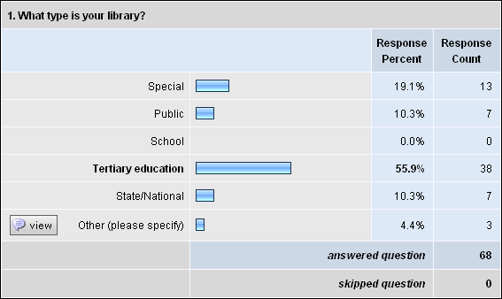

Other:
- Aboriginal
- Cataloguing Agency
- We are a business unit providing services to public libraries

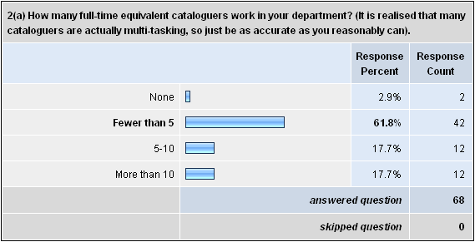

2 (b) Extra comments:
- 3 F/T; 2 P/T
- Our three cataloguing staff also spend 4 hours on a desk shift per week.
- 0.6 fte cataloguer for the collection. In addition we are the state contributor to SCIS (Schools Catalogue Information Service) which employs an additional 1.0 fte cataloguer.
- Included in the 10 EFTS are 4 part-time staff members - 2 are due to retire in the next 12 months.
- One full time cataloguer, with copy cataloguing done by serials staff and contract staff working on monograph backlog and projects.
- In this survey I have interpreted the word cataloguer as a professional librarian position.
- There are 3 cataloguers who perform original cataloguing work, authority work, import of e journal records. There are 5 Collection Services Officers who perform copy cataloguing as part of their multiskilled role.
- Cataloguers do minimum desk shifts.
- There's only me - I'm an OPAL and do everything from A to Z and backwards!!
- There really is no such thing as a "cataloguer" any more. Cataloguing is just one of many tasks that librarians, library assistants and others perform. In this day and age no one should have such a narrowly defined job title – it’s very 1970's. Even having a separate "technical services" division is extremely outmoded.
- Figure includes cataloguing library materials and adding metadata to e-resources.
- 1 person one day a week
- [We do] not have specific "cataloguers" any more; those professional positions in our Collection Management Unit are now "CMU Team Coordinators" and they may be asked to do any professional tasks in the CMU; they also mentor and coach a team comprising a senior library technician and 2 para-professional library assistants (usually fractional appointments for the team coordinators and the team members) - we reorganised along UWS and UniSA "pod" lines in 2006.
- One full time original cataloguer, with a part time staff member doing the close copies
- 1 f/t cataloguer
- 2.5 qualified cataloguers, at the moment 2 acquisitions staff carry out some copy cataloguing duties. A further two acquisitions staff are being trained now.
- Fewer than 5 librarian original cataloguers, and fewer than 5 FTE technician copy cataloguers. Most are part-time, and/or work at other jobs as well as cataloguing.
- We have 4.5 fte professional cataloguers, doing original cataloguing and authority control. The copy cataloguing and callmarking is done by the acquisitions team.
- I use contract cataloguers - up to 15 hours per week
- about 1.5fte
- Library Technicians primarily copy cataloguing and Librarians mainly original records on Libraries Australia. In future likely to have more people engaged in providing records for manuscripts and pictorial material and also material currently only described in card catalogues and paper based guides.
- Have included 'Cataloguing Librarian' plus 'Copy cataloguer' positions. Cat. Librarians also work rostered shifts on the reference desk; this time has not been subtracted from the total.
- We have a staff of 8 in our Technical Services unit, 7 of whom perform cataloguing as part of their duties. But all our staff are involved in multi-tasking.
- Most are part time.
- All are currently part time including the Chief Cataloguer. I envisage this would change when the present incumbent leaves and this role would be made full time.
- It's difficult to provide an accurate number as TS operates across 3 teams with each team member undertaking monograph and serial (print and electronic) acquisitions and cataloguing plus document delivery (as appropriate to their HEW level).

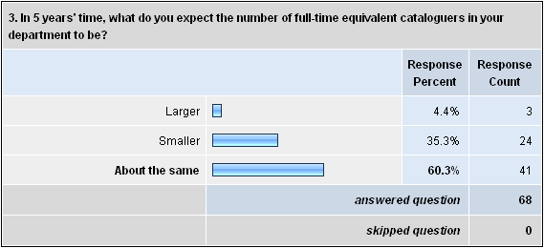

4 (b) Extra comments:

- Books and serials probably less than 5%. Other stuff such as ephemera, photos, articles, websites, etc probably will all require original cataloguing.
- This figure is heavily impacted by the fact that we purchase and catalogue stock for public libraries, much of which doesn't involve original cataloguing.
- A review in early 2000s indicated that we have about 96% success rate from Libraries Australia, in its previous guise. We believe that the success rate may now be higher.
- Depending what "original cataloguing" actually means... very small percentage start from scratch.
- This includes our own publications, e.g. theses, research reports and otherwise mostly English language, European science/environment titles.
- Original cataloguing includes copying from similar bibliographic records e.g. children's DVDs in series. Most original cataloguing is music CDs, Council reports and local studies resources, straightforward fiction monographs
- A lot of the ATSI items have not been legally deposited, so therefore no NLA/Libraries Aust/AIATSIS records.
- Where original cataloguing is defined as pure original records and extreme upgrading of records
- The average is not very meaningful because it includes learning objects, digitised course readings, exams, eprints etc. Records can be found for most library resources.
- Because of the specialist nature of our collection and the fact that much of our material is sourced from overseas agencies and research organisations much of the material is not currently in Libraries Australia. With the introduction of Worldcat records to Libraries Australia I would envisage a drop in the amount of original cataloguing required over the next couple of years.
- As more catalogues have become z39.50 compliant this percentage has declined. More suppliers are offering bib records with items as well. James Bennett is considering this service for academic libraries.
- Original cataloguing is usually now only required for NZ items, they are put aside for 1 month in the hope that when we check again on Te Puna the national Library will have catalogued the item.
- The % would vary slightly from campus to campus.
- Around 12%.
- Most original cataloguing is in-house theses and gov pubs.
- Most of our titles are original cataloguing as we have our own cataloguing system.
- Given the type of material we buy we can drag the overwhelming majority of records for print materials from sources like libraries Australia. We do, however, put time and effort into editing cat records we import for e-journal content from vendors (mainly Ebsco).
- Special responsibility for contributing records for State government publications and legal deposit receipts on ANBD. Also a lot of material in community languages acquired to support public library network requires original cataloguing.
- This library has responsibility for legal deposit for [this country] and for compiling [our] national bibliography. Its purchasing of [overseas] material is fairly low, so the percentage of original cataloguing is quite high.
- We are experiencing increasing numbers of research theses and unique titles for Special Collections requiring original cataloguing.
- Given that many items we acquire go into [our specialist] database, it's more cost-efficient to catalogue all material. We don't use LCSH or strict AACR2, for reasons covered later
- When an item is ordered or received, we will search Libraries Australia etc for a catalogue record for it. If one is not found, we will catalogue it originally if we feel the material warrants this and if time and staffing permit.
- Access to OCLC has made a big difference
- Majority of cataloguing is done in-house creating original records due to historical and workflow reasons. At present we are unable to accurately judge what "requires" original cataloguing as items aren't checked on LA before creating the record. Some external cataloguing is undertaken and it is from this that the above result is estimated.
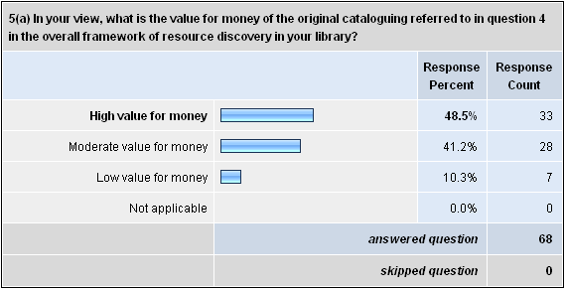

5(b) What kinds of factors or evidence helped you form that view?
- In terms of access, we need to assess how clients are searching for and discovering the information. The Google/web interfaces clients are used to have changed what constitutes a 'quality record'. Original cataloguing relevance is therefore questioned.
- Outsourcing this activity to publishers is cheaper and "good enough" for resource discovery needs. In times where budgets are stretched we have higher priorities to spend the money on.
- Assume that the effort that goes into original cataloguing means that the resources are as accessible as copy catalogue records
- We only do original cataloguing for items that require it, thus it is something we need to make those items available.
- My personal view is that original cataloguing is worth the money but the organization I work for does not agree.
- It should be high value but we are still working our cataloguers through understanding the importance of what they can achieve in this area. Time taken to catalogue some of the original material is amazing and doesn't represent value for money. Backlogs continue to build.
- We are able to provide a very good service to our clients because our catalogue records are of a high standard which enhances information retrieval. Feedback from clients bears this out.
- Original records are often agency publications, some of which may seem ephemeral in the bigger picture. The catalogue record with all enriched data may be the only opportunity to contextualise the initiative/project for the corporate memory.
- Type of material that is catalogued originally is foreign language material, non-book material and grey literature. We catalogue onto the national utility so our records can be used by others; this material is often hardest to acquire, is rare, and for researchers who have requested it can be particularly useful. Making it more accessible is of benefit to many.
- If we add items, we want people to find them, so we have no choice in adding the record. The return on investment depends on the use of the item, which can be hard to predict - for both originally catalogued as well as for material which we acquire through other processes...
- High value because of the access it provides our users and for maintaining an institutional research profile.
- The original cataloguing is for our organisations publications and therefore assist in resource discovery and add value as access to the intellectual property of the department. Usually the cataloguing data is not readily available from bibliographic agencies such as Libraries Australia.
- Recent benchmarking studies have revealed the very high cost of current cataloguing operations
- Council reports and local studies resources are highly used and would not otherwise be known if not catalogued and accessible. However, maximum resource discovery not available because records are not contributed to Libraries Australia.
- Provides access to a range of resources including eCollections for a large client group of 100+ libraries.
- The cataloguers are also involved with providing metadata for the university's electronic repository which is growing all the time and are developing expertise with the preparation of bulk downloads into the catalogue.
- We have some original works and are the only holders.
- Items catalogued are generally items which are considered local in nature that probably won't be purchased or provided by any other library. With that aspect then items needing original cataloguing are widely accessible to the wider community.
- If original cataloguing wasn't undertaken then unique material would not be accessible. -Issue of timeliness, in those cases where we are the first library to catalogue a newly published item. -Our rich historical unique collections would remain unavailable without original cataloguing. -National obligations
- Cataloguing / metadata is required for local collections and is expensive to provide. We get higher usage of electronic library resources like ejournals when they are catalogued than when they are not. Open URL Resolver knowledge bases are however providing additional access points.
- The main factor is our users. I think the original cataloguing is currently making items available for our users but it also takes away from time we could be spending on providing value-added services such as literature reviews and bibliographies on specific topics.
- [This library] holds unique collections which can only be made accessible to the public by original cataloguing work. This requires highly experienced cataloguers.
- There are no other means of resource discovery.
- Ours is a government departmental special library with a high degree of subject specialisation of material not always readily available elsewhere but of great importance to the library's clients.
- Creation of records for materials that are highly relevant to our users and that would otherwise not be discoverable - maintain a comprehensive catalogue to support a research collection - generally only originally catalogue materials for which a copy record cannot be sourced
- Ease of retrieval from OPAC ; importance of works which are originally catalogued (usually [local] thesis material etc)
- We don't have an in-house collection as such, but for customers we see the value in minimizing the library unauthorized entries, and to efficiently manage their library materials.
- I believe that most clients have become familiar with online keyword searching of full text resources and that the level of cataloguing provided by libraries does not meet with clients expectations. The access points are very limited; author, title, publisher, date and limited subject headings. The time taken to do this original cataloguing, the staff costs seem excessive in comparison to the benefits to our clients.
- The material originally catalogued is usually material specific to the library, e.g. theses. It is also material that needs describing specifically for the library users, e.g. models.
- Staff in smaller staffed libraries may not have the expertise to attribute appropriate call no's. Conversely cataloguers' decisions are often subjective. Cataloguers should consider call no's already in place in their collections and align their call no's accordingly.
- Adds to the records available for all to download. Helps share the workload if everyone contributes to the original cataloguing required.
- We are currently in the process of reviewing and streamlining our original cataloguing practices. After that process is complete, the ROI will be higher.
- Doubts about the level of cataloguing that is required for our users to be able to locate material. As long as author, title and subject headings are correct I am not sure what the return on investment is in getting all other fields in MARC records absolutely correct.
- In the future, I believe we will rely more on key word searching to locate resources, and will use more searchable fields, such as TOC. Resource description will not rely so much on the analysis of content to assign authoritative subject headings and a classification number.
- Much of our original cataloguing is providing access to our unique materials. Most of our records are contributed to the national database.
- We do not differentiate between "research" material which needs fuller levels of cataloguing and teaching. Also a large % of originals are audiovisual materials.
- The non-commercial resources for which we do original cataloguing are generally items that are of high value to researchers and higher degree students.
- Keywords are specific to our specialised area and we don't rely on generic thesauri. This library has developed its own authorities. Descriptive cataloguing follows a data structure that was developed 20 years ago.
- Well, perhaps this is more of a hope than a fact. I would hope that we would only add things of value and having made that decision there is no point in adding the item if it isn't adequately described.
- Time taken to catalogue, including use of standards that are not really relevant or useful for retrieval in our context; e.g. Dewey and LCSH.
- Original cataloguing provides access to uniquely held materials; records contain rich metadata that can be used in other discovery services; our cost of cataloguing survey.
- The majority of original cataloguing carried out is for two specialised collections of the corporate library and the heritage library. Both of these collections are moderately to highly valued by both the organisation and patrons.
- As a Library of record for publications of our State we have an important role to play in resource discovery at State and national level.
- We are creating records for [this country's] publishing output and contributing these to [the national] bibliographic utility, allowing other libraries to use this as a source of bibliographic records. This increases the copy cataloguing percentage of all libraries.
- Prior to cataloguing being outsourced service level agreements with the network were not being met and turnaround times for materials to be sent to libraries was very poor and a huge backlog of materials existed.
- Requirement to index for [specialist] database; waste of time adding pointless AACR2 information; don't use LCSH
- The difficulties we find in recruiting suitably qualified staff for our sector, considering the salary levels we are able to offer. - The staff resources, especially time, needed for original cataloguing vs. the resources available for it, given our multi-tasking constraints.
- Items should only need to be catalogued once and that record shared with all other libraries. For each library to spend time/resource to catalogue the same things is wasting this resource
- Ability to reflect local practices in determining classification and subject headings. We have undertaken benchmarking with external suppliers and found that our costs per record created are competitive. As a large percentage of items are catalogued at the point of selection and order creation, we have been able to reduce the time spent in process for new materials.
- The 'google-like' expectations of our users mean that keyword/phrase searching is far more important than a controlled vocabulary. Online searching is far more flexible than the old card days with comparatively limited access points.
- Original catalogued materials range from Junior Board Books to Locally produced material that has a high degree of historical value. It is difficult to weigh these in determining the value overall.
- Cultural and heritage value of this material as mainly for local studies/history collection
- I see it in terms of Return on Investment. Cataloguing is a function that can be outsourced with very little loss of services to clients so if forced to reduce staffing or increase functions with the same level of staffing; this is very much an area I would be looking to resource in a different way.
- The unique nature of the material being catalogued in terms of subject material and number of copies available.
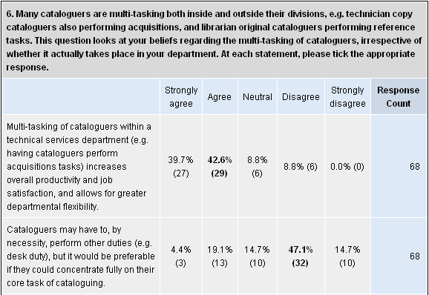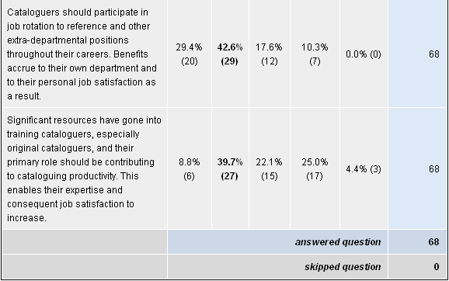

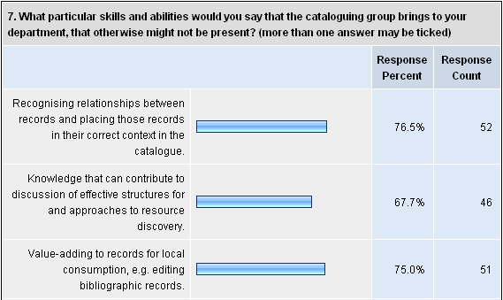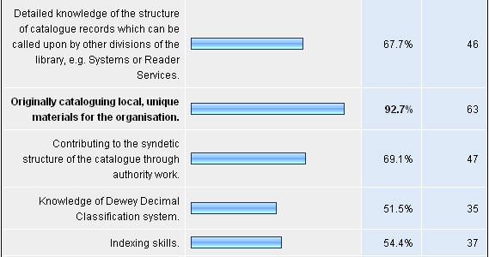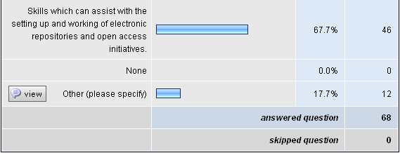

Other:
- All the above can be managed at an acceptable level by existing technical services staff. We don't need specialist roles for this. Resource discovery and metadata work should be able to be done by all.
- The key skills that every staff member must bring are flexibility and teamwork. Cataloguers have specific skills not special skills.
- Some in-depth subject knowledge
- Capacity to handle bulk transactions as well as single one off records. Our cataloguers now routinely bulk load MARC record collections for our electronic data. Fantastic.
- Awareness of the ATSILIRN protocols and use of the ATSI thesaurus
- Knowledge of a wide range of classification systems. High level searching skills that can be used for training non-cataloguing library staff.
- It’s not just the cataloguing group that brings these skills - others may have them too.
- Linkages with repositories. Mainstreaming metadata work.
- Expertise in other classification schemes
- We have contributed skills to projects, some of very significant size, developing products and services for [the country's] libraries and their end-users. Our expertise has been crucial to the development of this Library's [major digital archive], a system which will ensure the preservation in perpetuity of digital-born and digitised [national] material, published and unpublished.
- A systematic and informed approach to searching for information whilst helping our clients.
- A predisposition to be "details" people, which is of use in other contexts. Bringing a "cataloguers' overlay" in broader discussions of collection management, maintenance and development.

8 (b) Extra comments:
- We provide cataloguing services for one of the local high schools
- The only outsourced cataloguing we currently have is for some of our LOTE material. We are currently looking to have suppliers catalogue some of our English language material.
- Although you could argue that obtaining copy cataloguing records from a bib utility is a form of outsourcing.
- We are currently investigating vendor supplied records for monographs.
- Outsource foreign language material or thesis cataloguing when we are overwhelmed.
- Catalogue records mostly sourced from Libraries Australia and Library of Congress and edited to local requirements. DVDs and music CDs fully catalogued by supplier (see below)
- Outsourcing - It would "blow" the budget!!
- Our book agent provides about 40% shelf-ready material and about 70% cataloguing records.
- As we use the same record for print and electronic, outsourcing the latter is not viable
- We make use of copy cataloguing wherever possible
- We receive records from suppliers who have an approval plan. Also approx 80% of the remaining records come from Libraries Australia.
- The Library has been using outsourced cataloguing records for a number of years. We do not edit records imported into our system unless there are glaringly evident mistakes.
- Some doubts about how best to answer this. Less than 20% of items are originally catalogued, for the others agency records are used with a variable amount of editing of each record. We are moving towards a copy cataloguing environment where, hopefully, the amount of editing each of these agency records receives is reduced or eliminated.
- Occasionally the donation of a collection may require us to outsource the cataloguing
- We catalogue for another organisation though.
- It is very close to 100% if not actually total.
- This figure is either 0 or 100% My cataloguers are part-time contract staff.
- Most of outsourced cataloguing is of Lending collections in community languages as well as talking books, large print acquired to support public library network rather than heritage collection material which is done by our staff in-house.
- Vendor-supplied data for commercial imprints provides descriptive cataloguing. Subject cataloguing is done in-house.
- More than 50% if outsourcing includes buying copy cataloguing data from agencies such as Libraries Australia and OCLC. Otherwise 0% if it means sending our cataloguing out to be done by an organization such as CAVAL. [The second meaning was intended by the survey.]
- Cataloguing was outsourced to our material suppliers in August 2004. Cataloguing is completed by suppliers with those staff remaining [here] playing a quality assurance role. This assists in having the item shelf ready when unpacked at the library.
- Work is split between an outsourced indexer, who does subject analysis and abstracts for Australian records, and in-house staff who do pre-cataloguing and other subject analysis
- I assume that "outsourcing" here does not include downloading records from external cataloguing agencies such as Libraries Australia and then incorporating them - perhaps with modifications - into our catalogue. This work would represent 95% of our records. [This assumption is correct.]
- Only outsourcing is currently world languages which we do not have language expertise to transliterate. We are looking at outsourcing other work like fiction/large print where the cataloguer adds little value and to shift them into more value added work such as cataloguing and upgrading heritage collection access.
- Some cataloguing is done by an external contract worker at the library.
- Due to the arrangements we have with our state library, a large percentage of our records are downloaded automatically from their system into ours. However, due to the sometimes-poor quality of many of these records our cataloguers must modify many of the entries before they are up to the standards we use in our system.
- I assume this refers to copy cataloguing, or adding holdings. ["Outsourcing" was not intended to equate to "copy cataloguing" for the purposes of the survey. The definition provided was clearly not unambiguous.]
- We have taken this question to refer also to records imported from agencies such as LoC, LA etc. [That was not the intention of the survey. Importing records for the local database would be included in "copy cataloguing".]
- I am making the assumption that you include downloading of records from Libraries Australia, Library of Congress etc as "outsourcing". [Downloading of records was not intended to be understood as "outsourcing".]
- More than 50% i.e. acquire records from Libraries Australia 0% from purchased resource + record [Therefore 0% applies to this survey.]
- I am including Libraries Australia in my answer, and it would be 90+ percent in that case. I don't treat copy cataloguing as adding any significant intellectual work :-) ["Outsourcing" was not intended to include downloading records from Libraries Australia.]

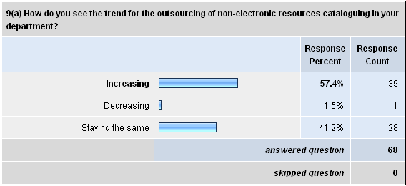

9 (b) Extra comments:
- This is difficult to estimate - we are about to change our workflows to use OCLC as the primary cataloguing tool so outsourcing may increase (we do outsource e-book catalogue records). Up till now outsourcing has not been an efficient option and record quality from outsourcers was variable.
- Outsourcing cataloguing for DVDs/CDs has proved unsatisfactory due to excessive turn-around time and sometimes poor quality control. Would consider outsourcing audio-visual resources if quality and satisfactory timeliness could be achieved by supplier. Will continue to edit catalogue records downloaded from other agencies.
- If outsourcing means including the purchase of MARC records with electronic titles then outsourcing would increase as we are increasingly purchasing more electronic resources. [In the survey “outsourcing” refers to non-electronic resources.]
- We already do this via Serials Solutions and various ebook suppliers and agents.
- It will probably increase once I move on.
- I can see the number of items coming to us for cataloguing is increasing i.e. the demand for outsourcing is increasing.
- Re-using existing bibliographic data saves time and resources
- As the non-electronic proportion of our acquisitions decreases in relation to electronic purchases, we must consider more cost effective ways to process those decreasing resources. Out sourcing of cataloguing to library suppliers is being considered.
- We have just undergone a major restructure in order to facilitate doing more with less. Not fewer staff but a broader range of tasks in Tech Services, such as electronic reserve. One of the things we plan to do is buy many more electronic books and the bib records to accompany them.
- We don't outsource - our staff know our business.
- It is almost all outsourced now.
- There is a strong move in [this state] for centralised profile selection and supply of resources to public libraries which will include cataloguing and processing and several public library services have already or are planning to go down this road.
- We will move towards acquiring MARC records with books acquired via overseas approval plan.
- We did a significant exercise some five years ago aimed at increasing the productivity in the cataloguing/acquisitions areas. We made significant productivity gains out of that. Given that most of what we catalogue is [national] material received under legal deposit it is not practical to out-source this work.
- We have reached the point where the suppliers are undertaking the cataloguing for us, anything less for our network would be a step backwards. In the next round of contracts we hope to include more cataloguing requirements that our customers are asking for.
- We believe that we will always need to add value to the records we download to make them more usable and more useful to our clients, even though we may not perform this task very often.
- Changes at the Victorian state-wide level may impact on the amount of original cataloguing that is required. This will reduce the amount of original work that is done in house as the record will already have been added to the catalogue. I would see that our cataloguing department will decrease over time.
- I believe that vendors will supply full level bib records with or at time of order providing another avenue for records. I believe that this will become a 'free' service in order to survive in the market place.
- This is also dependent on future collaborative initiatives the NLA may develop with other international cataloguing bodies in terms of record sharing. It may make a difference to our Library as a large percentage of our material is international.
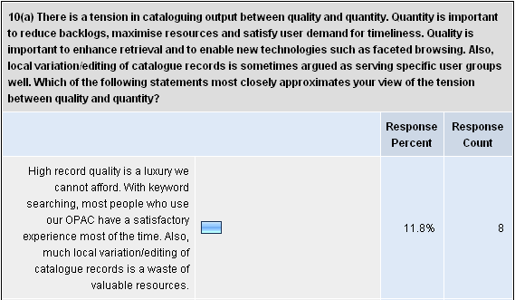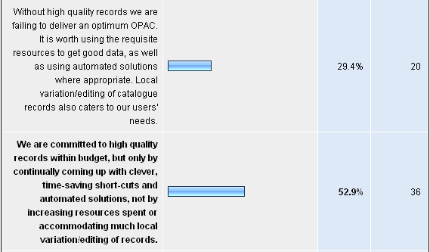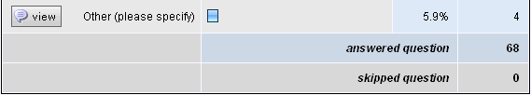

Other:
- We are committed to high quality records for our own publications, for contributions to the National bibliography, but accept good enough is good enough for some collections and types of material, e.g. ebooks, multimedia materials, eserials.
- I take pride in my ability to catalogue and to do the job well, but the LM system does not allow for a full tertiary level record with e.g. access points. The client base is not interested in the catalogue - "everything is on the Internet"!!!!!!!!!!! The cross referencing, see also have gone. It's all keyword searching. With subject headings they can be a misleading search e.g. railroads v. railways, motor homes v. caravans, so I tell the few catalogue users not to use them. Back to keyword searching!!!
- High quality records are required, but not in the traditional MARC context. Analytical summaries are much more critical than knowledge of LCSH and Dewey. The 4th point above is also relevant to our context-i.e. time-saving shortcuts and automated solutions. The MARC record is so technologically outdated in the web context we now operate in.
- High quality records are of importance for many of our materials however deficiencies in our OPACs to use and display high-quality data make this a lower priority than would otherwise be the case.

10 (b) Extra comments:
- It isn't an either /or. Faceted browsing etc can be done with less effort by knowing where in your catalogue records you put the effort.
- Records with specific in-house or local value are selected for added data. Majority of records are not subject to edit.
- High quality records are the ideal - but having an item catalogued and accessible is more important than having an item sitting in a backlog unable to be used.
- the definition of high quality is also being adjusted downwards - primarily pragmatic and driven by reality and budgets
- Quality in authority work and allocation of access points is important for maximum resource discovery. Access points are hyperlinked. In a public library it is important to show relationships between titles by adequate description and access points (e.g. fiction series). Records are enhanced with summaries when provided by source or necessary to explain subject access relationships. This is important for users searching the catalogue from home. Local variations are mostly collection subject headings and editing of records to delete unnecessary codes/data resulting in a visually cleaner record for the public library user
- Old style cataloguers tend to be too purist and all the effort doesn't necessarily translate into value
- Influencing providers to deliver quality records is one of our strategies.
- At present we have funding for 12 months following implementation of a new LMS/RMS to ensure high quality records (or high compared with previous records held by this department) however in the future we will be identifying with the third statement above and relying on coming up with clever, time-saving short-cuts etc.
- It is difficult to sacrifice quality for quantity but it can be done. Users want to discover the items as quickly as possible, not wait for weeks while the t's are crossed and the i's are dotted.
- A look at the type of searches carried out in the catalogue shows that they are relatively unsophisticated. High quality records are not necessary to enable the vast majority of our users to go about their business finding things in the catalogue.
- We want to keep local variations to a minimum, but enrich the catalogue by adding TOC notes and look forward to innovations such as social tagging to improve accessibility to resources.
- You're right, there is a constant tension around this. Cataloguers need to concentrate their efforts in the areas that affect retrieval, and stop worrying about the height of the spine, or the number of pages. We simply don't have the time for that anymore (note I was a cataloguer for many years)
- Garbage in garbage out. Quality is a priority for this library otherwise clients will lose confidence in our abilities.
- We are using semi-automated ways of producing catalogue records for certain categories of material, for example generating MACR records from data recorded in spreadsheets and other lists entered by staff or volunteers. Increasing the amount of copy cataloguing available is a priority for us and we seek out additional targets/sources depending on the nature of material to be catalogued.
- There are opportunities for suppliers of library management systems/OPAC software to improve the experience/results of users.
- Level of record relates to significance and value of the material. We do enhance records with copy specific information when we are dealing with heritage material but generally accept copy found on ANBD or OCLC unless poor or inaccurate data affects retrieval.
- We have worked hard to minimise local variations and editing of copy cataloguing records.
- Currently we monitor performance of suppliers and as part of their service level agreement with us. Out of the number of records that suppliers provide to us they must reach a 2% error rate and under each month. We monitor them against the cataloguing guidelines that we provide to them. We also provide monthly feedback to them about the errors we note from the sample checking we undertake.
- The third answer in 10(a), which is the one I ticked, does not do full justice to the value judgements made by our cataloguers as to when local editing is necessary. These happen constantly, even though the outcome may be that most imported records are largely left untouched.
- I believe in high quality records that match international standards and that we should avoid local customisation as the costs are very high.
- There is always the argument that the catalogue needs to be accurate and useful because that's where users interface with the collection. However, the bulk of our users browse the collection and non-users go to google for their information. For libraries to remain viable we need to increase the usefulness of the information on the catalogue and develop federated searching - the catalogue then becomes a one stop shop for specific, accurate information that is easy to access for time poor patrons.
- Full multi-skilling of staff across all areas of TS has provided us with a staff of around 30 able to acquire, catalogue and process materials to an acceptable quality level.
- Particularly where records can be purchased elsewhere.

Other:
- Depends totally on the individual. Information discovery is the goal not data perfection.
- Learnt MARC in my Technician's course but cannot use it cos of LMS. I know what I am looking at but it becomes an employer issue. Got to know it but no one will teach you and if not used lose it.
- Our current cataloguers are at the retirement end of their careers and not very interested in learning new skills such as metadata creation so I don't think their skills are transferable. But given the right replacements when the current cataloguers do retire I would think we would be looking at staff with skills that were transferable and people who are willing to learn.
- It depends on the schema. The more complex and specialised the schema, the less portable are the skills.
- It depends on the individual and their interest.
- However, cataloguers should be able to transfer their skills to metadata use.

11 (b) Extra comments:
- Describing and organising resources is what cataloguers say they are good at. Here's a chance for them to prove they are, and can be relevant in the modern networked world. There is a new world of metadata and ontological effort outside MARC, authorities and Dewey. My view is that all library staff should have at least a passing understanding of how knowledge is described and organised effectively for different uses - hard to claim the title of information professional if you don't (I would have thought).
- I would hope that skills are transferable but don't believe this to be so with our current cataloguers.
- Metadata activities generally require speedy often immediate take-up of task. Timelines are tighter. Many cataloguers fail in this environment. However it is the innate understanding of controlled vocab that sets experienced, articulate flexible cataloguers apart.
- We have had no difficulty with existing cataloguers picking up Dublin Core skills. More advanced skills may require some training.
- Yes, but I found traditional cataloguers are often not taking it upon themselves to learn metadata schemas and applications. There is some resistance to taking on new roles amongst some staff.
- I believe that this is where cataloguers can most enhance their value to the University and yet the cataloguers themselves seem resistant to taking on this role. Leaves me frustrated.
- Staff have been attending Library Association courses and workshops to update their skills and knowledge.
- While there is a degree of overlap between cataloguing skills and metadata skills the degree of transferability depends on the nature of the individuals involved. While the organisational skills may be similar, the technical skills are quite different.
- My exposure to the Metadata format suggests it is more straightforward than MARC, and therefore easier to use. Some staff might be resistant to change, but cataloguers should understand the need for consistent description of resources in order to maximise access.
- I firmly believe that metadata is what cataloguers have been doing forever and the rest of the world has just discovered. It's amazing how it has raised the profile of library skills, especially for cataloguers. Our institution accepts without question, the library's assertion that they are the metadata experts.
- This is a very transferable skill set.
- Cataloguers can traditionally carry an aversion to developing new related skills like Metadata creation and analysis without understanding that they already have similar / complementary skills.
- Most metadata schemas are less difficult to master than AACR or MARC.
- We are encouraging as many of our cataloguers as possible to involve themselves in associated activities/projects, where they can contribute their skills, as well as benefit personally by expanding their own skill sets.
- Subject analysis and understanding the structure of information are applicable to any such exercise
- This is an area that we have not yet explored in much detail.
- On the whole have found that cataloguing staff are not interested in metadata schemas and prefer to focus on MARC and physical resources. Our current set-up of indexing and database creation is in a non-MARC format and a lot simpler than cataloguing. We currently use a wide range of staff and volunteers to do this work. We wouldn't let any of them near the catalogue! Having said that the metadata schemas are designed by professional staff - again these tend to be experts in digitisation rather than cataloguing.
- I believe that this is what they do anyway using subject headings and classifications which often require careful thought. It's just a new way of doing the same task.
- Those staff who undertake original cataloguing (qualified HEW 5+) already add metadata as required.

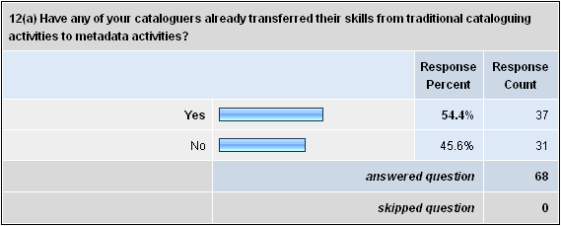

12 (b) Examples of that transition:
- Cataloguing staff have worked with our online services group and have provided metadata for ANTA Toolboxes. Cataloguing staff also contribute and maintain a keyword database for course information
- Creating records in Dublin core for repositories
- Our cataloguer is currently learning a new schema so she can work on an in-house database we produce.
- Previous cataloguer has now become the metadata guru for a major component of the agency website
- Advice in database creation and structure and metadata in that database. Subject and name quality control for various thesauri using different metadata standards. Adding additional indexes to traditional catalogue to allow for non-standard material - e.g. archives, ephemera. Setting up cross-walks between MARC records and DC to automatically populate 2 d/bases (in development) Linking to web pages
- (No, but metadata activities are being developed by a cataloguer transformed into information technology librarian.)
- Eprint server; ADT - Australian Digital Thesis. Can't get university interested in uni. site metadata though.
- participation in institutional repository development, federated search systems and image database development using other metadata schemas.
- One of our cataloguers was involved with the process of setting up the university e-repository and took over the responsibility of the metadata creation from the start with very good results.
- 1. In support of institutional repository developments. 2. Contributing records to Australasian Digital Theses database.
- MARC XML, Dublin Core - use in institutional repository etc.
- Some members from our Monographs and Serials Teams applied for positions in the Digital Repositories Team and learned new skills.
- Cataloguing associated with the PANDORA NLA project. Linking digitised images to the catalogue.
- I provided expert metadata advice to a subject gateway
- Input in the creation of our intranet site and addition of some metadata to enable library clients to easily find resources listed on the library's intranet, including full text documents.
- Some cataloguers also maintain repositories of publications as part of their role.
- Our CMU staff have used their cataloguing knowledge to update digital repositories such as ADT, and we see that they will do this more and more.
- They were involved in a Metadata project and they were trained in using a Metadata Schema.
- The Cataloguing Co-ordinator position was set up 3-4 years ago and has a stated role to work with metadata projects across the University. Joining the ADT consortia has also changed the way in which the University handles theses. Creation of a University repository is changing the nature of how resources are handled.
- Assisting with the conversion of theses catalogue records into Dublin Core compliant metadata records for our DSpace repository.
- Cataloguers provide metadata for our digital thesis collection, digitised archive collections and our institutional repository.
- Not a lot done so far, but cataloguers are involved in Digital repository project and larger Digital Object Management project. Any time metadata is mentioned in such contexts, the library gets involved.
- No but it's on the cards!
- I hope that they will in the near future.
- Thesaurus construction and metadata advice for internal databases.
- Develop and implement standards and guidelines for various schemas used in a number of databases.
- Development and administration of library systems and resource discovery services, development of standards, thesaurus creation and maintenance, development and implementation of search protocols.
- Some of our cataloguers have been adding AGLS metadata to Library publications on our website.
- We have had cataloguers work using EAD to describe unpublished materials. Likewise staff have used Dublin core to describe materials also.
- Participation in [repository/e-learning projects]; regular creation and maintenance of Metalib resource configurations.
- Preparation of metadata for website
- Head cataloguer transferred to indexing coordinator. Focus on metadata schemas for our internal indexes and databases. This is an exception to the rule.
- We take 'transfer' to mean incorporate ... records within the institutional repository are created by library staff with appropriate metadata added.
- Tagging Library web pages.
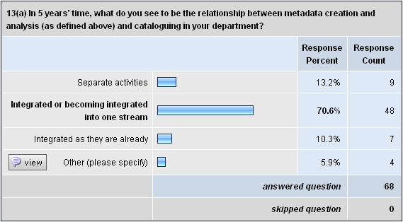

Other:
- Original cataloguing and broader metadata work seen as work of single area.
- Have no idea!!
- N/A
- Some will continue to be integrated; non-bibliographic will probably still be separate

13 (b) Extra comments:
- The development of our IR is focusing our thinking on how we create/transfer records.
- Integrated into a common work group, but with some specialisation in each.
- To be sustainable, repositories will need to be based on self-archiving
- Partially already integrated - this will continue to grow.
- This is assuming that the whole system as we know it is not turned upside down by a new system of discovery tools.
- I think that for us they will be carried out by different people, but they will work more closely together.
- I think though that we need cataloguers to go the next step and assist with managing the research outputs for academics.
- Again, this is a hope and will depend on decisions made outside of the Library.
- Would be desirable to see greater integration but I do not believe this will happen within next 5 years.
- Our staffing resources and policies would not allow for separate metadata cataloguers.
- Federated search tools should enable the searching across all resources. Currently these tools are not performing well enough, but it's only a matter of time. I think there will be a shift away from everything being in the catalogue to some overriding search that easily brings together and displays search results from a multitude of target resources in a usable format similar to Google.
- This is what I would hope would happen. Cataloguers however can sometimes become very narrowly focussed and need some help in seeing the possibilities for them to expand their duties. There seems also to be a push towards having IT professionals doing this work rather than cataloguers - which doesn't mean that the work is as authoritative as it could be.
- Metadata creation will most likely be handled by Systems/E-services staff.

14. What other areas do you see your traditional cataloguers transferring their skills to, within your library and organisation, if that became necessary?
- Collection development analysis; Research assistance (RQF records management); information literacy training - how to use the catalogue for example; digital rights management.
- Becoming part of regular technical services roles that will do all cataloguing and metadata process work in addition to other duties. We will have the role of metadata expert (developing and extending existing regimes) being part of the domain of the systems team.
- Contribution towards the organisation of the website and intranet sites
- Good cataloguers often make good systems analysts, and we need lots of those!
- Possibly database management but practically nowhere within this organization as it is very small and specialized.
- Increased indexing duties.
- Reference work
- Indexing major publications such as annual report and other key publications.
- Advice on how best to integrate different databases so that searching and discovery is seamless. One example is creation of metadata for digital theses in the institutional repository (mostly supplied by the author of the thesis) and the data in the catalogue - ensuring that both sets of information are integrated and accessible, both to the end user and to search engines.
- Repository and university wide content management initiatives
- Institutional repository resource description.
- More work with organisation and access to user created information. Currently it is the eprint server but clear signs this is already a growth area.
- Database creation Web page creation and architecture Thesaurus creation for specific applications
- regular interaction with users as part of front line desk teams
- Contribution to web design in terms of structure of information finding. Contribution of knowledge to open linking technologies
- Involvement in training staff and users in search strategies on OPAC
- Reader services.
- Provide more management support, such as with the evaluation of packaged electronic products (ebooks packages), analysing usage statistics, assisting with the development of the electronic reserve and other areas to help the Library in the transition from print to an electronic collection.
- Indexing and abstracting Records Management
- Providing help in organising access and structure to learning objects stored in digital repositories.
- Potentially any area of the library, although there would be particular skills to offer in the area of systems, other technical services, collection development and reference enquiry work.
- They are generic librarians first and foremost and just because they may have done cataloguing for a period in their lives does not make them a "cataloguer" as distinct from a librarian. So they should already have all the other skills of a librarian/information professional
- Describing learning objects.
- Indexing, reference and research (using their knowledge of the collection holdings), electronic repositories.
- Using other applicable software e.g. EAD. Digitising and linking to the catalogue.
- Structured organisation and access to information. My head cataloguer now spends most of her time coordinating content on the library's website.
- Data Management in support of research
- Already involved in web publishing - library's intranet site and this will continue to grow. Also involved in reference desk shifts and some training activities.
- Indexing of articles
- Creation of organisational taxonomies
- Reference services.
- Responsibility for the maintenance of other resource discovery tools such as an Open-URL resolver (catalogue the publication and activate links at the same time) and subject specific portals.
- Digital object management
- Subject Resource development on our Portal - adding local search keywords to data.
- Good cataloguers also make good reference people.
- Reference work, Acquisitions, etc.
- Customer service areas including online assistance to clients and delivery of "packaged information" to clients.
- Reference Desk duties
- Working with systems.
- Possibly Metadata
- Working on resources in e-reserve collections. Utilising their skills to help create repositories within their own Universities and in collaborative activities locally, regionally, nationally and internationally.
- Cataloguers with eJournal cataloguing experience will assist in the installation and maintenance of federated search/link resolving and ERM packages.
- We have recently reduced the number of cataloguers to what we think is the minimum level required for the next few years. With that and the personalities and skills of the remaining cataloguers in mind I do not foresee their moving in to other areas. I believe that they will be working more closely with digital resources as this area is built up.
- To the management of electronic resources, to the acquisitions of non-electronic resources, to information services, assisting users online or in person.
- They are also doing more work in the Web environment - cataloguing selected web pages for subject portals, creating dynamic web pages from the catalogue, etc.
- Work with Institutional repositories; creation of resource discovery tools; federated searching; webpage creation; ERM work; training
- Cataloguers make great reference people in my opinion, as long as the people skills are there. That's because they understand the structure and relationships of bib data and the concepts of storage and retrieval.
- Indexing and inputting data to repositories, e-research data management and information management initiatives, e-learning and the e-environment.
- Organisation of knowledge management databases for the parent organisation.
- I would like to get involved in compiling and maintaining a database of items related to the history of the University (documents, photos and publications) and see that these staff could provide some catalogue expertise even if they are not doing the work directly.
- They need to be able to provide analytical summaries of books and articles so users have an idea of likely relevance. LCSH is meaningless.
- Increasing involvement in digital resource discovery and provision.
- Reader services, website services, database services, providing access to web resources (in particular online resources collected under legal deposit), rights management
- One cataloguer is a qualified librarian and could transfer relatively easily into a reference role. The other lib tech would probably move into acquisitions duties.
- The online catalogue is a library's most heavily used service. Cataloguers are used to working collaboratively to provide services to remote clients. As such they are ideally placed to use their skills to provide other Web based services such as FAQs (e.g. how to find a government publication, how to find a newspaper) and subject guides (e.g. how to find stuff about Australian music).
- Projects such as the [major digital project], where cataloguers have been involved as "subject matter experts" and in business process change activities.
- The University's digital repository is to be managed by the Library, and cataloguing staff will perform important roles in the creation and maintenance of this metadata.
- Creating metadata / catalogue records for University data / digital storage areas such as streaming servers.
- Likewise our cataloguers have adopted a more quality assurance role. I think it is all about ensuring the OPAC is searchable using terms that ordinary people will ask and search for and not some long winded explanation.
- Database creation and management for non-bibliographic items
- Acquisitions (not selection but all other parts of the acquisitions process). - Systems (management of the library automation software, not hardware, communications or networking). - Client services, especially adding value to client search requests at information desks.
- Expert advice in database structure, thesauri etc.
- We are encouraging our cataloguers to become more involved with the overall collection management, such as weeding and selection. With available time we are also hoping to encourage some work to be done in the promotion of the collection via various methods.
- We no longer have "traditional cataloguers". However as an example, one of our former "cataloguers" is now our local Document Delivery expert ... still undertaking some cataloguing/acquisitions/Document Delivery ... see 2b above.
- Reference/Local studies or into central services management of programs such as Books on Wheels housebound service or data management of systems.
- Contract control and supervision. Retirement.
- Management of access, electronic resources.
- Possible contribution to records management.

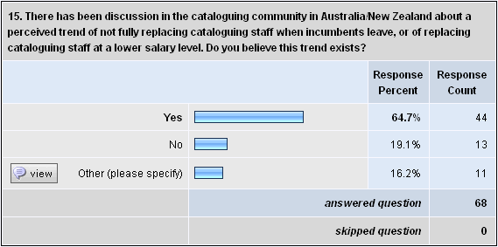

Other:
- We would not replace cataloguing staff at a lower salary level but would probably replace with staff with IT qualifications and not necessarily with library qualifications.
- Was not aware of this trend.
- Not been our experience -- cataloguing staff closely aligned with reference staff and paid at same level.
- I believe that cataloguers must become more flexible and take on more functions within CMU type areas, and that they will be replaced.
- There has been ongoing speculation on this for some time, but I have not personally experienced any real indications of this.
- Not in academic libraries though
- If it does then they are very short-sighted. Cataloguers have excellent information management skills.
- Not sure but it would not surprise me.
- N/A
- There is a place for cataloguers to be in a quality role however they need to be adaptable and more multiskilled.
- Unable to comment.

16. If you answered "Yes" to Question 15, what factors do you identify as contributing to this trend?
- Changing trends away from 'cataloguer' so they are not being replaced as a like with like position. This should not be perceived as negative, but rather evolutionary and as a result of improved resource discovery tools.
- The value of the function (traditional skills) is declining relative to others (such as good IT skills) as the breadth and type of resources we are expected to manage and provide simple access to, moves ever further away from traditional printed materials.
- The majority of cataloguing is copy cataloguing. We replaced a cataloguing position with a lower classification level to undertake the copy cataloguing.
- The popularity of Google as a one-stop shop for finding information has contributed to this trend by valuing search algorithms over accurate description and careful analysis.
- - Availability of CIP and record sets - Reduced practical cataloguing training in post grad courses, leading to lesser appreciation of cataloguing and fewer new staff with any skills at all - Intransigence on the part of cataloguers, and their reluctance to acknowledge the googlisation of the online world - Blending of libraries into overall IT/IM management areas, has diminished the perceived value of many service lines attached to the management of hard copy.
- Cost - budgets are always tight and there are always new priorities to invest in. It is also likely that it will be harder to find appropriately skilled staff. Whenever we have a vacancy we always investigate whether that gap could be replaced by a person at a lower salary level.
- Increasing availability of streamlined processes for acquiring records, reducing the need for cataloguing staff, and the growth of alternative models e.g., where records for eresources are bulk imported into the catalogue with minor modification.
- Greying of the profession, reduced operational budgets and less value placed on cataloguing skills.
- Short-sighted view of value of libraries to the university community. Let's be realistic the whole university arena is on less budget so all are suffering. I hope that some recognition of the value of Higher Ed would also flow onto the recognition that quality staff require appropriate payment i.e. not a cataloguer issue but a university funding issue.
- Budget pressures Perception that availability of data from bibliographic agencies such as Libraries Australia has diminished the need for as much effort towards original cataloguing Staffing pressures - with reductions in staff there is added pressure to utilise existing staff and skills over more library services
- Greater availability of external copy cataloguing which can be handled at the library technician level and integrated into the acquisition process
- Saving money by recruiting less experienced staff at lower salary levels. Also as more records available (e.g. LA providing access to WorldCat), need for very experienced cataloguers to do (lower percentage of) original cataloguing seen to diminish.
- Availability of outsourcing, shrinking budgets, low value placed on cataloguing skills.
- Services which allow copy cataloguing; institutions purchasing same resources such as electronic aggregations that supply records; decline in the budget for local purchases.
- The work is changing and as a result some libraries have reduced staff, others have restructured to incorporate changing trends.
- And rightly so when most of it is just downloading records and checking - library assistant level work. For the minimal amount of original cataloguing required, this can be done by qualified librarians but as part of their general job of being a multiskilled, generic librarian.
- We downsized our cataloguing teams many years ago. This trend is in the past and not current. We are currently multi-skilling existing staff.
- Library priorities
- A trend to outsource cataloguing to outside agencies.
- Cutting costs. Better search capabilities of catalogues and search engines. Undervaluing the importance of cataloguing by library managers.
- Cataloguers have generally been within an organisation for a long time and have worked their way up through the organisational structure. A new cataloguer would need to make the same progression rather than being employed immediately at the higher level.
- Requirements for staff with different skills, greater flexibility.
- The high demand for customer service, front of counter staff to meet customer needs in a busy public library. The possibility of saving staff costs by employing lower paid staff and utilising the extra funds for outsourcing cataloguing duties. The reluctance of some "traditional cataloguers" to multi-skill and participate in customer service activities.
- Cataloguers with the experience are retiring and with the trend to outsourcing, multi-skilling and the work becoming a matter of manipulating records en masse, new staff no longer need to acquire such skills (metadata skills can be obtained in other ways and often require advanced technical skills and knowledge).
- Decrease in the need for original cataloguing by re-using existing cataloguing data. Electronic networks allowing access to other libraries' catalogues and exposing cataloguing data not previously available. Bibliographic tools are now easily accessed e.g. Libraries Australia, Te Puna, OCLC and "bundled" access is included within these memberships.
- 1. Budget factors 2.A lack of suitably qualified original cataloguers may result in jobs being offered to in house para-professionals with substantial practical experience.
- The falling number of print serials subscriptions which have been replaced by electronic access, all records for which are outsourced. The increasing number of e-books, the cataloguing of which is also outsourced. The increasing availability and quality of agency records for books. These records do not need much if any local modification. The corollary to this is a reduced need for original cataloguing.
- Copy cataloguing is now dominant, and requires less skills and knowledge. The digital environment is requiring a different approach to descriptive cataloguing. Initiatives such as the Resource Description and Access standard will accommodate descriptive models such as the Functional Requirements of Bib. Records, and metadata, and suggest the traditional cataloguing skills will be redundant.
- Failure of the people in these roles and their managers to articulate the importance of what they do. Perception of senior management that life in the back-room is fairly cushy. Concentration on no. of items catalogued as opposed to the range of other contributions that cataloguers typically make. I am concerned about where this trend is leading. Essential skills may not be there in the future.
- 1.The belief of some senior staff (outside the library) that everything is available on the internet and requires little or no input by the library, leading to a squeezing of funds. 2 .Shared cataloguing has led to much less original work being needed and therefore less need for highly skilled cataloguers & more work for copy cataloguers.
- Full records are available from bibliographic utilities and outsourced services more than ever.
- Increase in use of imported records and outsourced data
- Change in the nature of the work, change in organisational structures, there are fewer experienced people to replace those who leave, tension between budget and productivity.
- There is a general belief that, for public libraries, the specialist skills of a fully qualified cataloguer are a luxury especially with increased outsourcing. However, we know that outsourcing suppliers use less qualified staff for cataloguing (usually lib techs) which may lead to a lower standard of cataloguing record being produced. The long-term effect of this is yet to be determined I believe.
- We need new librarians at Grade 1 level. Most of our cataloguers have been with us for some time. They are very experienced Librarians at grade 2 level. Until they retire we are unable to achieve right mix of Lib 1s and Lib 2s.
- Yes the former is the experience in this library as this organisation has come under budget pressure.
- Lack of trained or interested staff available at time of recruitment.
- Failure by library management to understand the importance of making the local collection (in whatever form) relevant to the home community.
- Dwindling numbers of new print resources added to the collection as electronic resources grow. - Cost saving (e.g. replace a professional with long experience by one with less experience or by a para-professional).
- Lack of understanding by management of the value of the work being undertaken. This can be a particular problem where the manager is not a librarian but a professional manager. There are also budget pressures - more work for less money; the feminization of the profession - women still don't earn the same as men in the workforce and women's work is never valued (in money terms) as highly as men; trends towards managerialism - professionals are not as valued as the people that manage them.
- The need for a truly multiskilled workforce - single focus cataloguers will not survive in the modern library world. Records are increasingly available from such a variety of sources - vendors, union catalogues etc - that a "cataloguer" is however sadly a bygone relic.
- Erroneous belief that copy-catalogued records are 'good enough' and a perception that search overlays that mimic search-engines remove the need for higher cost maintenance of catalogue records.
- Increased interest in contracting out and consortia purchasing. No new staff being employed so backroom work needs to stop so these staff can be moved to public areas.

17(a) Over the past 18 months, important papers such as the "Calhoun report" (CR) and "A white paper on the future of cataloging at Indiana University" (WP) have been published in the US and UK, and they have caused great discussion amongst the worldwide cataloguing community. How much have these and many other papers influenced your thinking regarding the direction and future of cataloguing activity in your department?
CR is at http://www.loc.gov/catdir/calhoun-report-final.pdf
WP is at http://www.iub.edu/~libtserv/pub/Future_of_Cataloging_White_Paper.pdf
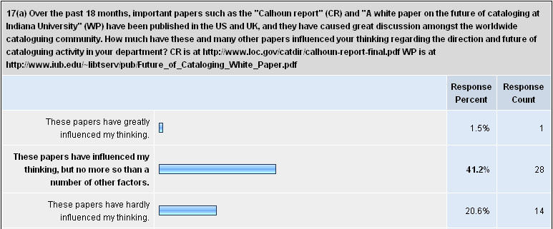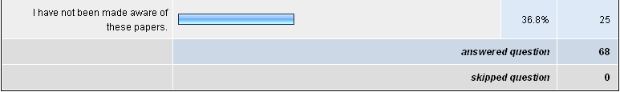

17 (b) Extra comments:
- Had only seen some of these before answering this questionnaire.
- I will now have a look at papers
- Served to confirm what is becoming fairly obvious
- The public library, with its high percentage of resources for "entertainment" compared to very limited research level material, does not share most of the concerns of the research library.
- It is great to have lively debate on these issues.
- It's not a major issue
- I have read this paper, but it was by no means the first or only paper to be released on these issues. Many libraries have been implementing these changes before the paper was written.
- The key issue is the future of the catalogue as a resource discovery tool. If the catalogue is not being used, the issues surrounding the metadata found in same become largely irrelevant.
- It is interesting that the papers are coming out and it's good to see the debate occurring. We have to change to remain relevant.
- I have become aware of these discussions via Forums and conferences sponsored by the National Library. But it was clear some years ago when metadata and the Dublin Core were first introduced at Cataloguing Conferences, that the internet and digitised documents were going to require faster and easier descriptive processes, aimed at users of internet search engines rather than users of library OPACS.
- One of the things that stuck in my mind from the Calhoun report was the resources that we put into choosing and customising our automated library systems and how we are too small an industry to be doing this. Interestingly, we are seeing a reduction in the suppliers of library systems and I think this will continue. Shared infrastructure makes sharing on other levels a lot easier.
- I need to put these reports in the local context and this is difficult. No response from the cataloguers themselves, even though they are made aware of the reports' existence.
- I will be reading them now that I'm aware of them
- These papers have been interesting but we operate in a different environment to the US scene they describe. Our in house programs exposing staff to new technology have been more influential and useful.
- Now that my awareness is raised I will source these papers and have a read of them.
- Most of what they say is already abroad in the library community, so it's not particularly new.
- I wish I could make sufficient time to read these and similar studies. In our sector time for research and personal professional development is at a premium.
- Calhoun makes really interesting comments about the declining use of catalogues. We need to think of how people are searching for information and get ours out to them. Worldcat is making some interesting advances in getting our catalogue records out onto the web.
- Hadn't seen these until this survey was promoted. The Calhoun report's focus was on academic libraries who seem to be serving their niche market of researchers well at present and didn't consider how effective or otherwise searching of google is. As a prompt towards thinking about how cataloguing is developing, we had already started down this path due to the strategic planning that is happening across Victorian public libraries.
- I'll have a look at the papers and will also notify my primary cataloguer of them.

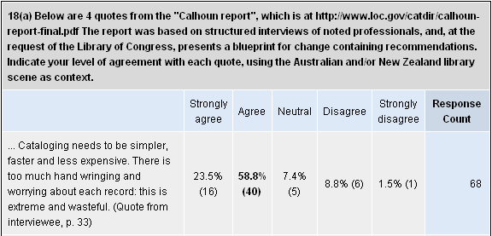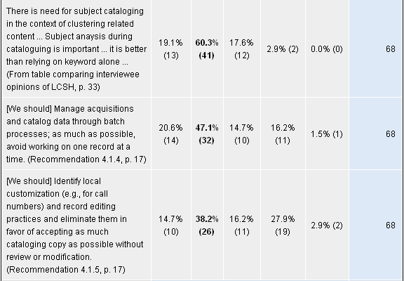
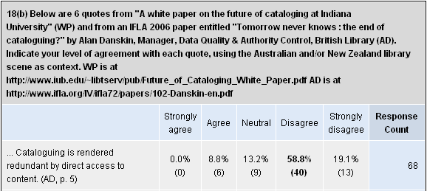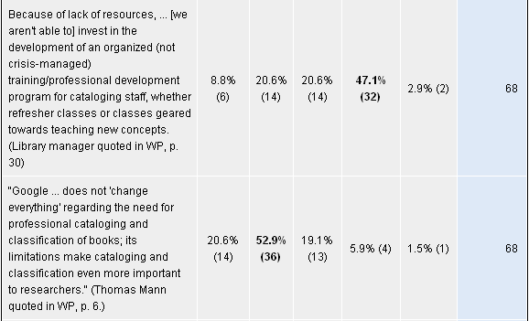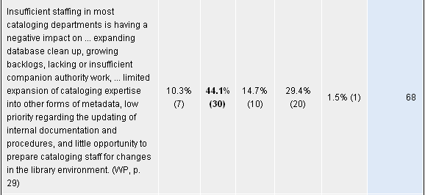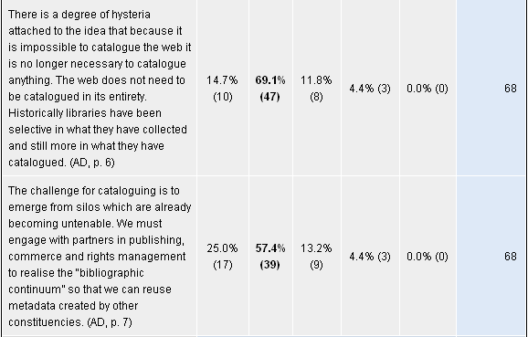

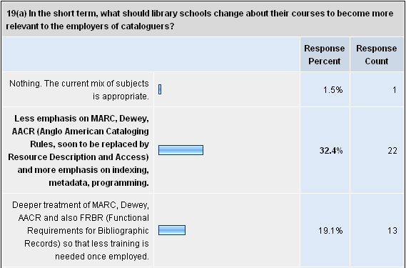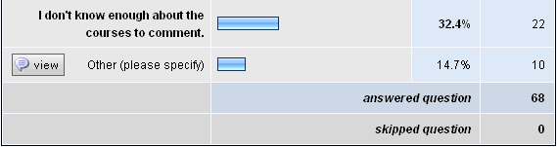

Other:
- Deeper treatment should be available as an option. This does not seem to be the situation at present.
- Be enthusiastic about the role of cataloguers and encourage them to develop these skills. Offer continuing educational opportunities.
- Whilst record structure is important more emphasis is required on acknowledgement of how library clients access information through catalogues
- Library schools in Australia seem to be reducing the emphasis on resource description and access (to focus on the more public client-sides of business) and I think this is a real mistake.
- Anecdotally you hear that Library courses are not training the students as cataloguers, perhaps it is a paradigm shift that is required, and we train resource discoverers.
- Students need to be prepared for the transition from print to digital resources, and know how to process both.
- They need to be aware of other schemas; TEI; metadata systems; etc.
- A solid grounding in metadata standards used in libraries. This would form the basis for study of related standards and systems of information organisation.
- The reality for us is that graduates come to us with theoretical knowledge; we train in practical application of that theory.
- While I don't know much about courses, I believe there is an unquestioned assumption that all libraries use MARC, LCSH and AACR, and copy cataloguing. I don't find graduates with an inquiring mind about the purpose of cataloguing or other approaches.

19(b) Please add any extra comments you have about cataloguing education, e.g. how much training you feel should be undertaken by the schools versus by your staff or external courses which you send new cataloguers to attend.
- I think there is a great unmet need for external courses which less experienced cataloguing staff can attend. In a small library with only one cataloguer the luxury of consulting more experienced staff which exists in an academic library is not possible. Regular top quality courses focussing on particular areas would be of great benefit.
- Should also add that I don't know all that much about the courses to comment. I do think that Cataloguing (or something like) should be a core course - this has not always been the case. Also it is clear that we are often well ahead of the educators in our knowledge and experience, - in some ways cannot expect more than base knowledge from cataloguing educators - practical experience is the most valuable. (and change is so rapid that we are all learning all the time).
- We actually are finding it difficult to find trained cataloguers.
- New cataloguers should be able to catalogue and classify monographs, serials and audio- visual formats to Level 2/Libraries Australia recommendations for catalogue records. New cataloguers should only need to be trained in local practices and variations, and requirements for authority work.
- Develop understanding of WEB2 technologies, of searching functionalities and interfaces such as Google as opposed to the old OPAC interfaces which have not progressed in the last decade. Have proper component in IT processes included in course.
- The "MARC of Quality" training courses have been incredibly useful for new cataloguers. This level of training isn't offered in the graduate library courses, though more practical classes are offered at the technical institutes. Suggest that the schools outsource their cataloguing training to practitioners.
- I would like to see library schools offer greater specialisation in resources description and access. We are finding it more difficult to recruit new staff.
- Local course has some aspects which seem irrelevant and outdated.
- Specialisation in cataloguing should be made available as an option in courses so that graduate cataloguers, that do not require training from scratch, are available.
- Schools need to get out of the 19th Century and restructure their courses with more emphasis on understanding technical infrastructure and knowledge management.
- The cataloguing section of the Library degree I did in 1995 was minimal at best. Unless Library u/grad Schools have changed - they need to decide one way or the other to either train cataloguers properly or don't offer cataloguing at all - perhaps they should offer cataloguing/metadata/indexing as a specialty area...! Alternately stop teaching at the librarian level and leave cataloguing with Lib Technicians as they at least are given comprehensive training.
- Of the 8 staff we have undertaking Library training in a variety of courses at the moment, two of those staff have stated that they would like to work as cataloguers when they qualify. People who are able to think laterally understand links and connect and disconnect pathways, will always be interested in providing simpler and better ways to create access to resources.
- My impression has been that Library Schools have undervalued cataloguing for years, and relegated it to Library Technician courses. Now, as the public tends to access resources from home, bypassing reference desks, Schools might refocus their attention on the organisation of and access to resources, and educate students for this era of transition. I think students will be looking for employment outside of libraries.
- My understanding is that there's a push to stop teaching cataloguing to library undergraduates, which is alarming and sends the message that cataloguing is unimportant. Obviously honing one's cataloguing skills is a lifelong endeavour and most learning is done on the job but in my experience, library technicians come out of training far better equipped to start cataloguing than do library school graduates. Most of our training is done on the job by senior cataloguing staff, who attend outside training themselves when major changes occur, then on-train the others.
- Integration with Faculties of IT has not helped the training as the move to Information Management has tended to dilute the librarianship stream for subjects such as cataloguing.
- Students should be trained in the basics of descriptive and subject cataloguing and authority construction. Knowledge management in organisations is gaining momentum and people with cataloguing skills can apply!
- I am not sure that university courses are well suited to this kind of instruction. I think that many of the skills are closer to the kind of skills that TAFEs teach effectively. I wonder whether we ought not to be moving to an apprenticeship model rather than an academic model of instruction.
- We arrange courses for new cataloguers but this may be some weeks or months after they have been appointed. If the staff have a grounding in metadata standards or prior cataloguing experience then they generally find the courses, and their on the job training, to be of greater benefit because they have a basis on which to build.
- Librarians need to understand the theoretical bases and principles of cataloguing, subject analysis, thesaurus construction, classification, facet analysis etc) as well as being exposed to some practical applications.
- Cataloguing beyond the basic introduction to the theory is an optional course at our graduate school. We will always favour a combination of pre-work compulsory training, and short courses for those already in work. This allows for new knowledge to be adopted by those who have trained earlier and in some cases much earlier. We have a commitment to training and growing our own staff.
- Schools should cover the basics (MARC structure, Dewey, AACR, FRBR) in greater depth. They should cover the basics of record import/export in theory at least (eg.Z39.50 loads from libraries Australia, FTP file loads of Bib/item/invoice data from vendors), perhaps combined with visits to local institutions for practical demonstrations of real life workflow.
- Subject analysis and information structures should be core to any formal education of library/information workers.
- We do not have the budget to send our new cataloguers to external courses on cataloguing, other than one-day programs of the type offered by CAVAL. Our own staffing resources limit the amount of on-the-job training we can provide. So, whilst I would like schools to offer more in-depth courses, the chances are that our staff may not be able to benefit from them.
- MLIS in NZ has moved away from detailed cataloguing training and into a more theoretical approach to organisation of knowledge. I think this is a good approach as much of what cataloguers learn is on the job. The more metadata and understanding of schemas in general the better.
- It would be useful for the schools to use the most popular LMSs so that when they start work they don't require such intensive training in the tools used in the workplace.
- The idea that a single class which covers MARC, Dewey, AACR and metadata (DC, XML) prepares someone enough to catalogue is in my idea ridiculous. I feel that schools should expand their programs, adding a dynamic allowing participants to specialize or not instead of being spoon-fed the same curriculum no matter the interest or personal background. Additional short course could also be provided by education providers and in concert with professional organizations to bolster knowledge in specialist areas (Cataloguing being one of many). Internal staff training works well for in house quirks that need to be accounted for and for gaining the knowledge from people who 'Do' vs. 'Teach', but external training is valuable to keep ahead of trends and technology that affect our profession.
- There will always be a need for cataloguers but I am not sure that every institution needs to do its own cataloguing. I have always believed that tasks such as cataloguing are built over time. Proficiency definitely needs a mix of both the theory and the application of the theory.

20. Finally and in a few sentences, what do you see as the future of cataloguing in your library and also in Australia/New Zealand in the medium to long term?
- Change management - the role of the cataloguer is changing. This will impact on the role also of the NBD, which should be revising the way it approaches access/cataloguing and recommendations.
- Day to day cataloguing is mainly process work now and will continue to be so for most people. Tech services areas will largely absorb this aspect of the work - once regimes are established and staff trained it is easy to understand and anyone can do it. The technical expert role in metadata and ontology has already moved to the realm of IT and other information professionals and will probably stay there. I think traditional cataloguers largely have missed the boat by being too rigid and inflexible. That said I hope they can prove me wrong :-)
- In the future there will be very little for cataloguers to catalogue. They will need to expand their skills base and move into other areas.
- I think we will continue to need these skills, but the level of use will remain low.
- Cataloguing our collection and making these records available through a public, web-accessible catalogue will probably never be a priority in this organization because of lack of resources and lack of interest from senior management.
- I see cataloguers doing more original cataloguing to make accessible the unique material we hold in the library. Suppliers will be doing more of the basic cataloguing. Our cataloguers will also be doing more indexing of unique material held in the library.
- A thorough understanding of the principles underlying the cataloguing process will remain important but the skills of metadata creation and analysis of information will be combined with the traditional cataloguing processes to streamline our in-house work. Our users' needs will remain our focus and thus we would continue to provide local variation/editing of catalogue records where necessary to enhance retrieval and enrich our records.
- In the Special Library and research environment, we can see value in enriching some records. If the future includes warehousing of collections the call number may become redundant.
- There will always be a need to provide access to resources (whatever they are)- and quality access (authority control on names, standard subject descriptors etc.) will always be preferable. There will be better ways to reuse data and to automate basic processes (we are using a tool to check coding and standard punctuation). Cataloguing will remain a part of the library but may be called something different to better describe what it does.
- Role of cataloguing will continue to be one of the core functions ... but as the use of the hard copy collection plateaus (if we are lucky) or continues to fall, I think we will be forced to rethink all our approaches to collections - how we build them, weed them, store them etc. So the pressures which have led us to refine our processes will continue, and we will continue to be looking for more efficient ways to deliver an adequate level of collection description.
- The role is essential to our mission of making resources available, but we differentiate even more between groups of resource, accepting outsourced records on a collection basis, and continuing to provide original cataloguing for our own material. Although regional cataloguing consortia may also be an option here.
- Cataloguing is the gateway to the catalogue: our primary resource discovery tool. Our catalogue contains all our e resources as well as hardcopy and it is vital that this material is appropriately located within the context of the catalogue and is indexed in such as way as to make it retrievable by not only the ILMS but other presentation systems which increasingly are using our catalogue as a source to harvest data. Cataloguing is essential to ensure we have uniformity and standardisation which meets user requirements.
- More superficial cataloguing. More emphasis on electronic information and access provided to this. There is still a need in special libraries to catalogue the material published by the organisation which often falls into the "grey literature" category and does not always stay on the web forever so there is a need for knowledge of cataloguing principles to continue that can be applied in the online environment in a more holistic way.
- A shift in balance between what is necessary in terms of the level of quality required and the need to ensure items become available to the user as quickly as possible. Greater demand for evidence of the asserted benefit where arguments of quality are entered into.
- More of a balance between cataloguers approach to their work – i.e. cataloguing within guidelines/standards and flexibility as to how the client searches for information.
- Medium term, cataloguing in this Library will remain the same. The unsatisfactory experience of obtaining cataloguing from supplier of stock this year will be evaluated. New formats, e.g. e-books, will be catalogued consistent with monographs. Uploading records to Libraries Australia will be investigated shortly. The recommendations of Libraries Australia will remain the basis of cataloguing for this library. The future of cataloguing in Australia/New Zealand medium and long term will be of more concern to academic, state and the National Library than public libraries. I think the standards and sources of cataloguing for public library OPACs will remain constant.
- Metadata, resource description and access will be the focus.
- As the trend to make library materials available in electronic form we need more library professionals with a sound IT background. Present library degrees are too "soft" and do not provide enough expertise for the new online environment and Web2 technologies. If library schools are not fundamentally redesigning their programs the traditional librarian will become redundant. All new positions which we have created are with IT graduates.
- Cataloguing is needed here in this library because of being the only staff member I need to find things. So will catalogue them as any defined/described system will work. My replacement will not have to fathom what I have done if I use international standards.
- There will be a need for cataloguers to provide access points for users to retrieve desired items even if everything is "eventually" produced in electronic form.
- Greater emphasis on management of local knowledge - institutional repositories, rights management. Higher level technical ability will be required by a few key staff who will have broad data analysis skills. Catalogues will be interactive, attractive and collaborative.
- Cataloguing, if referring to the activity of original cataloguing, is already miniscule and will continue to decline.
- The past trend towards downsizing information resources management and access departments has come to an end as executives realise that workload in the electronic environments is increasing, not decreasing. This is partly due to the increasing complexity, but also partly due to the massive increase in the amount of information resources we are dealing with.
- I think we need to find the right mix between the traditional cataloguing of material relevant to our collection with the way people use and access information. If people are going to use google we need to make our catalogues more like google by using pictures, relevant subject terms, spelling corrections (did you mean....) We need to think more about our users and less about whether we need to use a colon or semi-colon when following the cataloguing rules. Rules are made to be broken.
- Cataloguing remains essential and relevant at [this library] due to the nature of our heritage and general collections. A greater range of cataloguing skills is required [here] due to the broad nature of the collections.
- The demand for metadata expertise is expanding in my library, but within a wider context of skills in managing resources, particularly electronic. The demand also exists in the wider information community, but it does not view our profession has having the necessary expertise. That is a pity.
- Cataloguing needs to become more flexible to cope with changing workflows and demands on Library staff. We need to carefully consider where cataloguer resources are expended to add the most value and accept that quality could be impacted on elsewhere. We need to explore expanding the role of cataloguers into metadata and the management of digital objects.
- Cataloguing remains an important activity in our library and relevant online resources (both subscription and free online) need to be catalogued to ensure clients find the right answers. Ensures the library catalogue remains a truly relevant resource and makes it a one stop shop for research. Also gives library clients some sense of which freely available web resources are credible, since librarians have first reviewed these sites before suggesting their inclusion in the catalogue.
- Trend toward outsourcing the function.
- The future of cataloguing in our library will continue as it is. I can also see greater collaboration with other libraries.
- I believe that once I retire cataloguing will be significantly changed. As a group we undervalue the importance of cataloguing assuming search engines like Google can find everything. Therefore there will be less and less of it performed.
- In the medium term we will reduce the number of people involved in cataloguing and increase the number of specialist cataloguers with the aim of increasing efficiency.
- Outsourcing of lending and general reference cataloguing, greater emphasis on value adding to local government, heritage and electronic material. Emphasis on creation of records which support user friendly facet searching.
- Cataloguing is very important to the integrity of the library db. To maintain a high standard the cataloguer must be the key person in this role.
- I think that cataloguing will still be important [here], but that we will find better more effective ways of doing things using technology where we can. If we want to value-add our bib data so that we can have new and interesting retrieval mechanisms, the underlying data must be tagged and coded correctly (e.g. for clustering etc.)
- Cataloguing should continue to be an important profession in the Information Services Sectors. Maybe it will become easier, simpler with the introduction of the new AARC2, i.e. RDA.
- I see more centralising of processes and outsourcing occurring. With limited budgets it is difficult to justify staff working in the "back rooms" while customers are queuing at the counters for assistance. I believe the underlying principles of information retrieval need to be reviewed so that practices are better matched with client expectations and client expertise. Marketing principles need to be incorporated into practices to promote "user friendly" information retrieval, particularly in public library environments.
- Cataloguing will continue to be done in-house, with the exception of electronic resources (e.g. online journals) where we purchase the catalogue record. Efficiencies in our workflow have indicated that is it more economical to catalogue in-house.
- Automation of process and outsourcing. Makes no sense at all to have large cataloguing depts in every institution doing the same thing. And less hand wringing over metadata schemas, how many do we really need? Let's make it LESS complicated. There are commercial organisations doing a much better and cheaper job than us - we should stop thinking we are the only experts in this area, we are not.
- Libraries need to decide what kind of and level of service they should aim for regarding cataloguing. Public Libs, regional TAFE, Schools etc could perhaps copy catalogue only and specialist/higher level academic libraries still employ full cataloguing/metadata.
- I believe we are lucky as we have staff who are comfortable moving towards a future which will not be dominated by DDC, LCSH, AACR2 etc. As the Web 2.0 environment engulfs us sophisticated search engines will take many different data elements and help us to discover the resources we require, we have seen a glimpse of this with federated searching and these types of discovery tools will continue to proliferate.
- Although we will continue to streamline and simplify our processes, cataloguing skills will be fostered and developed to ensure local institutional resources are catalogued at a high level. This will include metadata cataloguing of repository based resources.
- A greater reliance on agency records for books (as we already do for electronic resources). Less local editing of these records. More and better "batch" processes. Concentration on original cataloguing of local material. Increased working relationship with those involved in metadata creation for institutional repositories etc.
- Traditional cataloguing skills are becoming redundant. The decreasing but enduring print trade will require more partnerships between editors/publishers, suppliers and libraries. Print resources will be affected by the digital medium - authors may be required by their publisher to complete a catalogue record that will be enriched before it reaches the library catalogue.
- What has become apparent in the move to working with the institutional repository is that the work is becoming more about knowledge management and relationships with academics. Whilst some cataloguers are able to make this transition, others just do not have the requisite people skills. This cataloguing department is full of baby-boomers, some of whom just want to catalogue until they retire. I do worry about succession planning.
- In our Library, I would like to see more emphasis on adding value to the cataloguing of our institutional materials. Cataloguers need a more outward focus; authority control remains important; FRBR important; role of the OPAC needs to be assessed; value to users critical rather than perfection of catalogue record.
- Because we are seen in our institution as catalogue and metadata experts, I think that the foreseeable future will be OK. As newer generations of more net-savvy students come through and net searching continues to improve I'm not sure about the longer term.
- Move from print to electronic formats. Move to reference desk work.
- Don't let this expertise wither. Knowledge management is a big factor in many organisations and getting bigger. Training institutions need to integrate these skills with content management and metadata.
- In my library we struggle to find people with these skills and through a chicken and egg situation (because we don't do much original cataloguing) these skills aren't developed. This leaves us dependent on the quality of work produced elsewhere. As the expertise behind this work disappears we will be left in a difficult situation. I tend to agree with the view that we still need to provide quality descriptions of quality resources and without this quality we don't have a library we have a book warehouse. Translating this vision into reality is proving difficult because of lack of skilled staff.
- Cataloguing is only a small part of our service and our catalogue, while important to our service, is not our flagship product. We do business using a variety of services and products, of which the catalogue (web OPAC) is only one. There is no future in special libraries for a person with one skill set only. They need analytical skills, subject knowledge - this can be built over time but only through wider engagement with clients, their needs etc, not through processing material bought for clients.
- Concentration on the records that count - i.e. - the records unique to our library as well as continued development of quality management, resource discovery enhancement and the provision of access to digital resources.
- This Library continues to make inroads on bringing its uncatalogued collections under control. We are seeking out innovative ways to be more efficient in cataloguing retrospective collections and new acquisitions. Australia's strong tradition of shared cataloguing has enabled the development of powerful resource discovery services. The future will bring new challenges but with opportunities for the rich cataloguing data that we produce to be exploited in new ways and to a wider audience.
- For public libraries, cataloguing is expensive and the need for specialist cataloguers is decreasing quickly. Public libraries will rely more and more on other academic and scholarly institutions to provide quality cataloguing records for the national database and copy.
- We will continue to have a role to play in cataloguing publications produced in the state by government and non-commercial publishers however I anticipate we will increasingly be acquiring files of metadata for commercial material and using batch process to enhance records. I fear that expertise will be lost when our senior cataloguers retire because library schools have largely abandoned teaching core skills. Ironically at the very time that there will be pressure to simplify cataloguing, new interfaces will depend on well structured metadata to deliver FRBR displays and features like faceted browsing a la AquaBrowser and LibraryLabs .
- As long as there is publishing in [this country] there will be a requirement for this library to have cataloguers. We would expect that those cataloguers would in future carry out a wider range of tasks - we may merge cataloguing/acquisitions/indexing, requiring staff to be multi-skilled. We do and will increasingly require that they work on all formats of material including born digital. Outside the national Library and across [the country] I would expect that more and more of our libraries will want to increase their copy cataloguing rates, so that at the local level there will be less demand for cataloguers.
- A continuing need for high quality records that comply with international standards for data exchange. Cataloguing is all about sharing data and enabling access to resources. The demand for cataloguers' logical and analytical skills will increase with increasing uptake of Lib 2.0 developments. A good cataloguer's price is above rubies......
- I see cataloguing skills coming back into their own as we look past the cataloguing of books and encompass the cataloguing of online content be it pod casts, web sites etc. Metadata creation is, in my opinion, cataloguing for the 21st century, and we need to be out there selling our expertise.
- [Here] we already undertake a state wide perspective however we would be interested in joining other consortia, perhaps another state(s) to ensure cataloguing costs are kept affordable and at a minimum.
- My library - ok. Generally - dismal, and it's the profession's own fault.
- We try to select new staff who are well trained, experienced and motivated, and success in staff selection and management on the ground will determine how our cataloguers are perceived by librarian colleagues, by clients and by senior management of our institution. We are small enough to be known personally to our directorate and personnel staff. If we continue to impress, then our future will still be bright, because we all multi-task and there is plenty of work for us here in helping our clients with their information resource needs. In other sectors, the future may depend more on an academic view of cataloguing as a process rather than, as here, a practical view of the value of our cataloguing staff to the [organisation].
- Moving to a single shared catalogue for discovery and then linking into each library's holdings on the fly. Making our content available to search engines to find and then link back to local holdings. The library to provide access to all materials - more integration of electronic resources.
- With the introduction of SWIFT to Victoria, I can see that there will be benefits to be gained by reducing the need for original cataloguing. This will reduce the stress that cataloguers usually feel in coping with their workloads leading to more harmonious working environments. With less stress on quantity we will be able to increase focus on quality.
- I believe there will always be a role for organising data. How this is done and by whom remains to be seen. "Cataloguers" need to broaden their skills base to ensure their continued relevance and importance - Libraries need to retain their roles as 'portals' to knowledge - google is not the answer to everything and it's up to us to convince the rest of the world.
- Cataloguing is perceived by many who hold the budgetary controls in our libraries as a resource waster in many ways. Efforts such as Libraries Australia are excellent resources, but to those who are outside the speciality are often seen as justifications to reducing staff hours on cataloguing in the public library sector. Whilst cooperative efforts may reduce the time needed to manage traditional collections, Cataloguers are well placed to diversify into assisting to create digital content and the standards by which they are provided to our customers. This may require more training in most cases, but I believe that a structured, systematic approach in the provision of digital content is preferable to expecting customers to find information by chance or happenstance on our sites, or other content providers.
- There is no future for cataloguing in my library. I think cataloguers will be employed by Book Suppliers, Publishers and agencies, so when the item is purchased so is the record.
- As a staff member responsible for managing the full spectrum of service delivery across the information services provided by the Library, I am always looking at alternative ways of meeting the accountabilities of the service teams. Some technical services functions are able to be outsourced but the quality of the outsourced product still needs to be maintained.
- This function is a critical component of our Library; staff resourcing is an issue, given that our senior cataloguer is 0.6 FTE and has other duties to complete. I see cataloguing as a critical task in libraries, but would like to see more "federated" searching across more catalogues at the national and international level as well as more data sharing.

-------------------------------------------------------------------------------

http://ll01.nla.gov.au/
Calhoun, Karen. The changing nature of the catalog and its integration with other discovery tools: final report. Ithaca, N.Y.: Cornell University Library, March 17, 2006. http://www.loc.gov/catdir/calhoun-report-final.pdf
Byrd, Jackie … [et al.]. A white paper on the future of cataloging at Indiana University. Indiana University, January 15, 2006. http://www.iub.edu/~libtserv/pub/Future_of_Cataloging_White_Paper.pdf
Danskin, Alan. “Tomorrow never knows: the end of cataloguing?” June 6, 2006. http://www.ifla.org/IV/ifla72/papers/102-Danskin-en.pdf
Miller, Dick R. “Principia bibliographica? Balancing principles, practice, and pragmatics in a changing digital environment.” Cataloging & classification quarterly, Vol. 44 No. 3/4 (7-2007), pp. 281-305.
Myall, Carolynne and Chambers, Sydney. “Copy cataloging for print and video monographs in two academic libraries: a case study of editing required for accuracy and completeness.” Cataloging & classification quarterly, Vol. 44 No. 3/4 (7-2007), pp. 233-257.

