IMPLEMENTING PRIMO AND PRIMO CENTRAL
David Wells
Curtin University Library

A good deal of this presentation will be about definitions, but one thing I’d like make clear straight away is the distinction between Primo and Primo Central. Primo is the name of the Ex Libris software product that provides new-generation discovery capability for library systems; Primo Central is an Ex Libris hosted database of bibliographic data for electronic resources, including books, journal articles and conference papers, which can be accessed by libraries remotely using the Primo software.
Curtin University implemented Primo v. 2 software as an interface for accessing the Library’s local collections in October 2009 and, after upgrading to v.3, relaunched it in November 2010, incorporating the Primo Central database, which at that time had not long been released. I was the project manager for both phases of this implementation, and I would like to share with you some of my thoughts about the nature of the switch from a more traditional OPAC to the Primo discovery system, and to discuss some of the decisions that needed to be made along the way.
Primo, like other library discovery systems, operates differently from the OPACs which were developed in the 1980s and 1990s. While the later are in many ways extensions of the logic of the card catalogue, the discovery systems consciously emulate internet search engines. But if they are designed to appear intuitive to the Google generation, they do represent a significant perceptual shift from the point of view of seasoned uses of the older OPACs. I will discuss some of the factors that require this perceptual shift in more detail, but in short it lies in a difference in the way people think about retrieval. On the one hand you construct a search that you think will get you what you want, then if it doesn’t, you refine it and start again. On the other hand you conduct a search and then subtract from it to focus in on what you want. The first strategy tends to emphasise discovery of a known item, the second the discovery of a body of information.
In order to manage the necessary change of perception within the Library we were very conscious of the need for effective communication at all stages of the project. As soon as we had a functioning system in our development environment we encouraged all library staff to investigate the Primo catalogue. We organised a series of information sessions to explain features of Primo and to gather feedback from as wide a group as possible. A majority of Library staff attended one or other of these sessions and we also prepared an iLecture version so that staff at the Library’s remote sites could also be included. Feedback was incorporated into the planning and development process, and was extremely useful for gauging what worked and what didn’t, what terminology was clear and what was not. A second, equally useful, series of information sessions was run once the software had been upgraded to Primo v.3 and Primo Central had been included.
At a more formal level the New Catalogue implementation project was overseen by a Steering Group which concerned itself with strategic direction, resourcing and timing issues. A Reference Group, which met (and continues to meet) monthly to advise on specific aspects of implementation, includes representatives from different areas of the Library (reference, circulation, reserve, technical services, institutional repository, archives, the Faculty Librarian (academic liaison) group and the Library’s communication and web development officer). This group also insures that Primo-related decisions are conveyed throughout the Library and that promotion and communication are ensured for the Library’s various client groups. A technical group meets weekly to discuss any issues relating to hardware, server set-up, and configuration, and is responsible for negotiation with Ex Libris to apply software updates and to resolve specific issues as they arise. Email distribution lists for these two last groups are supplemented by a more general list open to anyone in the Library who is interested in catalogue related matters.
One issue that continually has to be faced was that the terminology of Primo, like the terminology of any new system, does not necessarily match the terminology that the library is used to. What is a view? What is a scope? What is a tab? These are all things that require a particular focus on communication, as it is difficult to discuss the functionality when there is uncertainty about the terms used to discuss it. Even simple changes to result displays like changing the out of the box term “Details” to “Full Record”, or “Locations” to “Check Availability” tend to make an evolving system easier to engage with and interpret.

Data Sources
The main datastream for our initial Primo implementation, of course, was bibliographic records from the Library’s Aleph catalogue. In addition, in order to include data about required and recommended reading from academic units, we needed a separate stream from the Aleph Course Readings (or Reserve) library. We also included two separate bibliographic databases managed using Ex Libris’ Digitool software: the University’s institutional repository of research outputs, and archival data from the John Curtin Prime Ministerial Library and other Library archival collections. The first of these is coded in a localised form of Dublin Core, while the second uses a form of localised MARC, so it was necessary from the outset to ensure that the different standards were sufficiently reconciled in order to allow normalised indexing and display. The addition of a Primo Central stream allowed considerable expansion of discoverable resources.

Tabs & Scopes
Undoubtedly the main advantage of discovery systems is their ability to fulfil the longstanding requirement for a single search interface that embraces all a library’s resources. However, this is not necessarily the only thing that people want. We implemented a single ‘view’ of Primo in Ex Libris’ terminology, that is a single start point for accessing the system, but within that view, to cater for different client groups, we have set up three ‘tabs’, which are associated with different ‘scopes’ or subsets of the Primo data (see Fig.1). In the most general of these, which we have called ‘Library Collections’ the default is to search across all records, whether they come from Aleph, Digitool or Primo Central. Alternative, more specific scopes are available from a drop-down menu to allow searches to be limited from the outset to selected specific subsets. These were chosen after much discussion to represent either specific data streams or special research collections which we wished to give particular prominence to. Archival Collections contains the archival records from Digitool, Curtin Research is the University’s institutional repository. Women’s Health Collection and Jules Black Sexology Collection are particular collection strengths, taken from records within the Aleph database. More contentious as a term is Books, DVDs, etc., which is intended to denote the totality of material from Aleph, and therefore of course also includes among other things journal and database titles. However, so far we have not succeeded in coming up with a succinct acceptable alternative. We discussed creating a separate scope for Primo Central records only, but decided against this on the grounds that we wanted to encourage clients to search Primo Central in conjunction with our more traditional holdings.
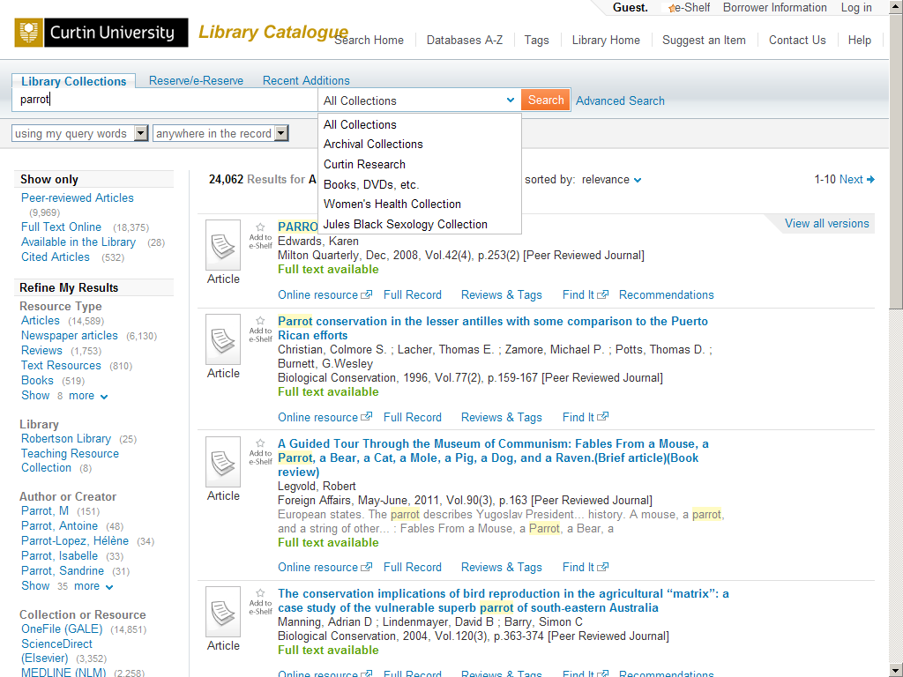
Figure 1.

The other two tabs provide the ability to search quite narrow subsets that are considered critical areas of functionality. Reserve/e-Reserve allows students to locate physical and electronic materials set for them by their lecturers. Recent Additions provides clients with a simple way of tracking content that has recently arrived in the Library, and checking the status of material that has been ordered on their recommendation. Each tab can have a different set of facets assigned to it, so that search results can be further broken down in a variety of different ways depending on their nature.

One Catalogue or Two?
One decision we had to make with the introduction of Primo as a discovery layer was whether or not also to maintain public access to the Aleph OPAC. In fact during the first phase of Primo implementation, that is before we were able to include Primo Central records, we continued to offer Aleph as the main public interface, with Primo available, as it were, as an alternative, branded as ‘the new catalogue in development’. This enabled users to experiment with the new system without losing the security of the old. Once Primo Central became available, and therefore most of the Library’s resources were accessible through a single interface, we rebranded the enhanced Primo as the ‘Library Catalogue’ and removed access to the Aleph OPAC. One consideration here was to reduce the complexity of the user experience by reducing the number of interfaces that were presented to them for resource discovery. An additional benefit was that we no longer had to resolve the question of what to call the old and new catalogues to distinguish them. Although there was a strong feeling that Primo as a discovery layer was not in fact a library catalogue in the sense that the term had previously been understood, we also recognised that the meaning of terms changes over time, and that it was preferable for us to accept Primo as the catalogue in the same way we had accepted the change in meaning of the term Library that has taken place over the last twenty years.
Because Primo Central to a large extent indexes the content of our subscribed databases, it also diminishes the role of federated searching that we had previously provided through Metalib. Primo does in fact contain a mechanism for linking into Metalib and presenting Metalib search results in Primo format. But we decided not to enable this, partly because it still relies on z39.50 searching, so is slow compared with Primo Central, and partly again to reduce the complexity of the user experience. In its current incarnation Primo does not completely replace Metalib functionality, but we are currently looking at the feasibility of further streamlining our suite of discovery interfaces by decommissioning the Metalib search interface altogether.

What is the Library Collection?
Discovery layers also throw a spotlight on the question of what a library collection actually is. Clearly library collections have not for some time been limited to things that are physically in the library, or even accessible from library controlled servers. However, with Primo Central and similar products the library catalogue is starting to include bibliographic data for items that are neither materially owned by the library nor accessible electronically from external sources. This is because the aggregated data in Primo Central can easily go beyond what the library has purchased or subscribed to. It is indeed possible to activate in Primo Central and thus bring into the library discovery catalogue large bodies of records, demand for which the library cannot automatically fulfil. Document delivery is of course always an option, but in practice a balance needs to be kept between satisfying library clients’ need for discovery, and conveniently satisfying their need for resource delivery. Nevertheless, however this question is addressed, it is clear that the old distinction between a library catalogue that can provide access to texts or other materials, and a bibliographic database that only provides metadata for these materials is a distinction that will not be sustainable into the future.

Facets
Once you have completed a search in Primo you have the ability to refine it further using facets. Decisions about which facets should appear, how these facets are created, what order they should appear in have potentially a considerable impact on the user experience. We decided, for example, that for our users limiting by resource type was more important than restricting searches by date, so put resource type at the top of the list (see Fig.2). Definitions of resource types and their relationship with the icons that appear to the left of each item on the results list generated considerable debate. The Audio Visual facet for example includes
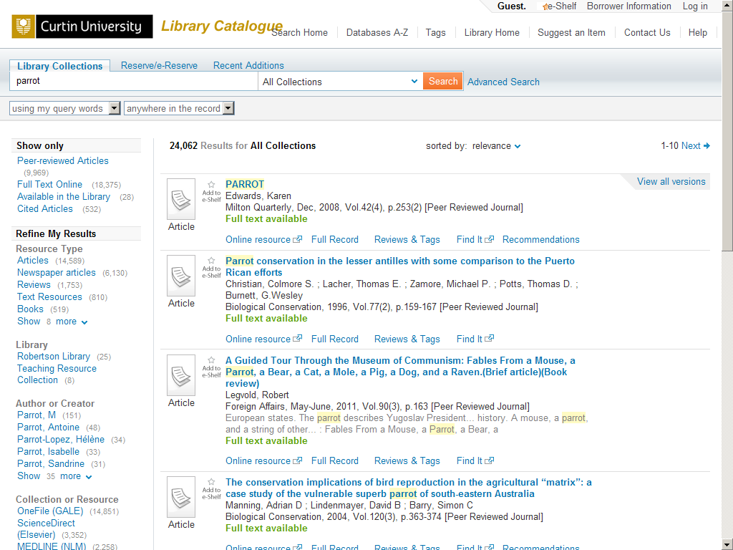
Figure 2.

both Audio and Video material, which have separate resource type icons. We decided against distinguishing between books and ebooks or journals and ejournals at the resource type level (both in the facets and the icons) on the grounds that what was important was the content type in RDA terms rather than the physical medium (to retrieve ebooks you can select the Books resource type facet and then the Full Text Online facet (see Fig. 3)).
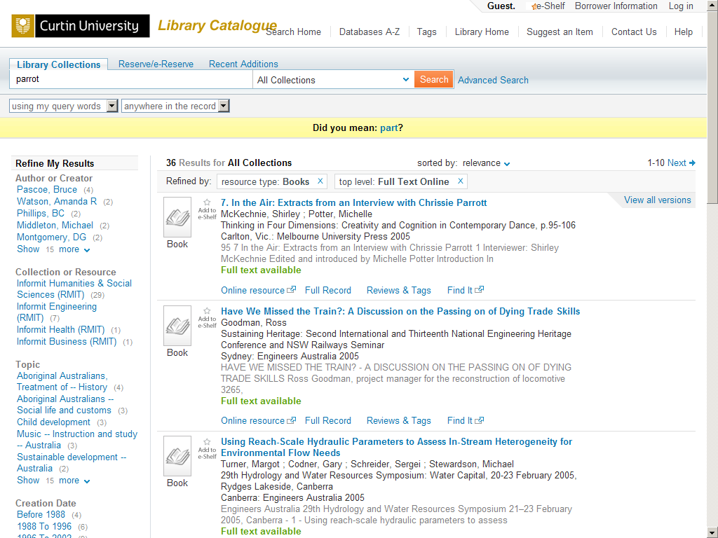
Figure 3.

One facet that raises particular issues with normalised results from multiple data sources is the author facet. In the Curtin Catalogue this is called “Author or Creator” because we needed to find a compromise description that made sense for users of both our library and our archival collections. The different data sources also inevitably have different standards for recording names, so the same name is liable to appear in different forms. Consistent authority control might be possible over those datastreams which the library controls, but once Primo Central is added to the equation, itself taking data feeds from multiple sources, the situation becomes considerably more complex. There are real questions, indeed, about the possibility of authority control in a complex aggregated environment.
The different Primo tabs we have set up have been configured with different sets of facets, relevant to the particular scopes they represent. Thus the Reserve/e-Reserve tab includes facets to limit by academic unit number or lecturer’s name, and this appears above other facets (see Fig. 4). The Recommendations scope of the Recent Additions tab allows a
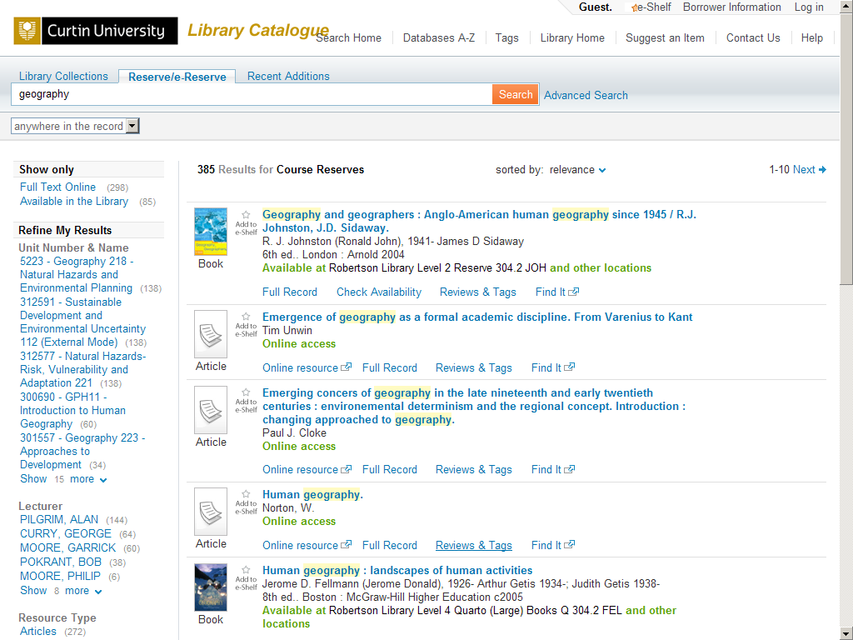
Figure 4.
Library client to review the recommendations they have made, and includes facets to distinguish between received and on order items, and to filter by the date received items entered the Library (see Fig. 5)
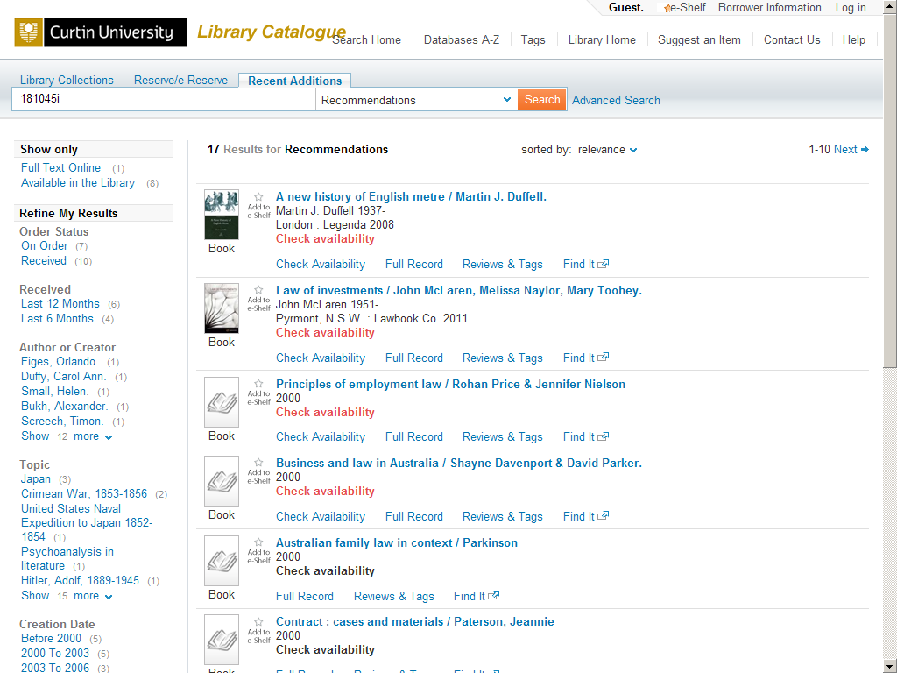
Figure 5..

FRBR
Primo allows for the possibility of bringing together different manifestations into a single record in the results list – so that for example multiple editions of books would be brought together, and electronic and print versions of electronic journals would be linked. This functionality was something we investigated in some detail. In the end we decided not to implement it as in the current version of Primo the linking mechanism does not sufficiently follow the FRBR model, and indeed often produces confusing results for the user. Thus Primo does not generate an Expression level record that is independent of any of the actual manifestations. Instead it groups the different manifestations underneath the record for the first manifestation it encounters. In our implementation this tended to mean that the top-level record as the first edition rather than the fourth, and the print rather than the electronic, because that was the order in which the records had been entered in the database. This is a significant short coming and one that in hope will be addressed in the next Primo release.

Conclusion
In conclusion I’d like to repeat the obvious point that discovery layers do not behave in the same way as traditional OPACs, and that when implementing them it is important to focus on the new possibilities they afford rather than trying to reproduce the functionality of the previous system. There are a lot of decisions that need to be made about how to present the library’s data most effectively, and these often entail new ways of thinking about what a catalogue is and does. It is not always immediately apparent what will be successful and what will not, and only time will tell if we have got everything right. Primo, at least, includes a great deal of flexibility which makes it relatively easy to make changes in response to the actual experience of users.

