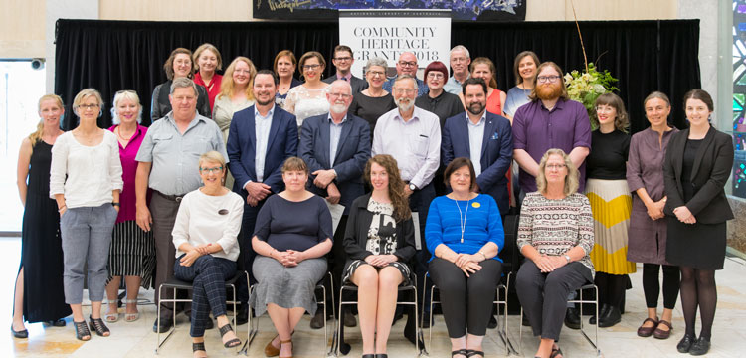
In 2018, 60 Community Heritage Grants were awarded, totalling $367,470.

Australian Capital Territory
Organisation | Project | Amount
Canberra & District Historical Society Inc | Significance Assessment of the Patience Australie Wardle Collection | $4,950
Duntroon House Officers' Mess | Significance Assessment of the Duntroon House Collection | $4,500
Village of Hall & District Progress Association (Hall School Museum & Heritage Centre) | Significance Assessment of the Lyall Gillespie Collection | $4,950

New South Wales
Organisation | Project | Amount
Australasian Pentecostal Studies Centre | A Disaster Combo Workshop | $2,250
Australian Jewish Historical Society | Preservation Needs Assessment of the Collection | $4,950
Bathurst District Historical Society Inc | Preservation Needs Assessment of the Photographic Collection | $4,950
Broken Hill City Council | Rehousing of the Ralph O'Connor Negative Collection | $12,790
Care Leavers Australasia Network Inc | Significance Assessment of the National Orphanage Museum Collection | $4,500
Children's Hospital at Westmead | Significance Assessment of the Archive Collection | $4,500
Coffs Harbour Regional Gallery | Significance Assessment of the Regional Museum Collection | $5,400
Friends of the Hawkesbury art community & Regional Gallery Inc | Preservation Needs Assessment of the Clint Collection | $5,070
Georges River Council | Significance Assessment of the Georges River Libraries Local Studies Collection | $4,500
Hawkesbury Regional Museum | Preservation Needs Assessment of the Collection | $4,500
Lithgow Small Arms Factory Museum | Preservation Needs Assessment of the Archives and Library Collections | $4,700
Manning Valley Historical Society Inc | Preservation Needs Assessment of the Wingham Museum and Archives | $6,600
Moore Theological College Council | Rehousing and conservation treatment of the Marsden, Broughton, Waterhouse and Mary Andrews Collections in the Samuel Marsden Archives | $13,420
Moree Cultural Art Foundation Ltd | Five Conservation Training Workshops | $10,960
Moree Cultural Art Foundation Ltd | Significance Assessment of the Bank Art Museum Moree Collection | $6,090
Mosman Art Gallery | A Disaster Preparedness Plan and two Disaster Kits | $6,950
Museums Australia - Mid North Coast Chapter | Seven regional Significance Assessment Workshops | $9,160
National Trust Norman Lindsay Gallery and Museum | Conservation treatment of Norman Lindsay's Lay Figure | $13,500
Stanton Library | Significance Assessment of the Luna Park Collection | $4,500
Tamworth Historical Society Inc | Purchase of environmental monitoring equipment (HOBO) | $1,230
Tamworth Regional Film and Sound Archive | Preservation Needs Assessment of the Collection | $6,350

Northern Territory
Organisation | Amount | Project
Batchelor Institute of Indigenous Tertiary Education | A Digitisation Training Workshop | $7,030
Batchelor Institute of Indigenous Tertiary Education | Purchase of archival storage materials and equipment, and digitisation of the film and audio tape collection | $6,720
Darwin Military Museum | Significance Assessment of the Collection | $4,500
Finke River Mission Services | Conservation treatment of selected watercolours in the Hermannsburg Historic Precinct Art Collection | $13,630
National Pioneer Women's Hall of Fame Inc | Significance Assessment of the Objects Collection | $6,030

Queensland
Organisation | Amount | Project
Abbey Museum of Art and Archaeology | Purchase of archival storage materials | $6,000
Cairns and District Chinese Association Inc (CADCAI) | Conservation treatment of the Lit Sung Goong Temple Collection temple drum | $13,630
Healthy Options Australia | Purchase of archival storage materials and equipment | $6,170
Rockhampton Art Gallery | Purchase of archival storage equipment and materials | $5,950
Rockhampton Regional Council | Preservation Needs Assessment of the Central Queensland Collection | $5,120

South Australia
Organisation | Amount | Project
Central Adelaide Local Health Network Heritage Office | Significance Assessment of the Collection | $4,500
City of Holdfast Bay | Conservation treatment of the 1950s 'Zorita' sideshow banner | $13,630
Flinders University Art Museum | Preservation Needs Assessment of the Historic Papunya Painting Collection | $4,500
Port Adelaide Historical Society Inc | Significance Assessment of the Collection | $4,950

Tasmania
Organisation | Amount | Project
COMA Tasmania | Significance Assessment of the Collection | $4,950
Queen Victoria Museum and Art Gallery | Significance Assessment of the Vertebrate Skin and Skeletal Collection | $4,500
Roman Catholic Trust Corporation of the Archdiocese of Hobart | Purchase of archival storage materials | $5,000

Victoria
Organisation | Amount | Project
City of Boroondara | Significance Assessment of the Town Hall Gallery Collection | $4,500
Civil Aviation Historical Society Inc | Preservation Needs Assessment of the Collection | $4,950
Duldig Gallery Inc | Preservation Needs Assessment of the Studio Museum Collection | $4,500
Glenelg Shire Council | Significance Assessment of the Cultural Collection | $5,550
Greater Bendigo City Council | Significance Assessment of the Bendigo Art Gallery Collection | $5,710
Royal Agricultural Society of Victoria | Preservation Needs Assessment of the Heritage Collection | $4,000
Royal United Services Institute (Victoria) | Purchase of archival storage equipment | $9,580
Sovereign Hill Museums Association | Conservation treatment of the Chinese Processional Lion | $9,000
Wangaratta RSL Inc | Significance Assessment of the Memorabilia Collection | $5,160
Warragul and District Historical Society Inc | Preservation Needs Assessment of the paper based collection | $5,710

Western Australia
Organisation | Amount | Project
Fremantle Prison | Preservation Needs Assessment of the Collection | $4,500
Law Society of Western Australia | Significance Assessment of the Collection | $4,500
National Trust of Australia (WA) | Significance Assessment of the Strawberry Hill, Albany, house and Collection | $4,500
Northcliffe Pioneer Museum Inc | Purchase of MOSAiC cataloguing software | $6,420
Perth Observatory Volunteer Group Inc | Preservation Needs Assessment of the Perth Observatory Heritage Collection | $4,500
Shire of Manjimup | Purchase of cataloguing software | $1,940
Shire of Manjimup | Two Conservation Training Workshops | $6,480
Shire of Northam | Significance Assessment of the Northam Historical Society Collection | $4,500
Swan Guildford Historical Society Inc | Purchase of archival storage materials | $3,390

