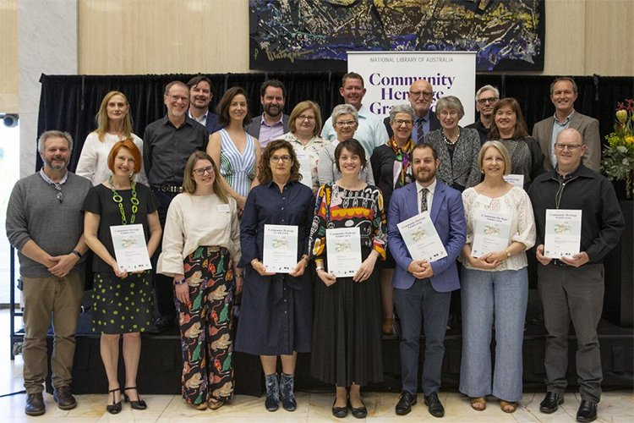
In 2019, 60 Community Heritage Grants were awarded, totalling $378,440.

New South Wales
Organisation | Project | Amount
Australian Jewish Historical Society | Purchase of Archival Materials | $4,480
Blacktown City Council | Significance Assessment of the Garage Graphix Archive Collection | $4,500
Broken Hill Regional Art Gallery | Significance Assessment of the Collection | $6,140
Care Leavers Australasia Network | Preservation Needs Assessment of Australia's Orphanage Museum's Collection | $4,500
Friends of the Hawkesbury Art Community & Regional Gallery Inc | Preservation of the Clint Collection | $12,940
Georges River Council | Preservation Needs Assessment of Georges River Libraries Local Studies Collection | $4,500
Goulburn Regional Art Gallery | Significance Assessment of the Collection | $5,120
Lithgow Small Arms Factory Museum Inc | Purchase of Archival Storage Materials | $2,600
Moore Theological College Council | Conservation Treatment of the Rev Frank Cash Negative Collection | $9,090
Naval Historical Society of Australia | Significance Assessment of the Collection | $5,880
Norfolk Island Museum | Purchase of Two Freezers for Pest Control Management | $660
Penrith Performing & Visual Arts | Pest Site Inspection and Purchase of Conservation Resources | $8,390
Penrith Performing & Visual Arts | Two Preventive Conservation and Object Storage Workshops | $2,200
Port Macquarie Historical Society Inc | Significance Assessment of the Costume Collection | $5,440
Royal Far West | Preservation Needs Assessment of the Archive and Museum Collection | $4,500
Shoalhaven City Council | Significance Assessment of the City Art Collection | $4,500
Tamworth Regional Gallery | Significance Assessment of the Collection | $5,920
The Children's Hospital at Westmead (The Sydney Children's Hospitals Network) | Preservation Needs Assessment of the Collection and Collection Management Software | $5,790
The Embroiderers' Guild NSW Inc | Significance Assessment of the Collection | $4,500

Northern Territory
Organisation | Amount | Project
Papunya Tjupi Arts | Preservation Needs Assessment of the Collection | $8,070

Queensland
Organisation | Amount | Project
Cassowary Coast Regional Council | Four Collection Policy, Handling and Disaster Preparedness Workshops | $12,380
Empire Theatre Projects | Twelve Digitisation Workshops | $10,000
Museum and Gallery Services Queensland Ltd | Collection Management, Significance and Preventative Conservation Workshops | $6,610
Rockhampton Art Gallery | Purchase of Archival Storage Materials | $10,290
Sunshine Coast Council, Cultural Heritage Services | Purchase of Archival Storage Equipment (compactus) for the Bankfoot House Heritage Precinct Collection | $13,630
Tablelands Regional Council | Three Collection Policy and Management Training Workshops | $11,000
Trustee for the General Douglas MacArthur Brisbane Memorial Foundation | Preservation Needs Assessment of the MacArthur Museum Collection | $4,500

South Australia
Organisation | Amount | Project
Australian Lithuanian Community Association Ltd | Significance Assessment of the Australian Lithuanian Archives Collection | $4,950
Australian Lutheran College | Significance Assessment of the Library's Rare Books Collection | $4,500
Central Adelaide Local Health Network Heritage Office | Preservation Needs Assessment of the Collection | $4,500
Flinders University Art Museum | Purchase of Archival Storage Materials and Conservation Treatments for the Papunya Painting Collection | $13,630
History Trust of South Australia | Digital Literacy and Collections Online Workshop | $8,300
History Trust of South Australia - National Motor Museum | Preservation Needs Assessment of the George Brooks Library and Learning Centre Collection | $4,500
Lutheran Archives | Conservation of the Lantern Slide and Glass Plate Negative Collection | $13,630
National Trust of South Australia Moonta Branch | Significance Assessment of Moonta Resource Centre's Collection | $6,000
Peterborough History Group SA Inc | Purchase of Archival Materials (Times Printing Office Contents Preservation Project Stage III) | $11,880
Port Adelaide Historical Society Inc | Preservation Needs Assessment of the Collection | $4,950

Tasmania
Organisation | Amount | Project
Narryna Heritage Museum Inc | Purchase of Archival Storage Equipment (Shelving) for the Costume Collection | $7,380

Victoria
Organisation | Amount | Project
Australian College of Educators | Preservation Needs Assessment of the Archives | $4,500
Castlemaine Art Museum Ltd | Significance Assessment of the Collection | $4,500
City of Boroondara | Preservation Needs Assessment of Town Hall Gallery Collection | $4,500
Civil Aviation Historical Society Inc | Purchase of Archival Storage and Environmental Equipment | $8,800
Geelong Regional Library Corporation | Preservation Needs Assessment of the Geelong Heritage Centre Archives Collection | $4,500
Kew Historical Society Inc | Preservation Needs Assessment of the Collection | $4,950
National Trust of Australia (Victoria) | Purchase of Cataloguing Software | $11,270
National Vietnam Veterans Museum Ltd | Purchase of Four Cataloguing Software Licences | $2,120
RMIT Design Archives | Significance Assessment of the Design Archives Collection | $4,500
Royal Historical Society of Victoria Inc | Purchase of Archival Storage Equipment (Shelving) | $13,540
Scout Association of Australia - Victorian Branch | Purchase of Archival Storage Equipment | $3,500
Seaworks Maritime Museum | Preservation Needs Assessment of the Collection | $4,500
Shrine of Remembrance | Preservation Needs Assessment of the Collection | $4,500
Trafalgar Holden Museum | Significance Assessment of the Collection | $4,950

Western Australia
Organisation | Amount | Project
City of Albany | Significance Assessment of the Princess Royal Fortress Military Museum Collection | $5,400
City of South Perth | Significance Assessment of the Art Collection | $4,500
Law Society Of Western Australia | Preservation Needs Assessment of the Collection | $4,500
Northcliffe Pioneer Museum Inc | Preservation of the Photographic Collection and Purchase of Archival Materials | $9,340
Perth Observatory Volunteer Group | Purchase of Archival Storage and Environmental Equipment | $3,900
Swan Guildford Historical Society | Purchase of Archival Storage Materials and Pest Control Equipment | $820
University of Western Australia, Berndt Museum of Anthropology | Conservation of Cultural Materials Workshop | $2,500
University of Western Australia, Berndt Museum of Anthropology | Preservation Needs Assessment of the Object Collection | $4,500

