National & State Libraries Australasia
October 2011

Australian Newspaper Plan
Preserving for Permanent Access

Annual Report 2010/11

PURPOSE
This report describes progress with the Australian Newspaper Plan (ANPlan) in 2010/11. The achievements of ANPlan are evaluated against a set of Key Indicators and the goals set out in ANPlan’s Five Year Plan, July 2010 - June 2015 (Appendix A).

BACKGROUND
ANPlan is a cooperation established by NSLA through which the Australian national, state and territory libraries are comprehensively collecting, preserving and providing access to Australian newspapers. The National Library of Australia (NLA) coordinates the Plan. The National Library of New Zealand (NLNZ) has observer status.
This is the first year that ANPlan libraries have reported on their progress with the Five Year Plan (2010-2015). This plan focuses particularly on emerging challenges, ‘at risk’ titles, aspects of ANPlan which are not currently being well met and on outreach activities. This is the third year that ANPlan libraries have reported against the set of Key Indicators developed and agreed by ANPlan libraries in June 2009.
Significant achievements for 2010/11 include:
- ten significant newspaper finds (Key Indicator 1);
- continued improvement in the percentages of Australian newspaper titles microfilmed (Key Indicator 3);
- a substantial increase in the number of digitised newspapers being made accessible through Australian newspapers on Trove (Key Indicator 4; Five Year Plan);
- the development of an ANPlan paper, ‘Environmental conditions for storing print and microfilmed newspapers’ (Five Year Plan);
- an increase in the percentage of newspaper microform titles catalogued onto the national bibliographic database (NBD), according to the microform cataloguing guidelines developed by ANPlan libraries in 2006 (Key Indicators 10 & 11, Five Year Plan);
- outreach to public libraries about using and contributing to Australian newspapers on Trove (Five Year Plan);
- maintaining public awareness of the role of libraries in collecting, preserving and providing access to newspapers through a range of publicity strategies including the ongoing search and rescue campaign to locate missing Australian newspapers (Five Year Plan).
Steady progress is being made in identifying and finding missing Australian newspapers. While a number of ANPlan libraries have reported increases in the percentage of their newspapers which have been preserved for permanent access through microfilming, one library reports a reduction, due to less funding for this activity. The availability of digitised newspapers has increased dramatically over 2010/11, largely due to mass digitisation being conducted by the NLA through Australian newspapers on Trove. While there is strong interest from the public in accessing these newspapers, and a number have committed their organisations to contributing titles to this resource, it is of concern that there has also been a marked increase in the number of newspaper titles which have been digitised outside this framework and may therefore not be able to accessed widely or in the long term.
The replacement of unstable acetate newspaper microfilm has not received much attention over 2010/11; in some cases, this is because libraries have already addressed this problem. There has been little change in the storage conditions which libraries are able to provide for their print and microfilm masters collections. Seven out of nine libraries report optimal environmental conditions for their hard copy newspapers; eight out of nine libraries report ideal environments for their first generation newspaper microfilm. It should be noted, however, that the environmental parameters which are considered to be optimal vary somewhat between libraries. While the vast majority of microfilm masters for Australian newspapers are owned by ANPlan libraries, the locations of those which are not have not consistently been recorded on the NBD.
Cataloguing newspapers onto the NBD continues to be an area in which further improvements may be made. Seven of the nine libraries report all of the print newspaper titles which their library takes responsibility for under ANPlan are catalogued onto the NBD, although not all libraries report detailed and up-to-date holdings information. Three ANPlan libraries report that all of the microform for their newspapers is catalogued according to the guidelines developed by ANPlan libraries in 2006; significant progress has been made by one library (State Library of New South Wales; SLNSW); however, other reporting libraries indicate that most of their newspaper microform has not been catalogued in this way. Digitised newspapers which are not delivered through Australian newspapers on Trove are also largely uncatalogued.
ANPlan libraries are still engaging with their library networks and with the general public about missing newspapers and, increasingly, about digitised newspapers. One library reports that it is collecting and providing free access to a pre-press digitised newspaper.
Issues for consideration by ANPlan :
- the number of newspapers which are being digitised outside the Australian Newspapers Digitisation Program (ANDP) and which therefore may not be able to be accessed widely or in the long term;
- the variation in the environmental conditions under which ANPlan libraries are storing print and microfilmed newspapers;
- the lack of consistent recording on the NBD of the location of newspaper microform masters which are not owned by ANPlan libraries;
- incomplete cataloguing of printed newspapers on the NBD;
- incomplete cataloguing of newspaper microfilm, according to the guidelines developed by ANPlan libraries in 2006, on the NBD—only 3 ANPlan libraries report that all of their newspaper microfilm is catalogued in this way;
- the lack of data available for Victorian newspapers for a number of the Key Indicators.
PROGRESS
- Collecting
Key Indicator 1: Newspapers found
ANPlan libraries report 10 significant newspaper finds in 2010/11. These are listed in Appendix B.

Key Indicator 2: Missing newspapers
Numbers of newspapers which are known to be entirely missing and which have significant portions missing are summarised in the table below:
No. newspapers | ACT | NSW | NT | QLD | SA | TAS | VIC | WA | Nat.
entirely missing | 0 | 2 | not known | 39 | 36 | 0 | 0 | not known | 0
with significant portions missing | >10 | >10 | 9 | 10 | 27 | 20 | 4 | not known | 0

The titles of newspapers which are known to be missing or have missing portions are published on ANPlan’s website at: www.nla.gov.au/anplan/about/collect.html
ANPlan libraries reported 16 new newspapers commencing publication from July 2010 to June 2011 (this included 8 changed titles); and 10 newspapers ceasing publication. One of the ceased newspapers is now an online publication. The titles of these newspapers are given in Appendix C.
B. Reformatting
Key Indicator 3: Microfilming
The percentage of their state/territory’s hard copy newspaper titles which ANPlan libraries have been able to microfilm ranges from approximately 50 to 96.8% across those states/territories reporting. Over the past three years, this estimated percentage has risen most markedly for ACT newspapers, with small increases in WA, SA and NSW newspapers. There is a small decrease in the percentage of Qld newspapers microfilmed. The percentage of these microfilmed newspapers which have been filmed to current preservation standards is very high, being between 80-100% of all filmed newspapers for all states/territories with the exception of the national newspapers which are not known to be filmed to current standards. No data is available for Victorian newspapers.
A list of Australian newspaper titles microfilmed in 2010/11 is given in Appendix D.
The State Library of South Australia (SLSA) completed a project begun in November 2008 to identify the extent of the microfilming backlog, the resources required to eliminate it and the storage implications. The backlog can now be tracked accurately and this will assist the development of funding proposals.
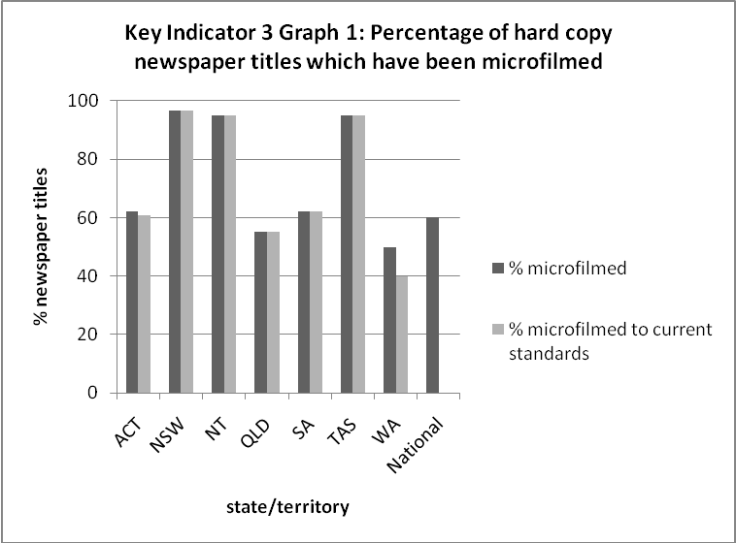

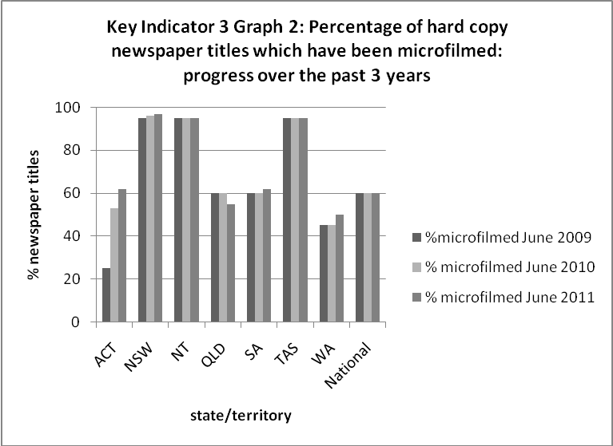

Five Year Plan reporting: Of the 14 ‘at risk’ newspapers listed in the Five Year Plan (2010-2015), 12 have been microfilmed, one has been filmed for part of the designated date range and one is yet to be filmed. Those newspapers which have been filmed or partially filmed are:
Blyth Agriculturalist (1912-1969)
Copper Age (1906-1908)
Daily Herald (1910-1924)
Glenelg Guardian (1914-1936)
Jamestown Star and Farmers' Journal (1903-1946)
Mining Standard (1904-1909)
South Australian [South Australian Liberal Federation] (1925-1929)
South Australian Times (1883-1885)
Transcontinental (Jan-Jun 1951)
Wakefield Sun (1910-1912)
West Australian (1955-1972) – completed up to 1959
West Suburban Echo (1923-1924)
West Torrens Gazette (1913-1914)
Key Indicator 4: Digitisation
The number of newspapers which are being made accessible through Australian newspapers on Trove has been steadily growing, reaching 138 at the end of June 2011. A comparison of the total number of newspapers accessible through Trove in June 2009, 2010 and 2011 is shown graphically below.
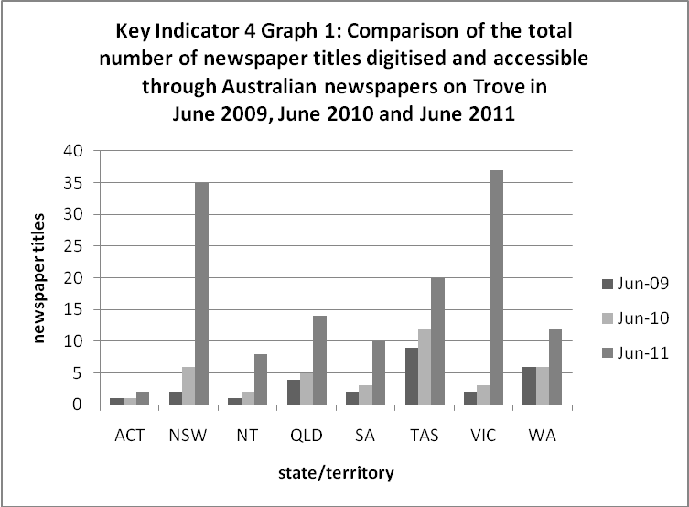

Titles of all Australian newspapers known to be digitised at 30 June 2011 are given in Appendices E (titles accessible through Trove) and F (titles known to be digitised but not available through Trove). Over 2010/11, the total number of newspapers which have been digitised, but not through Australian newspapers on Trove, has increased from 35 (June 2010) to 52 (June 2011), mainly due to the addition of 16 new Victorian titles.
Five year plan reporting: A goal of the current Five Year Plan (Appendix A) is to contribute all digitised newspaper content to the Australian Newspapers Digitisation Program (ANDP) as outlined in the NLA’s Contributor Guidelines. The substantial increase in the number of newspapers being digitised outside this framework indicates the desirability of further communication about the benefits of digitising newspapers through the ANDP with groups considering newspaper digitisation projects.
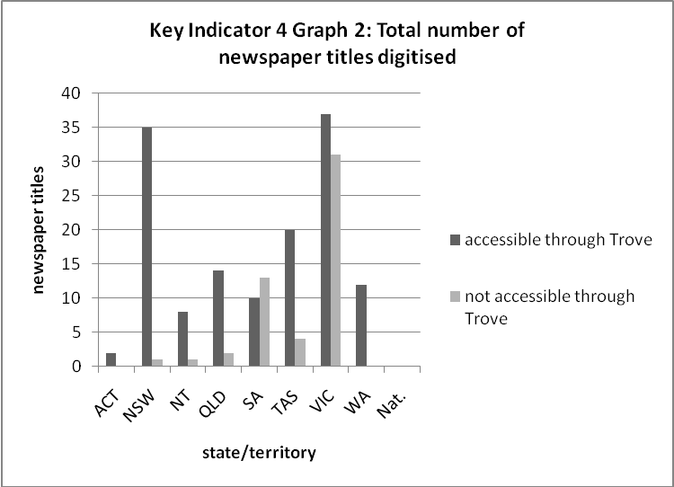
Another goal of the current Five Year Plan is to provide and maintain digital access to those titles and corresponding date ranges listed in the Australian Newspapers Digitisation Program, Phase 1. Of the 107 titles listed, 98 have been completed.
- Acetate replacement
Key Indicator 5: Replacing acetate microfilm
Replacing unstable acetate microfilm with polyester film is one of the strategies which ANPlan libraries have been using to preserve access to their newspaper collections. A number of ANPlan libraries have now completed acetate duplication projects for their newspaper microform collections or hold no acetate master microfilm. These are NLA, Northern Territory Library (NTL), SLNSW, SLSA and State Library of Tasmania (SLT). No significant acetate duplication activity was reported to occur in 2010/11; the SLNSW copied the Goulburn Herald (July 1848-Feb 1908; 35 reels) as part of a final audit of microfilm masters.
- Storage
Key Indicator 6: Storing hard copy newspapers
ANPlan libraries are generally able to store the hard copy newspapers which they hold primary responsibility for under ANPlan under environmental conditions which they consider to be optimal. Two libraries report that they are unable to store 100% of their newspapers ideally. The environmental conditions under which newspapers are stored are reported in the table beneath the graph. These conditions vary somewhat with reported storage temperatures ranging from 15±2 °C to 23±2 °C and humidity ranging from 35±5 to 50±5 %RH. All data refers to newspapers which libraries hold primary responsibility for under ANPlan—newspapers published in their state/territory.
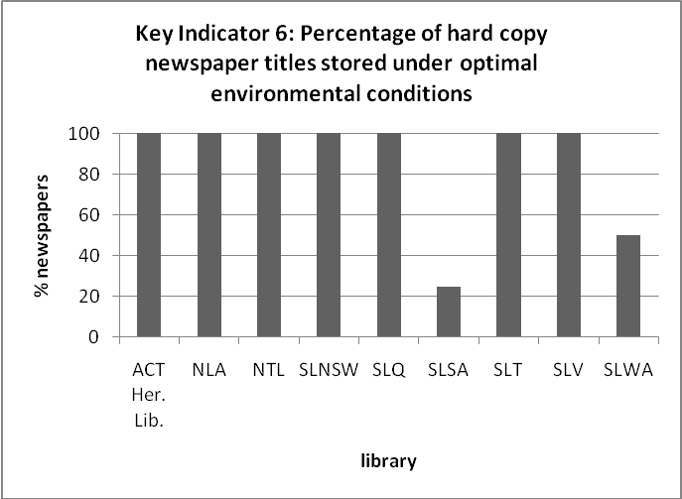

Environmental conditions used to store hard copy newspapers
 | ACT Heritage Library | NLA | NTL | SLNSW | SLQ | SLSA | SLT | SLV | SLWA
temp.(°C)  humid. (%RH) | 22±2  50±5 | 15±2; 20±2  35±5; 50±5 | 21±2  50±5 | 23±2  50±5 | 21±2  50±5 | 21±2  50±5 | 20±2; 19±1  50±10; 35-40 | 20±2  50±5 | 20±2  50±5
Key Indicator 7: Storing 1st generation microfilm masters
ANPlan libraries are able to store most of their first generation newspaper microfilm masters under environmental conditions which they consider to be optimal to preserve permanent access. However, there is considerable inconsistency between these reported conditions which are listed in the table beneath the graph below. All but one library reports storing 100% of first generation masters ideally; this library reports it is able to store 95% of its first generation masters optimally. Five libraries (NLA, NTL, SLSA, State Library of Victoria (SLV) and State Library of Western Australia (SLWA)) store preservation masters in the NLA’s cold store. All data refers to the newspaper titles which libraries hold primary responsibility for under ANPlan.
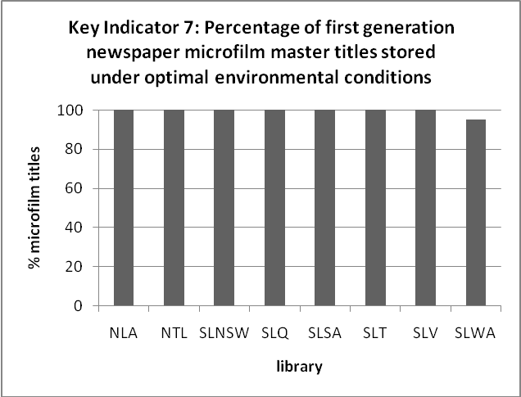

Environmental conditions used to store first generation newspaper microform masters
 | NLA | NTL | SLNSW | SLQ | SLSA | SLT | SLV | SLWA
temp.(°C)  humid. (%RH) | 8±1  35±5 | 8±1  35±5 | 15±1  45±5 | 10  40-45 | 8±1  35±5 | 13±1; 17±2  32-35; 50±5 | 8±1  35±5 | 8±1  35±5
Five year plan reporting: A paper which draws together the factors influencing ANPlan libraries’ selection of environmental conditions for storing print and microfilmed newspapers for long-term access has been developed and is available from the ANPlan website: http://www.nla.gov.au/anplan/documents/Documents.html.

Key Indicator 8: Control of microfilm masters
The overwhelming majority of Australian newspaper microfilm masters are owned by ANPlan libraries.
The NLA, SLSA and SLWA report that they own masters for all microfilmed titles from their state/territory and, in the case of the NLA, for ACT titles.
The SLNSW identifies 11 NSW titles which it does not own the masters for. The NTL identifies 1 title which it does not own the master for. The NLA reports that it does not own the complete set of masters for four of the five national titles. All of these titles have been catalogued onto the NBD with the location of the masters recorded.
The State Library of Queensland (SLQ) estimates that masters for six Queensland titles are not owned by the SLQ. The SLT has identified three Tasmanian titles which it does not own the microfilm masters for. None of these titles has been catalogued onto the NBD.
The SLV is unable to estimate the number of newspaper titles which have been microfilmed but which it does not own the masters for.

- Cataloguing on the National Bibliographic Database
Key Indicator 9: Cataloguing hard copy newspaper titles
Most Australian newspapers (hard copy) are accessible through the NBD and most libraries report that catalogue records for newspapers published in their state/territory include detailed and up-to-date holdings information. This data is essentially unchanged from last year. Libraries reported only on the newspapers which they hold primary responsibility for under ANPlan.

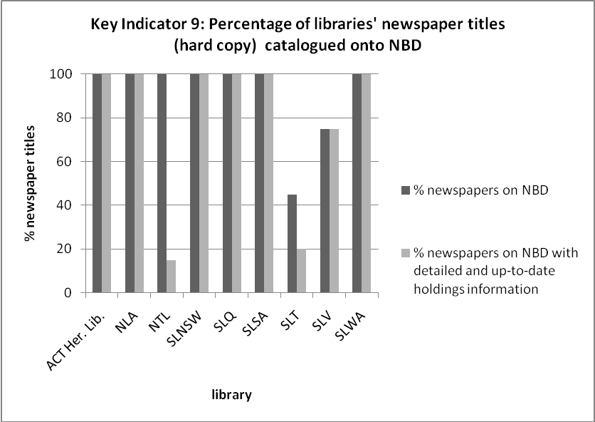

Key Indicator 10: Cataloguing 1st generation microfilm masters
As reported last year, three ANPlan libraries confirm that 100% of their first generation newspaper microfilm masters are catalogued according to the guidelines which were developed in consultation with all ANPlan libraries in 2006. The SLNSW reports an increase from 45% to 65% first generation microfilm masters catalogued according to the guidelines.
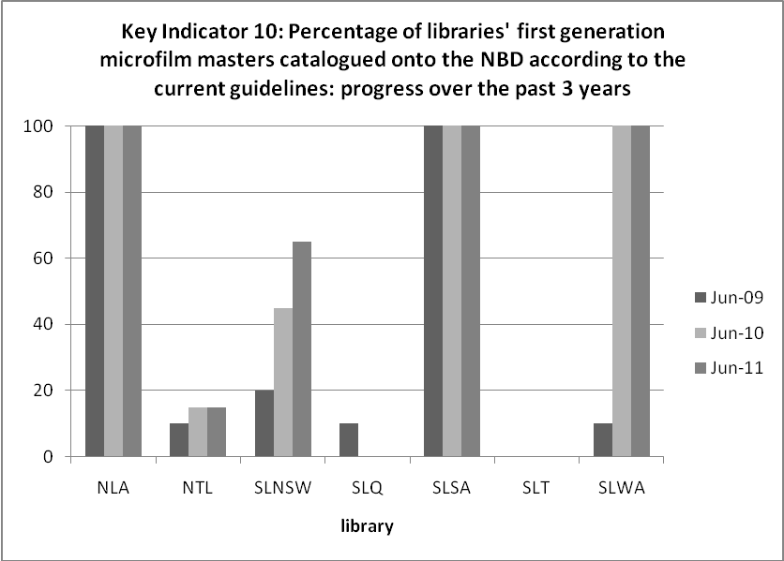
Key Indicator 11: Cataloguing microfilm
The extent to which ANPlan libraries have been able to adopt the revised guidelines for all microfilmed titles (including all generations of microfilm) and with holdings attached to the correct format and generation varies from 0 to 100% across the ANPlan libraries. Libraries have again reported only on newspaper titles which they hold primary responsibility for under ANPlan.
Five year plan reporting: A goal of the current Five Year Plan is to ensure that all generations of newspaper microfilm titles which ANPlan libraries hold responsibility for are catalogued onto the NBD, according to the microform cataloguing guidelines developed by ANPlan libraries in 2006, with holdings attached to the correct format and generation. Some progress has been made over 2010/11 with one library (SLNSW) increasing the percentage of its newspaper microfilm titles catalogued in this way from 45 to 65%. Three ANPlan libraries report that they currently have all their titles catalogued in this way; no progress has been made by other ANPlan libraries on this measure.
Another goal of the Five Year Plan is to ensure that all digitised newspapers are catalogued onto the NBD, according to the Guidelines for Cataloguing Remote Electronic Resources. The NLA reports that 91% of completed titles in Australian newspapers on Trove have a catalogue record of this type.

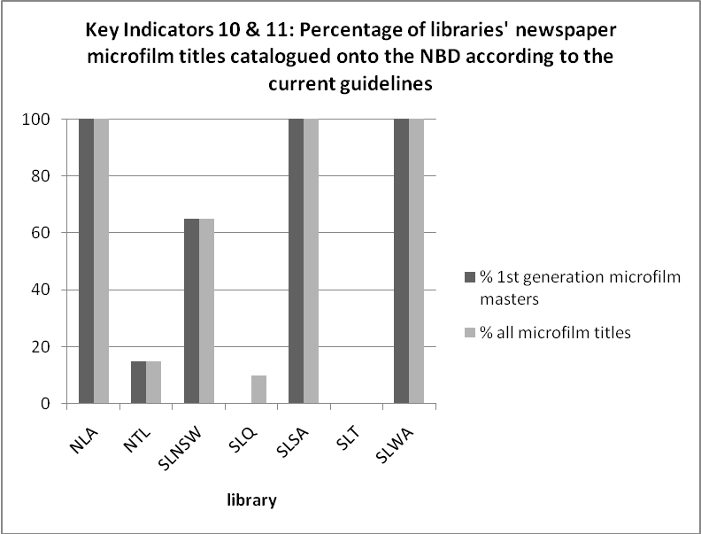
Five year plan reporting:
Investigation of the issues associated with collecting pre-press electronic versions of Australian newspapers as a preservation/access strategy including the cost-effectiveness of this strategy.
Several of the ANPlan libraries maintain an interest in collecting pre-press electronic newspapers. Pre-press copies of the Northern Territory News continue to be received from the publisher and made freely available via the NTL’s website.
Working through networks with public libraries to raise awareness of and knowledge about ANPlan, including how to contribute to the ANDP. Facilitating contributions from local libraries and organisations to the service, as outlined in the Contributor Guidelines and raising awareness of funding strategies that may be available for newspaper digitisation projects.
In August 2010, an NLA invitation to contribute to the ANDP with links to the Contributor Guidelines and a Factsheet describing the benefits of undertaking newspaper digitisation through the ANDP, was circulated to public libraries, university libraries, some other libraries, historical societies, museums, family history and local studies groups via the ANPlan libraries and other channels of distribution. In May 2011, the NLA announced the achievement of five million pages of digitised newspaper content through the NLA’s website, social media and distribution lists.
The SLSA has produced and distributed a bookmark which provides information about digitised Australian newspapers on Trove and the Australian Women’s Weekly. Daily and booked tours at the SLSA include information about newspaper digitisation. Information provided to the Historical Society of South Australia by Beth Robertson on the current status of newspaper digitisation was published in the Society's newsletter.
Alice Farrell presented a talk on 'Newspaper digitising' to the Regional Library Managers’ Annual Meeting held at SLNSW in November 2010.

Meetings
ANPlan meetings were held in August 2010 and in March 2011 (by teleconference).
Publicity
General publicity about ANPlan libraries’ role in collecting, preserving and providing access to newspapers has been through the libraries’ distribution of publicity material, talks, presentations, media releases, interviews and reports.
Jerelynn Brown, SLNSW, gave a presentation entitled, 'Tabloids in the State Library of NSW collection: a reflection of life in Australia', in September 2010, at The Centre for Media History at Macquarie University.
NSW newspaper catalogue data was loaded for use in the LibraryHack competition. The entry called Newserve http://www.3colors.com.au/newserve/ won the first prize on the LibraryHack day held at SLNSW.
The online availability of all historic Northern Territory newspapers had special mention in this library’s 2010/2011 Annual Report.
Search and rescue campaign
Distribution of search and rescue materials across public libraries within the ACT coupled with active pursuit of individual titles with publishers has resulted in significant increases in the holdings of some ACT titles.
The NTL continues to display posters and flyers requesting the donation of old and significant newspapers. Bookmarks publicising Australian newspapers on Trove and the search and rescue campaign have been distributed across the Northern Territory and are displayed within the NTL Reading Room.
SLV staff have promoted the search and rescue campaign during regular public learning programs about their newspaper collection and during participation at local and regional events around the state.
The NLA continues to receive enquiries and offers of newspaper material from members of the public, which are generally referred to the relevant ANPlan library.

RECOMMENDATIONS
That the report be noted.
Appendix A
Australian Newspaper Plan
Preserving for Permanent Access
Five Year Plan
July 2010 - June 2015

Established in the early 1990s, the Australian Newspaper Plan (ANPlan) aims to ensure that newspapers published in Australia are collected and preserved for permanent access.
ANPlan is a cooperative initiative of National and State Libraries Australasia (NSLA). It relies on collaboration between Australia's national, state and territory libraries. The National Library of New Zealand has observer status.
Under ANPlan, primary responsibility for a newspaper rests with the ANPlan library in the state or territory of the newspaper's origin. The National Library of Australia shares responsibility for ACT newspapers with the ACT Heritage Library and has assumed responsibility for a number of newspapers that are national in scope, coverage and distribution.
The Australian partners report to NSLA annually against a set of Key Indicators in the areas of collecting, preserving and providing access to newspapers. ANPlan’s second Five Year Plan (2010-1015) is intended to provide impetus to ANPlan libraries’ endeavours in those areas which are not currently well met. It is also intended to provide focus to current efforts to address certain key ‘at risk’ newspapers and to ANPlan libraries’ outreach activities.
Collect
ANPlan libraries will continue to enlist the help of community groups and the public in finding missing newspapers. The following goal has been identified for July 2010 – June 2015:
1. To identify all Australian newspapers which are entirely missing, in any format, from the national collection held within the ANPlan libraries, or for which substantial portions are missing.
Preserve
Preservation microfilming remains a key strategy for preserving permanent access to Australian newspapers. ANPlan libraries will continue to preserve their newspaper collections through preservation microfilming, re-filming poorly filmed material, copying from acetate microfilm to stable polyester microfilm, as well as through digitisation.
ANPlan libraries will aim to store all newspapers (hard copy and microform masters) under optimal physical and environmental conditions to preserve ongoing access and take steps to ensure permanent access to those newspapers whose microfilm preservation masters are not currently owned by the ANPlan libraries responsible for these titles (e.g. by ensuring that there are catalogue records for these titles or by negotiating transfer of custody).
ANPlan libraries will continue to explore the collection, archiving and provision of access to online newspaper material.
The following preservation goals have been identified for July 2010 – June 2015:
2. To preserve, for permanent access, the following significant ‘at risk’ newspapers through microfilming, re-filming or acetate duplication:
Blyth Agriculturalist 1912-1969 (State Library of South Australia; SLSA)
Copper Age 1906-1908 (SLSA)
Daily Herald 1910-1924 (SLSA)
Evening Journal/Journal/Saturday Journal 1869-1923 (SLSA)
Glenelg Guardian 1914-1936 (SLSA)
Jamestown Star and Farmers' Journal 1903-1946 (SLSA)
Mining Standard 1904-1909 (SLSA)
South Australian [South Australian Liberal Federation] 1925-1929 (SLSA)
South Australian Times 1883-1885 (SLSA)
Transcontinental January-June 1951 (SLSA)
Wakefield Sun 1910-1912 (SLSA)
West Australian 1955-1972 (State Library of Western Australia; SLWA)
West Suburban Echo 1923-1924 (SLSA)
West Torrens Gazette 1913-1914 (SLSA)
3. To investigate the issues associated with collecting pre-press electronic versions of Australian newspapers as a preservation/access strategy including the cost-effectiveness of this strategy.
4. To develop guidelines for the storage of newspapers which outline the impact of environmental conditions on the longevity of newspapers and which include critical factors which influence libraries’ ability to provide permanent access to newspapers.
Access
To ensure that Australian newspapers are universally accessible, ANPlan libraries will endeavour to catalogue all newspapers (hard copy, all generations of microfilm and digitised) onto the national bibliographic database, including detailed and up-to-date holdings information.
The following goals relating to newspaper access have been identified for July 2010 – June 2015:
5. To ensure that all generations of newspaper microfilm titles which ANPlan libraries hold responsibility for are catalogued onto the national bibliographic database, according to the microform cataloguing guidelines developed by ANPlan libraries in 2006, with holdings attached to the correct format and generation.
6. To ensure that all digitised newspapers are catalogued onto the national bibliographic database, according to the Guidelines for Cataloguing Remote Electronic Resources.
7. To provide and maintain digital access to those titles and corresponding date ranges listed in the Australian Newspapers Digitisation Program, Phase 1.
8. To contribute all digitised newspaper content to the Australian newspapers service as outlined in the National Library’s Contributor Guidelines.
Outreach
ANPlan libraries will continue to participate, as they are able, to raise awareness in the community of the role of libraries in collecting, preserving and providing access to newspapers.
The following goal relating to outreach has been identified for July 2010 – June 2015:
9. ANPlan libraries will work through their networks with public libraries to raise awareness of and knowledge about the national infrastructure which exists for collecting, preserving and providing access to Australian newspapers including how to contribute to and use the Australian newspapers service. ANPlan libraries will play a key role in facilitating contributions from local libraries and organisations to the service, as outlined in the Australian newspapers service Contributor Guidelines, and in raising awareness of funding strategies that may be available for newspaper digitisation projects.
Appendix B: Significant newspaper finds in 2010/11
Armidale budget Vol. 3 No. 30; 5 June, 1897; from University of New England Heritage Centre to SLNSW (microform version only).
Burrowa news and Marengo, Binalong, Murrumburrah and Cootamundra reporter; four miscellaneous issues from 1923-1951; from private donor to SLNSW.
Douglas times and Douglas Shire visitors’ guide 12 Feb. 1986-Apr. 1986; first 8 issues, donated by Douglas Shire Historical Society to SLQ.
The Laura standard: and Beetaloo, Wirrabara, Melrose, Booleroo Centre and Yarowie advertiser Vol. 1, no.1; 11 April 1889; first issue, printed on silk as a gift to the newspaper's sponsors. Although this issue was already in the SLSA’s collection, this edition is a significant find as no other South Australian newspaper is known to have been produced in this manner. Donated by Rocky River Historic & Art Society, which holds a second copy on silk, to the SLSA.
Mercury (Hobart) Southern edition July-Dec 1941. By historical accident, SLT's deposit set of the Mercury for the 1930s and early 1940s is the Launceston and North West Coast edition; a bundle of loose copies of the Southern edition from late 1941 was found in a Hobart school during renovations and donated to SLT.
Moruya Examiner (1989) Aug. 18, 1993; Dec. 1, 1993; Dec. 7, 1994; Apr. 2, 1995; Dec. 19, 1997; Feb. 18, Mar. 18, 1998 issues loaned to the SLNSW for microfilming.
News leader 1984-1990 Issues donated by Shoal Haven City Council to the SLNSW.
North Western Advocate and Emu Bay Times (Devonport & Burnie) miscellaneous issues from 1914-1916 have been acquired from various sources. Holdings for the period 1912-1918 are still fragmentary.
The Referee 1891-1895; 1901-1909 purchased by the SLNSW.
Van Diemen's Land Chronicle (Hobart) Mar 4, 1842 The significance of this newspaper lies in the fact that all standard accounts of the history of this paper say that it ceased in Dec. 1841, despite references in other newspapers suggesting that it continued well into 1842. The re-discovery of this loose copy is the first material evidence that the Van Diemen’s Land Chronicle did indeed continue beyond Dec. 1841.

Appendix C: Newspaper titles which have (a) commenced and (b) ceased publication from July 2010 to June 2011

- Commenced
New South Wales
AfricanOz: African Australian news & information pub Parramatta, NSW, June/July 2010-
Gosford Central community news, Gosford, N.S.W.: Ducks Crossing Publications, Nov. 15, 2010-
The Korean daily hoju dong-a, Eastwood, N.S.W.: Korean Daily, 2011-. Mar. 18, 2011-
Robina mail, Tweed Heads South, N.S.W.: Tweed Newspaper Co. Pty. Ltd., 2011- Apr. 14, 2011-
Newspapers with changed titles:
Armenia Oct. 2010-
Camden-Narellan advertiser Oct. 20, 2010-
Daily news (Tweed Heads, N.S.W. 2011) May 4, 2011-
Sun Holroyd, Parramatta, July 8, 2010-
Sun Parramatta, Parramatta, July 8, 2010-
Victoria
St Kilda News March 2011-
Western Australia
Kingsley express [Malaga, W.A.] : Independent Express WA, May 5, 2011-
Perth now Perth, W. A.: Sunday Times (Perth, W.A.), Dec. 8, 2010
Voice Fremantle, W.A.: Voice Newspapers, Mar. 2011-
Newspapers with changed titles:
Advocate community Northbridge, W.A.: Community Newspaper Group, Oct. 13, 2010-
Ellenbrook advocate community Northbridge, W. A.: Community Newspaper Group, Oct. 13, 2010-
Ellenbrook express Malaga [W.A.]: Independent Express WA, Nov. 11, 2010-

- Ceased
New South Wales
Newspapers with changed titles:
Armenia weekly
Camden advertiser (2003)
Parramatta sun
Tweed daily news (2007)
Northern Territory
Alice Springs News (last print issue 10 March 2011; now online)
South Australia
The Independent Weekly No. 1 (19 Sept 2004) - no. 315 (26 November/2 December 2010)
Victoria
Western plains advertiser Camperdown, ceased 25 November 2010
Phoenix Kinglake, ceased 6 September 2010
About town, Nhill & Kaniva news Nhill, ceased 6 July 2010
Western Australia
Advocate Bullsbrook W.A. : Advocate, Oct. 6, 2010

Appendix D: Newspaper titles microfilmed in 2010/11

NLA
ANU Reporter Feb1970-Dec 1996 (4 reels)
Army: the soldiers' newspaper Sept 1959-Dec 2001 (11 reels)
Canberra Doctor: a news magazine for all doctors in the Canberra region Mar 1988-Dec 2001 (2 reels)
Muse: arts & entertainment in Canberra, May 1981-Jan 1984
Muse communique Mar 1984-Nov 1986
Muse, Mar 1987-Feb 2004 (5 reels – includes previous 2 titles)
Northside Chronicle Jan-Dec 2009 (3 reels)
Southside Chronicle Jan-Dec 2009 (3 reels)
Queanbeyan Chronicle Jul 1993-Dec 1995 (7 reels)

NTL
All current newspapers microfilmed systematically.

SLNSW
In addition to the systematic microfilming of all current newspapers, the following retrospective titles were filmed:
Burrowa news 1923/1951 4 misc. issues (1 reel)
Cootamundra herald 1924 (1 reel)
Express Wieczorny May 1994-Dec 2010 (33 reels)
Forest & shine news Mar 1976-Sep 1979 (2 reels)
Iran news Apr-Dec 2010 (1 reel)
Lithgow spade Jul-Sep 2008 (1 reel)
Murrundi times (1 reel)
News leader Jan 1984-Aug 1990 (20 reels)
Nornews rural 1988-Mar 1999 (5 reels)
Quirindi argus Jan 15, 1897 (1 reel)
Quirindi gazette Jan 8, 1887; Apr 29, 1896 (1 reel)
Quirindi heralds (1 reel)
Referee 1891/1895; 1901/1909 (12 reels)
Serbian struggle Dec 1977-Sep 1981 (2 reels)
Southern star (Muruya) Jul 1998-Dec 1999 (6 reels)
Sydney news Aug 1993-Jul 1995 (4 reels)
Ulladulla & Milton times Jun 1958-Oct 1960 (1 reel)
Wagga Wagga progress weekly May 22, 1969 (1 reel)
Weekly mirror Jul 1961-Jan 1962 (6 reels)
Western mail Jan 1974-Mar 1991 (6 reels)

SLQ
Limited retrospective microfilming was undertaken in 2010-11; the following (mainly) current newspapers were microfilmed:
Advocate (Ayr) 2 Jan 2009-30 Dec 2009 (2 reels)
Beaudesert Times 6 Jan 2010-29 Dec 2010 (3 reels)
Bowen Independent 2 Jan 2009-31 Dec 2009 (3 reels)
Bundaberg Newsmail 1 Apr 2010-31 Dec 2010 (18 reels)
Cairns Post 1 May 2010-31 Mar 2011 (33 reels)
Central Telegraph 2 Jan 2009-25 Dec 2009 (3 reels)
Daily Mercury 1 Apr 2010-15 Mar 2011 (18 reels)
Dalby Herald 1 Jan 2010-31 Dec 2010 (3 reels)
Fraser Coast Chronicle (Maryborough edn) 1 Apr 2010-31 Dec 2010 (18 reels)
Gold Coast Bulletin 1 Apr 2010-31 Mar 2011 (48 reels)
Gold Coast Mail 1 Jan 2009-29 Dec 2009 (6 reels)
Gympie Times 1 Apr 2010-31 Dec 2010 (9 reels)
Jimboomba Times 7 Jan 2009-30 Jun 2010 (6 reels)
Longreach Leader 2 Jan 2009-25 Dec 2009 (2 reels)
North West Star 1 Jan 2010-31 Dec 2010 (8 reels)
Nth Qld Register 1 Jan 2009-31 Dec 2009 (3 reels)
Pacific Airlines 1 Oct 1969-30 Apr 1977 (2 reels)
Queensland Country Life 2 Jan 2003-25 Dec 2008 (51 reels)
Queensland Times 1 May 2010-31 Mar 2011 (22 reels)
Rockhampton & Fitzroy News 7 Feb 2007-30 Dec 2009 (6 reels)
South Burnett Times 2 May 2008-31 Dec 2010 (7 reels)
Sunday Sun 29 Jun 1980-28 Dec 1980 (6 reels)
Sunshine Coast Daily 1 Jan 2010-31 Dec 2010 (36 reels)
Torres News 5 Jan 2006-29 Dec 2010 (6 reels)
Townsville Bulletin 1 Apr 2010-31 Mar 2011 (36 reels)
Whitsunday Coast Guardian 2 Jan 2009-30 Dec 2009 (2 reels)

SLSA
The following titles were microfilmed by SLSA as part of its routine microfilming program:
Advertiser Jul 2010-Jun 2011 (36 reels)
Sunday Mail Jul 2010-Jun 2011 (12 reels)
Current SA Messenger Press and regional South Australian titles (140 reels)
The following retrospective titles were also microfilmed:
Blyth Agriculturist 1912-1969 (20 reels)
City and Country 1881-1883 (1 reel)
Copper Age 1906-1908 (1 reel)
Courier (Mt Barker) 1968 (2 reels)
Daily Herald 1910-1924 (58 reels)
Glenelg Guardian 1914-1936 (9 reels)
Jamestown Star and Farmer's Journal 1903-1946 (14 reels)
Mining Standard 1904-1909 (5 reels)
South Australian (Official organ of the South Australian Liberal Foundation) 1925-1929 (5 reels)
South Australian Times 1883-1885 (1 reel)
Sunday Mail 1978-1984 (96 reels)
Transcontinental Jan-Jun 1951 (1 reel)
Wakefield Sun 1910-1912 (1 reel)
West Suburban Echo 1923-1924 (1 reel)
West Torrens Gazette 1913-1914 (1 reel)

SLT
Routine annual microfilming:
Circular Head Chronicle 9 Jan-23 Dec 2008 (1 reel)
Cygnet & Channel Classifieds 11 Jan 2007-18 Dec 2008 (1 reel)
Gazette (New Norfolk) 9 Jan 2008-17 Dec 2008 (1 reel)
Huon Valley News 16 Jan 2008-24 Dec 2008 (1 reel)
Island News 18 Jan 2008-19 Dec 2008 (1 reel)
King Island Courier 16 Jan 2008-17 Dec 2008 (1 reel)
Lilydale Progressive Jan 2002-Dec 2007 (1 reel)
Tasman Gazette Jan-Dec 2007 (1 reel)
Tasmanian Country 5 Jan-21 Dec 2007 (1 reel)
Trading Post 4 Jan-26 Dec 2007 (2 reels)
Treasure Islander Jan 2006-May 2007 (1 reel)
Western Herald 24 Jan 2006-Dec 2007 (1 reel)

SLV
In addition to current titles, Herald Sun and Weekly Times, the following titles were microfilmed:
Bendigo Advertiser Jan 2000-Aug 2001 (14 reels)
Broadford Courier Jan 1921-Dec 1950 (8 reels)
Ferntree Gully and District Times May 28 1953-Jun 14 1956 (2 reels)
Graphic of Australia Jan 1916-Dec 7, 1933 (29 reels)
Hamilton Spectator Jan 1946-Dec 1957 (24 reels)
Maffra Spectator Jan 1921-Dec 1937, Jan 1944-Dec 1951 (16 reels)
New Graphic Dec 14, 1933-Dec 18, 1935 (3 reels)
Nhill Free Press Jan 1931-Dec 1950 (11 reels)

SLWA
Avon Argus 9 Jan 1925-27 Mar 1958 (23 reels)
Blackwood-Warren Sentinel 8 Jun 1950-3 Sep 1959 (8 reels)
Bunbury Herald 2 Jan 1903-13 Aug 1919 (23 reels)
Bunbury Herald and Blackwood Express 16 Aug 1919-20 Dec 1929 (14 reels)
Local Option Advocate Jun 1919-30 Dec 1927 (1 reel)
Post 1 Jan 1991-9 Apr 1991 (8 reels)
Reformer 31 Aug 1906-May 1919 (1 reel)
Southern Districts Advocate 25 Oct 1913-31 Aug 1936 (12 reels)
Sunday Times 2 Jul 2006-5 Nov 2006 (10 reels)
West Australian 1 Jan 1955-13 Nov 1959 (94 reels)
Appendix E: Newspapers digitised at 30 June 2011 which are accessible through Australian newspapers on Trove

Australian Capital Territory
The Canberra Times (ACT : 1926-1954)
Federal Capital Pioneer (Canberra, ACT : 1924-1926)
New South Wales
Australasian Chronicle (Sydney, NSW : 1839-1843)
The Australian (Sydney, NSW : 1824-1848)
The Australian Abo Call (National : 1938)
The Australian Children's Newspaper (NSW : 1899 - 1900)
Barrier Miner (Broken Hill, NSW : 1889-1954)
Bathurst Advocate (NSW : 1848-1849)
Bathurst Free Press (NSW : 1849-1851)
Bathurst Free Press and Mining Journal (NSW : 1851-1862; 1872; 1882; 1885-1897; 1899-1904)
Bell’s Life in Sydney and Sporting Chronicle (NSW : 1860-1867; 1869-1870)
Bell’s Life in Sydney and Sporting Reviewer (NSW : 1845-1860)
Braidwood Independent (NSW : 1867)
Clarence and Richmond Examiner (Grafton, NSW : 1859)
Clarence and Richmond Examiner (Grafton, NSW : 1889-1915)
Clarence and Richmond Examiner and New England Advertiser (Grafton, NSW : 1859-1889)
The Colonist (Sydney, NSW : 1835-1840)
Empire (Sydney, NSW : 1850-1875)
Illustrated Sydney News (NSW : 1853-1854; 1864-1894)
Liverpool Herald (NSW, 1898-1907; 1910, 1912)
The Maitland Mercury & Hunter River General Advertiser (NSW : 1843-1893)
The Monitor (Sydney, NSW : 1826-1828)
Morning Chronicle (Sydney, NSW : 1843-1846)
Queanbeyan Age (NSW : 1867-1876; 1878-1880; 1882-1884; 1886-1889; 1891-1903)
Queanbeyan Age (NSW : 1904 -1907)
Queanbeyan Age (NSW : 1908 - 1914)
Queanbeyan Age and General Advertiser (NSW : 1860- 1867)
Queanbeyan Age and Queanbeyan Observer (NSW : 1915-1926)
Queanbeyan-Canberra Advocate (NSW : 1925-1926)
The Sun-Herald (Sydney, NSW : 1953-1954)
The Sunday Herald (Sydney, NSW : 1949-1953)
Sydney Chronicle (NSW : 1846-1848)
The Sydney Gazette and New South Wales Advertiser (NSW : 1803-1842)
The Sydney Herald (NSW : 1831-1842)
The Sydney Monitor (NSW : 1828-1838)
The Sydney Monitor and Commercial Advertiser (NSW : 1838-1841)
The Sydney Morning Herald (NSW : 1842-1954)
Northern Territory
Army News (Darwin, NT : 1941-1946)
Centralian Advocate (Alice Springs, NT : 1947-1954)
Moonta Herald (NT : 1869)
North Australian (Darwin, NT : 1883-1889)
North Australian and Northern Territory Government Gazette (Darwin, NT: 1889 -1890)
Northern Standard (Darwin, NT : 1921-1942; 1946-1955)
Northern Territory Times (Darwin, NT : 1927-1932)
Northern Territory Times and Gazette (Darwin, NT : 1873-1927)
Queensland
The Brisbane Courier (Qld. : 1864-1933)
Cairns Morning Post (Qld. : 1907-1909)
Cairns Post (Qld. : 1884-1893)
Cairns Post (Qld. : 1909-1954)
The Courier (Brisbane, Qld. : 1861-1864)
The Courier-Mail (Brisbane, Qld. : 1933-1954)
The Longreach Leader (Qld. :1923-1939)
The Moreton Bay Courier (Brisbane, Qld. : 1846-1861)
Morning Bulletin (Rockhampton, Qld. : 1878-1954)
Morning Post (Cairns, Qld. : 1897-1907)
The Queenslander (Brisbane, Qld. : 1866-1939)
Rockhampton Bulletin (Qld. : 1872-1878)
Rockhampton Bulletin and Central Queensland Advertiser (Qld. : 1861-1871)
Townsville Daily Bulletin (Qld. : 1907-1909; 1912-1955)
South Australia
The Advertiser (Adelaide, SA : 1889-1931)
The Advertiser (Adelaide, SA : 1931-1954)
Advertiser and Register (Adelaide, SA : 1931)
Burra Record (SA : 1878-1954)
The Mail (Adelaide, SA : 1912-1954)
The Register (Adelaide, SA : 1901-1928)
The Register News-Pictorial (Adelaide, SA : 1929-1931)
The South Australian Advertiser (Adelaide, SA : 1858-1889)
South Australian Gazette and Colonial Register (Adelaide, SA : 1836-1839)
South Australian Register (Adelaide, SA : 1839-1901)
Tasmania
Colonial Times (Hobart, Tas. : 1828-1857)
Colonial Times and Tasmanian Advertiser (Hobart, Tas. : 1825-1827)
The Courier (Hobart, Tas. : 1840-1859)
Deloraine and Westbury Advertiser (Hobart, Tas. : 1910-1912)
Emu Bay Times and North West and West Coast Advocate (TAS : 1897-1899)
Examiner (Launceston, Tas. : 1900-1921; 1923-1924; 1926-1941; 1947-1953)
The Hobart Town Courier (Tas. : 1827-1839)
The Hobart Town Courier and Van Diemen’s Land Gazette (Tas. : 1839-1840)
The Hobart Town Daily Mercury (Tas. : 1858-1860)
Hobart Town Gazette (Tas. : 1825-1827)
The Hobart Town Gazette and Southern Reporter (Tas. : 1816-1821)
Hobart Town Gazette and Van Diemen’s Land Advertiser (Tas. : 1821-1825)
The Hobart Town Mercury (Tas. : 1857)
The Hobarton Mercury (Tas. : 1854-1857)
Launceston Examiner (Tas. : 1842-1899)
The Leven Lever (Hobart, Tas. : 1919- 1920)
The Mercury (Hobart, Tas. : 1860-1954)
The North Western Advocate and the Emu Bay Times (TAS : 1899-1918)
The Observer (Hobart, Tas : 1845-1846)
Wellington Times and Agricultural and Mining Gazette (Tas : 1890-1897)
Victoria
Advertiser (Hurstbridge, Vic. : 1922-1939)
Alexandra and Yea Standard and Yarck, Gobur, Thornton and Acheron Express (Vic. : 1908-1922; 1925-1949)
Alexandra and Yea Standard, Gobur, Thornton and Acheron Express (Vic. : 1807; 1877-1908)
Alexandra and Yea Standard, Thornton, Gobur and Acheron Express (Vic. : 1877)
Alexandra Standard and Yarck, Gobur, Thornton, Taggerty and Acheron Express (Vic. : 1949-1954)
Alexandra Times (Vic. : 1868-1877)
The Argus (Melbourne, Vic. : 1848-1954)
The Australasian Sketcher with Pen and Pencil (Melbourne, Vic. : 1873-1889)
The Australian News for Home Readers (Vic. :1864-1867)
The Broadford Courier (Broadford, VIC : 1891-1893)
The Broadford Courier (Broadford, VIC : 1916-1920)
The Broadford Courier and Reedy Creek Times (Broadford, VIC : 1891)
The Broadford Courier and Reedy Creek Times (Broadford, VIC : 1893-1916)
Camperdown Chronicle (Vic. : 1877-1954)
Eltham and Whittlesea Shires Advertiser (Vic. : 1940-1942)
Eltham and Whittlesea Shires Advertiser and Diamond Creek Valley Advocate (Vic. : 1917-1922)
Evelyn Observer and Bourke East Record (Vic. : 1902-1917)
Evelyn Observer, and South and East Bourke Record (Vic. : 1882-1902)
Gippsland Times (Vic. : 1861-1954)
Healesville and Yarra Glen Guardian (Vic. : 1900-1942)
Healesville Guardian (Healesville, Vic. : 1893-1898)
Healesville Guardian (Lilydale, Vic. : 1942-1956)
Healesville Guardian and Yarra Glen Advocate (Vic. : 1898)
Healesville Guardian and Yarra Glen Guardian (Vic. : 1898-1900)
Illustrated Australian News (Melbourne, Vic : 1890-1892)
Illustrated Australian News (Melbourne, Vic. : 1876-1889)
Illustrated Australian News and Musical Times (Melbourne, Vic. : 1889-1890)
Illustrated Australian News for Home Readers (Melbourne, Vic : 1867-1875)
Kilmore Free Press (Kilmore, VIC : 1876-1954)
Kilmore Free Press and Bourke and Dalhousie Advertiser (Kilmore, VIC : 1865)
The Melbourne Argus (Vic. : 1846-1848)
Mercury (Fitzroy, Vic : 1875-1877)
Mercury and Weekly Courier (Vic: 1878-1880; 1882-1903)
Portland Guardian (Vic. : 1876-1880, 1882; 1884-1953)
Portland Guardian and Normanby General Advertiser (Vic. : 1856-1876)
Traralgon Record (Traralgon, VIC : 1886-1911)
Yea Chronicle (Yea, VIC : 1891-1911; 1914-1920)
Western Australia
Kalgoorlie Western Argus (WA : 1896-1916)
The Perth Gazette and Independent Journal of Politics and News (WA : 1848-1864)
The Perth Gazette and West Australian Times (WA : 1864-1874)
The Perth Gazette and Western Australian Journal (WA : 1833-1847)
Sunday Times (Perth, WA : 1902-1955)
The West Australian (Perth, WA : 1879-1954)
West Australian Sunday Times (Perth, WA : 1897-1902)
The West Australian Times (Perth, WA : 1863-1864)
Western Argus (Kalgoorlie, WA : 1894-1895)
Western Argus (Kalgoorlie, WA : 1916-1938)
The Western Australian Times (Perth, WA : 1874-1879)
Western Mail (Perth, WA : 1885-1956)

Appendix F: Newspapers known to be digitised at 30 June 2011 which are not currently accessible through Australian newspapers on Trove
New South Wales
Koori Mail (1991-2011) available on the Australian Institute of Aboriginal and Torres Strait Islander Studies website; using metadata from the SLNSW’s Australian Indigenous Index.
Northern Territory
Centralian Advocate (1955+)
Queensland
Bowen Independent (1865-2005)
Nambour Chronicle (1903-1958)
South Australia
Bell's Life in Adelaide and Sporting Chronicle (April 1861-Mar 1862; 1 reel; approx 700 images)
Border Watch (1910-1912 - digitised from original hardcopy; 1617 images)
County Light Times (1949-1951; 1 reel; approx 700 images)
Kingston Weekly (Mar 1946-Mar 1951; 2 reels; approx 2000 images)
Northern Districts Courier (Aug 1925-Dec 1927; 1 reel; approx 1000 images)
Northern Suburbs Weekly (Oct 1952-Dec 1961; 2 reels; approx 2000 images)
Port Wakefield Monitor (1915-1941; 9 reels; approx 9000 images)
Southern Argus (Mar 1866-1913; 21 reels; 15,928 images)
Stanley Herald (1909-1948; 12 reels; approx 12,000 images)
Times (Victor Harbor) (Jan-Apr 1987)
Unley Welfare (Aug 1921-Oct 1924; 2 reels; approx 1400 images)
Unley Citizen and Suburban Chronicle (22 June 1906-27 Dec 1912; 3 reels; approx 2100 images)
Victor Harbor Times (1912-1986; 50 reels)
Tasmania
Derwent Gazette (1953)
Derwent Valley and Moonah News (1954)
Tasmanian Mail (1901 - 1935)
Weekly Courier (1901 - 1935)
Victoria
Boort Standard (Jan 1890-Mar 1916, 1926-1951; 19 reels)
Buzz (1933-1948; 1 reel)
Carrum Borough Gazette (Nov 1922-Apr 1929; 2 reels)
Cheltenham Leader (Jul 1887-Jan 1902; 9 reels)
City Chelsea News (1931-1949; 6 reels)
Dandenong Journal (Sept 1965-Dec 1965; 1 reel)
Donald Times (Feb1882-July 1885; 3 reels)
Kyabram Free Press (Feb 1892-Dec 1920; 22 reels)
Kyabram Free Press and Rodney and Deakin Shire Advocate (Jan 1921-Dec 1962; 24 reels)
Lilydale Express (June 1886-Feb 1902; Jan 1936- June 1965; 18 reels)
Mentone & Moorabbin Chronicle (Mar 1890-Feb 1895; 2 reels)
Moorabbin News (April 1900-Dec 1950; 17 reels)
Nathalia Herald, (1884-1974, 30 reels)
Nhill Free Press (Oct 1882-Dec 1930; 39 reels)
Numurkah & Nathalia Leader (Apr 1895-Jun 1896; 1 reel)
Numurkah Leader (Mar 1884-Sep 1885; 1 reel)
Numurkah Standard (Jan 1882-Sep 1895; 11 reels)
Powlett Express (Nov 1909-Aug 1969; 21 reels)
Pyramid Hill Advertiser (Mar 1890-Jan 1971; 19 reels)
Ripponshire Advocate (1919-1925; 7 reels; 1934-1994; 19 reels)
Riverine Herald (Echuca), (1863-1884, 23 reels)
Rochester Express (Jan 1874-April 1895; 5 reels)
St Arnaud Mercury (1864-1920; 46 reels)
San Remo Times (Feb 1896-Nov 1898; 1 reel)
Seaside News (Jul 1913-Dec 1922; 3 reels)
Southern Cross (Feb 1871-Jan 1908; 15 reels)
Violet Town Sentinel (1894-1920; 5 reels)
Warracknabeal Herald (1885-1967; 60 reels)
Warragul Guardian (Oct 1879-Dec1900; 15 reels )
West Gippsland Gazette (Jan 1906-Dec 1930; 15 reels)
Western Port Times (Dec 1898-Aug 1910; 5 reels)

Missing newspapers are ones which are missing from all ANPlan libraries both in hard copy and microfilm format.
A ‘significant’ portion is not generally defined by the amount of material which is missing but by its significance to the total collection. The SLNSW has reported titles which have more than 20 missing years.
Newspapers which are national in scope, coverage and distribution which the National Library of Australia has assumed responsibility for are: Australian, Australian Financial Review, National Times, Nation Review and Independent Monthly.
Percentages provided for newspapers from Queensland and Western Australia are approximate.
The percentage of South Australian newspapers microfilmed, based on amount of material, rather than number of titles is 67%.
The SLQ reports that the cessation of the National Library of Australia’s cooperative newspaper microfilming funding has meant that it has not been able to keep up-to-date with the filming of incoming newspapers.
i.e. microfilmed onto polyester with three generations of microfilm produced and of a quality suitable to support subsequent digitisation and OCR.
The backlog comprises 152 titles that are unfilmed (including 30 that are single pages or issues) and 53 that are unfilmed in part. It represents almost 5000 reels of microfilm at a cost of $3.6m.
Note that the date range digitised may differ from that originally proposed due to the unavailability of microform for some issues; two titles are no longer scheduled to be completed.
Last year, only the SLSA reported that it was unable to store 100% of its newspapers under ideal conditions; this year the SLWA reports that its offsite storage was found to have a RH of 30% or lower and have therefore deemed this to be below an ideal standard. A stacks management project has now begun to bring all copies of unfilmed South Australian newspaper titles to SLSA's North Terrace site where they are stored in optimal environmental conditions.
Environmental conditions refer to portion of newspaper collection stored optimally.
Percentages of material residing in storage in Hobart and Berriedale are estimates only; census currently in progress will provide more accurate data.
See footnote 11.
National titles.
ACT titles.
See footnote 14.
See footnote 15.
Hobart storage (estimated to contain >70% of material).
Berriedale storage (estimated to contain <30% of material).
See footnote 18.
See footnote 19.
Environmental conditions refer to portion of collection stored optimally.
Berriedale storage (estimated to contain >80% of material).
Hobart storage (estimated to contain <20% of material).
See footnote 23.
See footnote 24.
Northern Territory News.
Courier Mail, Sunday Sun, Gladstone Observer, Warwick Daily News, Toowoomba Chronicle, North Australian.
While it is not possible to list all individual issue gaps on Libraries Australia, detailed holdings means that any significant gaps are recorded as well as accurate start and end dates. If holdings change, then holdings on the NBD are amended to reflect this.
Figures shown for the SLQ for June 2009 represent the upper end of an estimated range provided at that time. The SLV reports that it catalogues 100% of new microfilm according to the current guidelines, but is unable to estimate the percentage of all first generation microfilm masters which it has been able to catalogue according to these guidelines.
The upper limit of the range reported by the SLQ has been graphed for this measure.
SLV: see footnote 30.
Australian, Australian Financial Review, National Times, Nation Review and Independent Monthly.
Newspaper titles commencing in the previous year (2009/10) which were not reported in last year’s Annual Report are: Kerala Times Bankstown, N.S.W., May 2010- and The District Bulletin Apr. 2010- (changed title).
Newspaper titles ceasing in the previous year (2009/10) which were not reported in last year’s Annual Report are: Palerang and District Bulletin (changed title) and West Arnhem Wire (last print issue Jan/Feb 2010; now online).

