The architecture of Walter Burley Griffin: Canberra manifestations
by Dr Jeffrey Turnbull, University of Melbourne

The aim of this paper is to consider Walter Burley Griffin’s architectural theory in relation to the Canberra Plan, 1911-12. Already elegant histories of Griffin’s landscapes, planning, and building works in their social and political context have been published, which perform some insightful analyses of his first Canberra scheme and its modifications during the second decade. The proposition here is that Griffin’s architectural theory also had a broad role in all of his schemes. In Griffin’s design for the Capitol building, for example, shown in the drawings for the Canberra Plan, the proposed building arouses the curiosity of an architectural historian. The Capitol has a cross plan with raked gable ended roofs to the arms and a pagoda form for the tower [Figure 1]. These features of architectural composition were important to Griffin, as research reveals. In putting forward Griffin’s apparent theory of architecture another layer of meaning can be added to the Canberra Plan.

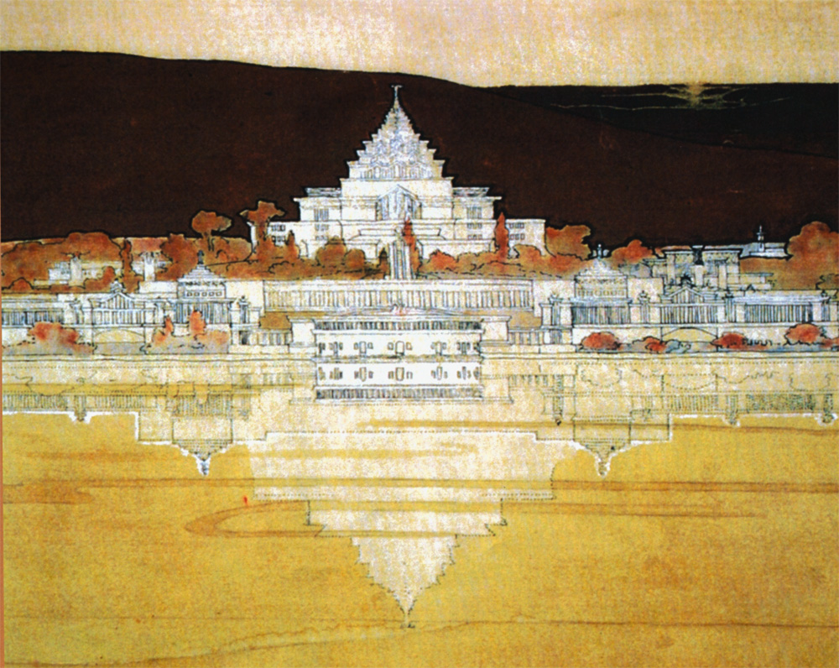
Figure 1: WALTER & MARION GRIFFIN, PROPOSED CAPITOL BUILDING, CANBERRA PLAN, 1911
Detail of drawing from Paul Reid, Canberra Following Griffin, Canberra, 2002, figure 4.4. p 53

A study of Griffin’s Newman College, 1915-18, revealed that true to his Beaux Arts training at the University of Illinois at Urbana Champaign, 1895-99, architectural precedence was an important factor in his architectural designs [Figures 3&4}. Of course, the scientific and engineering aspects of his degree course were also significant. Notwithstanding, in his architectural designs he layered together in a conceptual diagram underlying compositional structures or patterns that were alike. The patterns were drawn from his favourite architects, buildings and eras. Marion observed that, as usual, Walter presented her with a diagram of the Newman College design on the back of a small envelope. She exclaimed that ‘the design was all there – and in his head’.

Such diagrams were composites of the parti, that is, the underlying compositional patterns of a building type or building element, relevant to the functional task at hand. Griffin chose these patterns because thay had an ‘ideal purpose’. The patterns were drawn from Ancient and Modern eras, both Occidental and Oriental. Often these patterns occur in the works of the late 18th/early 19th Century American architect Thomas Jefferson (1743-1826), in the 16th Century French architectural works of Philibert de l’Orme (c1514-1570), in building examples shown in James Fergusson A History of Indian Architecture, and in modern examples seen in books and especially magazines. For example, the cross-plan of the Capitol is like the cross-plan of Jefferson’s own house, Monticello [Figure 3]. The tiled roofs to the arms have shallow gables and raked ends like the French Swiss chalets published during the 1890s in Griffin’s favourite magazine, Architectural Record. The pagoda form of the Capitol recalls a photograph of the Ananda Temple, in Pagan, Burma, shown in Fergusson’s History of Indian Architecture [Figure 2].

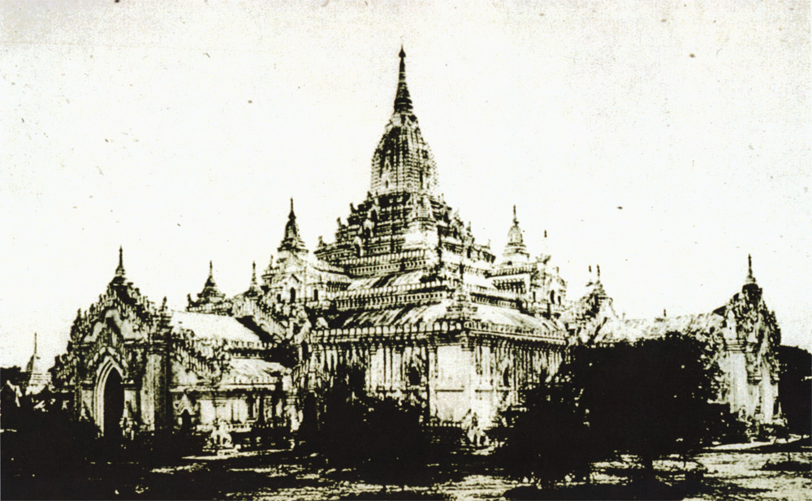
Figure 2: ‘ANANDA’ TEMPLE, PAGAN, BURMA
Photo from John Burgess and Richard Phené Spiers, James Fergusson’s History of Indian Architecture, revised and enlarged edition, London, 1910, p 395

In the Newman College study it is clear that one of Griffin’s precedents for the plan is Jefferson’s first 1772 scheme for Monticello. Both plans were drawn with west at the top of the sheet, toward the most desirable views [Figure 3]. The Chapel is at the centre of the College plan. Jefferson’s dwelling is at the centre of his large farmhouse, with two L-shaped roof walkways out to the two dependencies, an estate office and the other office for his legal practice. At this stage Jefferson proposed to place rotundas at the turns of the L-shapes. At Newman College Griffin also envisaged rotundas, a Dining Room beneath one dome, and a Library beneath the other. Griffin’s dependencies are recreation room blocks. The arms of the L-shapes have cloisters giving access to stairs and the ‘Oxford suites’ of two rooms per student

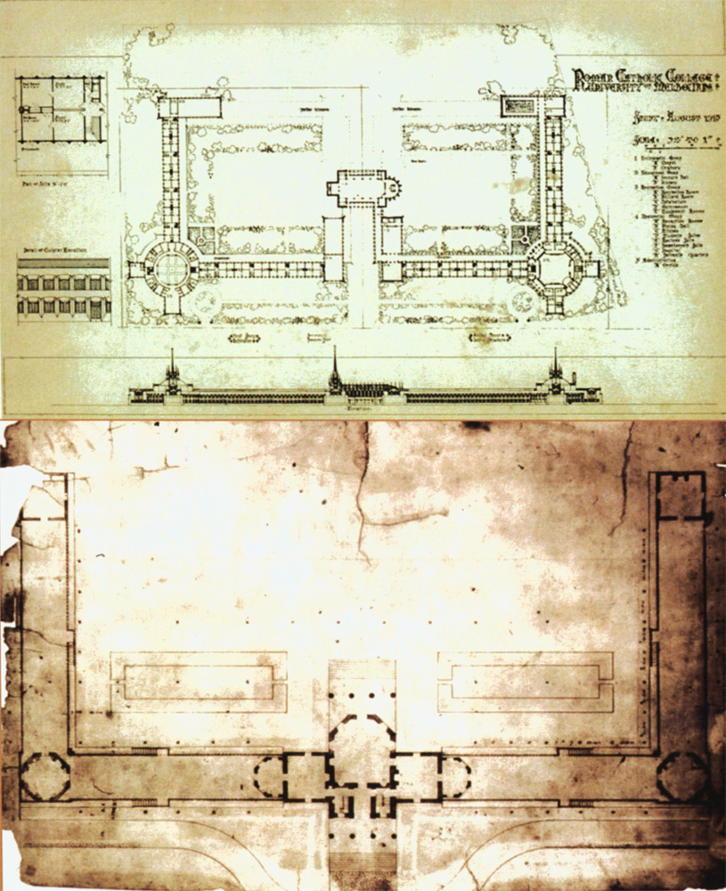
Figure 3: WALTER & MARION GRIFFIN, ‘ROMAN CATHOLIC COLLEGE’ presentation sketch plan, AUGUST 1915 SCHEME, & THOMAS JEFFERSON, OWN FIRST HOUSE MONTICELLO, plan, CHARLOTTESVILLE, VIRGINIA, 1772
Drawing from David Van Zanten, Walter Burley Griffin: selected designs, Palos Park, 1970, p 73, & drawing from William Howard Adams, Jefferson’s Monticello, New York, 1983, figure 55, p 65

Similarly it can be seen that architecture of Philibert de l’Orme was also one of Griffin’s sources for the battered base of the College. The Chateau is located at the site of the house of St Louis, has a sloping battered platform base, and windows with a prominent treatment of the flat arches. These motifs in the College design are rendered in rusticated stone coursework and smooth stone surfaces to supports and the arches, emulating the work of the earlier American architect, Henry Hobson Richardson (1838-1886). There are a number of motifs in the College design that stem from de l’Orme and from Jefferson.

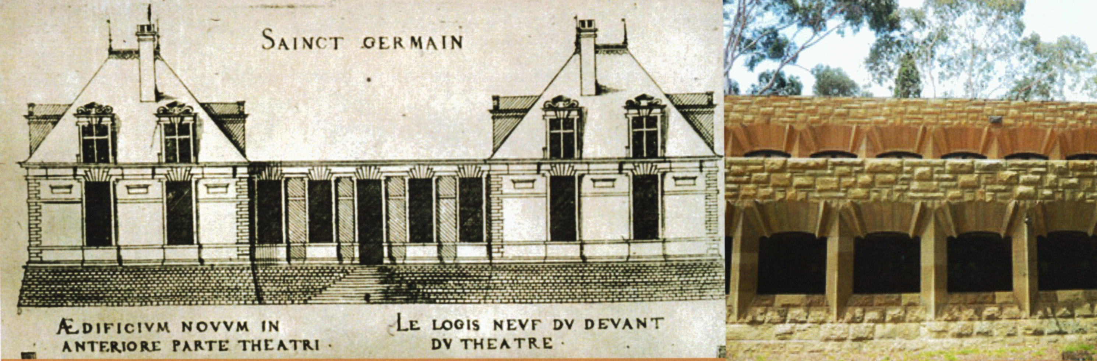
Figure 4: PHILIBERT de l’ORME, CHÂTEAU DE SAINT-GERMAIN-EN LAYE le LOGIS NEUF, 1544, & SOUTH STUDENT RESIDENCE WING, WEST ELEVATION NEWMAN COLLEGE, 1915-18
Drawing by Jacques Androuet du Cerceau from Anthony Blunt, Philibert de l’Orme, London, 1958, plate 40c & Internet image, 25 April 2013

The identification of the origins of compositional patterns at Newman College had further application. A further analysis of the whole of Griffin’s works showed that Griffin employed these same sources from his very beginnings. A very early work, the Elmhurst Golf Club building, 1901, has a metal roofing system of Jefferson’s devising, and the veranda piers abstract the French Order invented by de l’Orme. An analysis of the Canberra Plan also yields compositional patterns that reflect the same realm of original sources. For example, the equilateral triangle ‘measuring’ instrument shown in de l’Orme’s publications is one of the origins for Griffin’s triangle of avenues with the apex at the site of his Capitol building [Fig 5]. The shape of Griffin’s central lake basin can be seen enclosed in de l’Orme’s instrument. De l’Orme claimed that the equilateral triangle was useful for measuring houses, villas, villages and towns. He also observed that philosophers, architects and poets revere such a triangle for its cosmic properties.

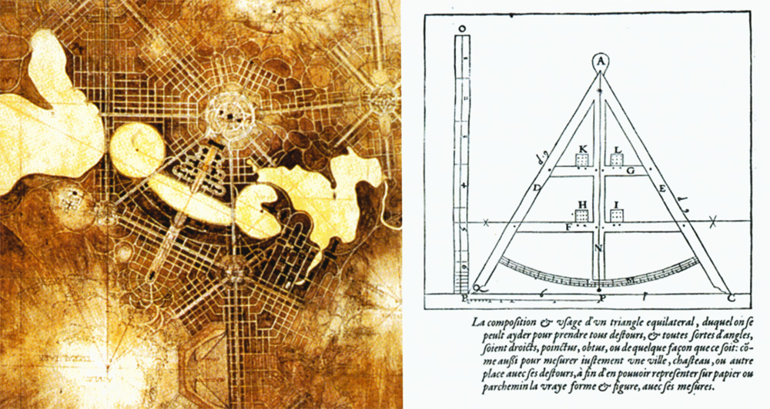
Figure 5: WALTER & MARION GRIFFIN, CANBERRA PLAN, CHICAGO, 1911, central area, & PHILIBERT de l’ORME, EQUILATERAL TRIANGLE INSTRUMENT, 1567.
Drawing from Paul Reid, Canberra Following Griffin, Canberra, 2002, figure 4.3. p 52 & drawing from Philibert de l’Orme, Architecture de Philibert de l’Orme oeuvre entiere, London, 1981 (1567), Livre II, Chapitre VI

In addition, the whole Canberra Plan can be interpreted as being inspired by Jefferson’s Monticello [Figure 6]. As described the cross-plan of the Capitol building [Figure 1] is like the cross-plan of Jefferson’s house. The Capitol was to contain the national reception hall amongst other archival and gathering functions, and that is like Jefferson’s multi-functional reception area in the Virginia house. Griffin’s proposed Casino, set below Mt Ainslie, at the end of the Land Axis, was to contain the national banqueting room, amongst other purposes, and so it is like Jefferson’s dining room, and placed on a similar north-south axis. The university Griffin proposed would have a library tower as the only building aligned with the Water Axis. Jefferson’s library had a similar position in relation to the reception and to dining areas in his house. At a vast scale Canberra would emulate the distribution of functions in the house of the man whom the Griffins believed founded democracy in America.

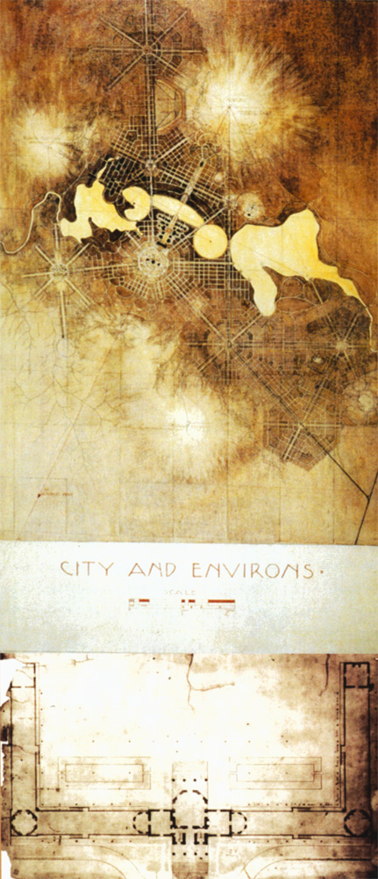
Figure 6: WALTER & MARION GRIFFIN, CANBERRA PLAN, CHICAGO, 1911, &
THOMAS JEFFERSON, OWN FIRST HOUSE MONTICELLO, plan, CHARLOTTESVILLE, VIRGINIA, 1772
Drawing from Paul Reid, Canberra Following Griffin, Canberra, 2002, figure 4.3. p 52 &
drawing from William Howard Adams, Jefferson’s Monticello, New York, 1983, figure 55, p 65

Apparently, to reinforce the ‘ideal purpose’ of the Capitol, Griffin placed it in the centre of a circular and oval pattern of roads similar to the internal

partition rotunda plan of Jefferson’s Library for the University of Virginia [Figure 7]. An article published in 1895 described how students used the library for study purposes, and once a year used it for the student dance. Archival and gathering functions were described thus for this multi-purpose space before it was destroyed by fire later that year. The architects for the restoration and renovation of Jefferson’s rotunda, McKim Mead & White, omitted the rebuilding of the original oval rooms. Griffin in his Canberra Plan intended to restore the purpose and meaning of this pattern.

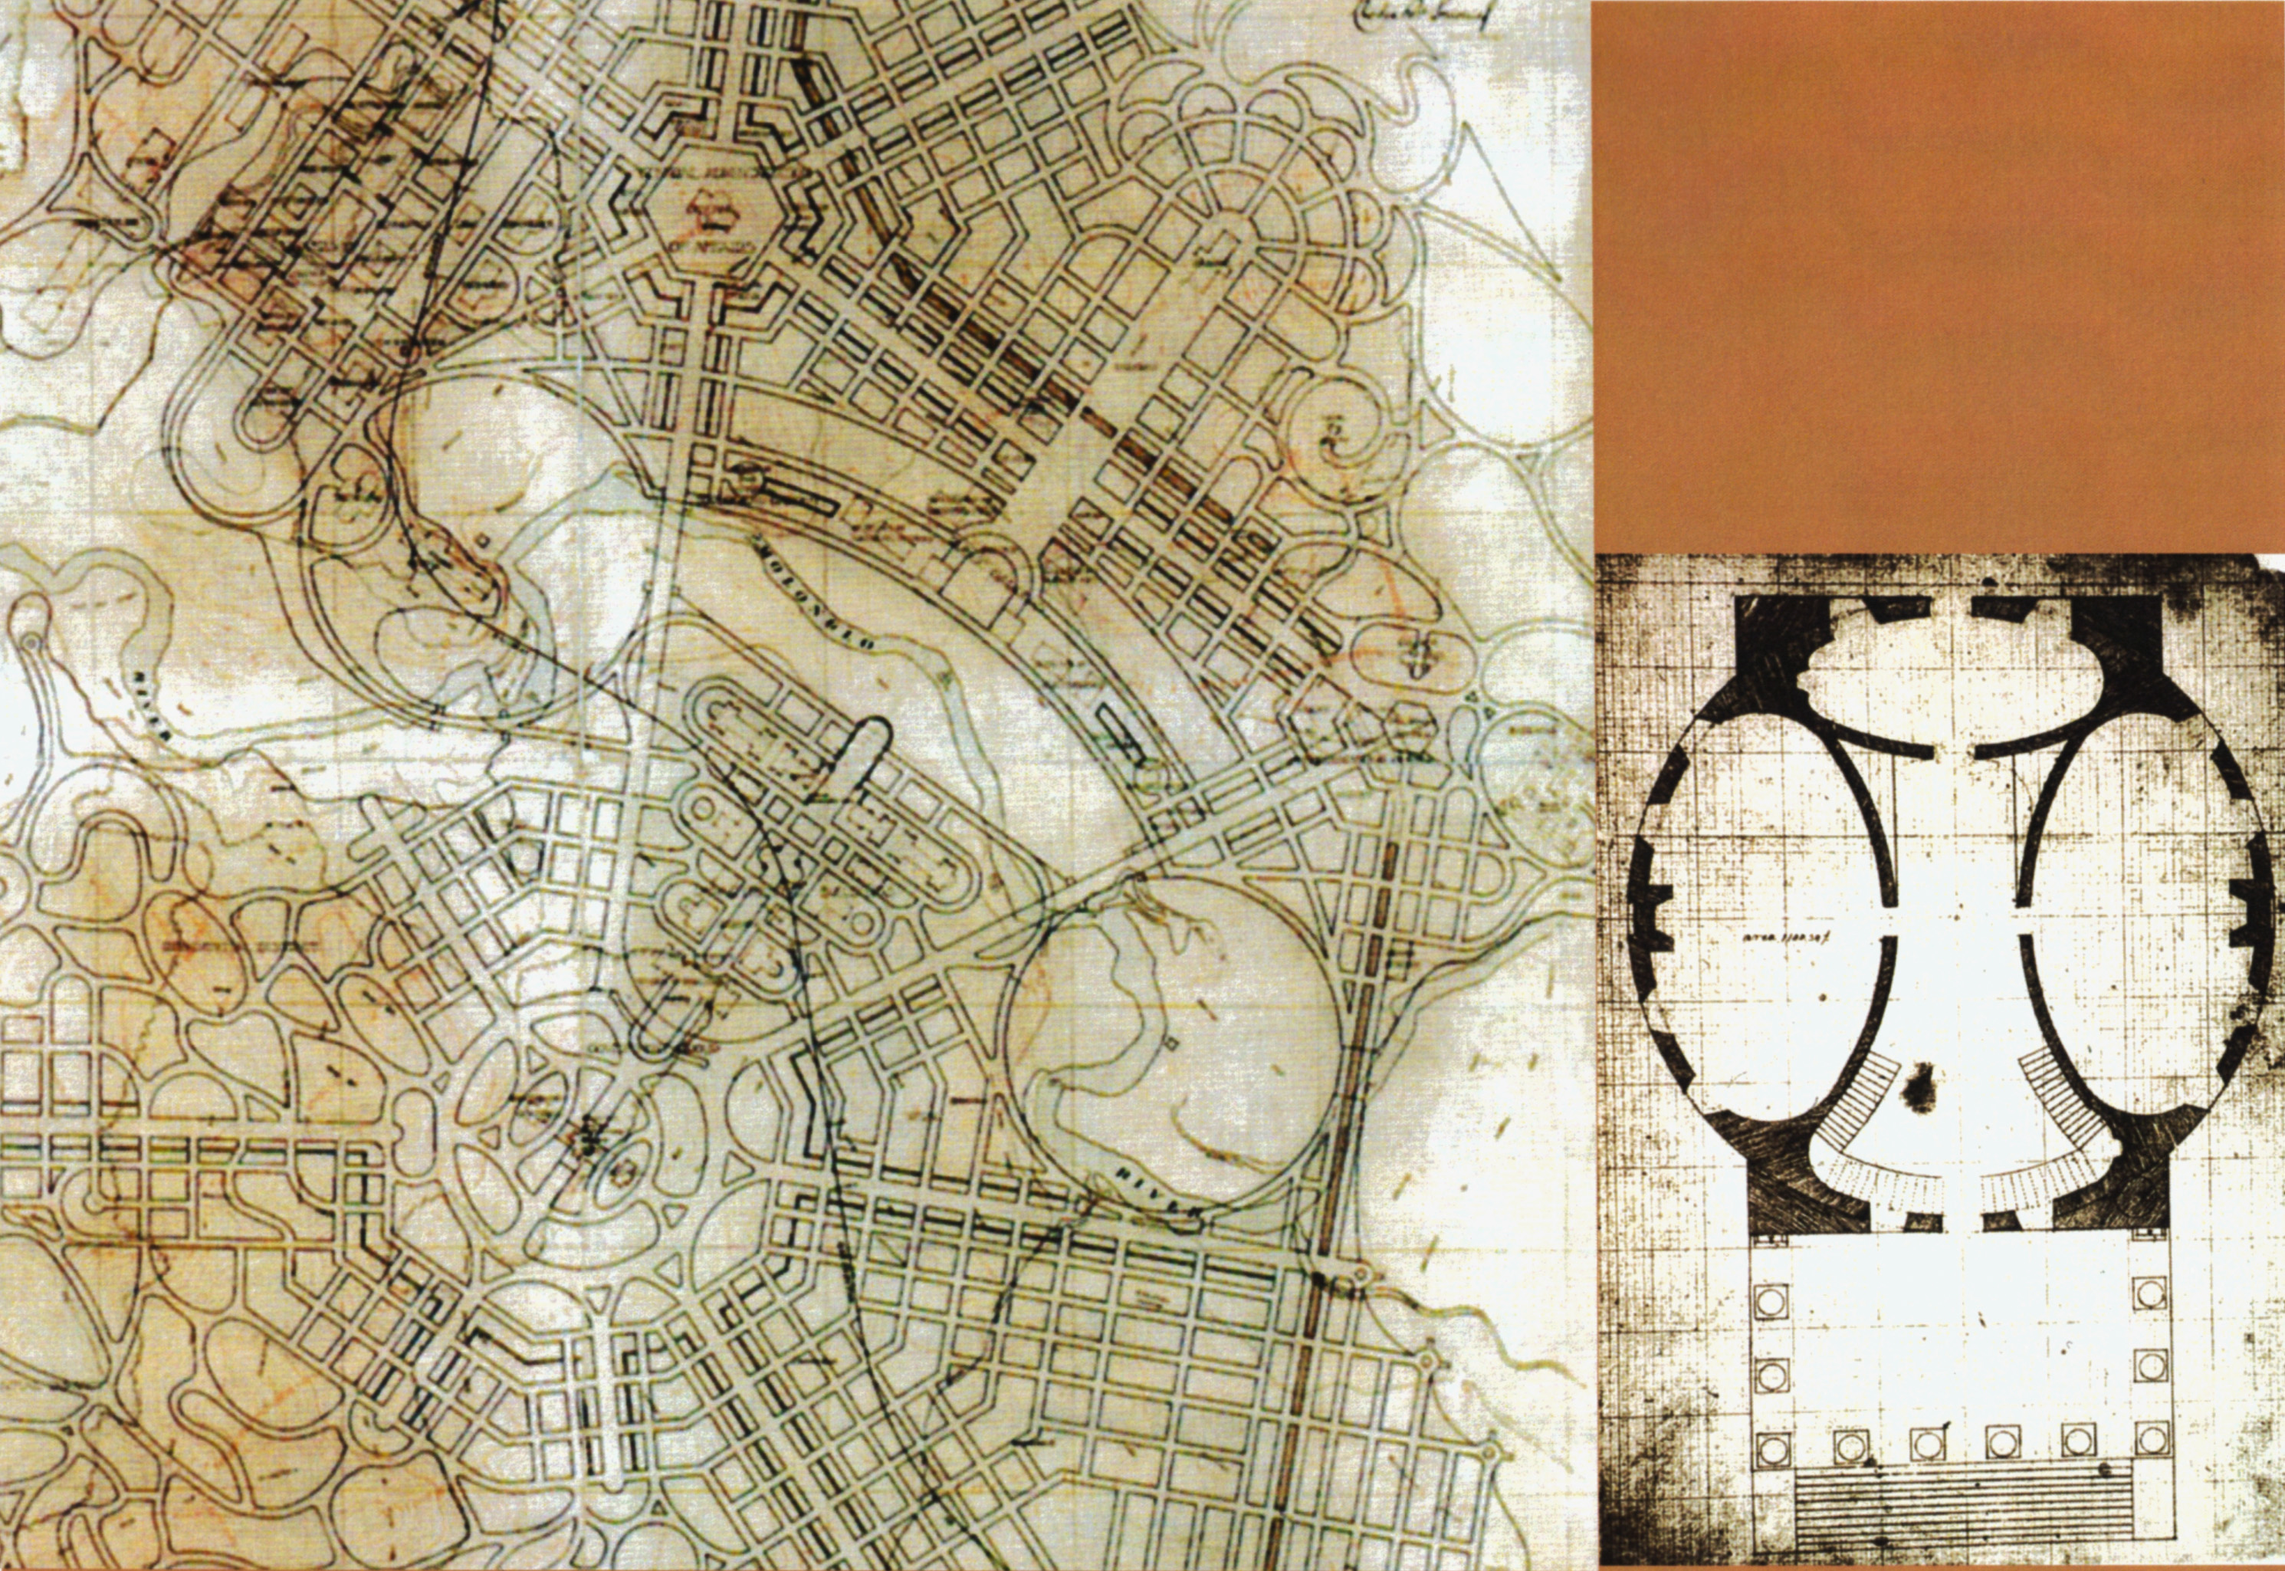
Figure 7: WALTER & MARION GRIFFIN, CANBERRA PLAN, CHICAGO, 1911, central area, & THOMAS JEFFERSON, UNIVERSITY of VIRGINIA, ROTUNDA (LIBRARY), plan
Drawing from Paul Reid, Canberra Following Griffin, Canberra, 2002, figure 4.2. p 51 &
drawing from Michael Brawne, University of Virginia: the Lawn, London, 1994, figure 49, p19

The patterns that Griffin recalled for the Canberra Plan came in large measure from Thomas Jefferson, but he also liked the ideas and patterns he could find in de l’Orme’s publications. A modern precedent was Burnham’s 1909 ‘City Beautiful’ Chicago Plan, characterised by cutting great radial boulevards through Chicago’s grid, as Baron Haussmann had done in mid-century Paris. Another modern source for his Canberra Plan was the architecture, planning and landscaping he saw at the Chicago Columbian Exposition in 1893. Griffin’s unbuilt scheme for a new parliament house complex, 1918, straddled the Land Axis on the government side of the future lake. The Lagoon at this Chicago Fair inspired Griffin’s parliament complex. Clearly, Griffin remained interested in the World’s Fairs in American cities that followed, especially in the design of architect John Galen Howard (1864-1931) for the Seattle Alaska–Yukon–Pacific Exposition, 1909 [Figure 8].
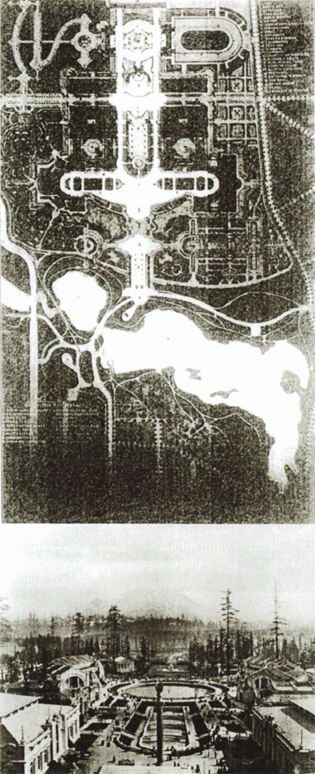
Figure 8: JOHN GALEN HOWARD, ALASKA-YUKON-PACIFIC EXPOSITION, SEATTLE, 1909, plan & view along the Land Axis from the ‘Cascades’ toward Mt Rainier
Drawing & photo from “Our Exposition in Seattle”, Architectural Record, Vol XXVI, January 1909, pp 24-32

The Land Axis in Howard’s Seattle scheme aligns with a distant mountain, in the manner of Canberra’s Land Axis [Figure 8]. A water cascade and round pond can be seen in the foreground, and beyond is a lake crossing the Land Axis, which has an edge that follows land contours formed after the local watercourse was dammed. For Canberra, Griffin generally followed a similar compositional strategy, proposing to dam the Molonglo River. The very distinctive difference in Griffin’s composition is the overlay of the (nearly) equilateral triangle of tree-lined boulevards. Indeed, Canberra is at the scale of a city, rather than a large fair ground.

Griffin went to great lengths to describe the functions and their distribution in his designs for planning schemes. Diagrams of that distribution for Canberra later accompanied the “Report Explanatory” prepared during his four months in Melbourne in the latter half of 1913. Nevertheless, Griffin is often blamed for being incapable of explaining his scheme. However, in any arena he was reluctant to reveal his design method. Marion in her memoirs does not seem to know precisely how his mind and heart worked. Indeed, Griffin considered himself an artist, who does not divulge deeply felt and highly personal ideas and means. For example, he did not commit to text the nature of his concept of ‘ideal purpose’, neither generally nor specifically. It is as though he believed these intentional qualities were obvious in his designs.

So the planning of Canberra became a political game. The English ‘Garden City’ notion defeated Griffin’s ideal ‘City Beautiful’. A Royal Commission concerning Canberra’s planning ran in Melbourne for nine months from 1916 into 1917, with Griffin and his Plan vindicated. However, Griffin until 1920 dealt with hostile bureaucrats, obstructive politicians, and indifferent professionals. As the norm, he contended with an aggressive and stubborn pragmatism. The meaning and purpose of Griffin’s art remained opaque. Eventually the national meeting place became the site for the Houses of Parliament; the national dining facility became the War Memorial. The university library tower was never built. Suburbia sprawled.

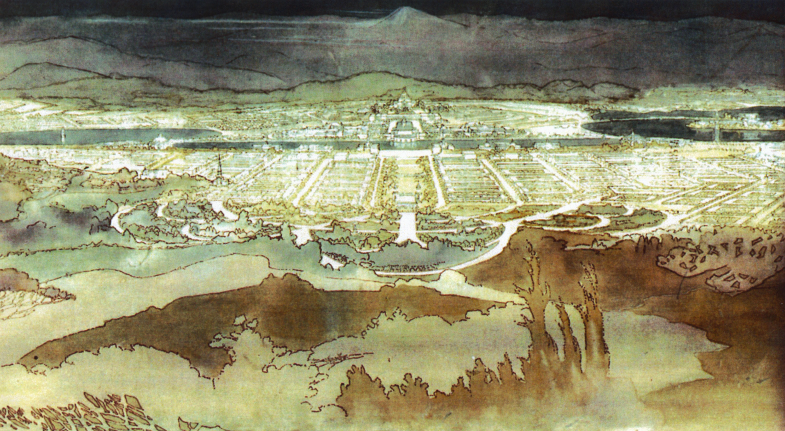
Figure 9: MARION MAHONY GRIFFIN, ‘VIEW from MT AINSLIE’, WALTER & MARION GRIFFIN, CANBERRA PLAN, CHICAGO, 1911
Perspective drawing, courtesy National Archives, Canberra

Griffin’s knowledge of the world was American, not Australian. American professionals were well educated and sophisticated. In contrast, Australian professionals, in all seriousness, promoted the inane Departmental Board Plan.

See Jeffrey John Turnbull, “The Architecture of Newman College”, unpublished PhD, University of Melbourne, 2004, http://repository.unimelb.edu.au/10187/4871.
During his first visit to Australia, August-November 1913, Griffin addressed the RVIA, and described his Beaux-Arts training amongst other matters. See , “Architecture in American Universities”, in RVIA Journal, December 1913, pp 170-184.
Marion Mahony Griffin, “The Magic of America”, unpublished manuscript, Chicago, 1940-1949, Section II, p 240.
French architectural composition terms, such as parti, still have currency in American architectural practice, indicative of the educational influence of the Ecole des Beaux-Arts, Paris.
The first edition of Fergusson’s History of Indian Architecture is dated 1842. Many editions followed. The 1910 edition was revised and Richard Phené Spiers added additional chapters on South East Asian architecture, an illustrated text of great significance to Griffin.
Jean Schopfer, “Wooden Houses in Switzerland”, Architectural Record, VI, (April-June 1897), pp 415-428, & VII, (July-September 1897), pp 33-61.
See Jeff Turnbull, “A Reading of the Griffins’ Early Australian Work”, in Jeff Turnbull and Peter Navaretti, The Griffins in Australia and India, Melbourne, 1998, pp 52-62.
Cardinal Wolsey’s purpose built Christ Church college, 1520s, began the tradition of ‘Oxford Suites’. From the stair off the cloister a study room was entered with a bedroom beyond.
In Marion’s August 1915 perspective drawing of the Newman College courtyard she drew flat arches to the cloister openings and windows. Griffin apparently changed these to shallow segmental arches during the design process.
Richardson is another favourite architect of Griffin, and of Marion. See Mariana Griswold Van Rensselaer, Henry Hobson Richardson and His Works, New York, 1888, for a description of Richardson’s design method, which is similar to Griffin’s later conceptual diagramming.
See Alasdair McGregor, Grand Obsessions, Camberwell, Victoria, 2009, which illustrates Griffin’s drawings for the Club building, p 83.
Griffin intended to cut the central basin into the land contours and use the fill for the railway causeway on the axis between the Capitol and the Market Centre.
Also, the Governor General’s House and the Prime Minister’s Lodge Griffin placed either side of the Capitol with cross-plans like the one at Monticello.
For a description of the Griffins’ Canberra Plan and their vision for the distribution of public buildings see Paul Reid, “A work of art: The Organic City”, in Canberra Following Griffin, Canberra, 2002, chapter 4, pp 46-81.
Marion in her memoirs “The Magic of America” enthusiastically wrote in her very first paragraph that Jefferson established the institution of democracy, equal in significance to Rutherford smashing the atom.
In this instance an interior wall pattern is applied to a road pattern. For Griffin, the pattern was significant in its ‘ideal purpose’, not the medium in which the pattern first appeared. The pattern was Platonic, an abstraction that had many manifestations. The philosophy is One and the Many, and One and the Other.
See, John Kevan Peebles, “Thomas Jefferson, Architect”, in The American Architect and Building News, ILVII, (19 January 1895), pp 29f.
The fair ground and its central exhibition building became the physical core of the new University of Washington in Seattle.

