SYNOPSIS

The architecture of Walter Burley Griffin

The aim of this paper is to consider Walter Burley Griffin’s architectural theory in relation to the Canberra Plan, 1911-12. Already elegant histories of Griffin’s landscapes, planning, and building works in their social and political context have been published, which allow an insightful understanding of his first Canberra scheme and its modifications during the second decade. The proposition here is that Griffin’s architectural theory also had a broad role in all of his schemes. In Griffin’s design for the Capitol building, for example, shown in the drawings for the Canberra Plan, why is the building on a cross plan with raked gable ended roofs to the arms and a pagoda form for the tower? What are the architectural features of this composition, and why were they important to Griffin? In answering these questions another layer of meaning can be added to the Canberra Plan

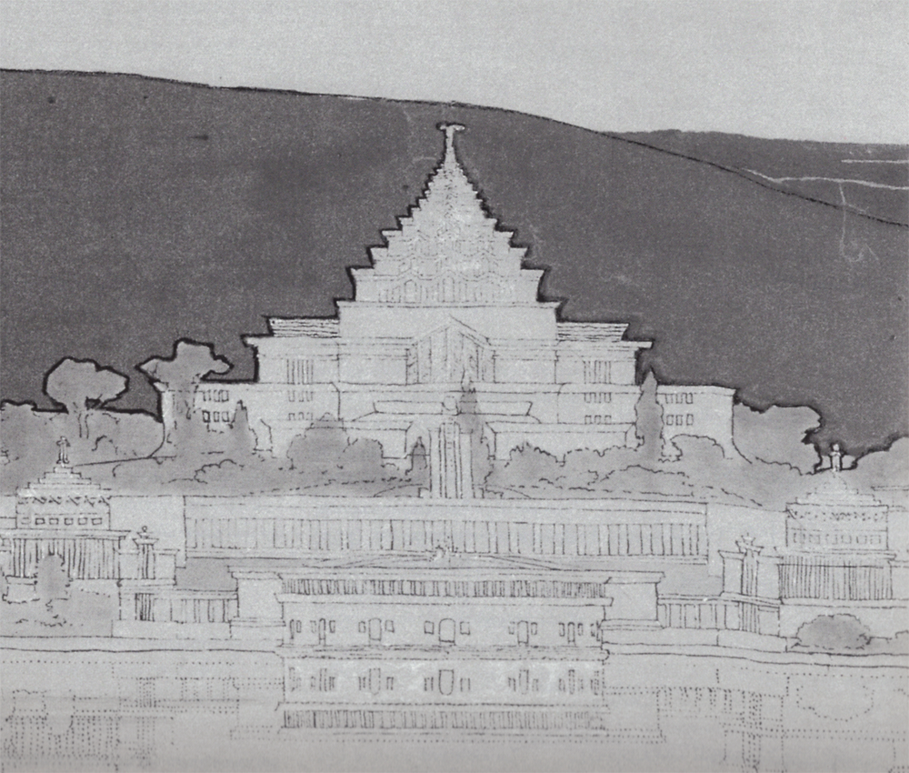

A study of Griffin’s Newman College, 1915-18, revealed that true to his Beaux Arts training at the University of Illinois at Urbana Champaign, 1895-99, architectural precedence was an important factor in his architectural designs. Of course, the scientific and engineering aspects of his degree course were also significant. Notwithstanding, in his architectural designs he layered together in a conceptual diagram alike underlying compositional structures or patterns drawn from his favourite architects, buildings and eras. Marion observed that, as usual, Walter presented her with a diagram of the Newman College design on the back of an envelope. She exclaimed that ‘the design was all there – and in his head’.

Such diagrams were composites of the parti, that is, the underlying compositional patterns of a building type or building element, relevant to the functional task at hand. The patterns were chosen from Ancient and Modern eras, both Occidental and Oriental. Often these patterns occur in the works of the late 18th/early 19th Century American architect Thomas Jefferson, the 16th Century French architect Philibert de l’Orme, building examples shown in James Fergusson A History of Indian Architecture, and modern examples seen in books and especially magazines. For example, the cross-plan of the Capitol is like the cross-plan of Jefferson’s own house, Monticello. The tiled roofs to the arms with shallow gables and raked ends are like French Swiss chalets published during the 1890s in Griffin’s favourite magazine, Architectural Record. The pagoda form of the Capitol is like a photograph of the Ananda Temple, in Pagan, Burma, shown in Fergusson’s Indian Architecture.

In the Newman College study it is clear that one of Griffin’s precedents for the plan is Jefferson’s first scheme for Monticello
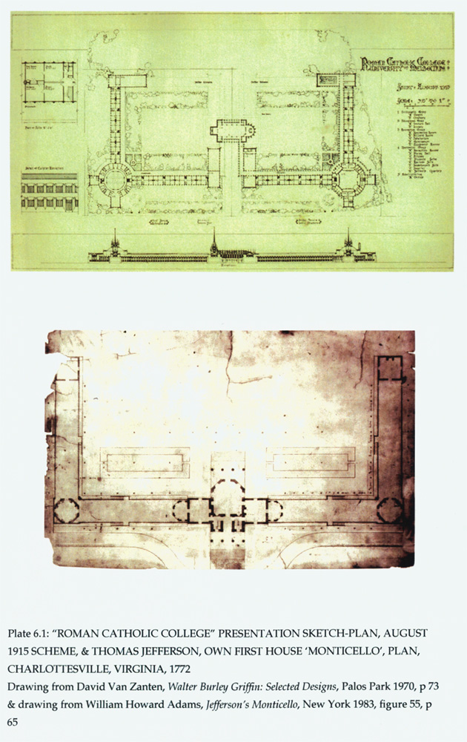

Similarly it can be seen that architecture of Philibert de l’Orme was also one of Griffin’s sources for the battered base of the College
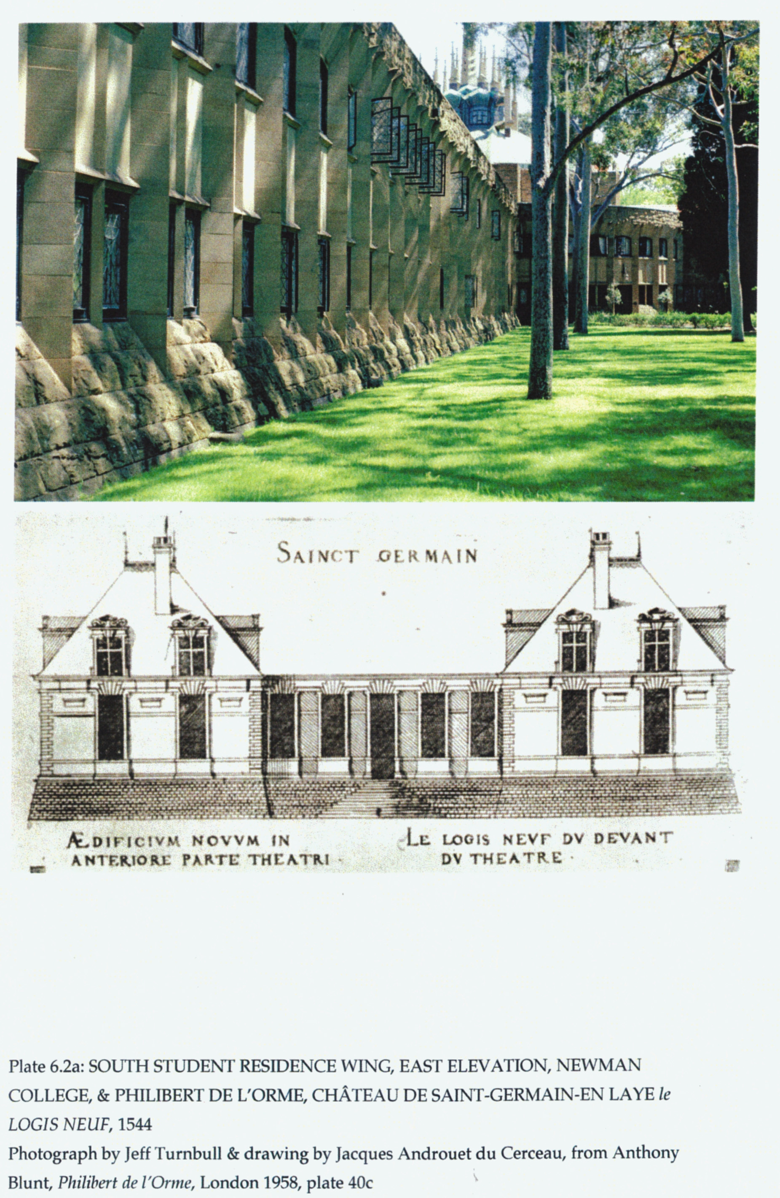

The recognition of the origins of patterns at Newman College had application to the whole of Griffins works, including Canberra. For example, the equilateral triangle ‘measuring’ instrument shown in de l’Orme’ is one of the origins for Griffin’s triangle of avenues with the apex at the site of his Capitol building. The shape of Griffin’s central lake basin can be seen enclosed in de l’Orme’s instrument. De ‘l’Orme claimed that the equilateral triangle was useful foe measuring houses, villas, villages and towns. He observed that philosophers, architects and poets revere such a triangle for its cosmic properties.

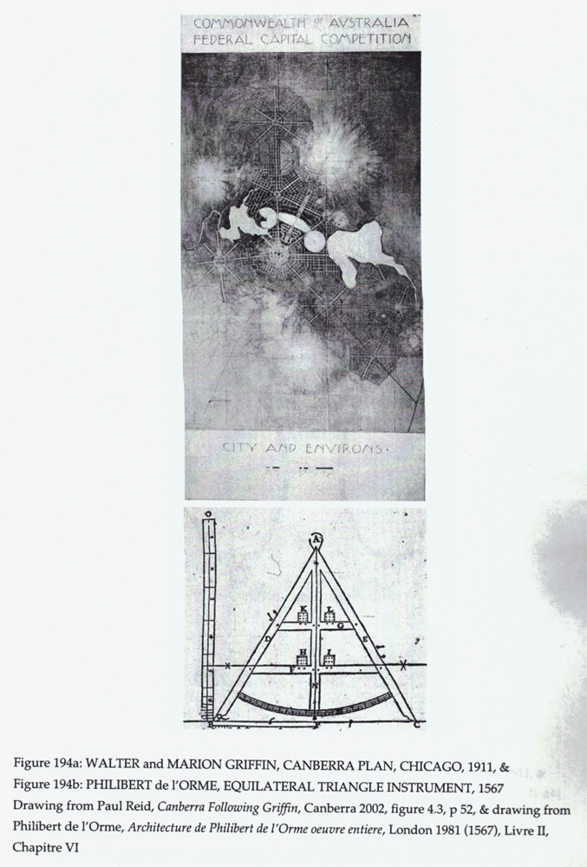

The whole Canberra Plan can be interpreted as being inspired by Jefferson’s Monticello. As described the cross-plan of the Capitol building is like the cross-plan of Jefferson’s house. The Capitol is the national reception hall amongst other archival and gathering functions, and is like Jefferson’s reception area in the house. The Casino, set below Mt Ainslie, at the end of the Land Axis, was to be the national banqueting place amongst other things, and so it is like Jefferson’s dining room on a similar north-south axis through the house. The university Griffin proposed would have a library tower as the only building aligned with the Water Axis. Jefferson’s library had a similar position in relation to meeting and to dining areas in the house. At a vast scale Canberra would emulate the distribution of functions in the house of the man whom the Griffins believed founded democracy in America.

In addition, to reinforce the ‘ideal purpose’ of the Capitol, Griffin placed it in the centre of a circular and oval pattern similar to the plan of Jefferson’s Library for the University of Virginia. An article in 1895 described how students for study used the library, and once a year used it for the student ball. Archival and gathering functions were described for this multi-purpose space before it was destroyed by fire later that year. Griffin in his Canberra plan was going to restore the purpose and meaning of this pattern.

Griffin considered himself an artist. He seldom committed to text the nature of his concept of ‘ideal purpose’, neither generally nor specifically. He did however, go to great lengths to describe the functions and their distribution in his plans for planning schemes and for buildings. The Departmental Board Plan indicated that there was no capacity in the Australian professions to read Griffin’s visionary forms. The meaning and purpose of Griffin’s art remained hidden, as an aggressive and stubborn pragmatism was the norm. The national meeting place became the site for the houses of parliament, the national dining facility became the War Memorial. The Library tower was never built.

