The gift of the Griffins to the continuing city.
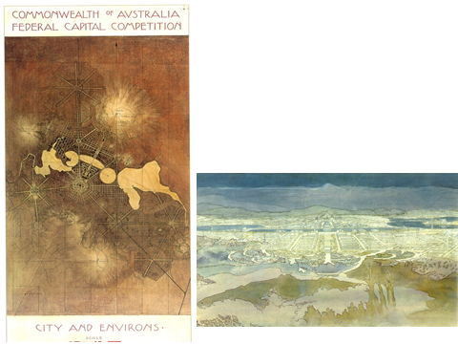
We can look at the contribution of the Griffins in Canberra and its fate through the passage of time, as well as its significance for the continuing city, from a range of different windows. They include the windows of the historical facts, that of the plan’s significance in terms of their heritage and cultural value, in terms of its political symbolism, the window of the fundamentals of urban design (“what works, what doesn’t – and why”) and the window of the potentials for the continuing city. The windows can be seen as building upon each other.

So let us briefly look at the first window, that of history: The historical facts have been extensively researched by the Australian historians such as those present today, and, in a narrower sense, by historians of architecture and landscape architecture, such as J. Weirick and C. Vernon, as well as by a range of biographers including J. Birrell, P. Harrison and A. McGregor; the evidence has been magnificently displayed in exhibitions including those by J. Reps in 1995, by C. Vernon in 2001 and the current ones at the NLA and the NA.
It is in these rare moments of history, when the beauty and painstakingly skillful artistry of Marion’s drawings can be admired outside the confined space of archival custody, that the justification for the plans’ inscription on the UNESCO World Register can be appreciated to its fullest. Watching the drawings in their exhibition settings and realizing that all this work had been delivered within an amazingly short time span has sent shivers down the spine of many an observer.
But even for those who are not as lucky as to experience the designs in this setting, the
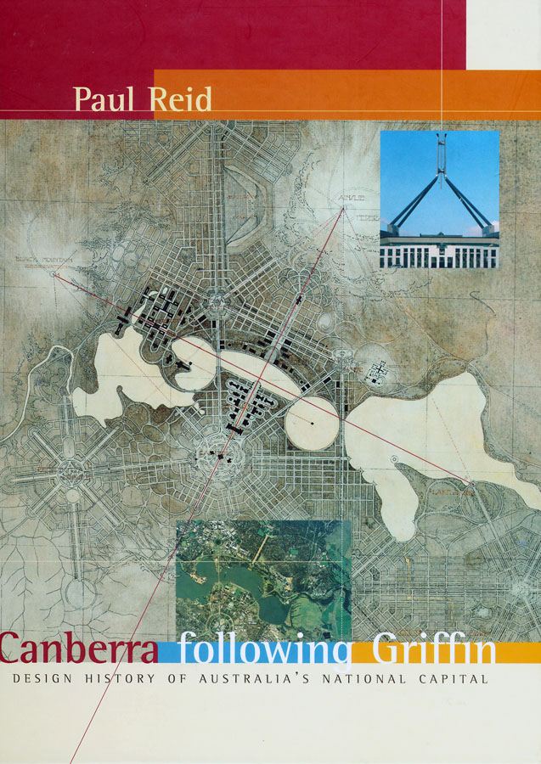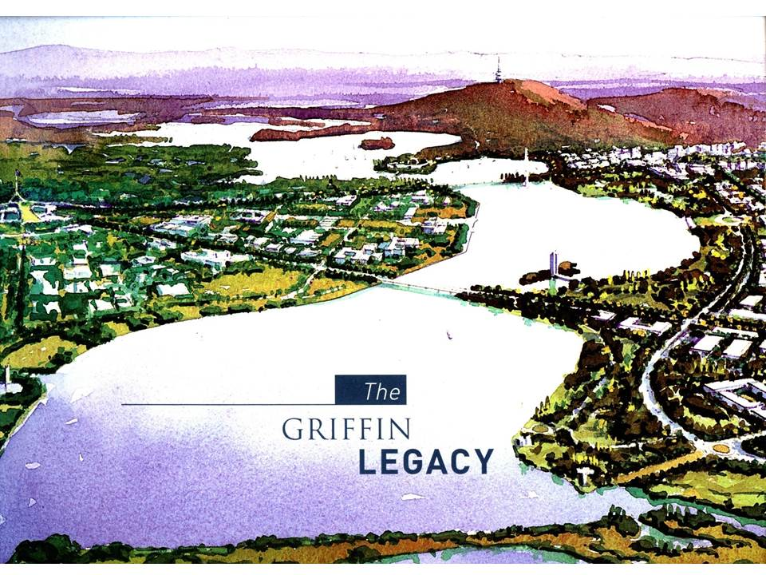
exceptionally beautiful productions in Paul Reid’s book and in “The Griffin Legacy” are impressive.

The theme of the ongoing city entails a look at the reception history of the Griffin Plan. So when we look beyond the thorough work of the historical scholars we also have to ask: Which material is presented where, how and why? How is it interpreted by whom and used with what interest? Who picks it up to use it in an instrumental way?
These are questions which at a certain level are simply interesting, but at a different level are significant and highly important because of the consequences for the continuing city. They have to be seen in the context of sanitized readings and representations of history in the interest of day-to-day politics and real estate economics which tend to impoverish the design and its potentials. I’m going to look at several examples ranging from the ludicrous to the worrying. Let me start with the hilarious.
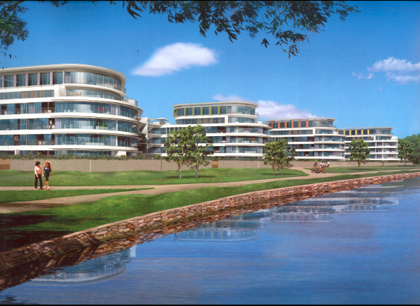 An advertisement in the sense of Sir Walter Griffin…., which reminds me of the great “letters to Tyrolean landlords” read out by the great English comedian Gerard Hoffnung.

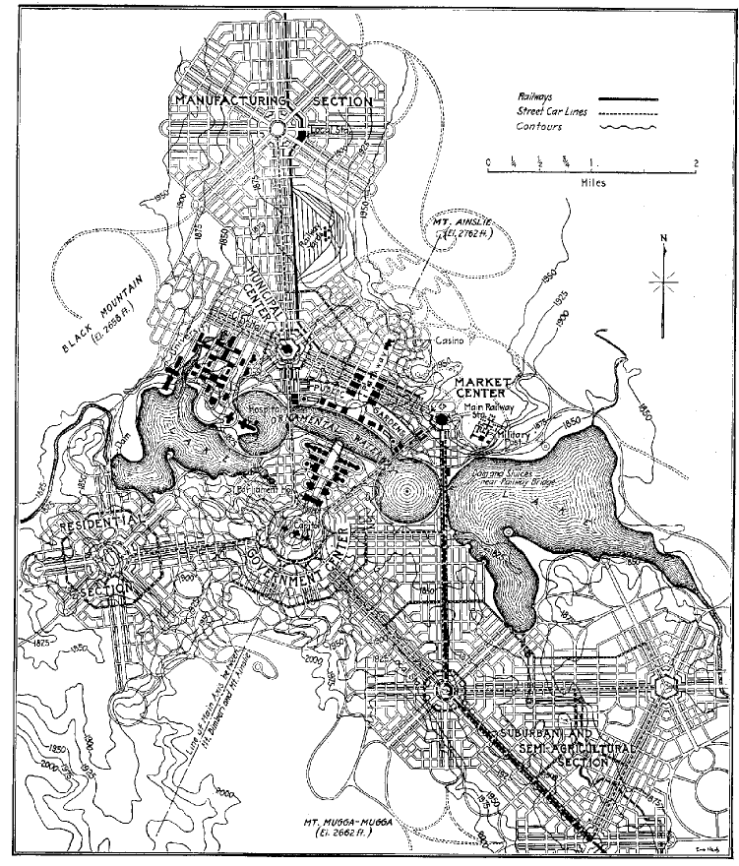
I’m trying to be serious again by examining the design itself in terms of its properties, qualities and potential for the continuing city by looking through the second window, that of the assessment of the Griffin plan in terms of the fundamentals of urban design.
As James Birrell pointed out in 1964 “no major concept in town planning has been put forward in the (then) 40 years since the city was designed that is not incorporated in the original scheme."

Features of the plan included: neighbourhood units explicitly named as such as early as 1911 and diversified urban sub-centres connected by trams; a multitude of principles of planning for sustainability including water recycling, decentralised sewerage treatment, urban gardening and the reduction of fossil fuels; ideas on functional and social mix; as well as on the public goods function of residential land, and so on. The tramway would be paid out of revenue from the leasehold system; more about that later.

Seen through this window, the plan is clearly amazingly “modern” – no, this term is problematic because of its multiple meanings. It would be better to say: The plan corresponds to the most recent insights of planning and urban design in the 21st century, and it does so in an amazingly comprehensive way – a superb basis for the continuing city:
Tram solutions for instance have been adopted in most cities, and sustainability is the current catch phrase – although it is all too often misused as a fig leaf e.g. justifying space standards lowered for reasons of narrowly defined economic profits; more on that later.

The American architectural historian Mark Peisch
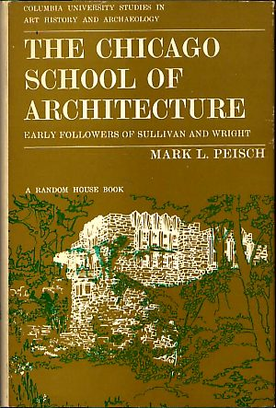
was the first to point out that Griffin had combined the seemingly contradictory principles of the City Beautiful with those of the Garden City.
This is an important observation, which has been repeated innumerable times – but mostly in the way of a taxonomical attribution, an act of labeling, of sorting facts into their proper intellectual slots.
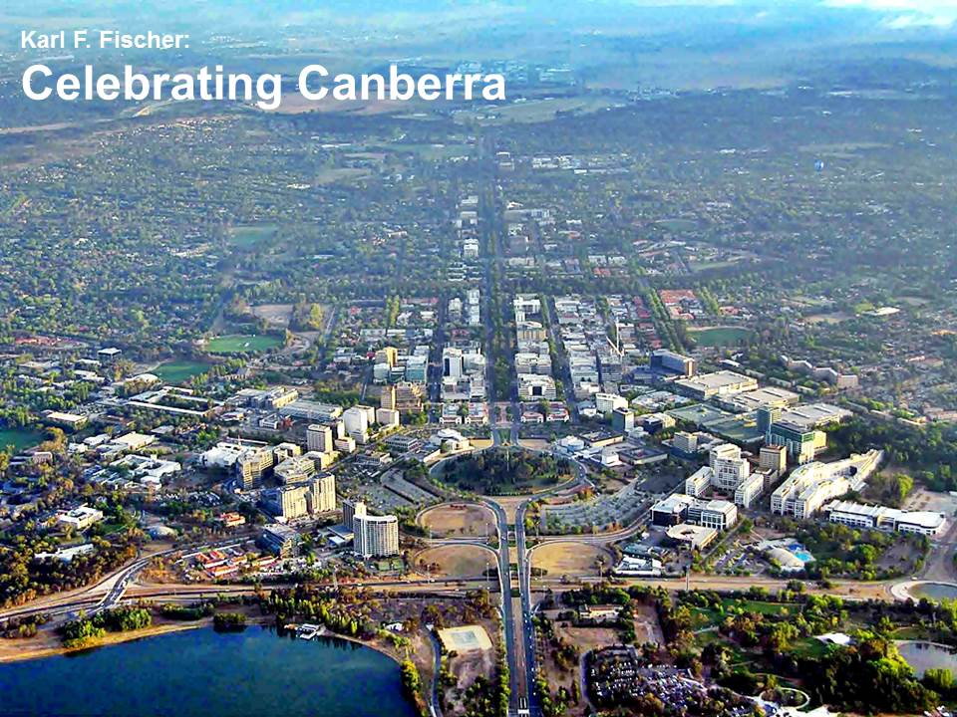Even Peter Hall’s oft-quoted statement that Canberra has ‘achieved the difficult feat of being one of the last Cities Beautiful, and also the world’s biggest Garden City’ does not go very much further. Is this of any significance for the continuing city, beyond the accolade of an honourful distinction?

I would argue that it is, because we can interpret Griffin’s approach of combining the underlying principles into a new, we might say, hybrid concept as an expression of one of the essential endeavours of planning and urban design: to produce the best of both worlds:
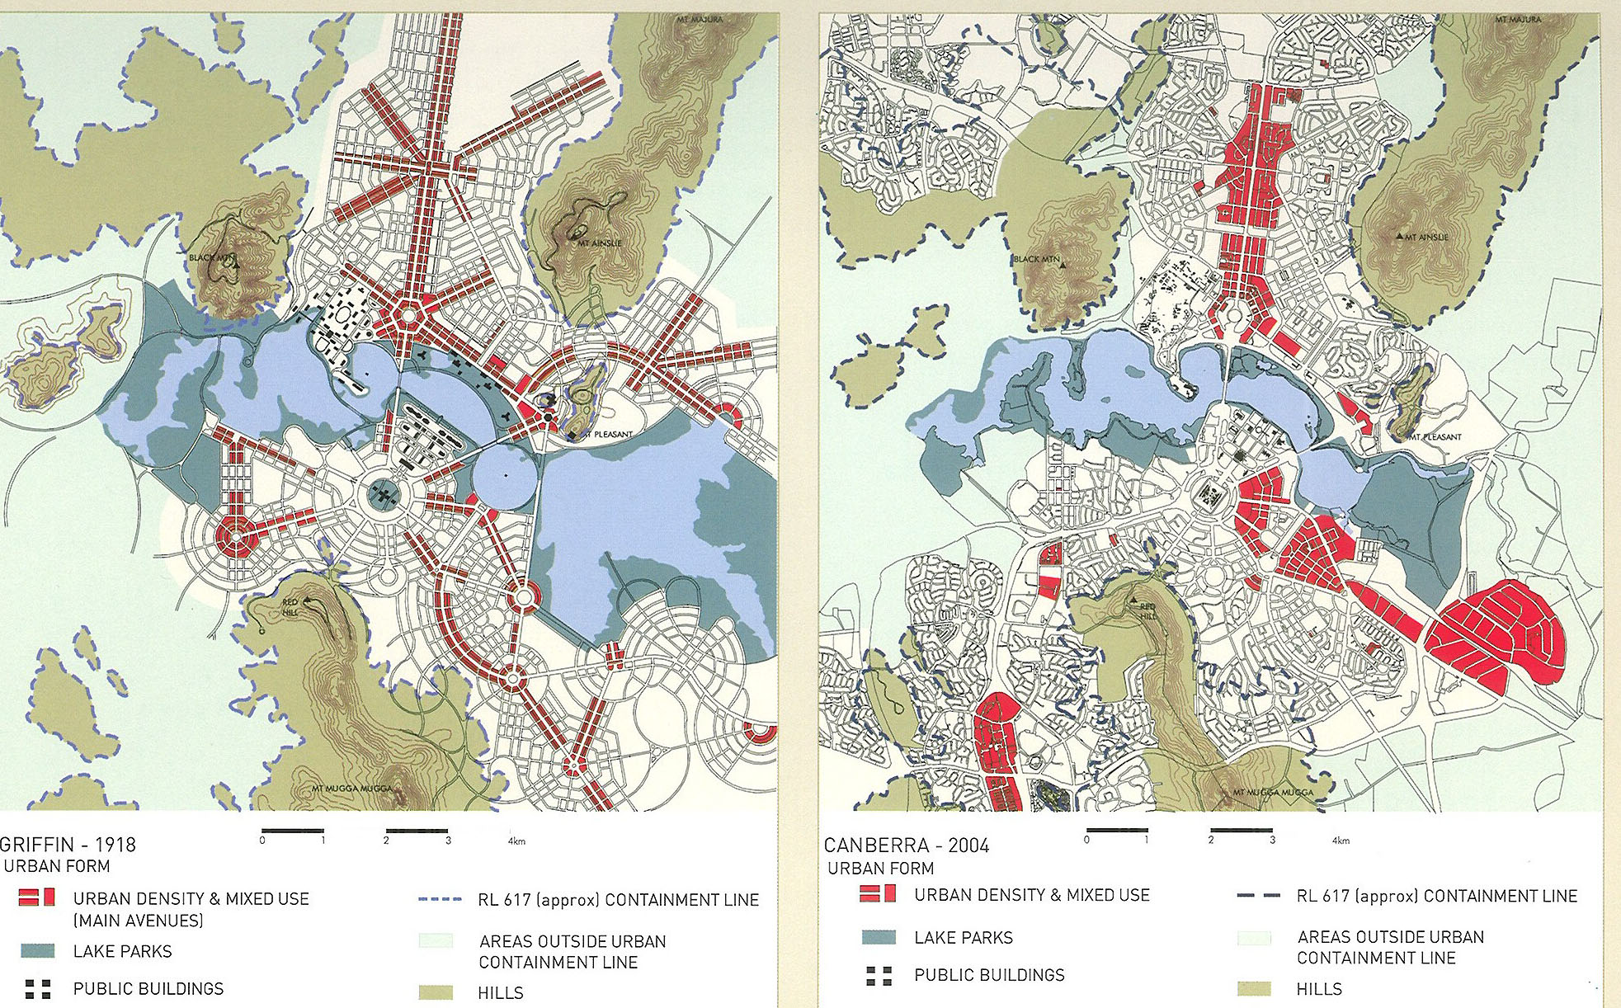
In this case: vibrant urbanity along the avenues and quiet seclusion in the lower-density quarters immediately behind them – a bit like Paris with its fairly regular 19th century apartment buildings along the avenues and the varied, small-scale mosaic of older historic buildings at the back: A city of contrasts. In Griffin’s Canberra, these would be contrasts of densities and uses: urban life along the avenues, suburban quietness immediately behind them.
However, the development of Canberra from the 1920s on did not pursue this course.
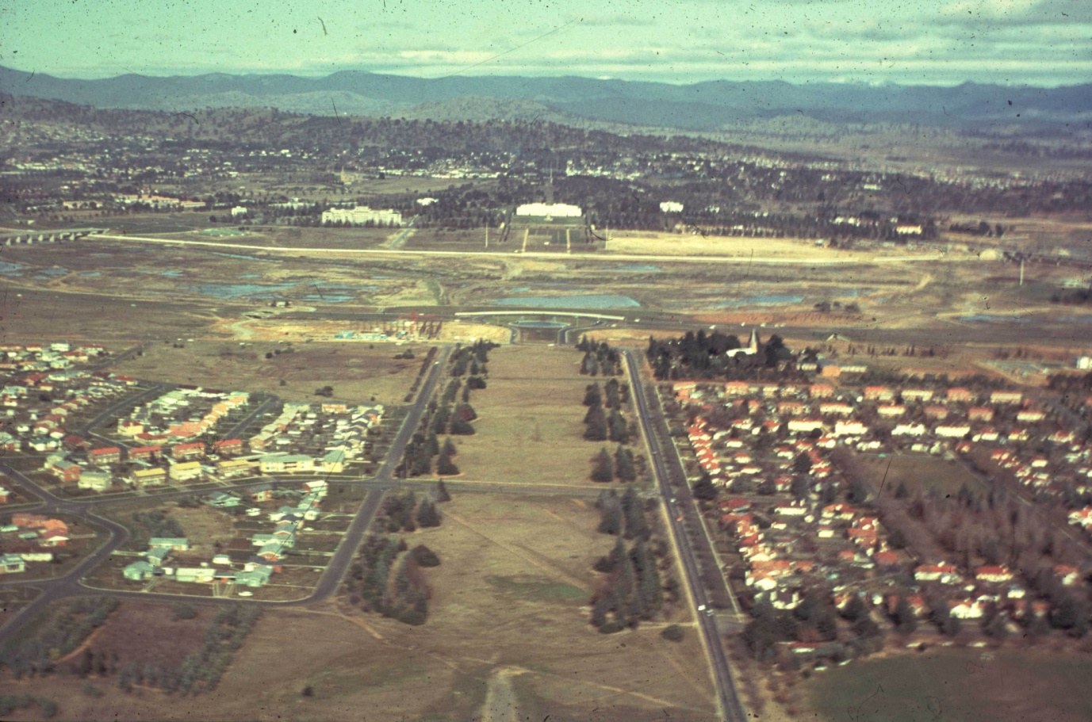
As we know, the skeleton of City Beautiful avenues designed as the backbone of the future mature city – which, as Griffin foresaw, would take more than a century to emerge – was fleshed out with bungalows, producing the somewhat incongruous pattern of what I would interpret as an adolescent city.
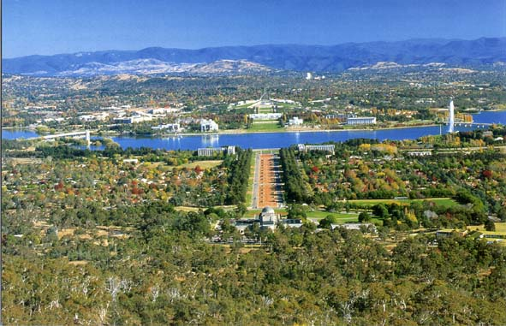
Although the decision in favour of the suburban, small town solution was said to be “for the first stages” of the languishing city of the doldrum inter-war years only, this had long-lasting consequences, and it was the basis for fundamental change. It has also been the basis for an ongoing cleavage in the discussion about the aims to be pursued for the ongoing city: Should the City Beautiful elements be ruled out and best be forgotten and should Canberra be seen as a garden city, spelt not with capital letters, not in the sense of Howard’s Social City concept nor in the sense of the Griffin plan with its notions of sustainability but in the sense of “a city of garden suburbs in the landscape”?
Should what Griffin had designed as City Beautiful avenues linked by trams lined with buildings with active frontages and hence alive with people – streets for people truly walking on their feet – be reduced to remain nothing but visual axes along car-oriented traffic corridors?
This may sound like a polemical juxtaposition, but it is the core of one of the cultural debates in Canberra at present. Undoubtedly, this would be an enormous impoverishment of Griffin’s concept.

The significance and the value of Griffin’s design principles for creating a vibrant city had all but forgotten since the days of the Sulman Committee in the 1920s. Sulman had warned in 1909 that “the European boulevard with its street cafés would be unappreciated in Australia”. And the Viennese Gus Petersilka did indeed have to muster enormous stamina in the 1970s to establish the first street café in Civic, because the DCT considered it plain unhealthy.
Well, as we know, the Griffins did not head Sulman’s warning,
but produced one of the world’s most beautiful plans for a city of great avenues and gardens. 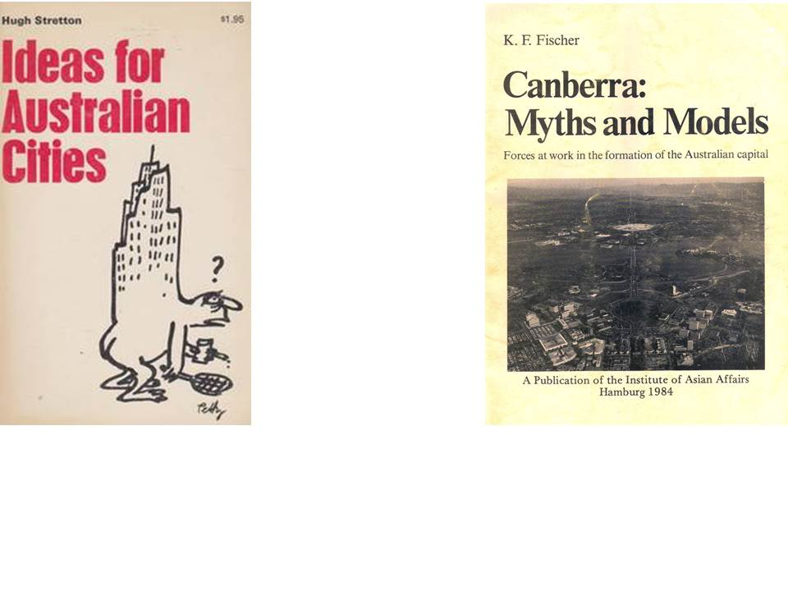Hugh Stretton was the first to articulate this potential in his “Ideas of Australian Cities” in 1971.

Another fundamental discovery of Griffin’s design principles had been made a few year before by the urban designer Edmund Bacon,
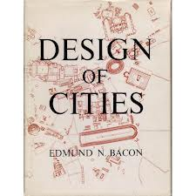
who called the Griffins’ plan “a statement of world culture” and “one of the greatest creations of mankind” – at first reading quite a mouthful and in fact not quite easy to understand, but in line with planning historian John Reps’ assessment of the Griffin plan as “a treasure not only of Australia but of the whole world”.
What Bacon was referring to, with his exceptional grasp of how space as such could be used as an element of urban design – and Peter Harrison understood this – was a design principle employed by Griffin in anticipation of the fact that it would take a long time before Canberra would have grown to the initial 25.000 population figure, let alone the 75.000 in the next phase postulated in the planning competition conditions. In fact, Griffin was even envisaging continuous growth.
In line with Chinese principles of space design, where the mental connection of the observer to a flag on one hill and a small pyramid of stones on another can create the perception of a cathedral in space, Griffin oriented his system of visual axes on the major hills. In this way, only a few points of architectural accentuation were needed to establish a spatial design interpretation of the natural landscape, to use Griffin's words, "almost without the assistance of man's handiwork”. This cathedral of space is what people have experienced as producing this sense of exhilaration in the central triangle, which motivated Bacon to use these big words. It is reminiscent of Burnham’s famous “Think Big” quote “a noble diagram once recorded will express itself with ever growing consistency.”
This goes far beyond the general statement that Griffin built “a city in the landscape”, and if you think this is esoteric highbrow waffle about space design – well, to put it simple: it accounts for the Wow Effect which extends beyond the triangle, and which is experienced by so many.

Peter Hall’s classification of Canberra as ‘the world’s biggest Garden City’ requires yet more background information if it is to go beyond academic labeling, because it is much more than that.
The first bit is probably known to everyone in today’s audience:
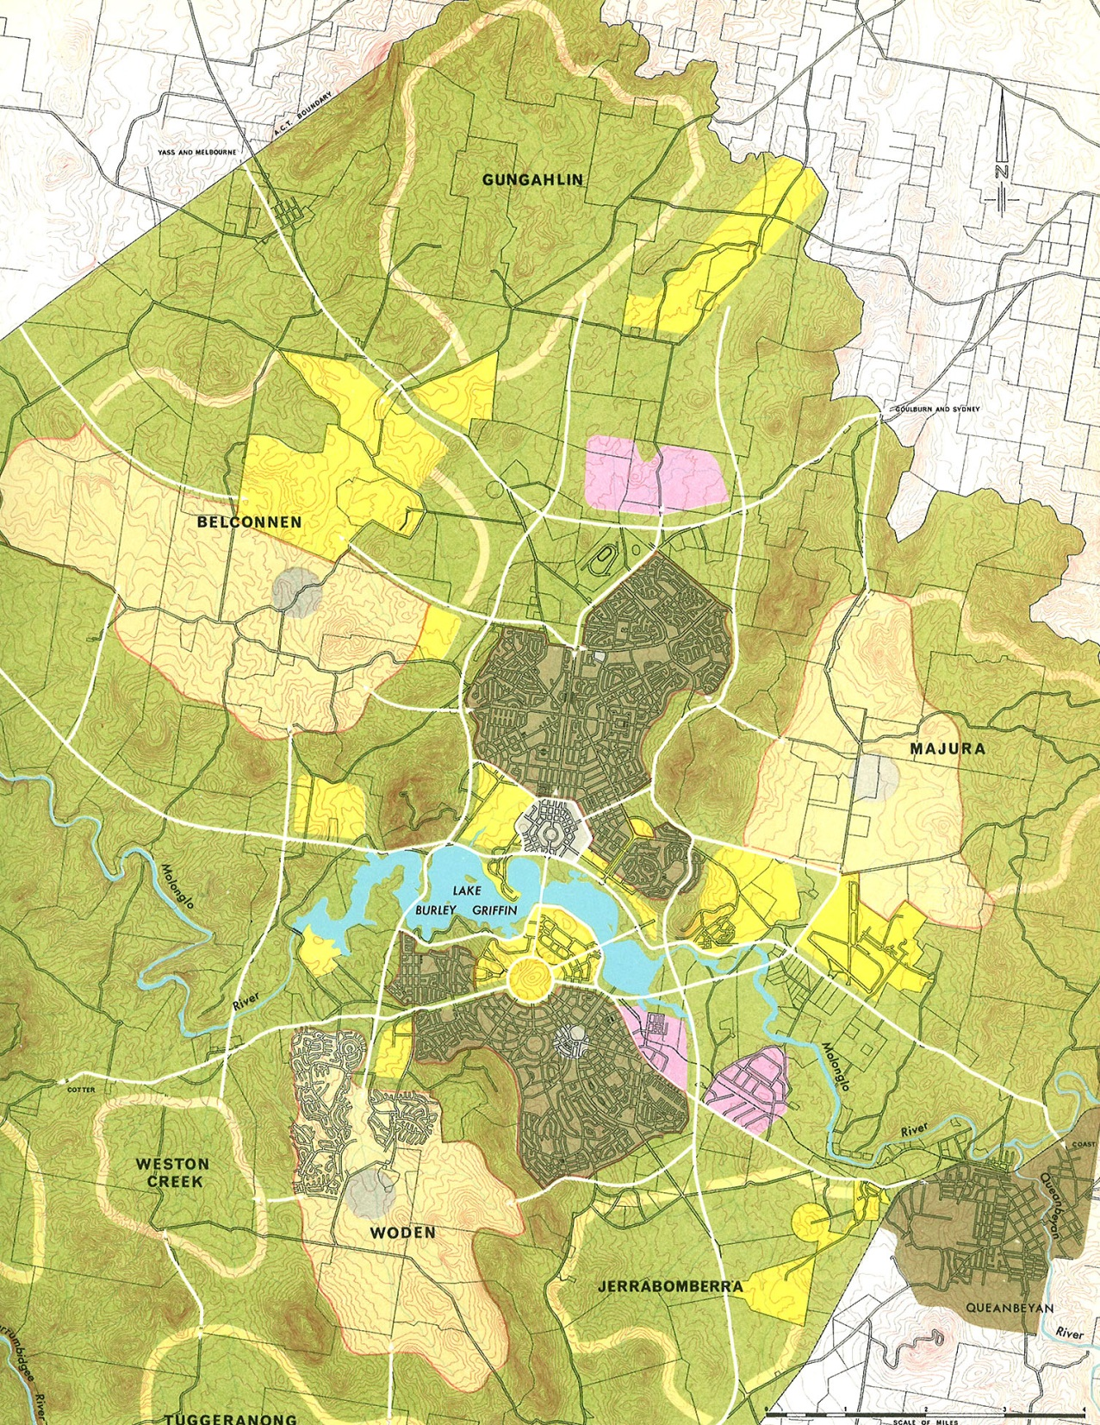
Following rapid population growth after the decision of concentrating the national public service in Canberra from the 1950s on, planning left the Griffins’ mother ship, which now came to be called ‘Inner Canberra’, and proceeded to the concept of ‘centre and satellites’ (Canberra Version 2.0). Howard’s Garden City diagram was the model, and the radial-concentric design of Canberra Version 2.0 looked exactly like this.
What seems to have been forgotten today are the lessons of the learning process that followed.
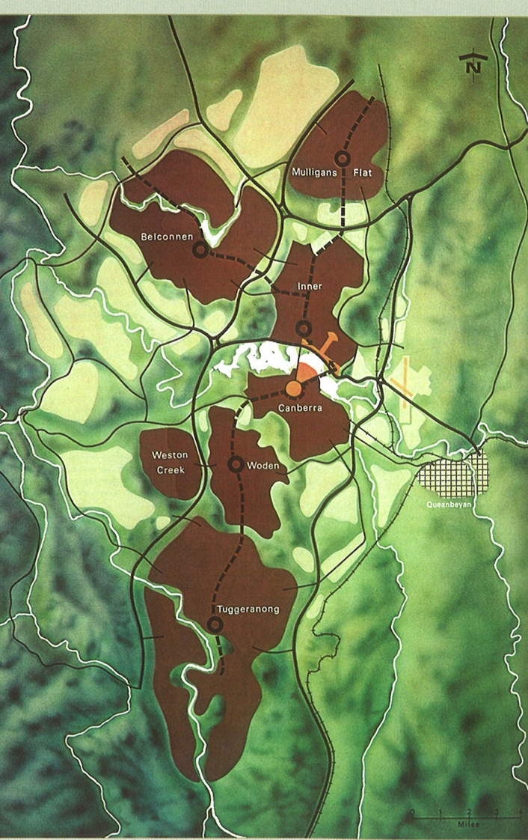
As the traffic analyses showed, the concept of radial highways emerging from the corona of satellites and converging on the CBD would have drowned the city centre in congestion and in a sea of asphalt. Hence the move to the well-known linear Y Plan composed of satellites with strong urban centres and a CBD of reduced size (Canberra 2.1). As can clearly be seen, the corona of developable land around Central Canberra (Molonglo & airport) is not used for new suburbs – for good reasons.
At the end of this learning process stood the reality of a city which has never been appreciated as such: Canberra is not only ‘the world's biggest Garden City’. It is the world’s only city in which Howard’s Garden City principles have been implemented in completeness – ranging from a (moderately) revenue-producing leasehold system to a set of rather autonomous, ‘self-contained satellites’ connected to a ‘central city’ with green core.
Again this is not a matter of academic historic curiosity but in line with the ideal concepts of planning for network cities around the turn of the 21st century and hence for decisions on how to develop the ongoing city. From this angle, we might also add 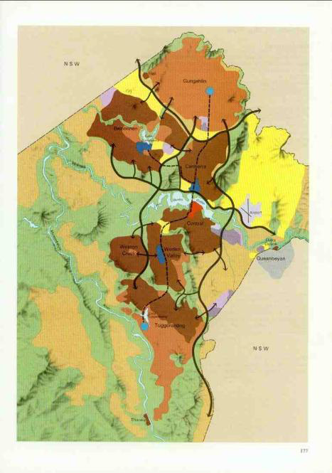that some of the central Griffin principles such as the landscape orientation and the preservation of hills pursued in NCOSS persisted through the iterations of the Y Plan.

In my book Canberra Myths and Models 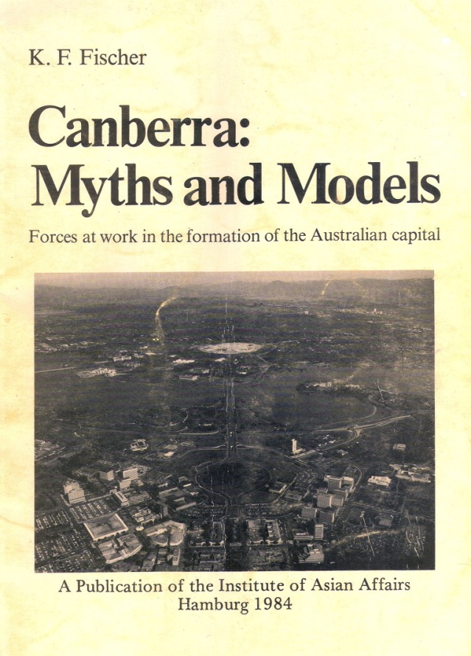and later essays on the theme I argued that the essential steps towards the dismantling of Griffin’s design as a crucial feature of the ongoing city were: the semantic impoverishment of the content of the central triangle – e.g. military replacing market functions at the eastern end, replacing the cultural functions in the middle by 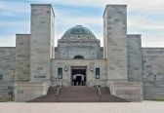a military cult zone, the neglect of the City Beautiful aspect in favour of the garden suburb approach and the solutions of post-World-War-II modernism: These included the reduction of Constitution Avenue from a “boulevard of cosmopolitan splendor” into a traffic arterial, exacerbated by the insertion of Parkes Way and finally the application of the modernist typology with buildings distributed like sculptures in the “urban landscape”.
James Weirick has pointed to the skillful way in which the plan was an intricate expression of Australian democracy as well to as the failure of recognizing and implementing these features in the design of the central area.
In recent years, this situation has again been exacerbated by the unfolding of a neo-liberal agenda, which began with the mutilation of the leasehold system 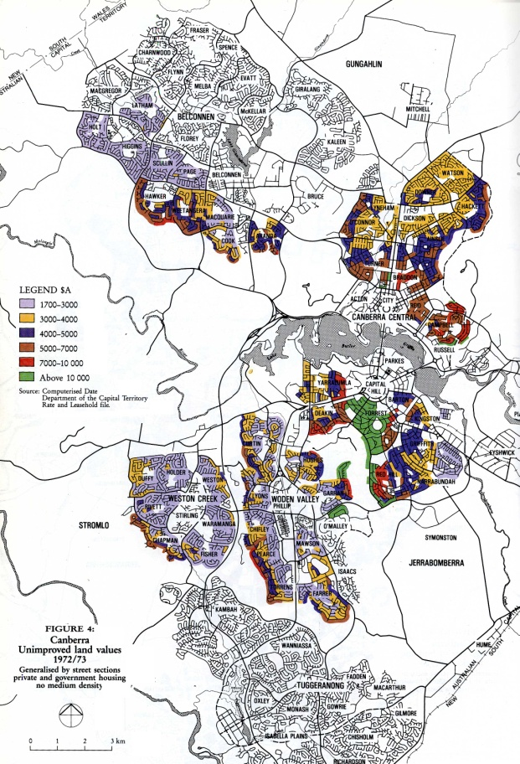and cumulated in the problematic arrangements 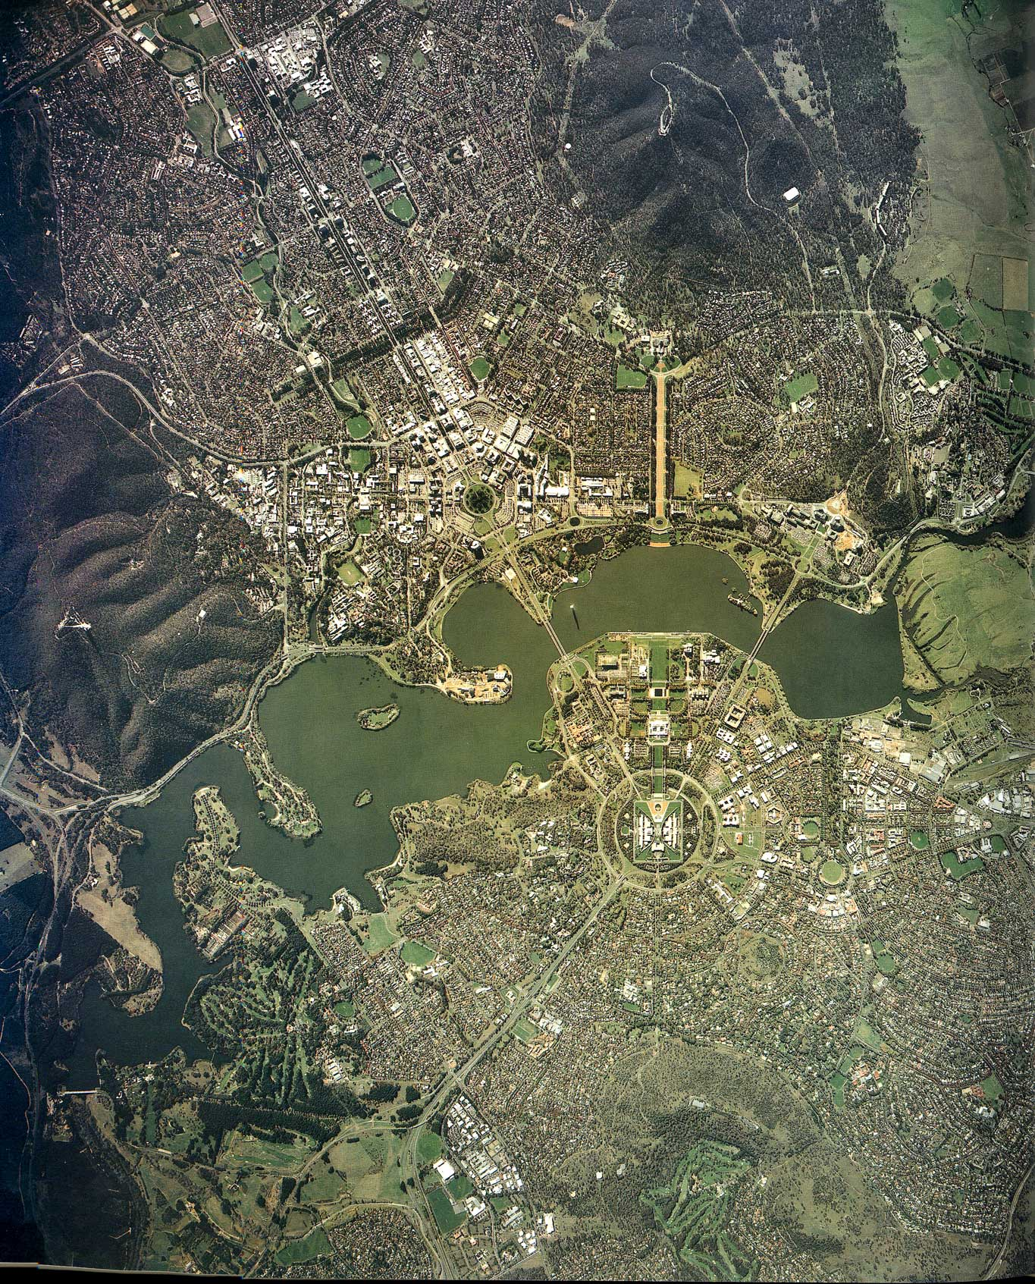surrounding the belated introduction of self-government.
Financing a substantial part of municipal revenue including infrastructure investment through selling the limited land once acquired for the foundation of Canberra is not only unsustainable (it’ll be gone before you know you had it).
What had once been conceived as a sustainable method of supplying building land at equitable cost for the homes of average citizens and of channeling land value increases not to banks and developers but into the public purse has been turned into its opposite. The strategy of maximising land values makes affordable housing a difficult issue, even if it were constructed as tents. Equally important, the time pressure resulting from the necessity of raising revenue for the day-to-day requirements of the municipal household changes the balance between the options of rapidly developing previously untouched new land reserves vs. considering the relative importance of the long-term consequences. It also weakens the government’s negotiation power with developers.
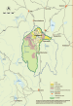
The results can be seen in the creation of the Molonglo suburbs and the development of the airport as a monstrous magnet of motor cars forcing office workers and factory outlet visitors into competition with air passengers. Among the consequences is a traffic tsunami breaking its way along the lake shore between Molonglo, the enlarged City Centre and the airport with its competing interests of passengers, office workers and factory outlet visitors.

All of this is continuing to tear the Griffin concept – as a manifestation of good urban form – to pieces. Let us recap: 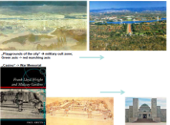Military and intelligence functions have been expanding in several steps. World War I resulted in the transformation of Griffin’s green “playgrounds of the city” into a red marching parade, and of his “casino” (not a gambling casino but the equivalent of F.L. Wrights Midway Garden in Chicago and, much closer to the point, the visitor centre at the arboretum) into the war memorial. Following World War II, 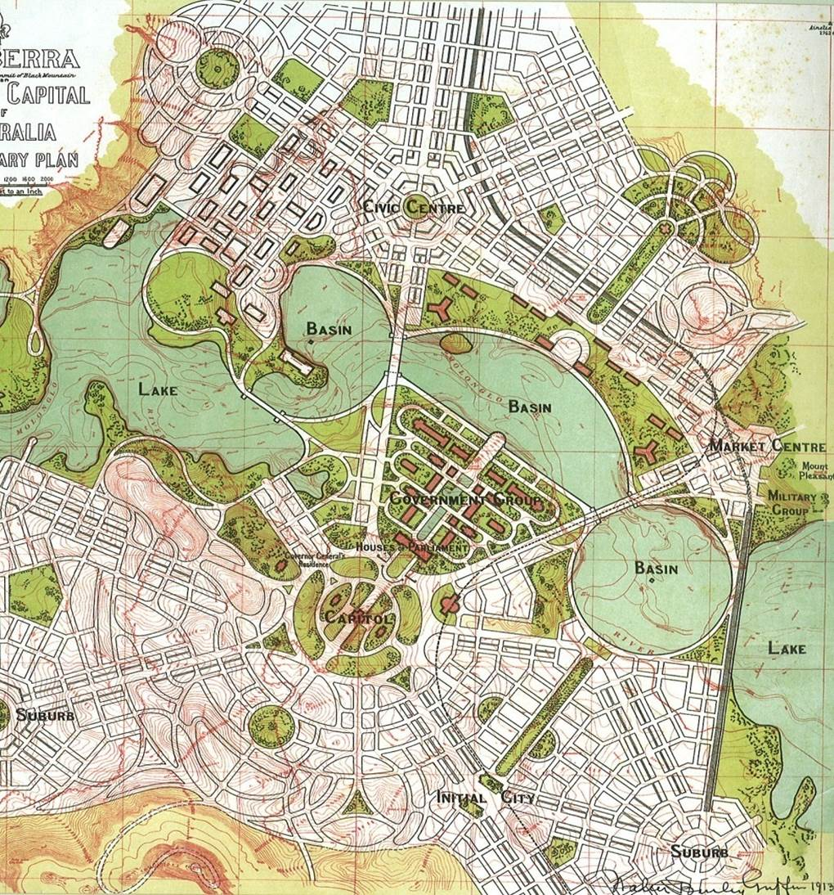 Griffin’s market centre was replaced by the military functions at Russell (the rug at the NCA reception, 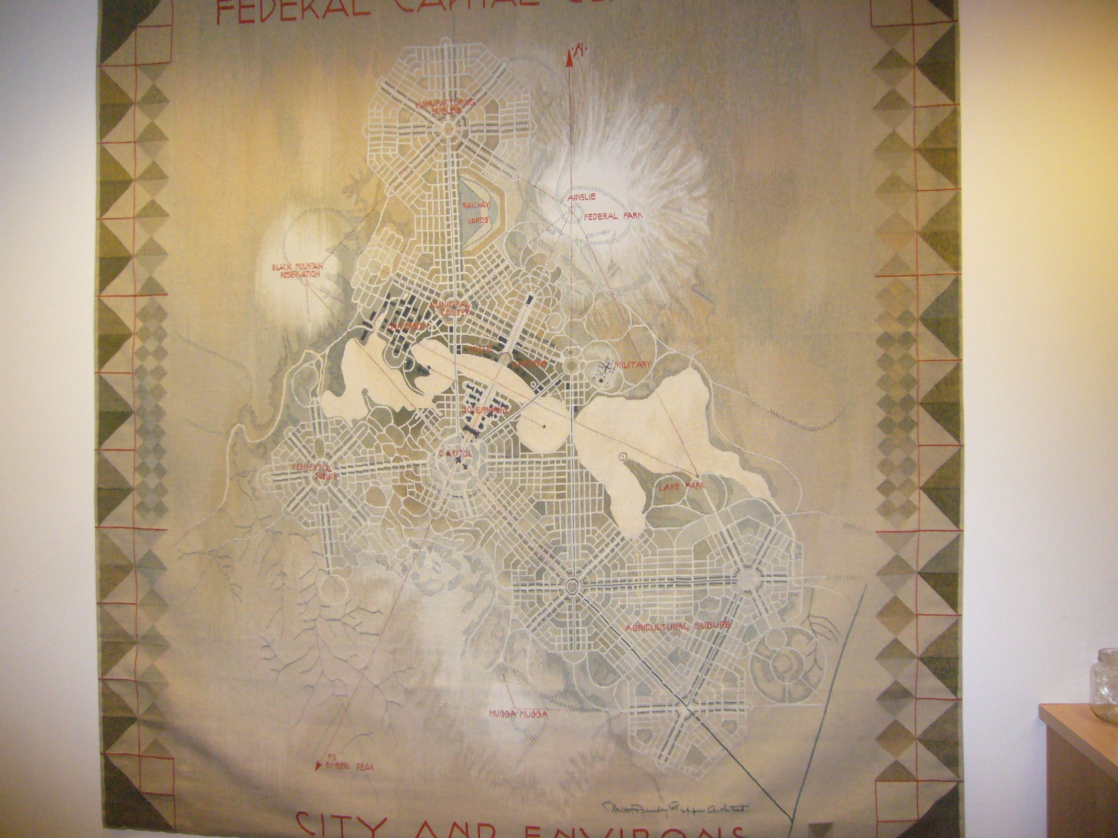 which purports to represent the Griffin Plan, has been eliminated the “Market Center” and replaced it by “Military”) 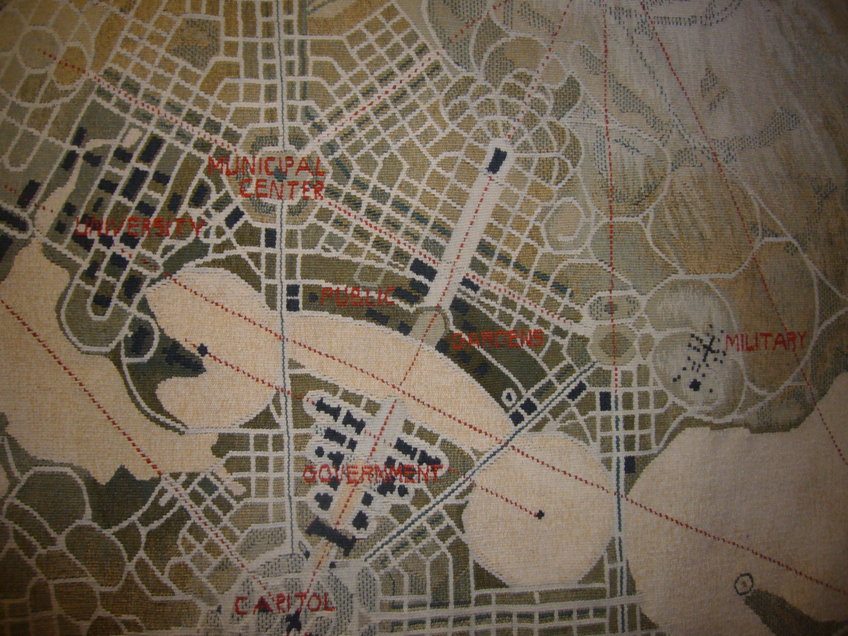; and following 9/11, 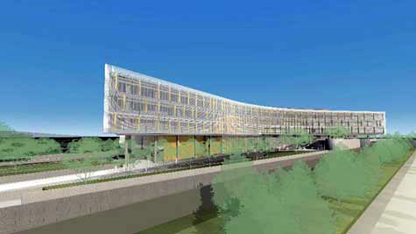 ASIO took control of much of the eastern part of the triangle, clearly stating: “Look, we’re very secret, but we’re also so ostensibly important that we’re not hiding in the Majura Valley behind Mt. Ainslie with any of the other offices in the Campbell Business Park, but instead put our big foot down in the heart of the city.”
Independent of its functions, the sheer bulk of the block buster sits in the urban fabric of the Griffin network like an embolism; far too big in terms of block size – a picture book antithesis of good urban form. But in terms of its security requirements it’s outright deadly for urban life.
[The next “logical” step would be the insertion of the Space Odyssey 2000 type World War I and II memorials like two voodoo needles into the fabric of the living city concept of the Griffin plan.]

How could this happen – at a time when the ideal concepts of an urban renaissance – meaning the rebirth and rejuvenation of the unwieldy office-and-automobile-dominated post-war city centers through strategies of urban development and design – the re-discovery of good urban form – were prevalent internationally and had also found their expression in Canberra?
Hadn’t there been this fascinating study of the “Griffin Legacy”, which re-visited the ideas of the Griffins and explored their potential for the re-urbanisation of Canberra? In 2004, a beautifully produced publication presented the ideas to the public. The concept promised also to re-instate Griffin’s vision of a lakeside boulevard of cosmopolitan splendour.
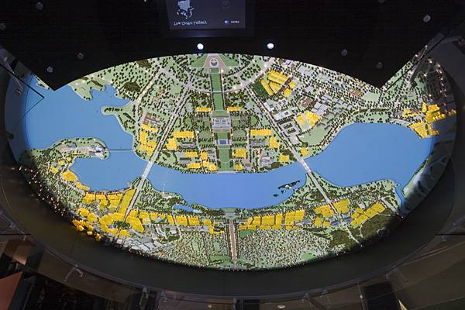
It simultaneously promised to transform much of the vast empty lawns around the lake into prime real estate land. This was tantamount to turning the ‘lady of the lawns’ at the NCA into a promoter of real estate land of immense value – several times over of Barangaroo. 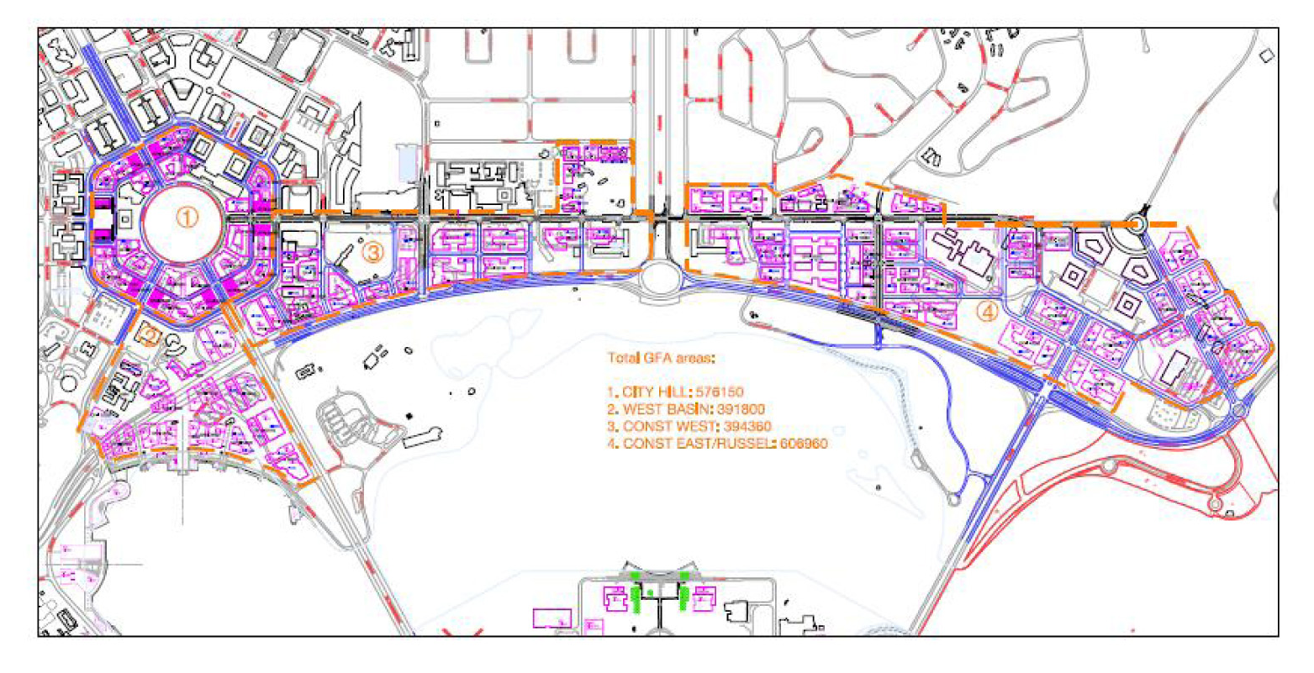
One of the many problems, however, lay in the fact that the NCA was not in control of the land in a similar way as the NCDC had been. Since self-government, the land in the ‘national area’ now belonged to the departments, and they decided what to build and where regardless of the NCA’s plans. Already in the 1990s, the Department of Foreign Affairs and Trade had jumped outside the Parliamentary triangle to locate in a kind of business park arrangement at Barton, and urban development at the airport had sprouted on land controlled by the Department of Transport outside the provisions of the National Capital Plan. At the time the NCA was proclaiming its 'Griffin Legacy' vision, the ASIO building was located on a Constitution Avenue site controlled by the Department of Finance & Deregulation - its stand alone, high security presence making a mockery of the NCA's plans for a 'Parisian' transformation of Constitution Avenue as a boulevard lined with active frontages, street cafes and vibrant city life.

Eventually, in the political crises around private development interests, ill-coordinated public agencies and their projects contravening the Griffin plan (leading to local citizens’ protest, not alone about the Albert Hall and Immigration Bridge) the Griffin Legacy project tragically fell to pieces.
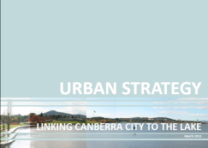
Recently, however, basic ideas of the Griffin Legacy have re-emerged in the “City to the Lake” project: Another fascinating urban design, transportation and overall development study; an exploration which has dealt in great detail with the complex nature of the design exercise operating at the cutting edge level of contemporary urban design and tram-oriented development. It should be added that, in contrast to a polemic in the Canberra Times by my favourite colleague in banter on planning issues, the designers have diligently, 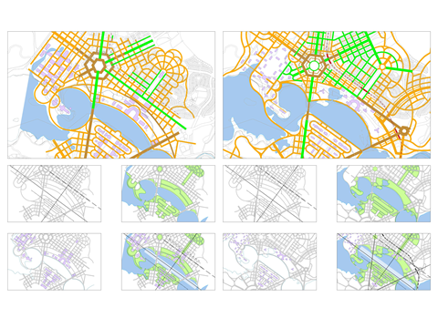 if not to say, obsessively dealt with the Griffin concept, its permutations and the changes which have occurred over the last decades.
And yes, they were not the first ones. In the auspices of the new governance structures which have become characteristic everywhere since the 1990s, urban development exercises have remarkably been undertaken by the private sector. They should all be seen as enriching the debate of the ongoing city.

But it cannot be overlooked: This can only be the first step in a very long-term process of design and political decisions.
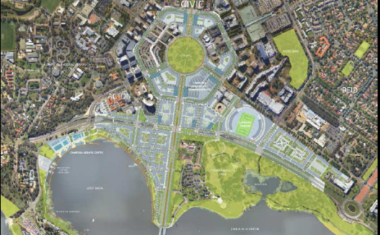
There are quite a number of largely unacknowledged urban development challenges, such as the issue of funding, timing and delivering the large-scale infrastructure works involved in dismantling the NCDC’s motor way system from City Hill to the Lake and along Parkes Way, and in constructing a new urban pattern.

It will also have to be seen whether the Griffin ideas of a vibrant city continue to be inappropriately appropriated by the property sector driven by land deals with both levels of government. Can the effects of the ‘traffic tsunami’ channeled right through the symbolic centre of the National Capital be mitigated or are they going to lead to a citizen revolt inspired by Griffin principles? The prospects of the continuing city remain fascinating.

